
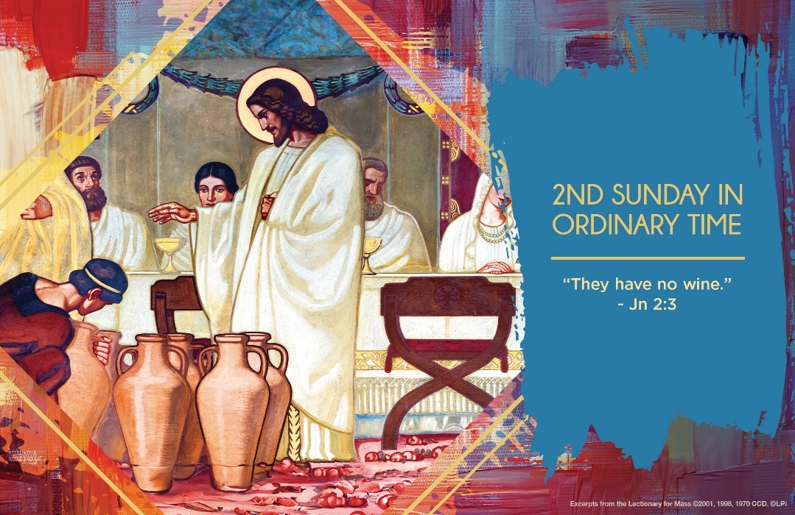
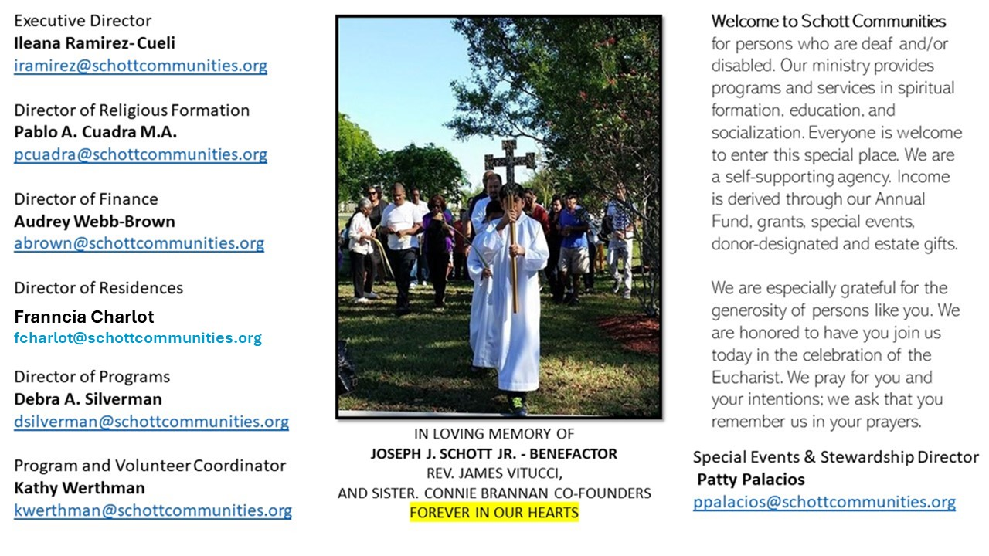

19 de enero de 2025
2º Domingo del Tiempo Ordinario
Estemos listos o no lo estemos, hemos llegado al Tiempo Ordinario. Se ha terminado la Navidad. Ahora, el Evangelio de cada domingo nos va ir presentando la imagen de Jesús en su vida pública. Jesús nos presenta el Reino de Dios con una fiesta, una boda. Y con esto cambia el sentido de lo puritano y se rompen algunos protocolos de la Ley. Las tinajas llenas de agua esperaban, sin saberlo, convertirse en el primer milagro de Jesús de transformar el agua en vino. La nota de alegría, de festejar y disfrutar es una noticia alegre. Jesús, nos muestra que, a pesar de lo duro de la vida, del sufrimiento y los fracasos, existe una esperanza. ¿Cómo podemos ponerle una chispa de alegría a nuestra fe? ¿Se te ocurre algo para disfrutar con Jesús en la fiesta de su Reino?
Asimismo, existe la otra enseñanza, la de María, la Madre de Jesús, que estuvo atenta en aquella fiesta y se dio cuenta que no había vino. Ella supo poner el problema en manos de Aquel que lo resolvería. Y dio la siguiente instrucción: “Hagan lo que él les diga” (Juan 2:5); e inmediatamente, desapareció totalmente de la escena, dejando en Jesús todo el protagonismo. ¿Qué debo aprender de María? Que ella nos lleva a Jesús y que cada vez que haga una buena acción, las personas le reconozcan a Él y yo desaparezca.

January 19, 2025
2nd Sunday of Ordinary Time
John 2:1-12

A friend invited me to an invitation-only wine-tasting event. There were over two hundred varieties of wine. Having no idea how to approach such a massive selection, I wandered aimlessly among the tables, sipping this and that. At the end of the evening my friend asked if I had tried some of the exceptionally expensive wines. I hadn’t. “The really good stuff disappears first,” he said. “My man, you missed out on some amazing vino.” I was so disappointed. I wasted my chance for amazing once-in-a-lifetime wine. The wine I tasted was, well, blah.

Don’t we often feel a similar disappointment in life? I missed this or that opportunity. If only I had known. Optimism sputters and fades. The glory days are gone. The chances, it seems, for the really great things in life come and go so quickly. Then they are gone forever. The good stuff goes first. Then life is just blah.

Not so with the Lord Jesus. In Jesus’ miracle at the wedding at Cana, the steward of the feast says, “Everyone serves good wine first, and then…an inferior one” (John 2:10). That’s the natural downward progression of life. The good stuff disappears quickly. But he says of the groom (who symbolizes Jesus), “But you have kept the good wine until now.” This is the ever-improving trajectory of the realm of God’s grace. With Jesus, the “good wine” of divine love, hope and peace gets better as our journey of faith progresses. Where are your greatest disappointments? Don’t give in to the lie that the really good stuff is gone. Tell Jesus you’ve run out. Then learn how to taste that amazingly good wine, because he saves the best until now.

— Father John Muir

St. Jude Chapel, Sunday, January 19th, 2025
Monsignor Roberto Garza
Celebrant

St. Marianne Cope | January 23

St. Marianne Cope immigrated to the USA from Germany when she was a child. A gifted leader, she oversaw schools, hospitals, and missions during her long life. Most notably, she volunteered to provide care to those outcasts with leprosy in Hawaii.


Christian Giving
January 12th, 2025
$484

We sincerely thank you and bless you for your generosity.
A bequest is a powerful tool to help the Deaf or Disabled.

Mass Intentions
“For the repose of the Souls in Purgatory
Requested by Schott Communities


Follow us on Facebook
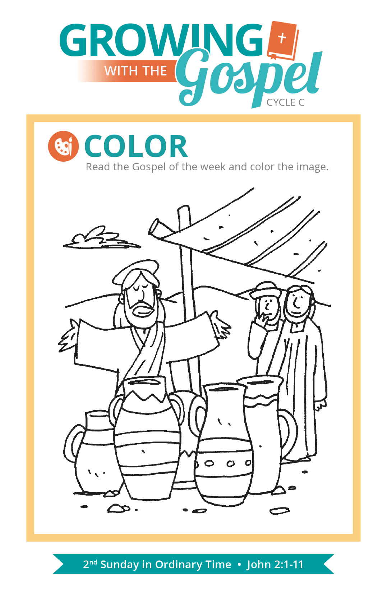
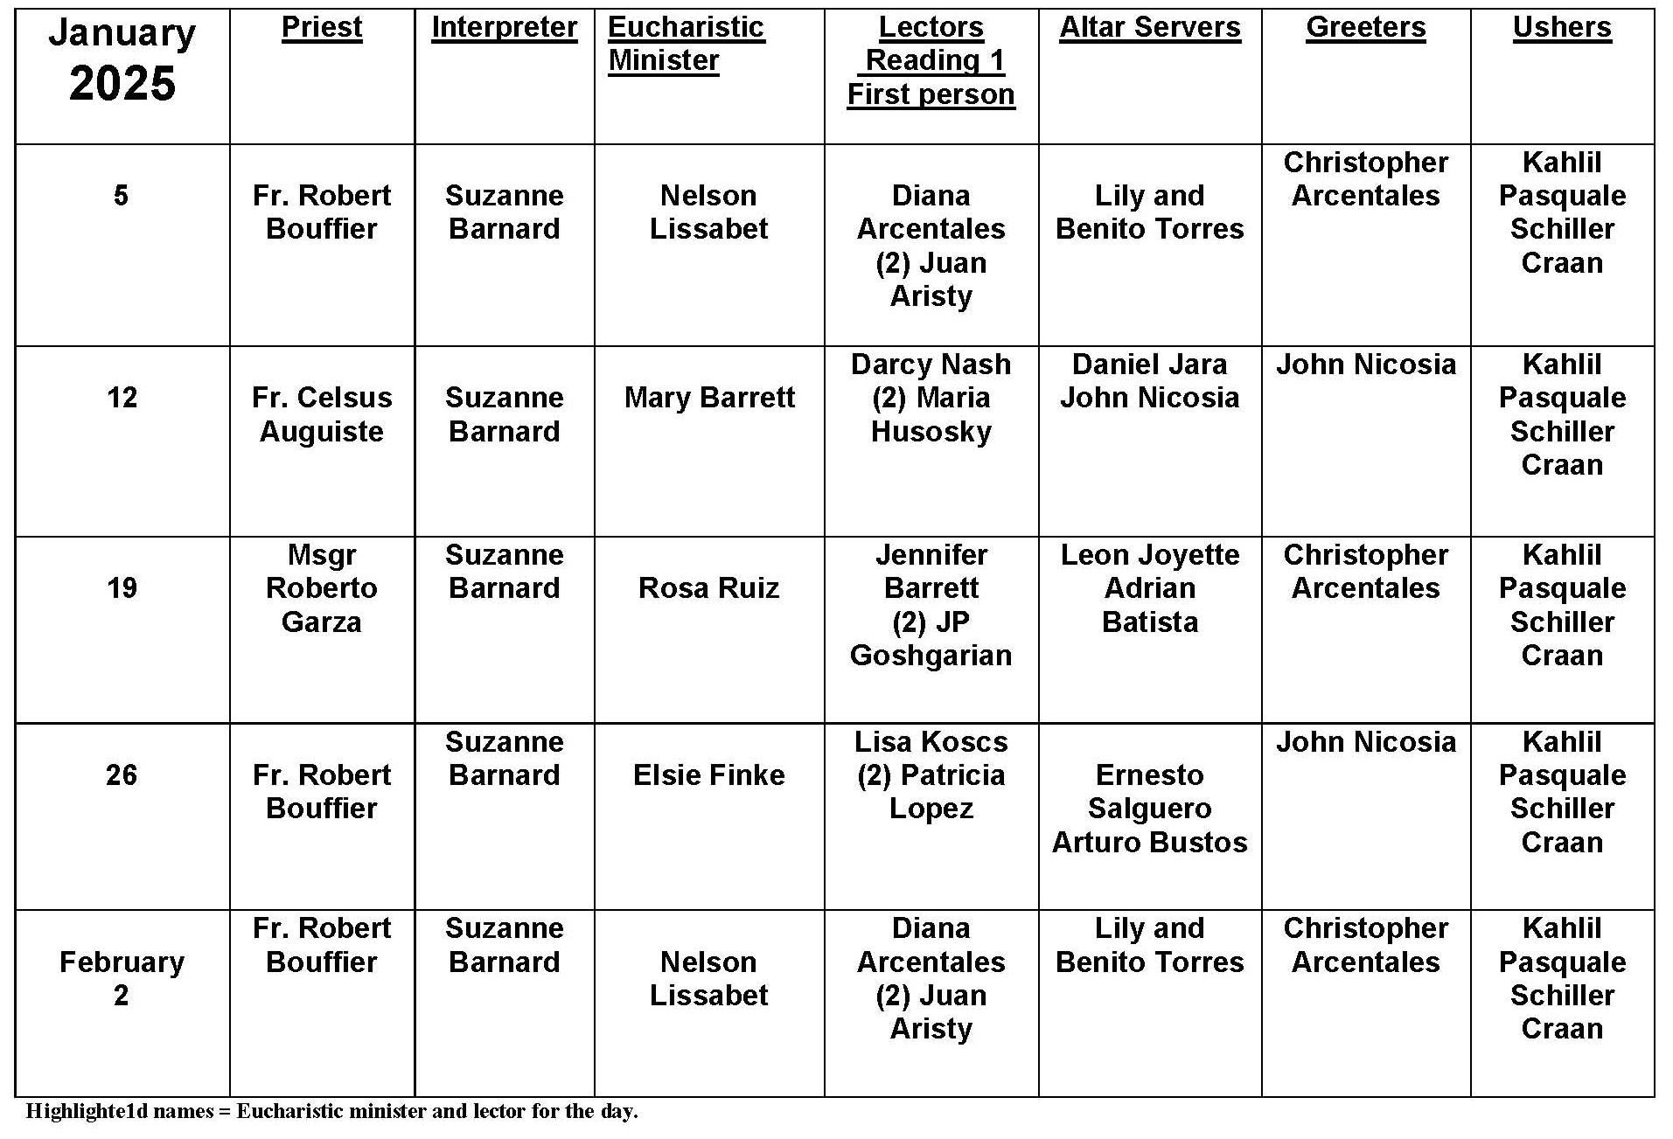
Holy Days

Question:
Why do some dioceses move holy days, or not even celebrate them at all. Doesn't everyone do the same thing?

Answer:
The short answer is no, not everyone does the same thing. Although the church is universal, there are many local customs and saints that each country, sometimes just a region, will honor. For example, feast days and patronal days may not be major feast days on the church's universal calendar, but are celebrated as such in one place. Holy days of obligation are the same way. The US Conference of Catholic Bishops has a certain amount of discretion in choosing days which best reflect the local church's experience and history.
Another reason certain feasts are moved is a practical one. With limited clergy, or a great difficulty for people to get to Mass, the feast day may be transferred to a Sunday. The rationale is that if a significant feast should be part of the church's celebration, then better to do so on a Sunday when people and clergy are available, rather than try to fit it on a day when one or both cannot be there.
Christmas and Immaculate Conception are always observed as days of obligation. In the USA we celebrate six holy days of obligation. There are also other special days and they are ranked, in order of importance as solemnity, feast, memorial and optional memorial.

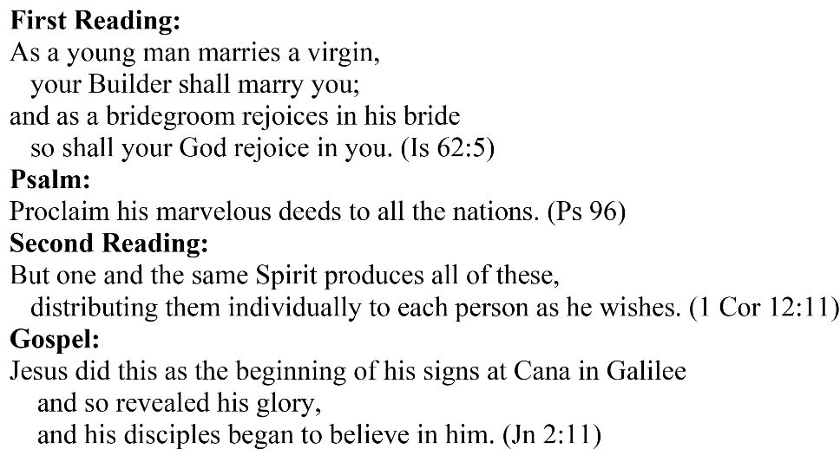
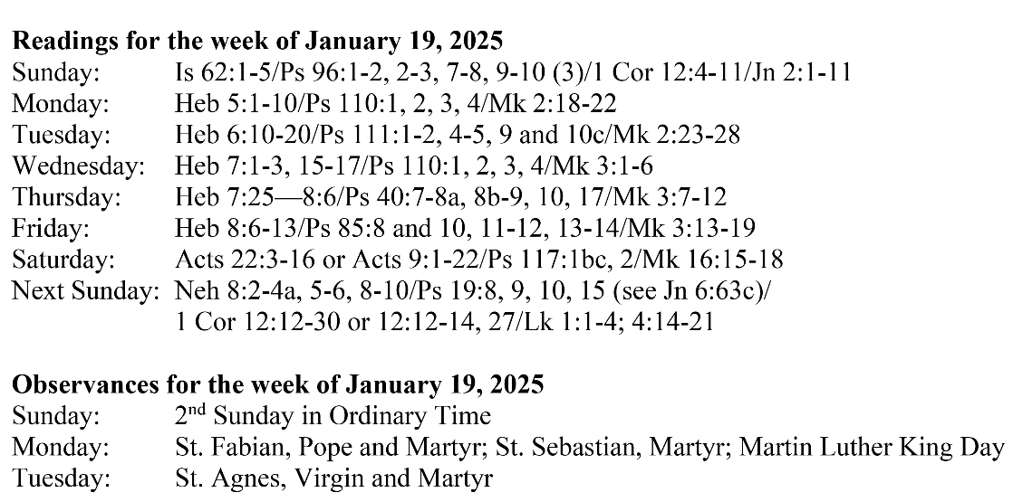
Are you in need of prayer? Do you have a prayer request? You can send your prayer requests to pcuadra@schottcommunities.org or call 954-434-3306 ext. 108

A copy of our prayer list can be found in the lobby of our chapel. To request a copy of our prayer list please email us at pcuadra@schottcommunities.org
To request a Mass please contact Pablo A. Cuadra at 954-434-3306 or e-mail at pcuadra@schottcommunities.org
Update: Celebrating a wedding anniversary soon? Let us know a week in advance and we can assist you with the renewal of your wedding vows.

Prayer to St. Michael the Archangel:
"St. Michael the Archangel, defend us in battle. Be our defense against the wickedness and snares of the Devil. May God rebuke him, we humbly pray, and do thou, O Prince of the heavenly hosts, by the power of God, thrust into hell Satan, and all the evil spirits, who prowl about the world seeking the ruin of souls. Amen"

