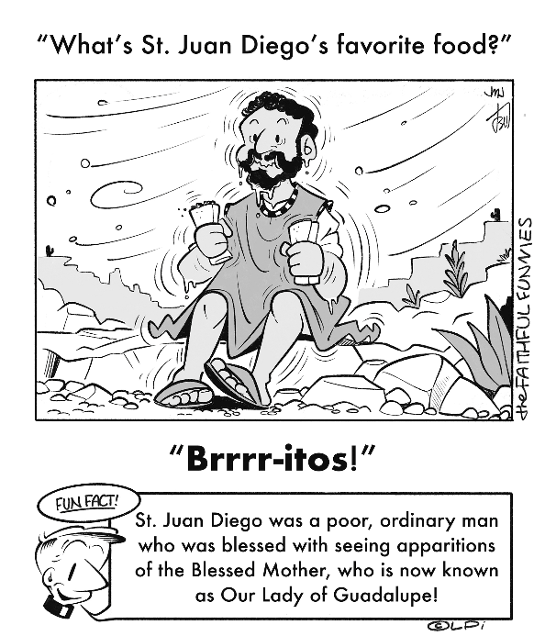
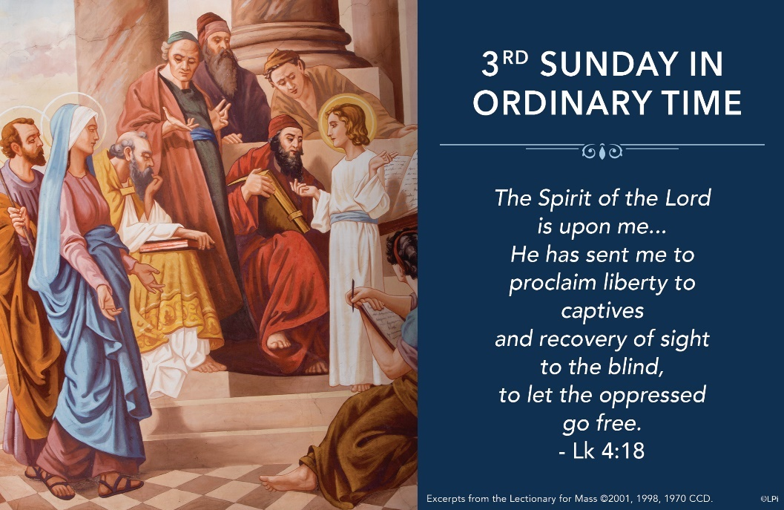
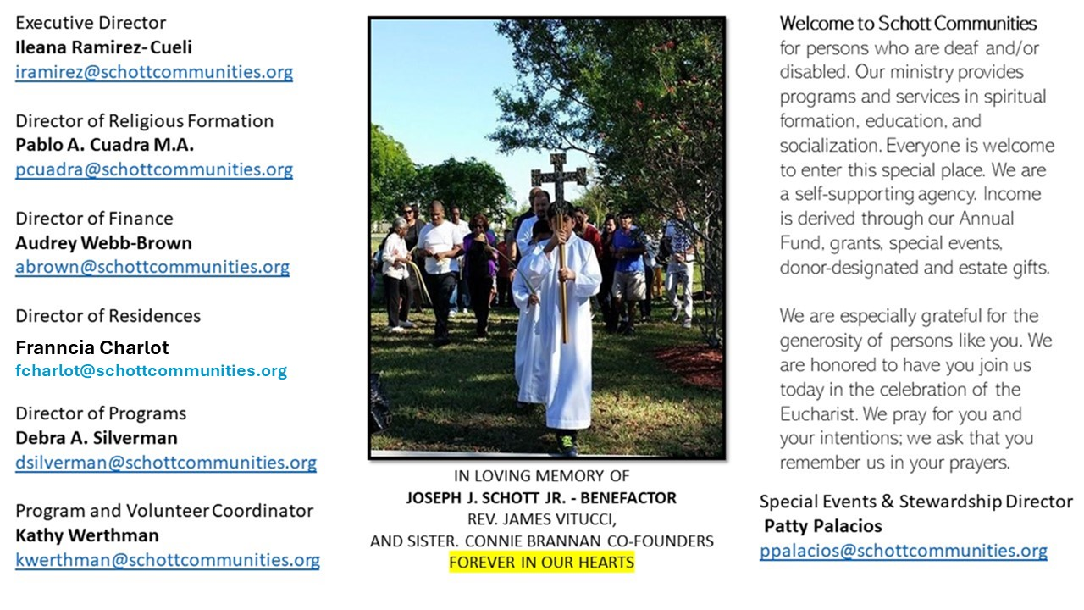

26 de enero de 2025
3er Domingo del Tiempo Ordinario
Tenemos tantas cosas atrayentes y entretenidas que nos distraen grandemente. La televisión, la computadora, y sobre todo nuestro teléfono; podemos pasar el día entero viendo y buscando cosas que no nos llevan a ningún lado. Cabe pues, que nos preguntemos lo siguiente: ¿Dónde ponemos nuestros ojos, nuestro pensamiento? Jesús, no tenía nada de estos instrumentos para anunciar el Reino de Dios. A Él se le entregó el rollo del Profeta Isaías, y leyó lo siguiente: “El Espíritu del Señor está sobe mí” (Lucas 4:18). Y ese mismo Espíritu de Dios está en nosotros, esperando que llegue un momento del día para estar juntos y mirarnos.
Toda la sinagoga estaba atenta con los ojos clavados en él. Y les dijo: “Hoy se cumplen estas palabras proféticas y a ustedes les llegan noticias de ello” (Lucas 4:21). “Cristo es el autor y guía de toda actividad evangélica que está expuesta. También la profecía predice que después de él sus propios discípulos serán los ministros de esta tarea cuando dice: “¡Qué hermosos son los pies del mensajero cuando anuncia la paz!” (Isaías 52:7). Se refiere a los pies hermosos de los mensajeros de Cristo. ¿Cómo no iban a ser hermosos, si en breve tiempo iban a recorrer el mundo e iban a llenar cada rincón de la tierra con esa santa doctrina del Salvador?” (Eusebio de Cesarea (260-340 La Demostración evangélica). Recordemos siempre, que la Palaba de Dios es espíritu y vida.

January 26, 2025
3rd Sunday of Ordinary Time
Luke 1:1-4, 4:14-21

A young couple in my parish told me they were expecting their second child, a baby boy. I knew that their five-year old only child Emma had been desperately wanting to be a big sister for years, so I said, “Emma must have been so happy when you told her the news.” “Actually,” they said, “she burst into tears. She wanted a baby sister!” How often in life God wonderfully fulfills our desires and we are sad because we don’t approve of the way he does it. We want to control the gift and the delivery method.

The same thing occurs in the Gospel this week when Jesus announces in his hometown that the promise of an Anointed One bringing glad tidings to the poor is “fulfilled in your hearing” (Luke 4:21). After a moment of elation, his fellow townsfolk realize this man is the way God is fulfilling his promises, and they erupt into a violent outburst. So Jesus departs. How sad for them.

Every single Sunday at Mass, including this one, some version of this happens to many of us. God’s word announces the fulfillment of God’s promises in Christ, and we easily overlook or disdain it. His way is almost never according to our narrow expectations. What’s required of us is to set these aside, and to embrace a new openness to God’s gifts, no matter how he wishes to give them. God is fulfilling his promises the way He likes — why be sad?

— Father John Muir

St. Jude Chapel, Sunday, January 26th, 2025
Father Jimmy Acevedo
Celebrant

St. Thomas Aquinas | January 28
One of the most famous members of the Dominican Order, St. Thomas Aquinas (1225 – 1274) is well-known by many for his theological work, “The Summa Theologiae.” Born in Italy, his mother wanted him to become a Benedictine and had high hopes that he would eventually become abbot of Monte Cassino, where he spent much of his youth. To change his vocation, she had him kidnapped by his brothers on his way to Paris at the age of 19. He spent two years in their captivity. Despite this, nothing could shake him from his vocation to become a Dominican priest and he was eventually released. Once free, he went to Paris and then to Cologne, where he finished his studies with Albert the Great.


Christian Giving
January 19th, 2025
$TBA

We sincerely thank you and bless you for your generosity.
A bequest is a powerful tool to help the Deaf or Disabled.

Mass Intentions
“For the repose of the Souls in Purgatory
Requested by Schott Communities


Follow us on Facebook
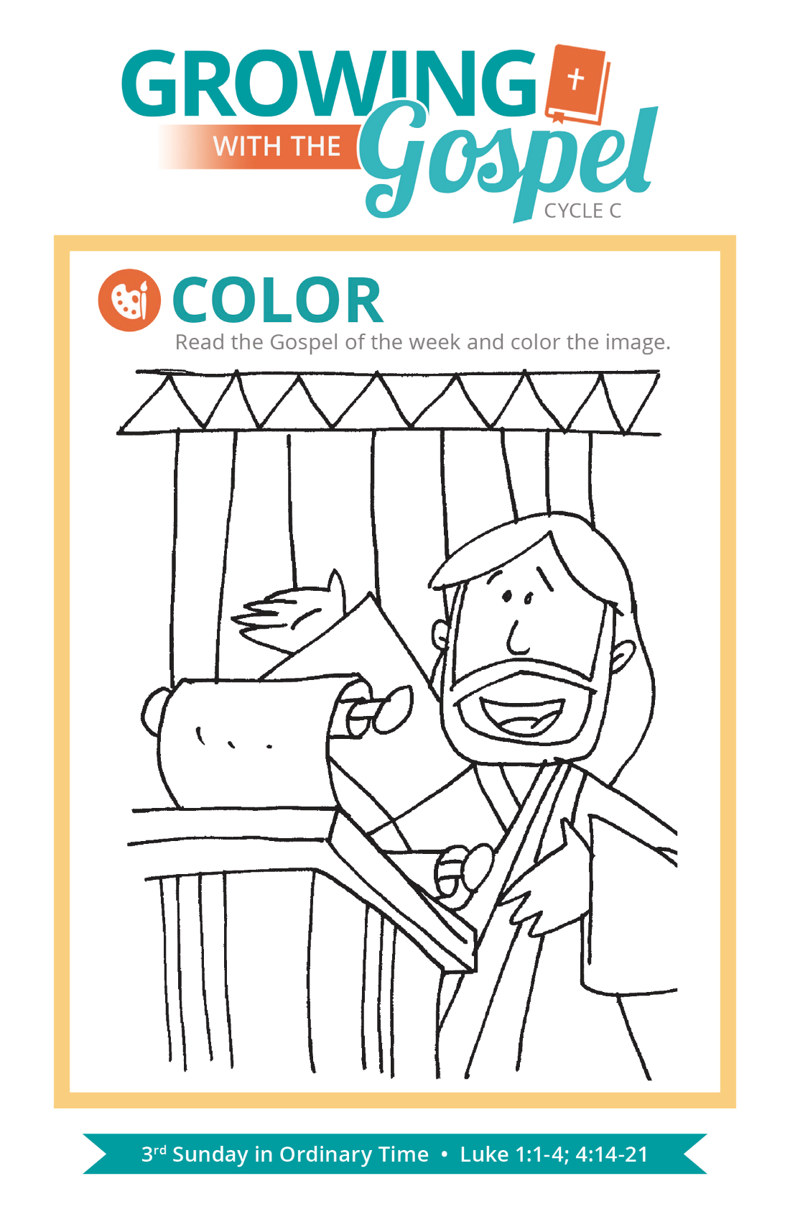
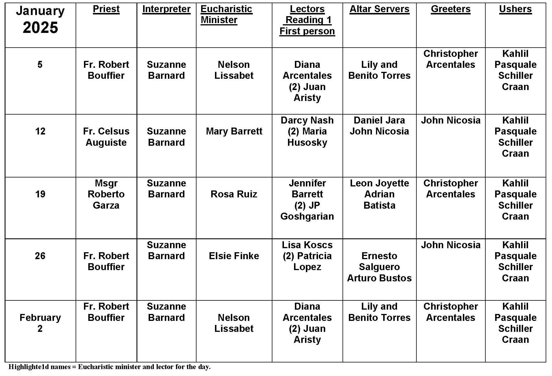
Love as a Theological Virtue

Question:
I’ve heard that love is a theological virtue. What does that mean?

Answer:
Charles Shultz, the creator of the Peanuts comics wrote, “I love mankind … it’s people I can’t stand!” This good humored comment gets at an important truth. St. John wrote a very strong statement in one of his letters: “If anyone says ‘I love God,’ but hates his brother, he is a liar; for whoever does not love a brother whom he has seen cannot love God whom he has not seen” (1 John 4:20). How often do we say “I love the homeless,” but ignore the parish food drive? Or insist on the importance of respecting others, but don’t bother to say hello to our cashier? If we can’t love an individual person, we might not love people like we think, and we certainly need to work on our love for God.

Love is “the theological virtue by which we love God above all things for His own sake, and our neighbor as ourselves for the love of God” (CCC 1822). God knows acts of love of Him and others isn’t always easy. So He invites us to pray for the grace to do it. The virtue of love gives us the grace and strength we need to offer our lives to God and love people in our lives, especially those who are difficult to respect, tolerate, and care for. Real love, of course, is risky. Real love wills the good of the other when we just want good for ourselves. Real love gets up on the cross when we’d prefer to take a nap in Gethsemane. Real love changes things.


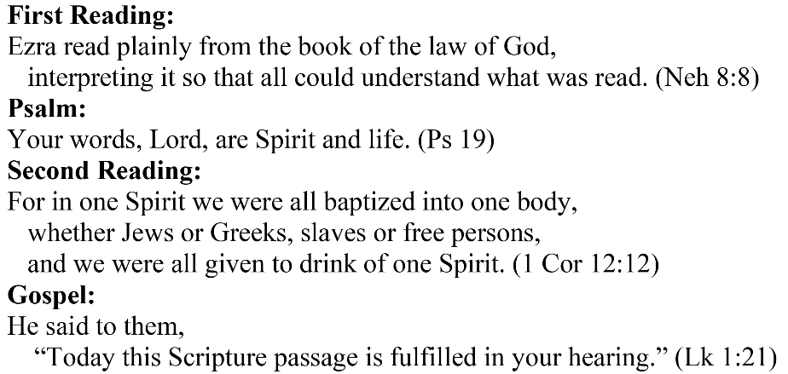
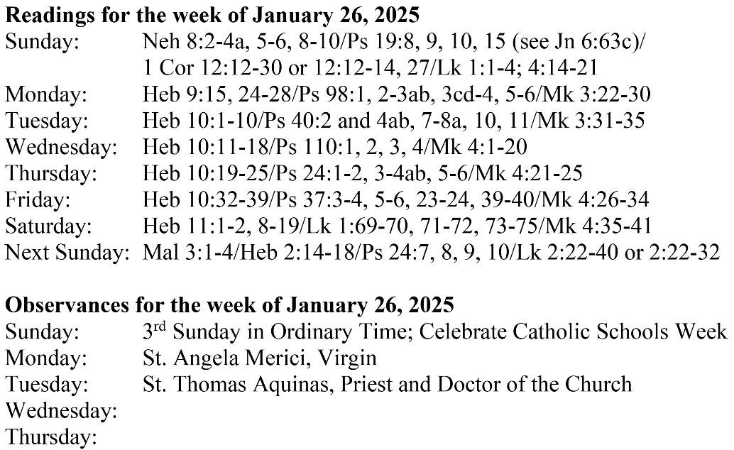
Are you in need of prayer? Do you have a prayer request? You can send your prayer requests to pcuadra@schottcommunities.org or call 954-434-3306 ext. 108

A copy of our prayer list can be found in the lobby of our chapel. To request a copy of our prayer list please email us at pcuadra@schottcommunities.org
To request a Mass please contact Pablo A. Cuadra at 954-434-3306 or e-mail at pcuadra@schottcommunities.org
Update: Celebrating a wedding anniversary soon? Let us know a week in advance and we can assist you with the renewal of your wedding vows.

Prayer to St. Michael the Archangel:
"St. Michael the Archangel, defend us in battle. Be our defense against the wickedness and snares of the Devil. May God rebuke him, we humbly pray, and do thou, O Prince of the heavenly hosts, by the power of God, thrust into hell Satan, and all the evil spirits, who prowl about the world seeking the ruin of souls. Amen"

