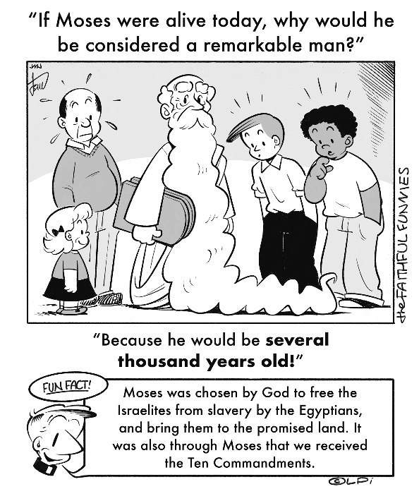
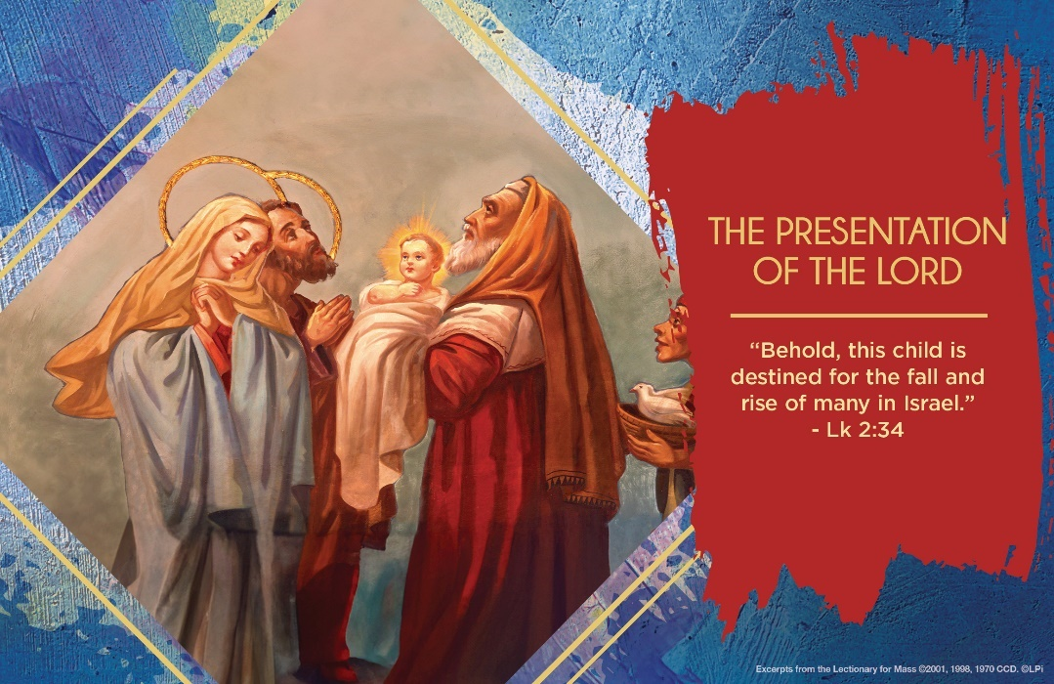
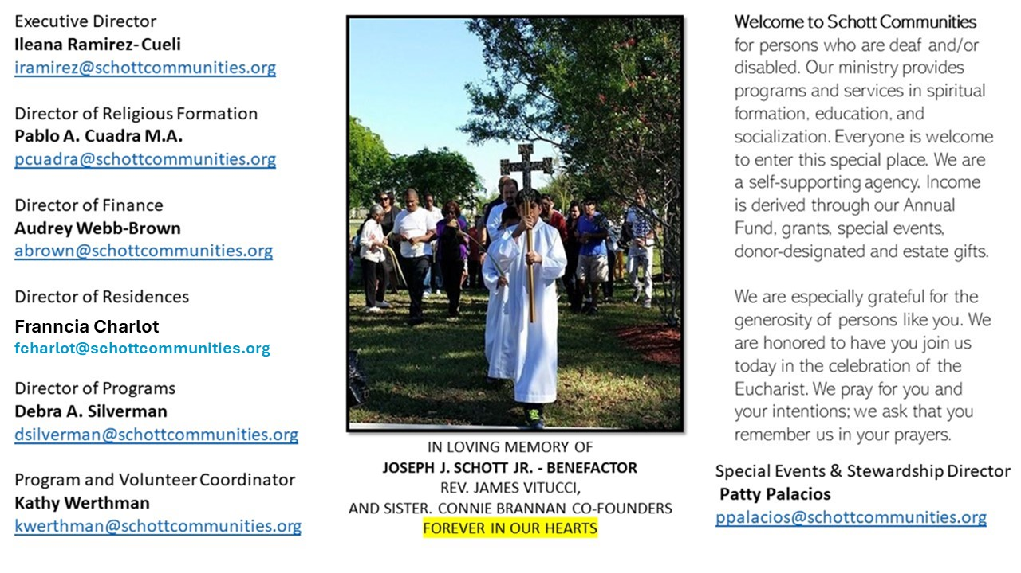

2 de febrero de 2025
La Presentación de Jesús
“Hoy celebramos la Fiesta de la Presentación del Señor. El Evangelio cuenta que, José y María llevaron al Niño a Jerusalén para consagrarlo a Dios, como prescribe la ley judía. Y, mientras describe un rito previsto por la tradición, este episodio llama nuestra atención sobre el comportamiento de algunos personajes. Reflejados en el momento en que experimentan el encuentro con el Señor en el lugar donde se hace presente y cercano al hombre. Estos son María y José, Simeón y Ana, que son modelos de acogida y entrega de sus vidas a Dios” (Papa Francisco). ¿Cómo me presento ante Dios cada día de mi vida? Nuestros modelos son Simeón y Ana que tuvieron la lucidez para reconocer a Dios que llegaba en brazos de María y José al templo.
Ellos, ya ancianos, nos enseñaron y mostraron el camino de ver, abrazar a Dios hecho niño y a anunciar la esperanza. Abracemos también nosotros la ternura de Dios y llevémosla a los tristes, a los enfermos, y a los que no tienen voz en muchos lugares de la sociedad en que vivimos, tal como son los niños y los ancianos. Abramos nuestro corazón al misterio de Dios que está en tantas personas que nos encontramos a diario, en casa, en el trabajo, y en nuestros vecindarios. Ojalá, que al final de nuestros días, Dios nos de la dicha de poder decir como el anciano Simeón: “Ahora, Señor, ya puedes dejar que tu servidor muera en paz, como le has dicho. Porque mis ojos han visto a tu salvador” (Lucas 2:29-30).

February 2, 2025
Presentation of the Lord
Luke 2:22-40

What is the secret to sharing in God’s power to overcome our difficulties? Mary teaches us this in the prophecy of her pierced heart. This Sunday, the old man Simeon prophecies that when her son faces opposition, Mary’s soul will be pierced by a sword. The seemingly pointless agony of a mother helplessly watching her son be mocked, tortured, killed and then cruelly desecrated in death by a spear — somehow this piercing of her heart releases a power by which “the thoughts of many hearts may be revealed” (Luke 2:35). What to make of this?

Whatever problems we currently face, the deepest threat is finally that evil thoughts are hidden in the human heart: hatred, envy, pride, lust, greed and so on. Behind every tyrant’s injustice, for example, is a heart unpierced by love. Evil hides in our hearts. Mary’s pierced heart, and its suffering love for her son, reveals and scatters these evil thoughts, and replaces them with love, forgiveness, generosity and peace.

This week, I invite us to ponder Mary’s pierced heart. Her heart is quietly at work for us in the Church and world, exposing our evil thoughts and making a path for her son’s divine love. This is how she gently cooperates in our salvation. Closed hearts are our biggest problem; love-pierced hearts are the ultimate power to overcome every difficulty.

— Father John Muir

St. Jude Chapel, Sunday, February 2nd, 2025
Father Robert Bouffier
Celebrant

St. Blaise | February 3 - You may be familiar with the annual “blessing of throats” that many parishes in the United States use to commemorate the beloved bishop and martyr. St. Blaise lived in the fourth century in Turkey and Armenia. Due to religious persecution, he was forced to flee and hide in a cave in the back country in order to save his life. History has it that one day a group of hunters stumbled upon where St. Blaise was living. They found the bishop kneeling in prayer, surrounded by wolves, lions, and bears that he had tamed. The legend has it that as the hunters dragged Blaise off to prison, a mother came with her young son who had a fish bone lodged in his throat. At Blaise’s command, the child was able to cough up the bone and thus lived.


Christian Giving
January 26th, 2025
$601

We sincerely thank you and bless you for your generosity.
A bequest is a powerful tool to help the Deaf or Disabled.

Mass Intentions
“For the repose of the Souls in Purgatory
Requested by Schott Communities


Follow us on Facebook
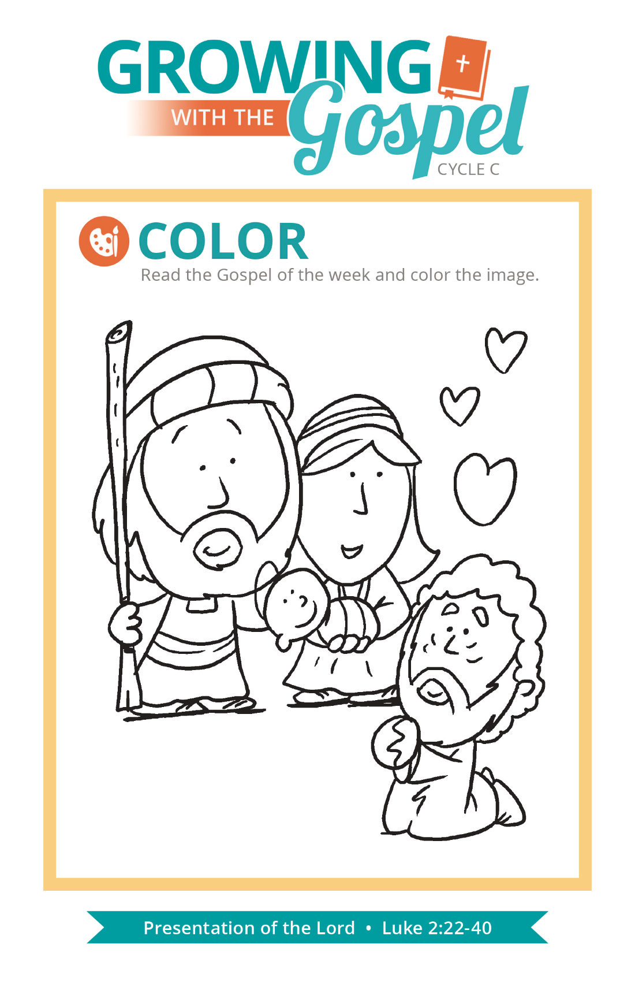
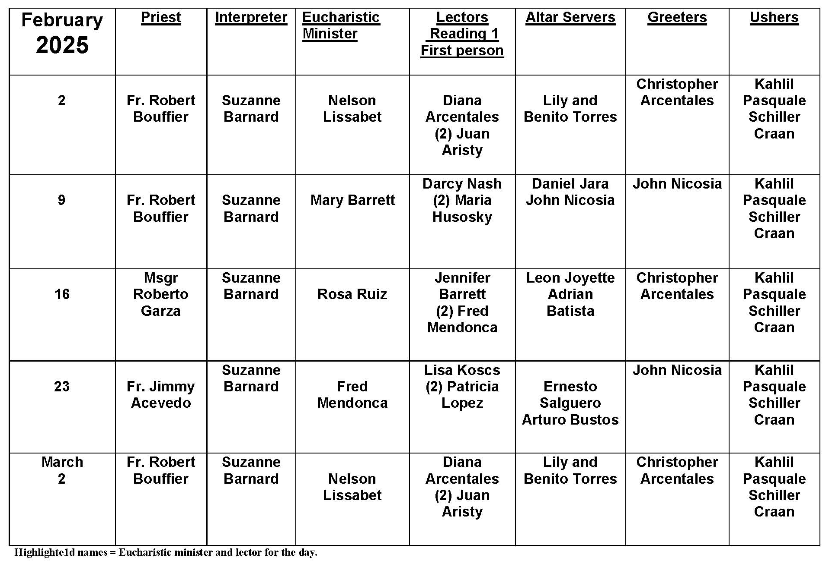
Presentation of the Lord
Question:
Luke’s Gospel is the only one to mention the Presentation of the Lord in the Temple. What is Luke trying to communicate here and what connection does it have with Mary?
Answer:
February 2 is exactly forty days after December 25, the nativity of Jesus. Jewish law (Ex 13:2, 12) dictated that Jesus, as the firstborn, be consecrated to God. This was done by the parents as they presented their Son in the Temple.
Jewish law further specified (Lv 12:2-8) that a mother was ritually impure after giving birth, and that she had to wait a set period of time (forty days for a boy) before she was to offer a sacrifice to the Lord for purification.
The convergence of these two Jewish regulations occasions Luke’s account of both the Presentation of the Lord and the Purification of Mary. These days the liturgical emphasis is more on the Presentation of Jesus. Luke highlights the role of Simeon and Anna, two righteous Jews who recognized Jesus as the long-awaited Messiah and praised God for being able to see and experience such a marvel in their lifetimes.
Simeon’s prayer concerning the special role of Jesus states that Jesus is “a light for revelation to the Gentiles.” This phrase eventually originated the custom of blessing candles on this day which were to be used in the ceremonies, rituals, and processions throughout the church year. Thus February 2 is also known as Candlemas Day. This day is indeed a rich feast to be savored.

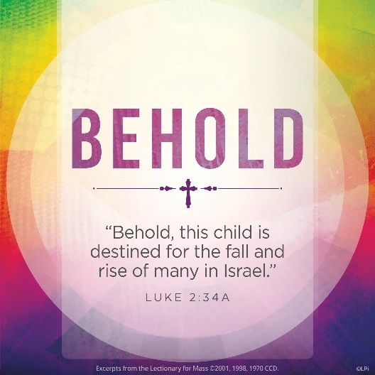
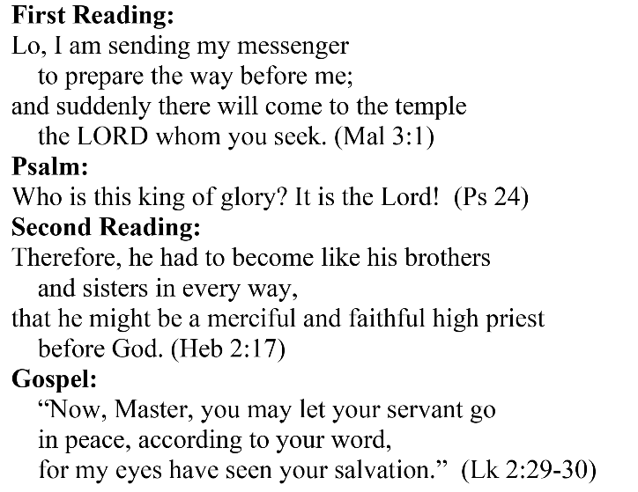
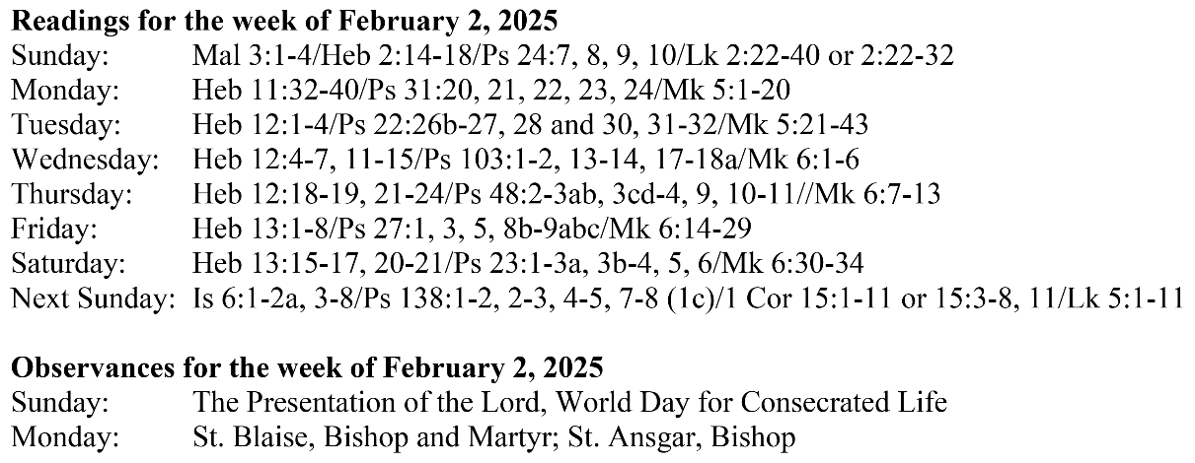
Are you in need of prayer? Do you have a prayer request? You can send your prayer requests to pcuadra@schottcommunities.org or call 954-434-3306 ext. 108

A copy of our prayer list can be found in the lobby of our chapel. To request a copy of our prayer list please email us at pcuadra@schottcommunities.org
To request a Mass please contact Pablo A. Cuadra at 954-434-3306 or e-mail at pcuadra@schottcommunities.org
Update: Celebrating a wedding anniversary soon? Let us know a week in advance and we can assist you with the renewal of your wedding vows.

Prayer to St. Michael the Archangel:
"St. Michael the Archangel, defend us in battle. Be our defense against the wickedness and snares of the Devil. May God rebuke him, we humbly pray, and do thou, O Prince of the heavenly hosts, by the power of God, thrust into hell Satan, and all the evil spirits, who prowl about the world seeking the ruin of souls. Amen"

