
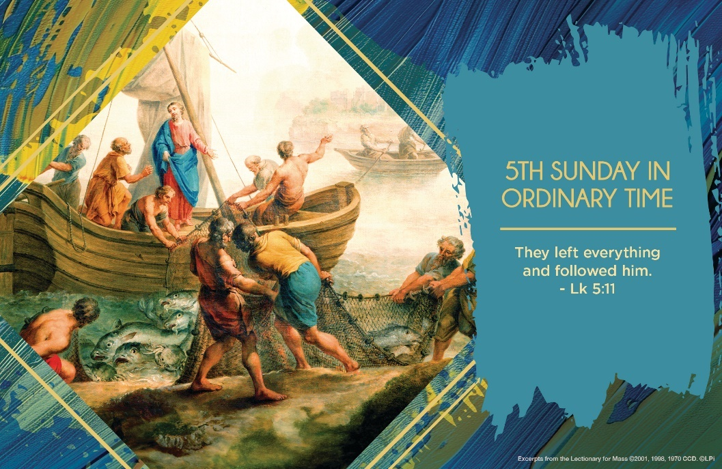
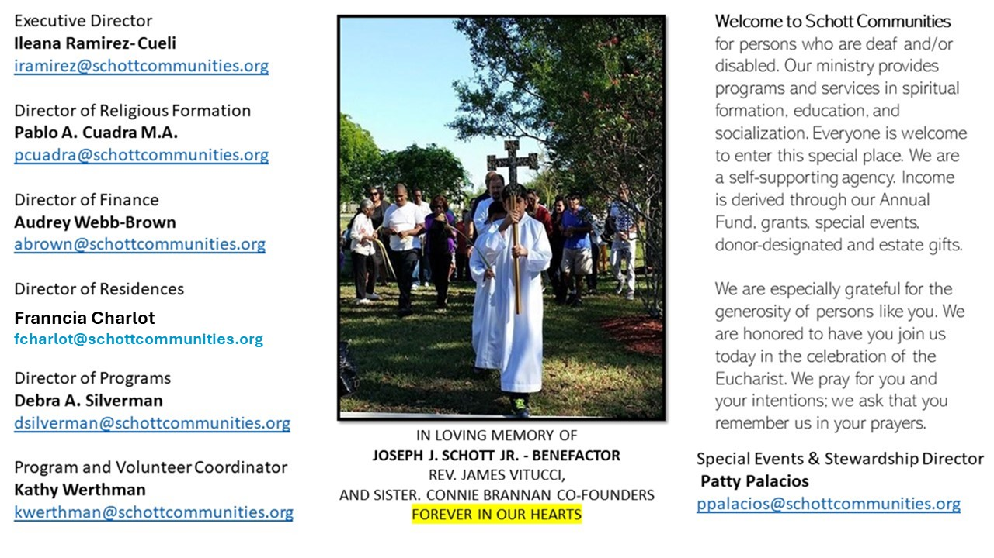

9 de febrero de 2025
5º Domingo del Tiempo Ordinario
¿Cuántas veces en la jornada laboral nos hemos decepcionado, trabajamos mucho, nos cansamos y pareciera que no avanzamos nada? Qué decepción nos embarga cuando esto pasa, nos lamentamos diciendo, lástima de cansancio. Y, a empezar de nuevo. Algo parecido le pasó a Pedro en su jornada laboral, había sido inútil el esfuerzo. De tal forma que, cuando Jesús le dice que navegue de nuevo mar adentro, Pedro le dice: “hemos trabajado toda la noche y ha sido en vano. No hemos pescado nada. Pero, confiando en ti, lo haré”. Y se obtuvo el resultado de la pesca milagrosa. “Y pescaron tal cantidad de peces, que las redes se rompían” (Lucas 5:6).
La respuesta de Pedro fue impetuosa y se arrodilló ante Jesús: “Señor, apártate de mí, que soy un pecador. Dios siempre se adelanta, y siempre nos espera. Jesús es el Señor, es la manifestación de Dios, y por ello Simón Pedro piensa que debe de haber una distancia entre el pecador y el Santo. Y es por su condición de pecador por lo que Jesús no se aleja de él. Si eres pecador, el Señor te espera aún más” (Papa Francisco). ¿Por qué será que la bondad y la misericordia de Dios nos asustan? Pedro, en lugar de correr y abrazar a Jesús y darle las gracias, le dice; “Señor, apártate de mí, que soy un hombre pecador” (Lucas 5:8). Sin embargo, la respuesta de Jesús es atrayente: “No temas; en adelante serás pescador de hombres” (Lucas 5:10). ¡Señor, quédate en mí, aunque soy pecador!
February 9, 2025
5th Sunday in Ordinary Time
Luke 5:1-11

My parents’ garage is full of old junk that no longer serves any purpose in my life. As a 46-year-old man, I admit that’s pretty lame. Either due to my sentimentality or laziness (or both, probably), I just couldn’t get myself to throw things away. But a few days ago, by a grace of God, I thought: “I’ll hire my nephew Ryan to throw a bunch of my stuff away — he couldn’t care less about my junk!” And you know what? It worked. In one day, Ryan chucked the majority of his uncle’s useless stuff. I feel so free, ready for a new junk-free chapter in my life.

This kind of thing happens in this Sunday’s Gospel. Peter’s net is full of useless junk. Luke says he and the others are cleaning their nets after catching no fish. Imagine them dejectedly and impatiently removing a nasty assortment of seaweed, sticks and muck. The Lord teaches and calls them once their nets are cleared out. So it goes with us. Spiritual life begins by removing that which is useless and merely taking up space in our hearts, minds and lives. Then Jesus teaches and acts in a marvelous way in our lives, too.

So what’s junking up your net? What habits, attachments, possessions, preoccupations? If, like me, you struggle to clean your nets by yourself, ask the Lord to send you someone like my nephew to be your “Peter” and help you clean it out. It is well worth it. Once Peter’s net is clean, he is free to make a wonderful catch.

— Father John Muir

St. Jude Chapel, Sunday, February 9th, 2025
Father Robert Bouffier
Celebrant

Sts. Cyril & Methodius
These brothers by birth became brothers in mission. Cyril and Methodius were born to a Greek diplomat in the 800s. The two brothers served in local governmental posts before each withdrew to a monastery. Their lives changed when the political leadership in Eastern Europe — what is now Ukraine — requested priests who spoke the native Slavic languages. Cyril and Methodius had proven themselves as able administrators and holy men, so they were sent as missionaries. First, Cyril invented an alphabet. This became the foundation for what is now used today and is still called the Cyrillic alphabet!


Christian Giving
February 2nd, 2025
$TBA

We sincerely thank you and bless you for your generosity.
A bequest is a powerful tool to help the Deaf or Disabled.

Mass Intentions
“For the repose of the Souls in Purgatory
Requested by Schott Communities


Follow us on Facebook

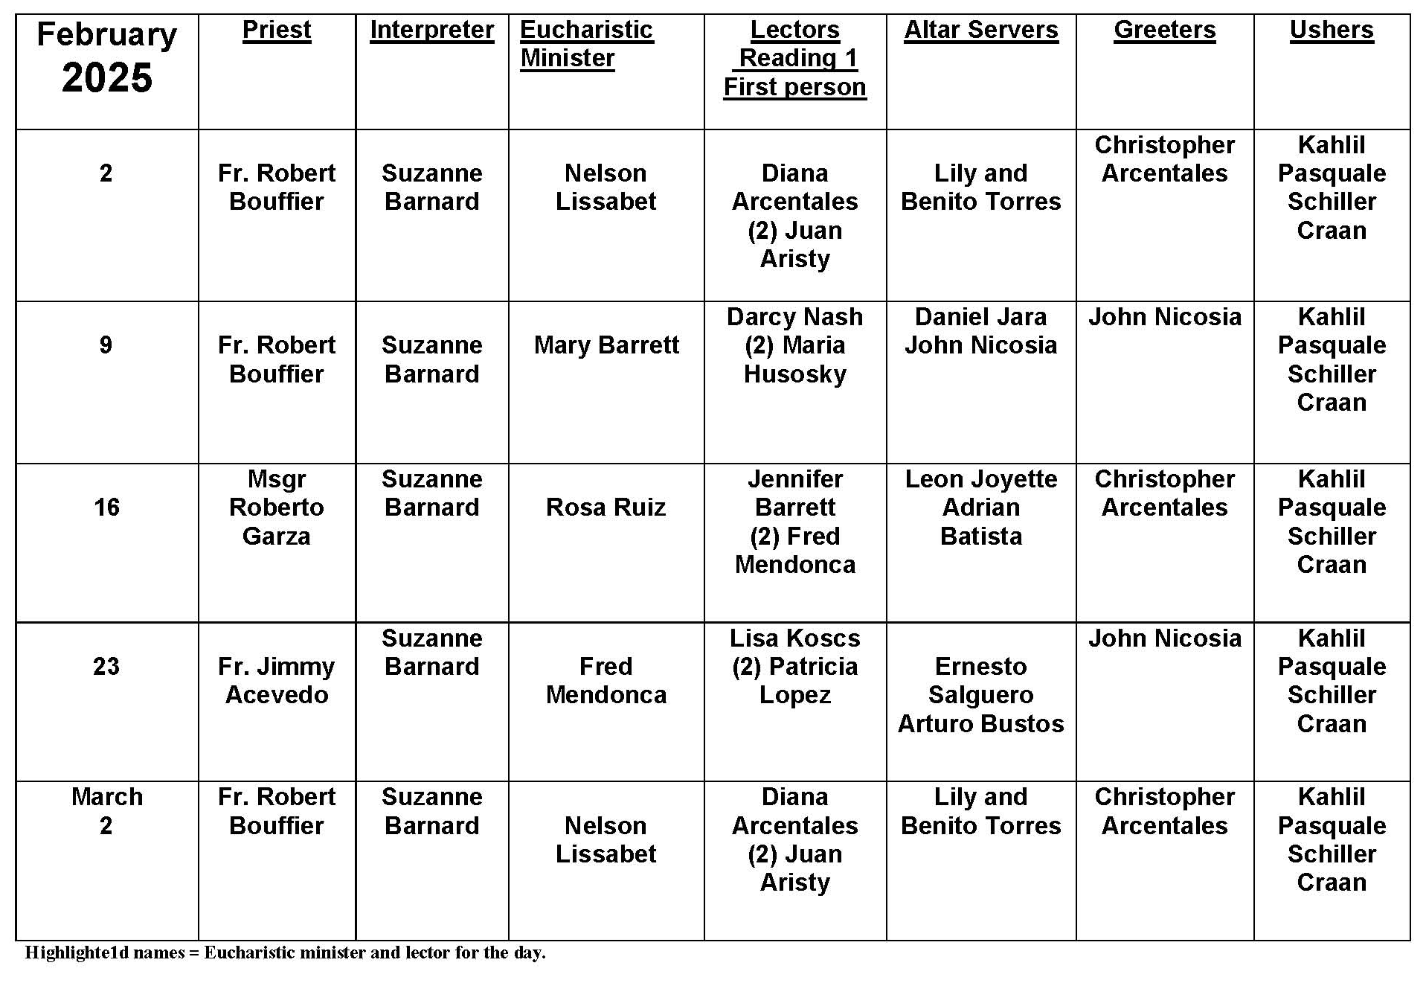
Priest Shortage
Question:
Would optional celibacy help the priest shortage?
Answer:
This is a hotly debated topic. There are good arguments on both sides, and there is no clear answer that emerges. However, the shortage of clergy in denominations that do allow marriage would seem to indicate that optional celibacy is not the quick answer that some might think. No one solution is perfect. Each one has its flaws and problems that are not easily solved. While optional celibacy would open ordination to some great men who are married, it also brings the problems of family, financial support, marital problems, and issues—good and bad—of childrearing. So it would not seem that optional celibacy is a realistic solution to the shortage of clergy.

With all of the varied challenges and problems facing the Church, it is easy to forget that the Holy Spirit leads us. Openness, dialogue, and education are second to our prayers and petitions to the Holy Spirit to make clear the path the Church should follow. A response that is rooted in a culture of political correctness is almost certainly doomed; a response that is rooted in prayer and in God cannot fail.

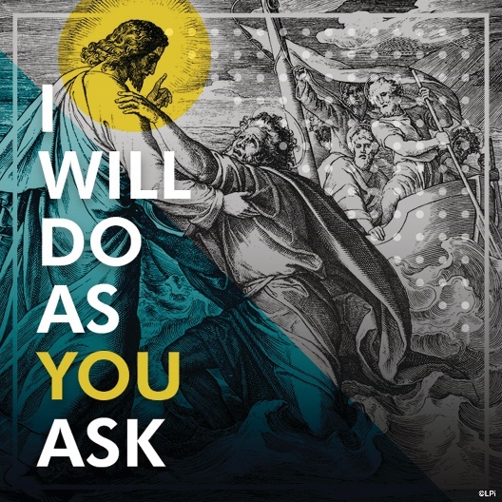
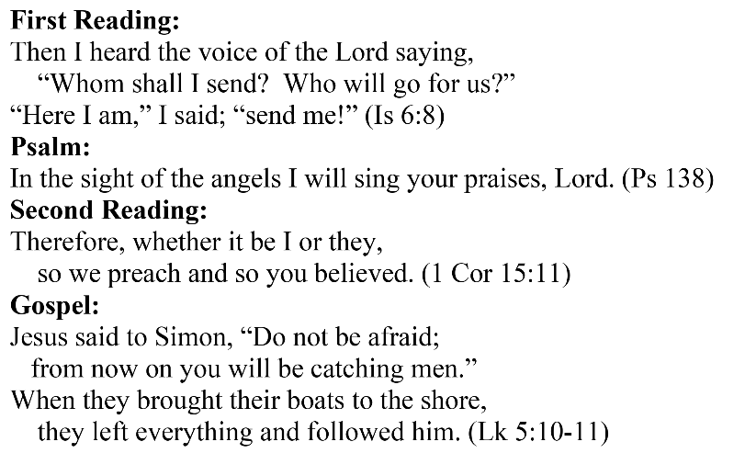
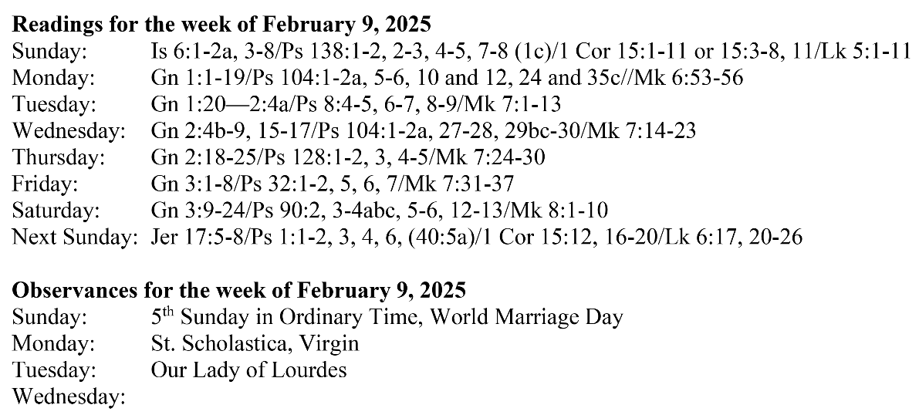
Are you in need of prayer? Do you have a prayer request? You can send your prayer requests to pcuadra@schottcommunities.org or call 954-434-3306 ext. 108

A copy of our prayer list can be found in the lobby of our chapel. To request a copy of our prayer list please email us at pcuadra@schottcommunities.org
To request a Mass please contact Pablo A. Cuadra at 954-434-3306 or e-mail at pcuadra@schottcommunities.org
Update: Celebrating a wedding anniversary soon? Let us know a week in advance and we can assist you with the renewal of your wedding vows.

Prayer to St. Michael the Archangel:
"St. Michael the Archangel, defend us in battle. Be our defense against the wickedness and snares of the Devil. May God rebuke him, we humbly pray, and do thou, O Prince of the heavenly hosts, by the power of God, thrust into hell Satan, and all the evil spirits, who prowl about the world seeking the ruin of souls. Amen"

