
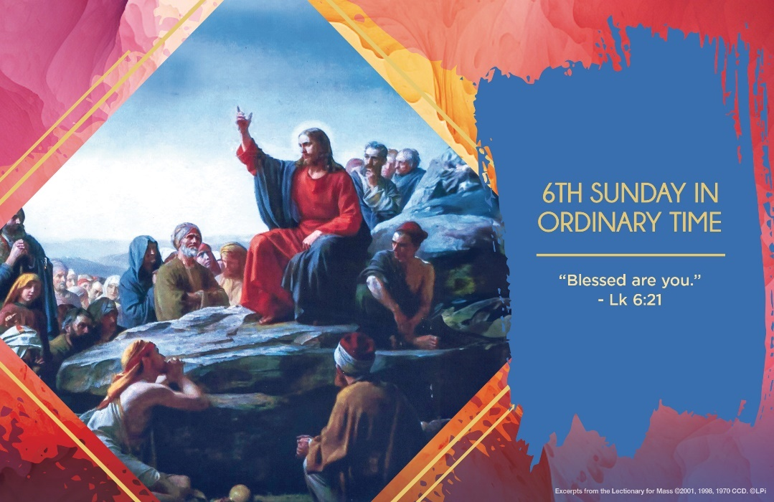
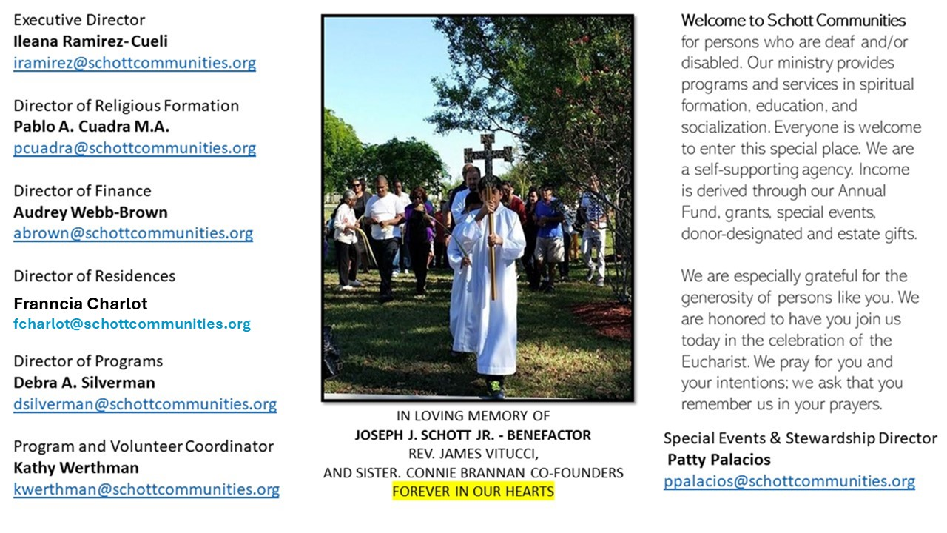

16 de febrero de 2025
6º Domingo del Tiempo Ordinario
Luchar por el bien común es la respuesta que debemos dar al evangelio de este domingo. No hay otra manera, y el mensaje es muy claro, no existe manera de suavizarlo. Lucas mira un solo punto, y es la justicia. La escena del evangelio nos narra que Jesús desciende del cerro y se detiene en un llano. Hay mucha gente de diferentes partes, muchos esperan ser curados por Jesús. Entonces, Jesús, dirige su mirada a sus discípulos y comienza su discurso. Les habla de la importancia de ser felices. Sí, Jesús llama felices a los pobres y a los enfermos. ¿Cómo podemos entender y asimilar ese llamado a la felicidad? ¿Que acaso no es contradictorio?
El mensaje está en que, al ver la pobreza, el hambre, la enfermedad, la guerra, la oportunidad, la educación, por mencionar algunas injusticias en el mundo del tiempo de Jesús y el tiempo nuestro, estemos dispuestos a dar la vida por la justicia y la paz. Entonces, es que el Reino de Dios florecerá para todos. Y esa es la verdadera felicidad que la Palabra de Dios hoy nos menciona. Pidamos al Señor que nos incomode la injusticia, que nos mueva a tener empatía para entender los problemas y sentimientos de los demás. Porque, de esa manera seremos felices e incansables luchadores del bien común. La recompensa es grande, es el cielo, es la promesa de Jesús. El sacrificio bien llevado y con intención recta, desde el fondo del corazón, es la felicidad. ¿Lo has experimentado?

February 16, 2025
6th Sunday of Ordinary Time
Luke 6:17, 20-26

I craved four things as a teenager: success in sports, food, fun and the attention of popular people. However, I noticed that as I acquired them, I was more unsatisfied than before. So, I’d strive even more energetically, achieve more, and the sense of emptiness was greater still. These four things started to feel like burdens or even curses. Soon after, I encountered Christ in my high school youth group. Experiencing his love was totally different than anything those four things previously produced. It produced a lasting happiness.

Jesus utters a kind of four-fold curse in this week’s Gospel of Saint Luke’s “woes”: “Woe to you who are rich…who are filled now…who laugh now…who are well-spoken of” (cf. Luke 6:24-26). How marvelous that these correspond perfectly to the four things that obsessed my teenage soul: riches, food, laughter and good reputation. The “woes” the Lord speaks are warnings: when those things are the purpose of your life, you’ll be miserable. He is saying, “You’ll be happy, or blessed, in the measure that these things do not determine the shape of our lives, and the kingdom of God does.”

To some degree, we’re all spiritual teenagers, addicted to one or more of those four “woes.” How splendid that the Lord wants his to bless us — that is, to satisfy us, make us laugh with joy, and in the kingdom of God, offer us what will truly satisfy us. But first let’s admit what is causing our “woes.”

— Father John Muir

St. Jude Chapel, Sunday, February 16th, 2025
Monsignor Roberto Garza
Celebrant

PRAYER – FOR EVERYDAY AND EVERYBODY
Prayer of God’s Blessing

Bless me, Lord, mold my heart in imitation of Yours.
Bless me, Lord, help me to see people as You do, and to hear their needs.
Bless me, Lord, replace my understanding with Yours.
Amen.


Christian Giving
February 9th, 2025
$TBA

We sincerely thank you and bless you for your generosity.
A bequest is a powerful tool to help the Deaf or Disabled.

Mass Intentions
“For the repose of the Souls in Purgatory
Requested by Schott Communities


Follow us on Facebook

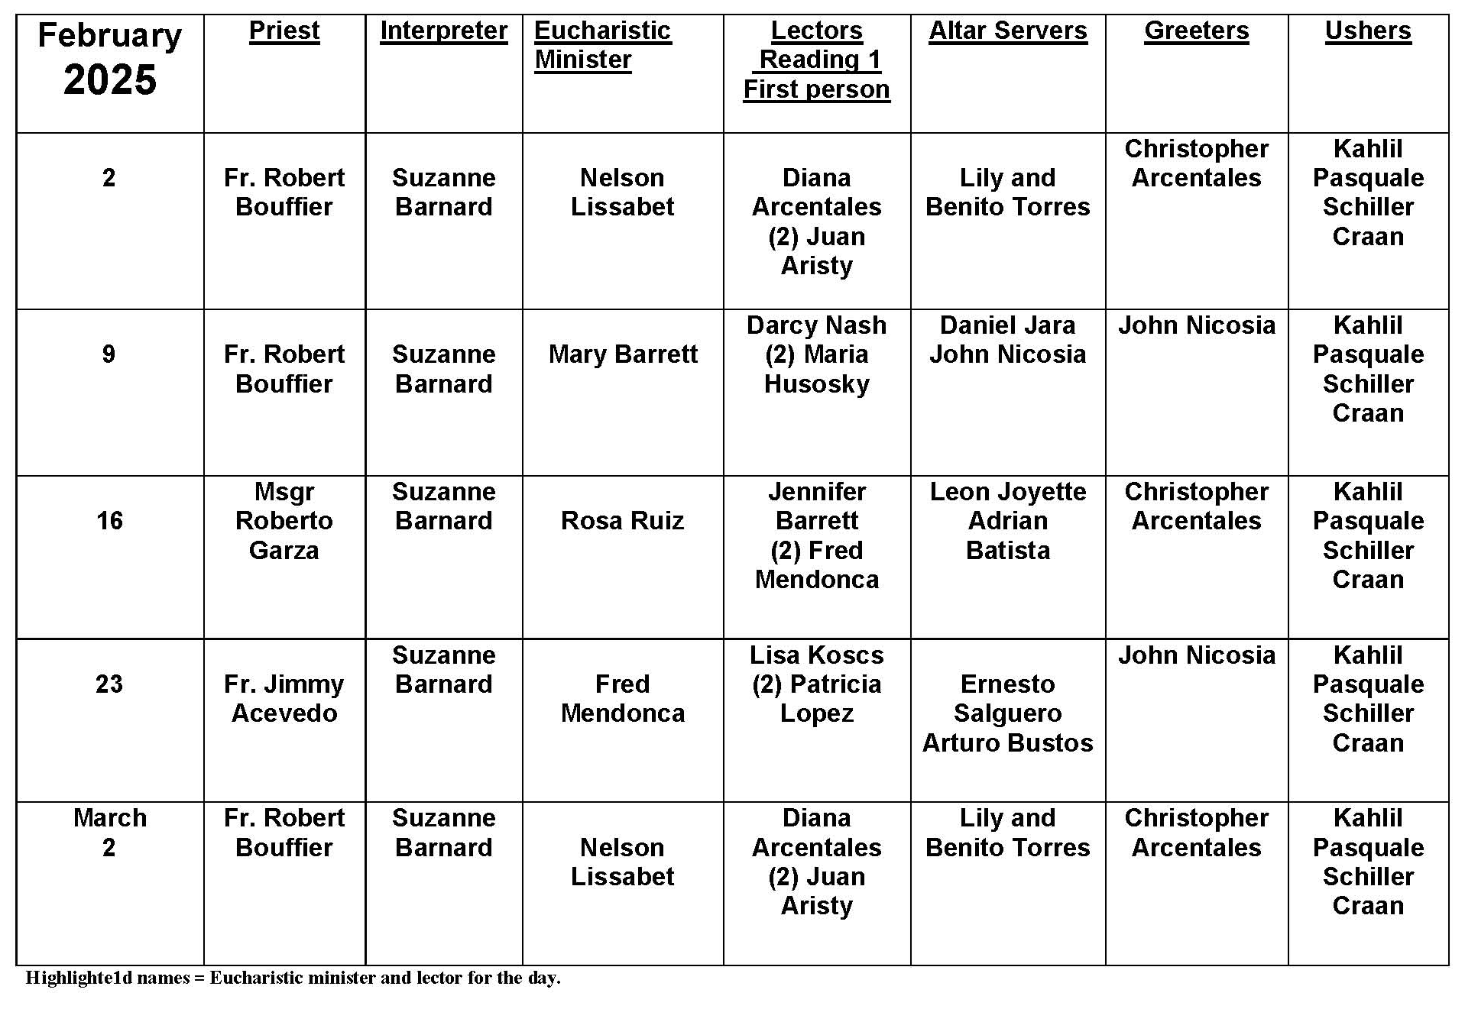
Mardi Gras
Question:
Carnivale and Mardi Gras celebrations are linked to Ash Wednesday, Lent, fast and abstinence. Can you tell us more about the connections between these events?
Answer:
Ash Wednesday is the beginning of the forty days known as Lent. Every year, Christians highlight this penitential season as a time of self-examination, reformation of one's life, and continued development of a deeper spiritual life. The recommended practices of prayer, fasting, and almsgiving become the focus of Lenten activity and ritual. Each of these spiritual practices is aimed at personal discipline as well as continued concern for the other, especially the poor or alienated.
Forty days is a symbolic biblical period of time, during which personal transformation occurs and out of which people surface as more spiritual, ready to carry out God's mission. Relying on God's providence and care, no matter how difficult life becomes, is crucial to Lenten spirituality. Fasting was initially stricter, permitting only one simple meal a day without meat, fish, or other delicacies. Such things were not even allowed in the house.
In order to prepare for this in an age of no refrigeration, people gathered to consume whatever was not allowed during Lent. This led to parties or celebrations originally referred to as Carnivale, literally meaning "goodbye to meat," or Mardi Gras, literally meaning "Fat Tuesday." The eating and celebrating ended on the Tuesday just before Ash Wednesday. Today we focus more on moderation in all things, as well as a strong concern the poor. What are you doing for the poor this Lent?

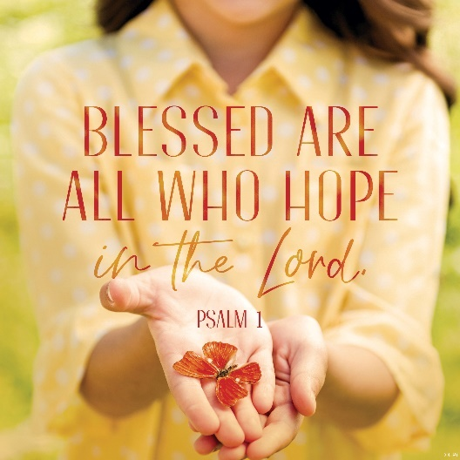
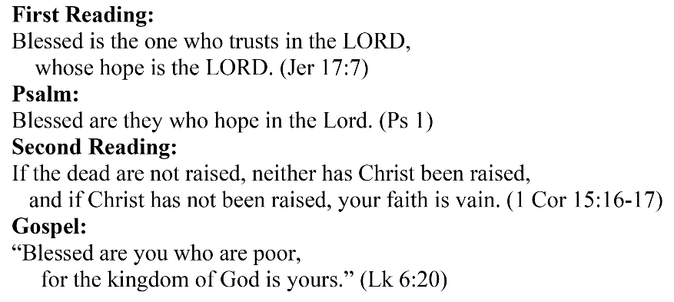
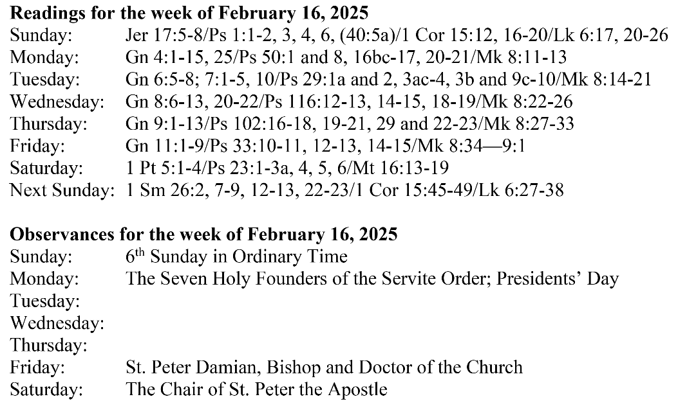
Are you in need of prayer? Do you have a prayer request? You can send your prayer requests to pcuadra@schottcommunities.org or call 954-434-3306 ext. 108

A copy of our prayer list can be found in the lobby of our chapel. To request a copy of our prayer list please email us at pcuadra@schottcommunities.org
To request a Mass please contact Pablo A. Cuadra at 954-434-3306 or e-mail at pcuadra@schottcommunities.org
Update: Celebrating a wedding anniversary soon? Let us know a week in advance and we can assist you with the renewal of your wedding vows.

Prayer to St. Michael the Archangel:
"St. Michael the Archangel, defend us in battle. Be our defense against the wickedness and snares of the Devil. May God rebuke him, we humbly pray, and do thou, O Prince of the heavenly hosts, by the power of God, thrust into hell Satan, and all the evil spirits, who prowl about the world seeking the ruin of souls. Amen"

