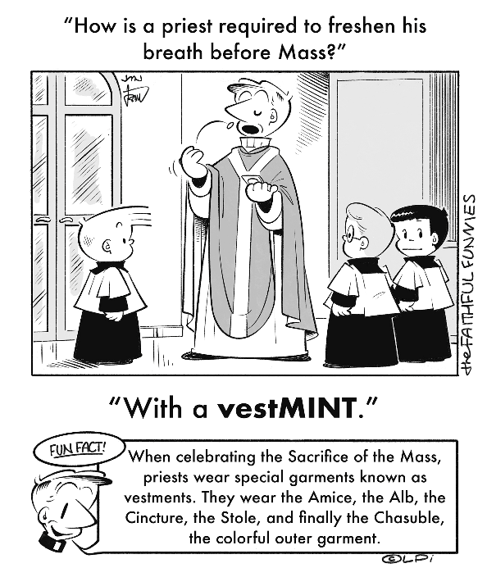
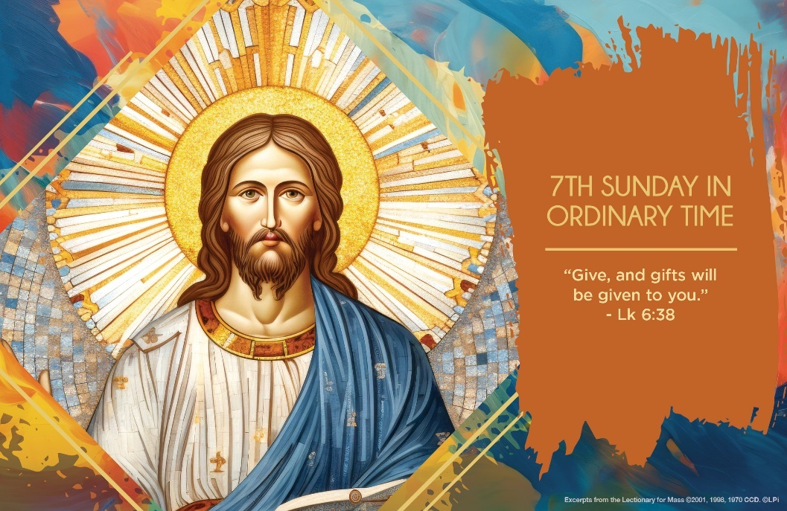
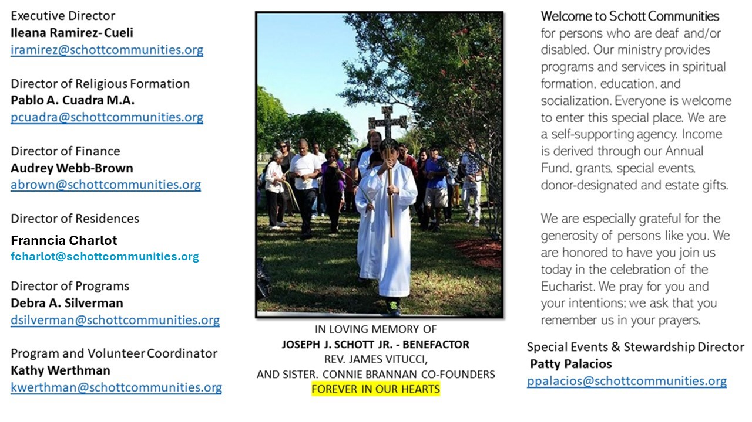

23 de febrero de 2025
7º Domingo del Tiempo Ordinario
Hoy el Evangelio nos propone una catequesis de amor que obliga a estirar el corazón, para rendir al máximo al pedido de Jesús. Nos impulsa a pensar distinto, a interesarnos por los demás. Llama al perdón, a la nobleza, la humildad y, lo más importante, a saber, compartir lo que poseemos materialmente y darse uno mismo. Es algo difícil lo que pide el Señor en este pasaje del Evangelio. Eso, de amar a los enemigos, hacer el bien a quien no nos quiere, de orar por los que nos persiguen, es fuera de serie, no se usa en la sociedad actual. Y agrega Jesús lo siguiente: “Traten a los demás como quieren que ellos les traten a ustedes” (Lucas 6:31). No se trata de que estemos siempre con la cabeza baja y humillados, mas bien se trata de luchar por la justicia, de no entrar en la violencia de tú me la haces, entonces, yo te respondo igual.
“Porque si ustedes aman a los que los aman, ¿Qué merito tienen? Hasta los malos aman a los que los aman (Lucas 6:32). Por el contrario, bendecir a los amigos y enemigos es lo que nos hace dignos hijos e hijas de Dios. Pidamos el don de perdonar, de no ser vengativos, de tener un corazón de compasión, rebosante de ternura para hacer el bien. “Sean compasivos como es compasivo el Padre de ustedes” (Lucas 6:36). Ser semejantes al que siempre es bueno con nosotros. ¡Ese es el reto a cumplir!

February 23, 2025
7th Sunday of Ordinary Time
Luke 6:27-38

One of my favorite new singers/songwriters is Noah Kahan. I’m a little biased because, like me, he is originally from Vermont. In a fine song entitled “Stick Season,” he sings of his hope to “cancel out the darkness I inherited from dad.” This lyric articulates his painful recognition of a dark spiritual “inheritance” from his father, and his hope to be free of it. We all inherit some degree of evil from our earthly forebears. It’s easy to feel doomed to repeat their darknesses.

But we’re not so doomed, thank God. This week’s Gospel proclaims this. Whatever good or bad we received from our parents, we have a more definitive and perfect inheritance in God. Jesus commands us, “Be merciful just as your Father is merciful” (Luke 6:36). We have a perfect Father in heaven and are destined to inherit and reflect that perfect and merciful love. We have an inheritance of light, not darkness, and thus a whole new possibility of magnanimous love. Like any inheritance, this is a free gift to us.

What are we destined to repeat? Not the darkness of our earthly parents. We are destined to be a reflection of God’s life. Jesus liberates us from the inevitability of repeating whatever evils and imperfections are in our familial or cultural upbringings. It’s time to claim that perfect inheritance.

— Father John Muir

St. Jude Chapel, Sunday, February 23rd, 2025
Father Jimmy Acevedo
Celebrant

Prayer of Christian Life
Dear Jesus,
Help me to pray for and bless everyone I encounter, whether that be easy or hard.
Help me to act in the mercy I have known through you.
Help me to demonstrate generosity, as you have given so much to me.
Amen.


Christian Giving
February 16th, 2025
$TBA

We sincerely thank you and bless you for your generosity.
A bequest is a powerful tool to help the Deaf or Disabled.

Mass Intentions
“For the repose of the Souls in Purgatory
Requested by Schott Communities


Follow us on Facebook

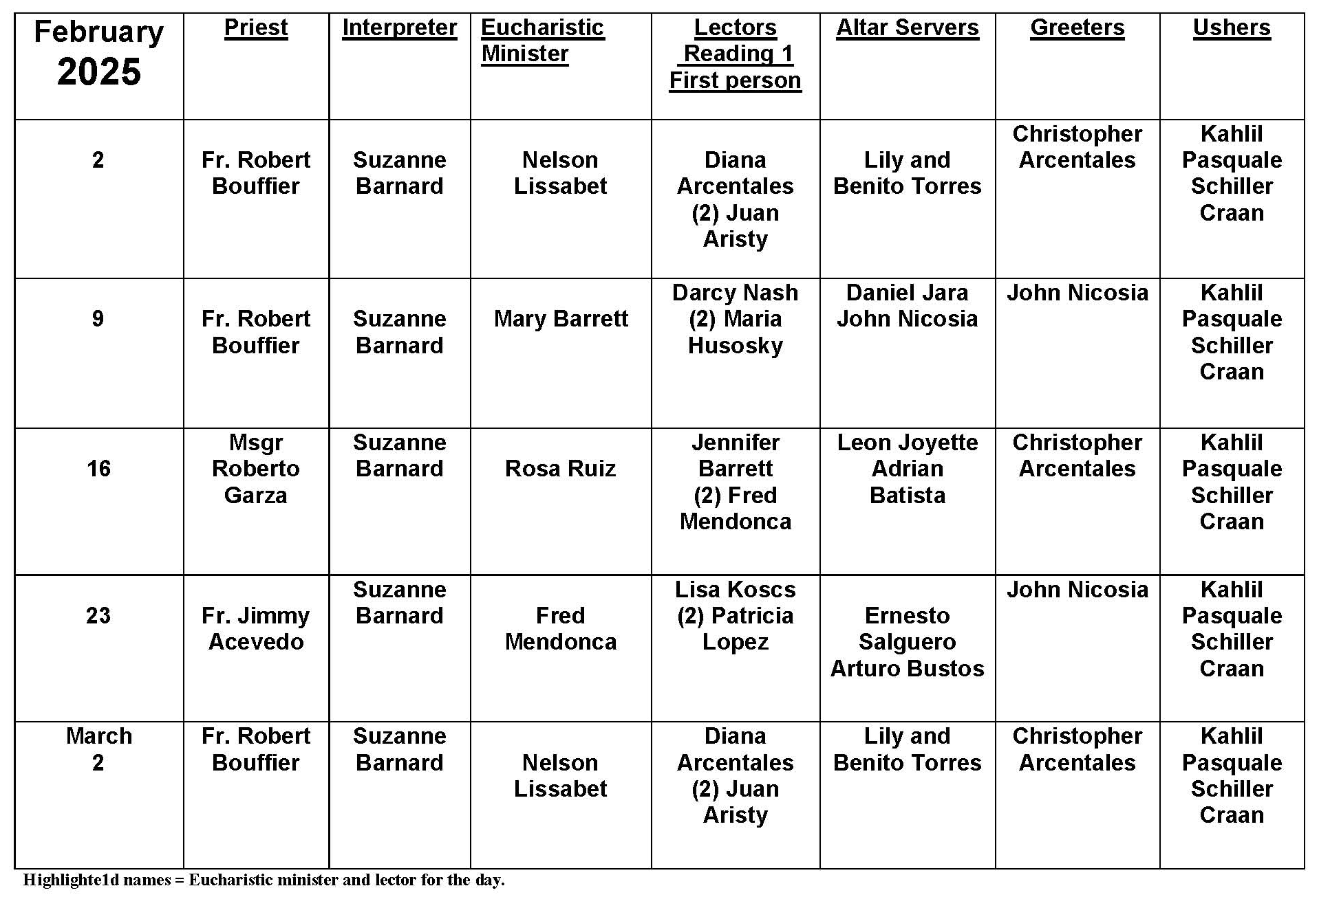
Ash Wednesday

Question:
Is Ash Wednesday a holy day of obligation?

Answer:
Despite the often packed churches, you may be surprised to hear that the answer is no! Holy days of obligation commemorate a particular event (such as the birth of Christ at Christmas) or celebrate particular people (such as Mary’s Immaculate Conception or the feast of All Saints). Ash Wednesday is a day of penance, fasting, and abstinence to begin the season of Lent. In a sense, it focuses on a concept rather than something particular and concrete.

Of course, repentance ought to be reflected in particular, concrete ways! That’s one of the reasons that attending Mass on Ash Wednesday is a very good idea. It marks the beginning of a solemn season of penance. Despite all its comparisons to the desert, Lent can be very fruitful for our spiritual growth! Beginning this season with the celebration of Mass and the reception of ashes is a sign of our commitment to God and to spiritual growth.

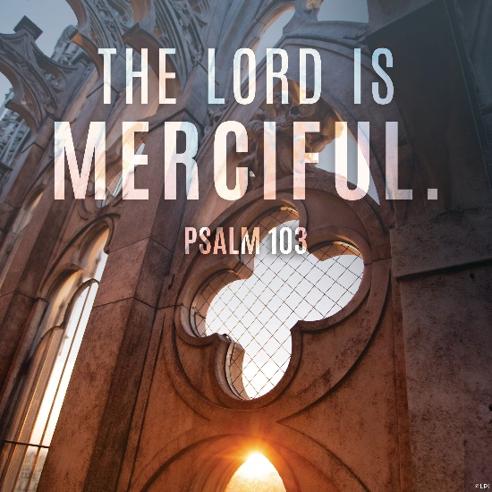
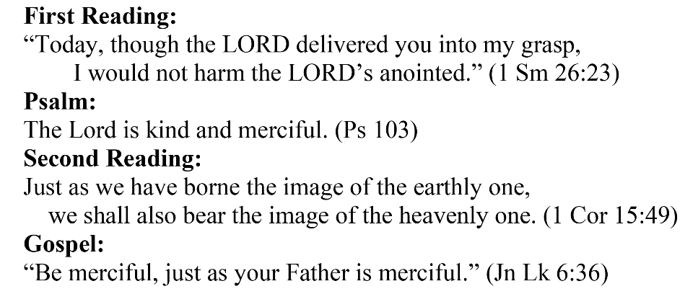
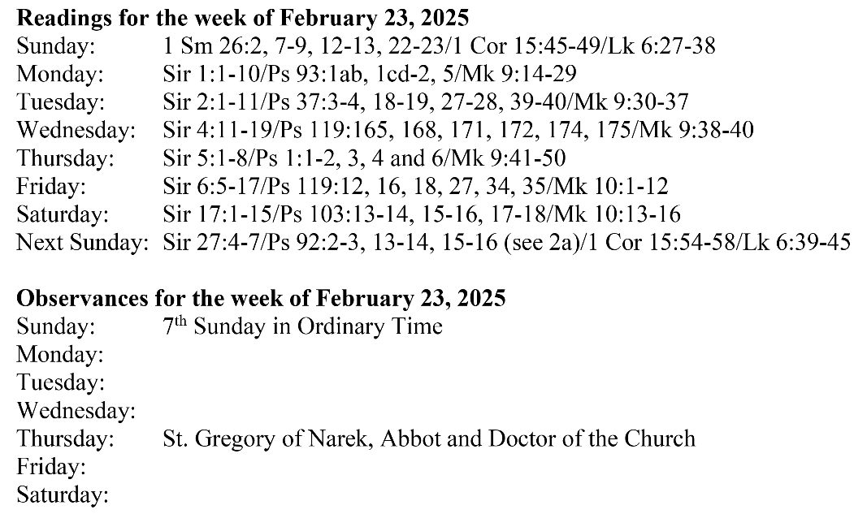
Are you in need of prayer? Do you have a prayer request? You can send your prayer requests to pcuadra@schottcommunities.org or call 954-434-3306 ext. 108

A copy of our prayer list can be found in the lobby of our chapel. To request a copy of our prayer list please email us at pcuadra@schottcommunities.org
To request a Mass please contact Pablo A. Cuadra at 954-434-3306 or e-mail at pcuadra@schottcommunities.org
Update: Celebrating a wedding anniversary soon? Let us know a week in advance and we can assist you with the renewal of your wedding vows.

Prayer to St. Michael the Archangel:
"St. Michael the Archangel, defend us in battle. Be our defense against the wickedness and snares of the Devil. May God rebuke him, we humbly pray, and do thou, O Prince of the heavenly hosts, by the power of God, thrust into hell Satan, and all the evil spirits, who prowl about the world seeking the ruin of souls. Amen"

