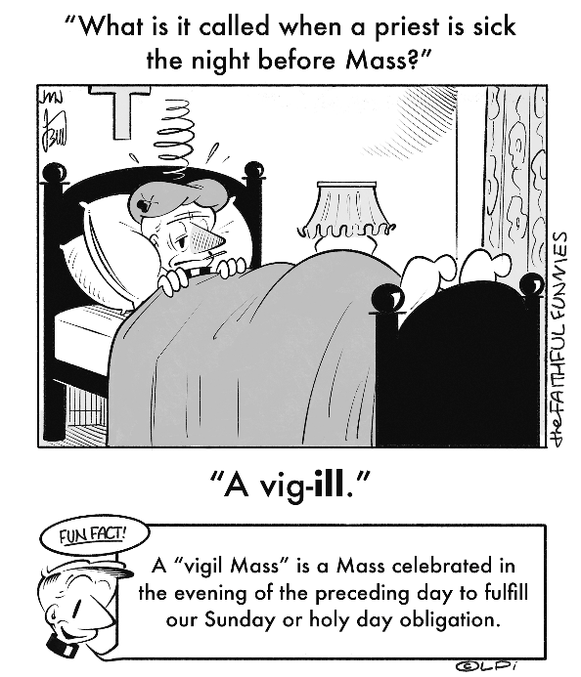
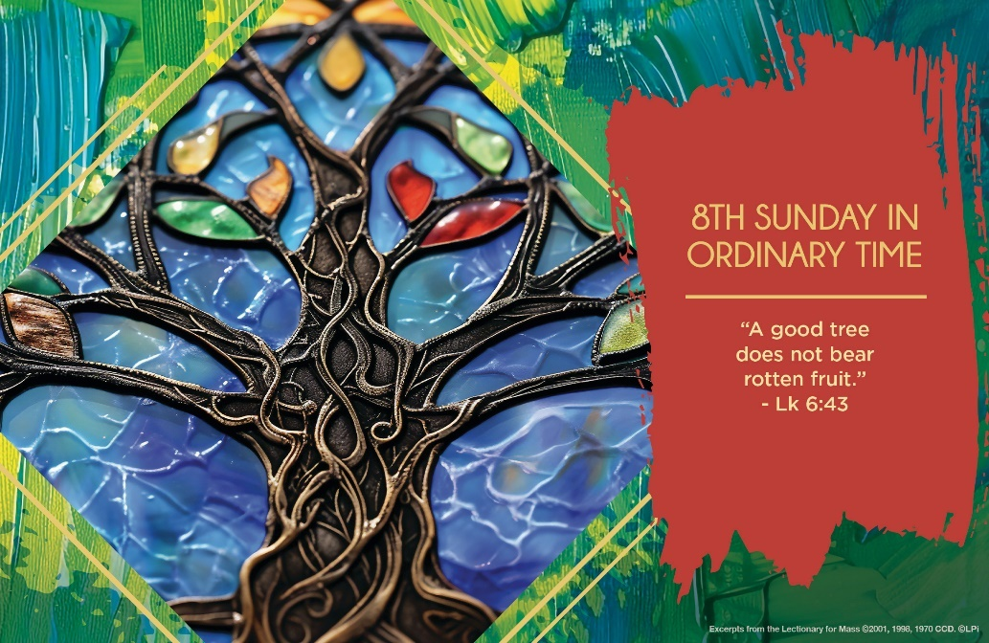
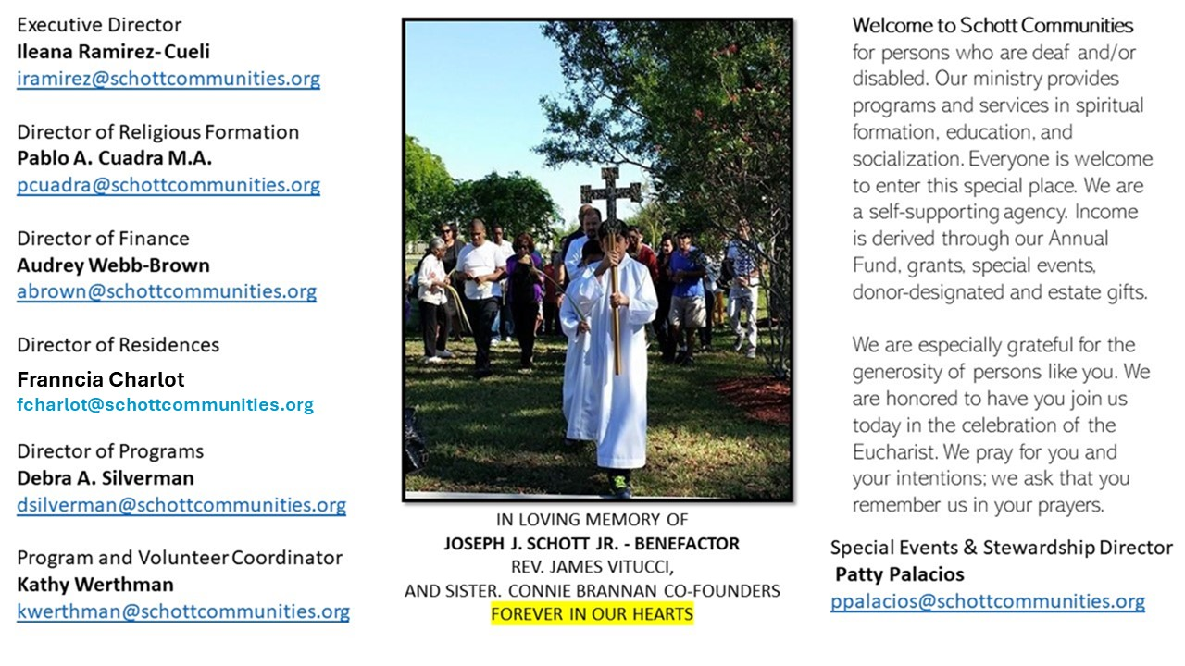

2 de marzo de 2025
8º Domingo del Tiempo Ordinario
Siempre que vamos al súper, llegamos con el buen deseo de escoger lo mejor. Especialmente la fruta, la queremos fresca, jugosa y dulce. Has pensado en los árboles de donde proviene la fruta. ¿Serán buenos, estarán bien regados y vitaminados? Porque depende del árbol cómo es que será su fruto, bueno o malo. Hoy, es día de examen, para saber cómo andamos de frutos. Mucho depende de lo que llevamos dentro del corazón y Jesús, sin rodeos, lanza la siguiente pregunta: “¿Puede un ciego guiar a otro ciego? Ciertamente caerán ambos en algún hoyo” (Lucas 6:39). Desde luego que no, alguno de los dos debe tener visión clara y saber hacia dónde se dirige. Observemos bien qué tipo de fruto esta dando nuestra vida y eso se mide en el refrán que dice: Obras son amores, y no buenas razones.
El Papa Francisco, también lo explica de la siguiente manera: “Los niños y los jóvenes son los frutos de los árboles. Y cuando un árbol tiene buenas raíces y un buen tronco (abuelos y padres) da buenos frutos. Debemos ser un bosque lleno de buenos frutos; las familias numerosas son una gran esperanza de la sociedad”. Todos por lo general tendemos a cuidar las apariencias, por lo tanto, descuidamos lo más importante, el interior del corazón, que es de donde sale lo bueno: “La boca habla de lo que está lleno el corazón” (Lucas 6:45). Pidamos al Señor, que nuestros frutos buenos sean para que los demás los disfruten.

March 2, 2025
8th Sunday of Ordinary Time
Luke 6:39-45

One of the things that older pastors and younger priests occasionally quarrel about is the proper balance between work and prayer. I know one pastor who complains that his younger associate ignores the people and the parish because he wants to spend more time in prayer. And the young priest complains that the pastor gives him too much work to do and no time to pray. The Lord’s words this Sunday speak into this tension with an image that can help us find a proper balance between life and prayer.

Jesus says, “For every tree is known by its fruit. For people do not pick figs from thorn bushes, nor do they gather grapes from brambles” (Luke 6:44). When we are deeply rooted and cultivating our relationship with Jesus, we are going to bear the fruit of that love in our lives. No fruit, no good prayer. How do we know that we are praying well? We are experiencing concrete fruits of love for others in our lives.

Someone who prays well will, sooner or later, burst forth the “figs” and “grapes” of acts of love. But without concrete commitment to deeds of selfless service to others, our prayer time is as useless as thorn bushes and brambles. Let’s recommit ourselves to be men and women of prayer and service. And hopefully the pastors will help their associates to pray and serve fruitfully…with minimal quarreling.

— Father John Muir

St. Jude Chapel, Sunday, March 2nd 2025
Father Robert Bouffier
Celebrant

St. Casimir
We live in a culture that tells children, "Follow your dreams! Be who you want to be!" It might be hard to imagine the courage it took to be St. Casimir. A prince second in line for the throne of Poland, the young man had great expectations placed upon him. Inspired by a devout tutor, St. Casimir developed a deep faith. As a teenager, he would often sleep on the ground, reject courtly finery for plain clothes, and dedicate long hours to prayer. He even made a private commitment to celibacy.


Christian Giving
February 23rd, 2025
$636

We sincerely thank you and bless you for your generosity.
A bequest is a powerful tool to help the Deaf or Disabled.

Mass Intentions
“For the repose of the Souls in Purgatory
Requested by Schott Communities


Follow us on Facebook
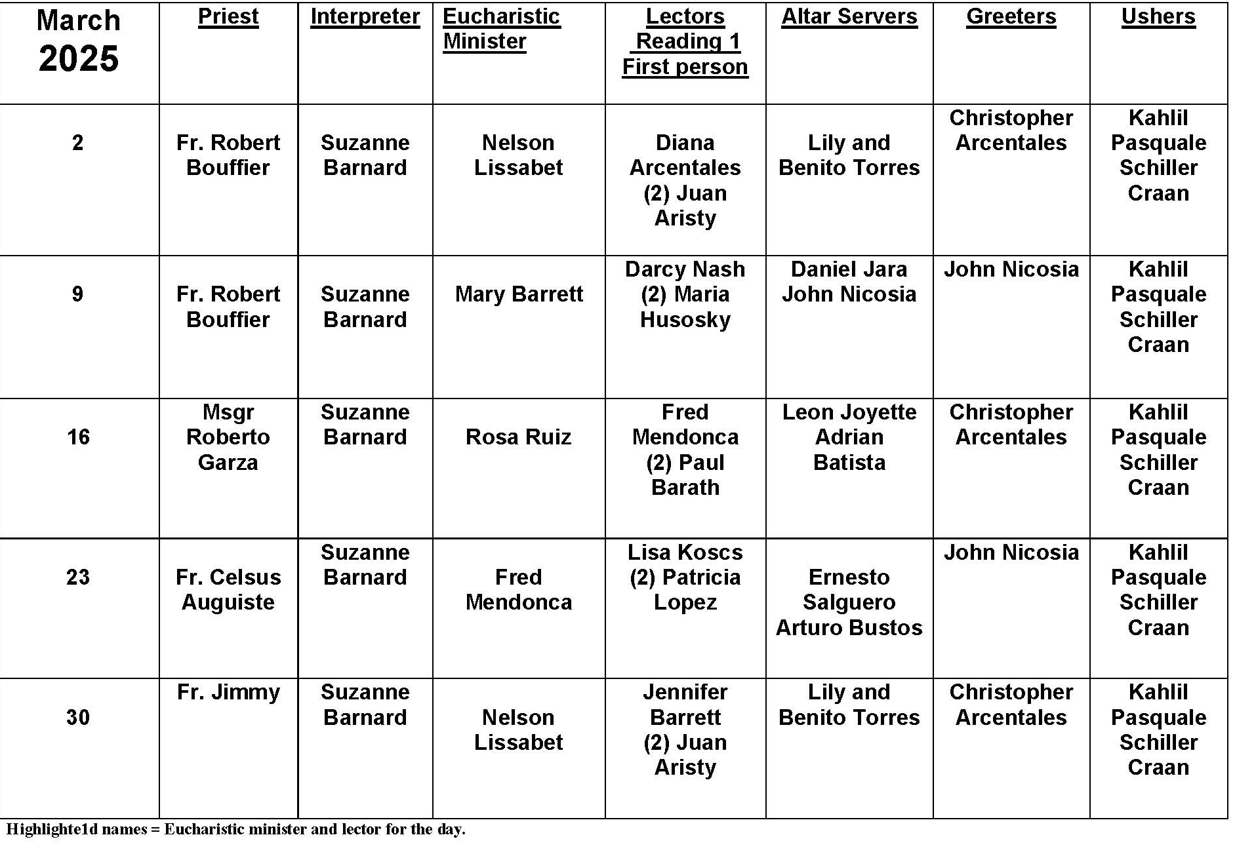
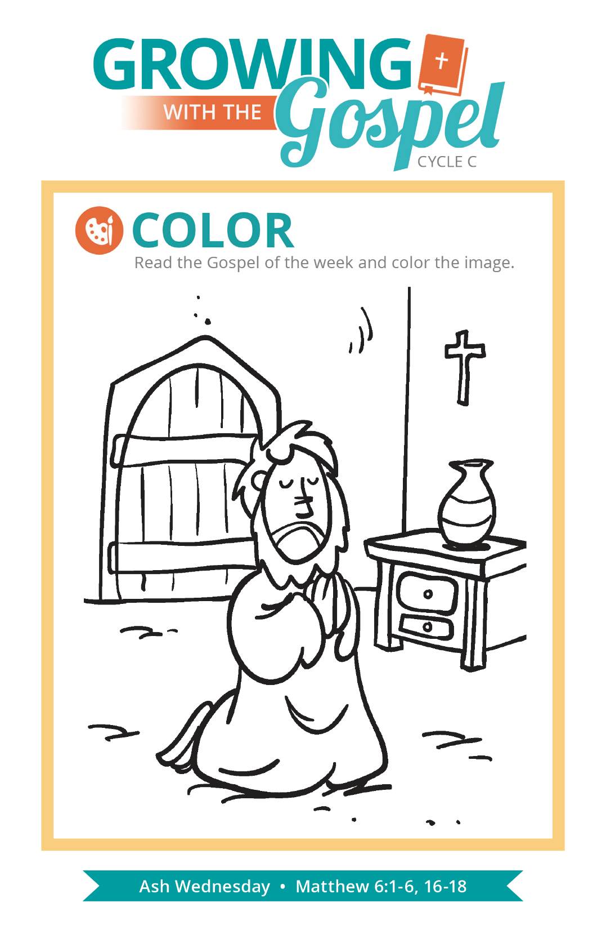
Ash Wednesday Ashes

Question:
Why do we place ashes on our forehead each Ash Wednesday?

Answer:
Ashes are rich in spiritual symbolism. We recall in the second chapter of Genesis, when the human person is fashioned “out of the dust of the ground” and receives the breath of life (Genesis 2:7). In death, a person returns to the ground from which we came. The ancient Hebrews used ashes as a sign of repentance, reminding themselves that God is God and we are not.

As the minister places ashes on our forehead, we hear either “remember that you are dust and unto dust you shall return” or “turn away from sin and be faithful to the Gospel.” When we receive ashes, we remember our own mortality. We’re reminded that we have limited time on this earth and we ought to make the best use of it that we can! People are in need of love, care, and compassion. We all need to continually rediscover the love of God. The Gospel invites every person in every stage of life to encounter and imitate Jesus here and now. The forty days of Lent are the perfect time to assess our own awareness of these realities.

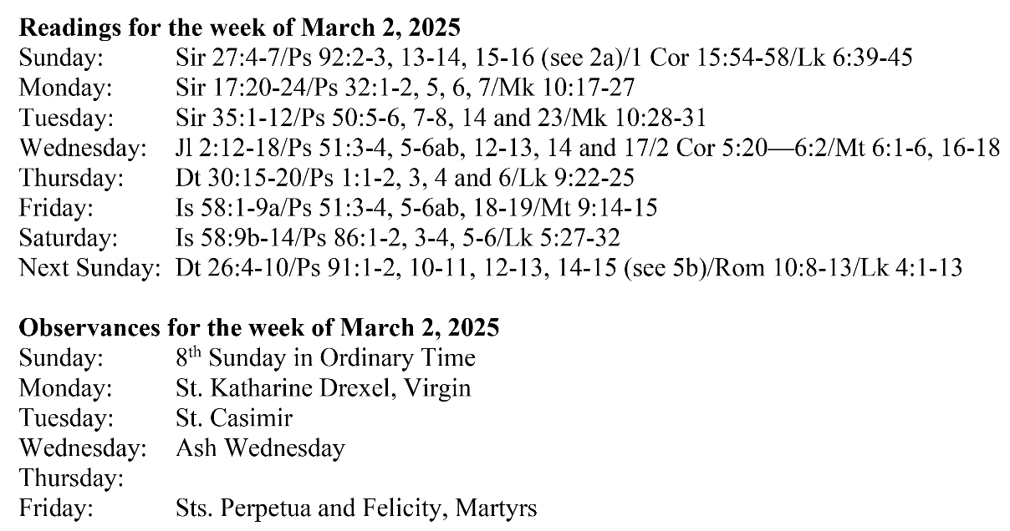

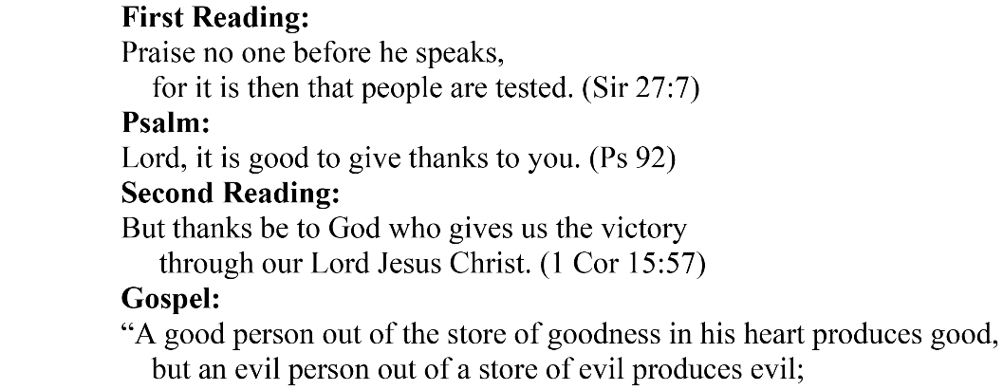
Are you in need of prayer? Do you have a prayer request? You can send your prayer requests to pcuadra@schottcommunities.org or call 954-434-3306 ext. 108

A copy of our prayer list can be found in the lobby of our chapel. To request a copy of our prayer list please email us at pcuadra@schottcommunities.org
To request a Mass please contact Pablo A. Cuadra at 954-434-3306 or e-mail at pcuadra@schottcommunities.org
Update: Celebrating a wedding anniversary soon? Let us know a week in advance and we can assist you with the renewal of your wedding vows.

Prayer to St. Michael the Archangel:
"St. Michael the Archangel, defend us in battle. Be our defense against the wickedness and snares of the Devil. May God rebuke him, we humbly pray, and do thou, O Prince of the heavenly hosts, by the power of God, thrust into hell Satan, and all the evil spirits, who prowl about the world seeking the ruin of souls. Amen"

