
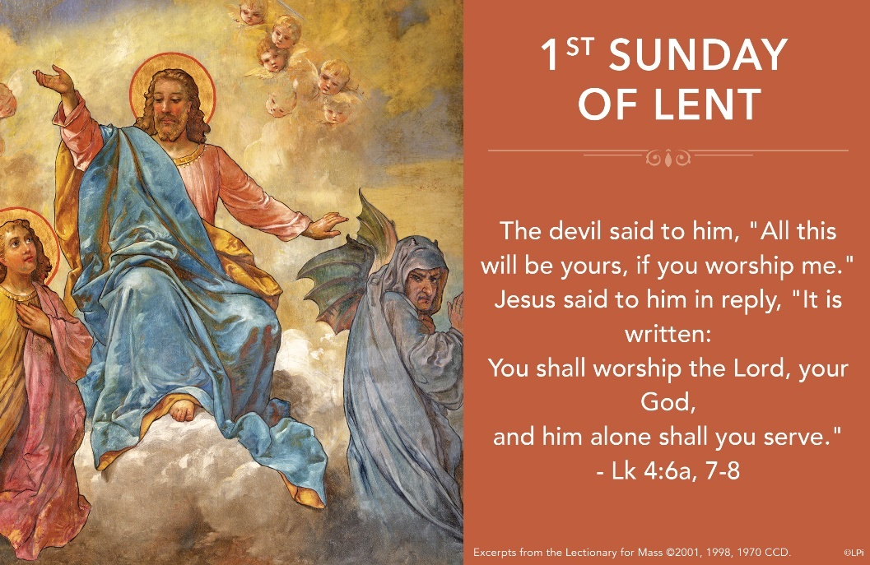
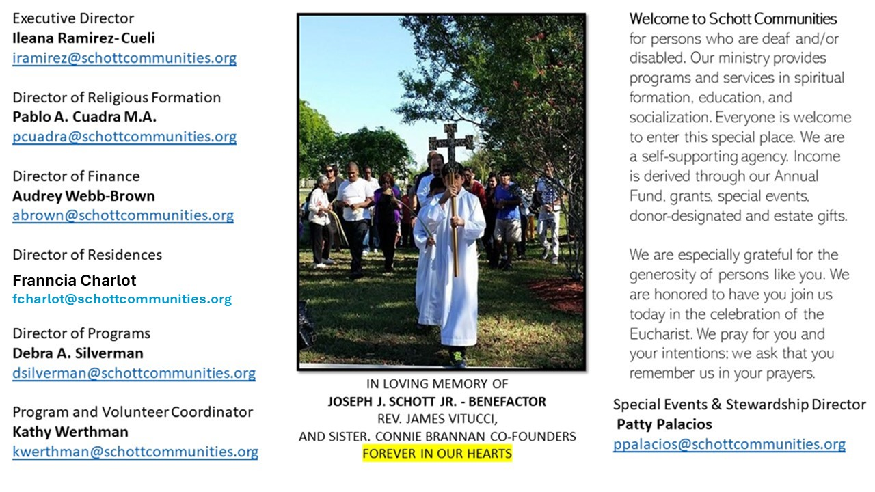

9 de marzo de 2025
1er Domingo de Cuaresma
Preparados o no preparados, la Cuaresma ha llegado a nuestra vida. Y, el Papa Francisco nos invita a reflexionar en lo siguiente: “Al comienzo de la Cuaresma nos hará bien a todos nosotros pedir la gracia de conservar la memoria de todo lo que el Señor ha hecho en mi vida: cómo me ha querido, cómo me ha amado. He aquí, pues, el significado de las expresiones: Mira hacia atrás - ¡que no es lo mismo que vuelve hacia atrás – el camino que has hecho. Y el bienestar, incluso espiritual, conlleva el peligro de caer en una cierta amnesia. Es precisamente en este momento cuando el corazón comienza a retroceder, porque no escucha la voz de su propio corazón: la memoria”.
La Iglesia también nos ayuda a llevar este tiempo Santo de Cuaresma invitándonos a la penitencia, a la purificación y de compartir lo que tenemos y somos con los necesitados. Es por eso que el Miércoles de Ceniza y el Viernes Santo son días de ayuno y abstinencia. Los viernes de Cuaresma son días de abstinencia. Todos los viernes de Cuaresma, como todos los viernes del año, somos invitados a practicar nuestra fe con actos de penitencia. Tan sencillos como visitar algún enfermo, ayudarnos en familia, hacer oración y asistir a actos de piedad a la Iglesia local. (Catecismo de la Iglesia Católica, numeral 1438). Y lo principal, acercarnos a la Eucaristía dominical para refugiarnos en la Palabra de Dios, que es lo que nos da vida y nos hará llegar a la Pascua resucitados.

March 9, 2025
1st Sunday of Lent
Luke 4:1-13

One of the most fascinating moments in American history is when George Washington could have become the king of the newly liberated United States and didn’t. At the height of his power and fame, on Dec. 23, 1783, he resigned his commission as Commander-in-Chief, and went home. The astonished King of England remarked that in doing so, Washington was “the greatest man in the world.” Greatness is often defined by what we could do but don’t. Greatness is measured by the temptations we overcome.

Jesus’ greatness is revealed in his victory over temptations, too. The three offered him by the devil contain, we might say, all potential possible temptations: food, power and fame. They correspond to the triple human needs of body, soul and spirit. In overcoming these three, he says “no” in essence to every and even the greatest temptation. We see that every desire of his humanity — body, soul and spirit — is perfectly united to God, to love. This is a power available to each member of his body. It is the path to true greatness. How can we, who so easily fall into even small temptations, find the power to overcome large ones? By entering into the great dynamics of Jesus’ temptations.

Lenten challenge: This first week of Lent, list some concrete ways you can overcome temptations that correspond with your desires. For example, you may give up snacks between meals, choose not to participate in an activity of which you are an expert, and decide to reduce social media posting by 50%. It may not seem like much, but by saying “no” to the tyranny of food, power, and fame (in this example), you’ll discover true greatness.
— Father John Muir

St. Jude Chapel, Sunday, March 9th 2025
Father Robert Bouffier
Celebrant

The Sign of the Cross

Christians have been making the sign of the cross since ancient times. It is not only an important component of formal liturgies and sacramental rites, but also a daily devotional practice whereby the faithful invoke the blessing and protection of God.


Christian Giving
March 2nd, 2025
$TBA

We sincerely thank you and bless you for your generosity.
A bequest is a powerful tool to help the Deaf or Disabled.

Mass Intentions
“For the repose of the Souls in Purgatory
Requested by Schott Communities


Follow us on Facebook
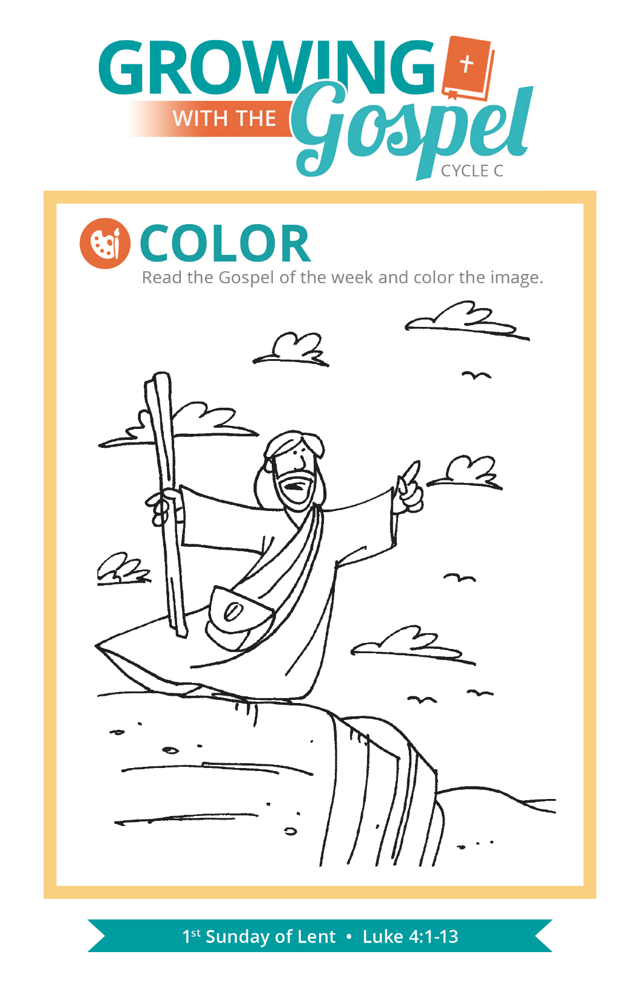
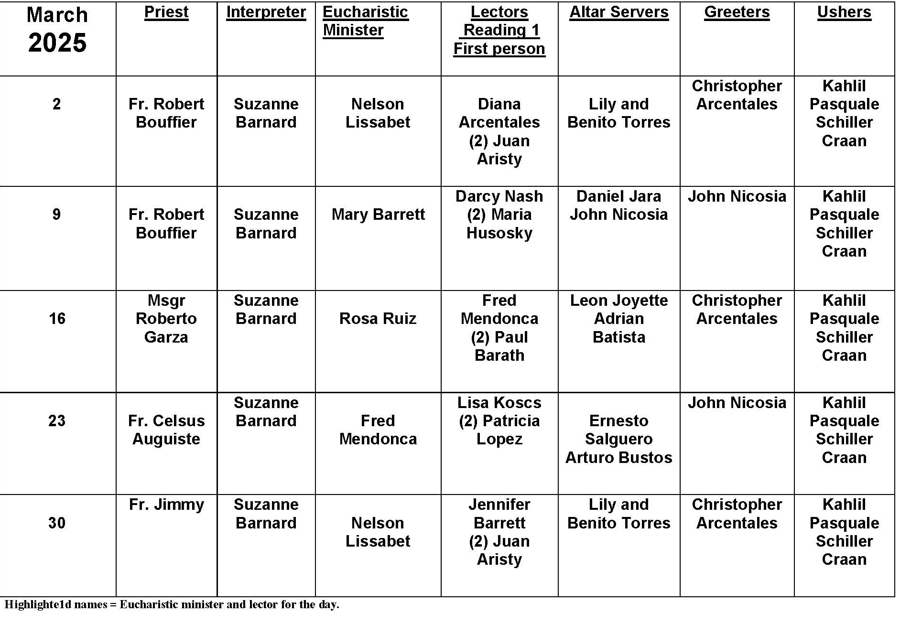
Lent

Question:
After attending our parish retreat and feeling much better and stronger about my faith, I want to make this Lent worthwhile. What can I do to keep the spirit and practice of Lent?

Answer:
You've already taken the first step by going on the parish retreat. It is important for us to "tune up" our faith, taking some time to renew ourselves through prayer, meditation and education. By deepening our knowledge and understanding of faith, we are often better attuned to its richness and meaning for our life.

Lent is an intense retreat, a forty-day period of reflection and penance that prepares us to celebrate the passion, death and resurrection of Christ. Our communication with God and our awareness of him is the purpose of prayer. Setting aside extra time each day helps intensify the season. Prayer includes daily Mass, Stations of the Cross, communal penance services and private confession. Making restitution for sin as well as disciplining our hearts and minds to focus on God is the purpose of penance. It helps us restore a sense of balance to our souls, thrown off kilter by sin. Penance includes personal sacrifice, self-denial, fasting, almsgiving and charitable works.

Finally, spiritual practices help us sharpen our understanding and insight into the meaning and understanding of our faith. When you take your faith seriously, you do what is necessary to follow Jesus more closely, to integrate your life and your faith more carefully.

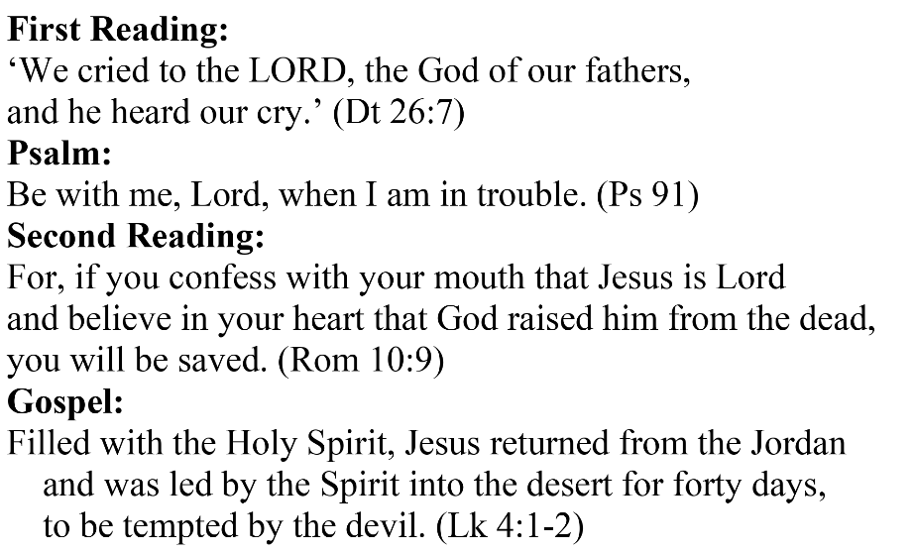
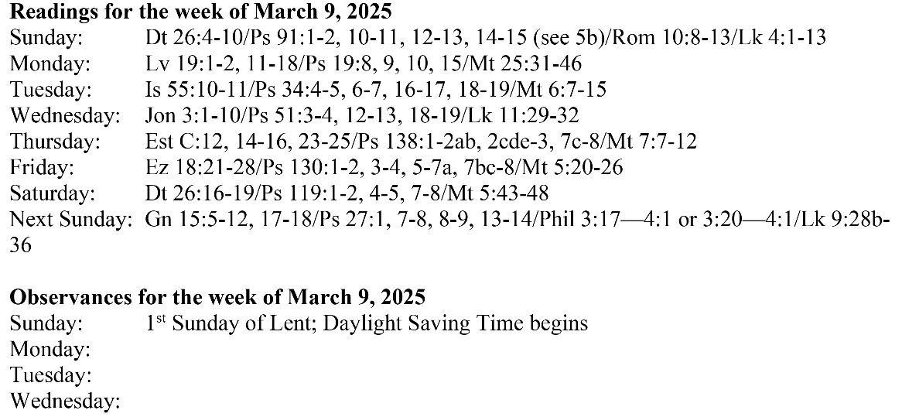

Are you in need of prayer? Do you have a prayer request? You can send your prayer requests to pcuadra@schottcommunities.org or call 954-434-3306 ext. 108

A copy of our prayer list can be found in the lobby of our chapel. To request a copy of our prayer list please email us at pcuadra@schottcommunities.org
To request a Mass please contact Pablo A. Cuadra at 954-434-3306 or e-mail at pcuadra@schottcommunities.org
Update: Celebrating a wedding anniversary soon? Let us know a week in advance and we can assist you with the renewal of your wedding vows.

Prayer to St. Michael the Archangel:
"St. Michael the Archangel, defend us in battle. Be our defense against the wickedness and snares of the Devil. May God rebuke him, we humbly pray, and do thou, O Prince of the heavenly hosts, by the power of God, thrust into hell Satan, and all the evil spirits, who prowl about the world seeking the ruin of souls. Amen"

