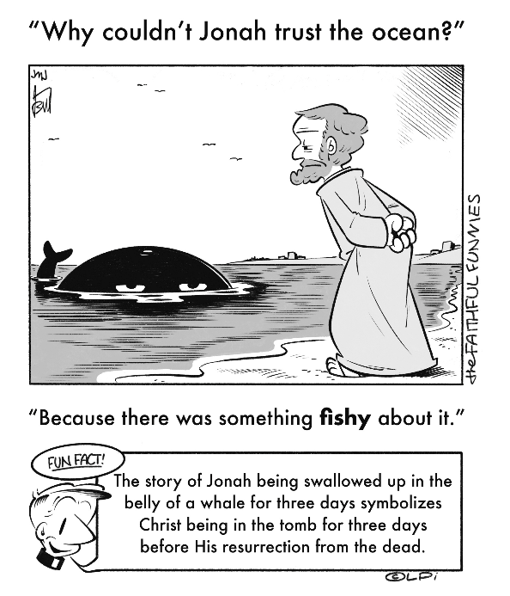
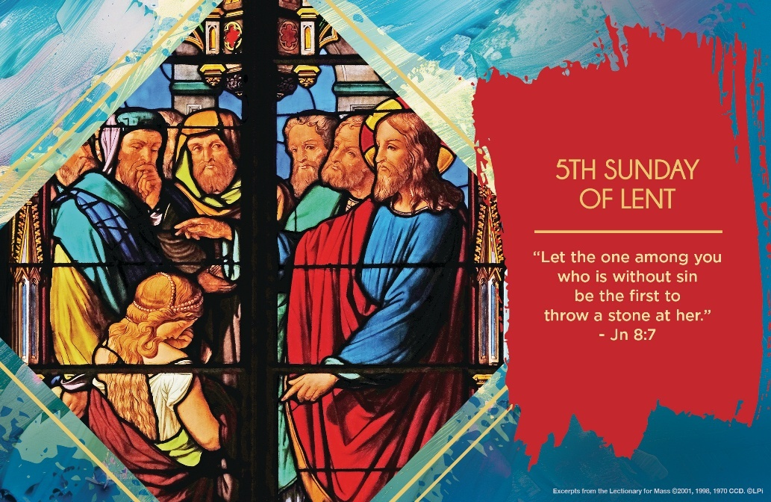
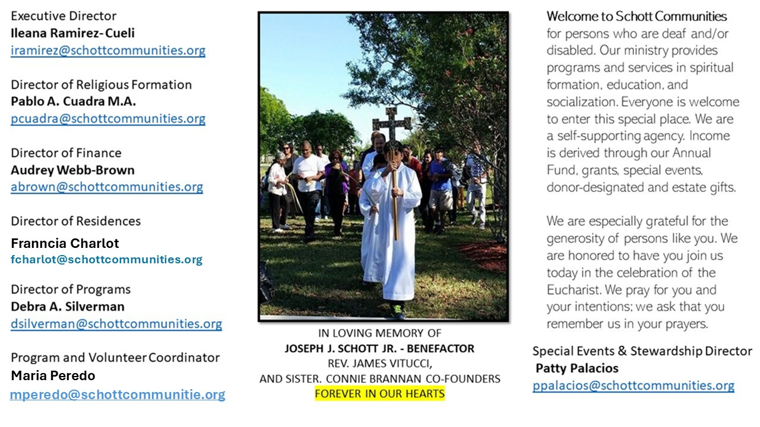

6 de abril de 2025
V Domingo de Cuaresma

Estamos llegando al final de la Cuaresma. Se termina el Jueves Santo con la Misa de la Cena del Señor. “En la Cuaresma, la Iglesia renueva la llamada a la conversión. El hombre nuevo nace en el Bautismo. Dios nos hace sus hijos y nos incorpora a Cristo y a su iglesia. Del corazón del hombre renovado, según Dios, proceden los comportamientos buenos. Estamos llamados a abandonar los comportamientos del pecado y a fijar la mirada en lo esencial” (Papa Francisco).
¿Qué sería lo esencial? Lo primero sería buscar dentro de nosotros mismos para dar respuesta, comenzando con mis actos y los de los demás. A veces, somos tan duros para juzgar. Aplicamos la ley de la piedra sin piedad. Duros de corazón, difíciles para practicar el perdón. Sin embargo, Tú, Señor, me perdonas con la blandura de un Evangelio escrito en el suelo, es decir, en tierra blanda. Aprovechemos hoy para pedir a Jesús la enseñanza de la misericordia. Esa misma misericordia aplicada a la mujer sorprendida en adulterio. ¿Qué debió haber sentido aquella persona acusada a la pregunta de Jesús? “Mujer, ¿dónde están? ¿Ninguno te ha condenado? Ella contestó: Ninguno, Señor. Y Jesús le dijo: Tampoco yo te condeno. Vete y en adelante no vuelvas a pecar” (Juan 8:10-11). Pues bien, el reto de la conversión es no volver a pecar. Es aprender día a día a ser buenos, con nosotros mismos y con los demás.

April 6, 2025
5th Sunday Lent
John 8:1-11

“The scribes and the Pharisees brought a woman who had been caught in adultery and made her stand in the middle” (John 8:3). Why do they make her stand in the middle? Why not expose her on the periphery? The reason is something that affects us practically every day.

The center is what stabilizes a community’s identity. We humans tend to center ourselves around an accused and condemned victim — though we rarely admit it. This renews our fragile communities and our power as those who weaponize the accusation. This is effective because it is often a victim who represents something truly dangerous for the group. In this case, adultery stands for the breakdown of a community and those within it, because it forces questions like: who is my father? Whose child is this? Is this child one of us, or that of an outsider? The accusers place the adulteress in the center because their community, like most, is built around turning an enemy into a victim.

Once you understand this, you’ll see it almost anywhere humans group together (families, politics, workplaces, sports, schools, etc.). The good news is Jesus exposes this dynamic by deftly pointing out the sin-infected hearts of everyone besides the woman. They all leave, symbolizing the breakdown of the old order, and she is “left alone before him.” A new community has begun, structured around the merciful love of Christ.

What is in your center? What is in the center of our parish and family communities? Strive to center on Christ’s forgiveness, and we experience the new, lasting community we call the Church.

— Father John Muir

St. Jude Chapel, Sunday, April 6th 2025
Father Robert Bouffier
Celebrant

Prayer of Community

O God,
Help us to see each other as You see us, not by our faults or failings, but by our identity as Your own. Give us Your eyes to see, Your heart to love.
Amen.


Christian Giving
March 30th, 2025
$584

We sincerely thank you and bless you for your generosity.
A bequest is a powerful tool to help the Deaf or Disabled.

Mass Intentions
“For the repose of the Souls in Purgatory
Requested by Schott Communities


Follow us on Facebook
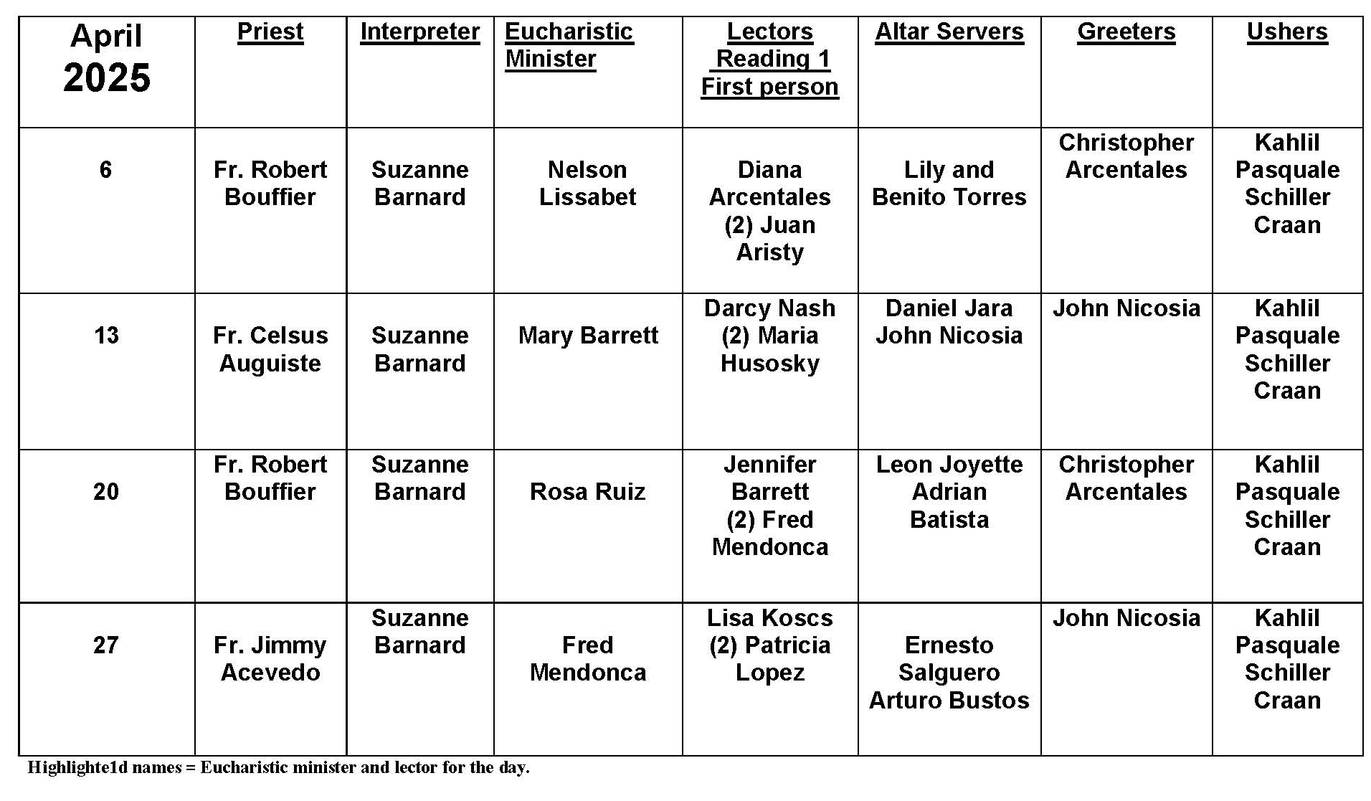
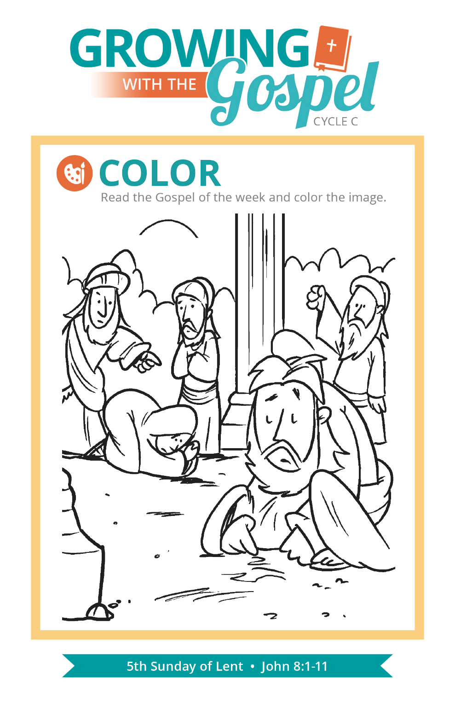
Priesthood

Question:
If someone is interested in becoming a priest, how does he go about it?
Answer:
Discerning a vocation can happen in any number of ways. It might come as a surprise to the person called or to family or friends. Sometimes it is a gradual process, and other times it is as quick and bright as lightning. Regardless of how it starts, a vocation to the priesthood or religious life requires a process of discerning, testing, and preparing. The best place to begin would be with lots of prayer, receiving the sacraments, and attending daily Mass whenever possible. Then talk to your pastor or a priest you know and trust. Your diocese may have a vocation director who can provide you with guidance and information. The Serra Club is also a great resource for information and contacts to help you discern if indeed God is calling you.
Remember that many young Catholic men have considered the priesthood. Some are ordained and others realize this is not their calling. However, we are all called to be of service to others as we practice our faith. These are extraordinary times in which we live, and they require an extraordinary witness to faith and to God’s presence in the world. Our work, our ministry as Catholics, is to be the body of Christ with and for others. The Church needs priests. If God calls you to ordained service in the church, He will provide the grace, direction, and support you need. Just listen and respond with all your heart, mind, and soul.

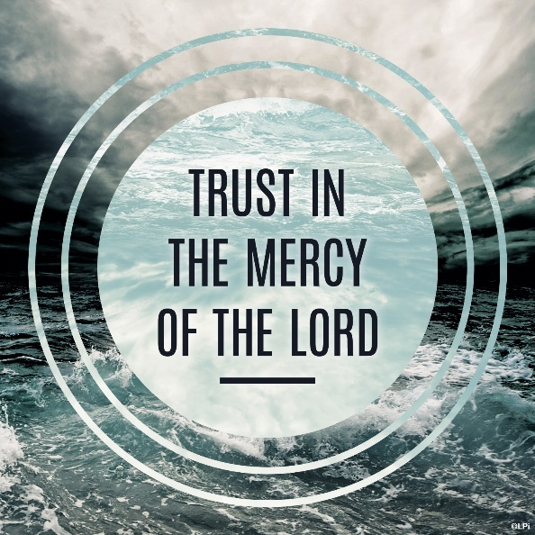
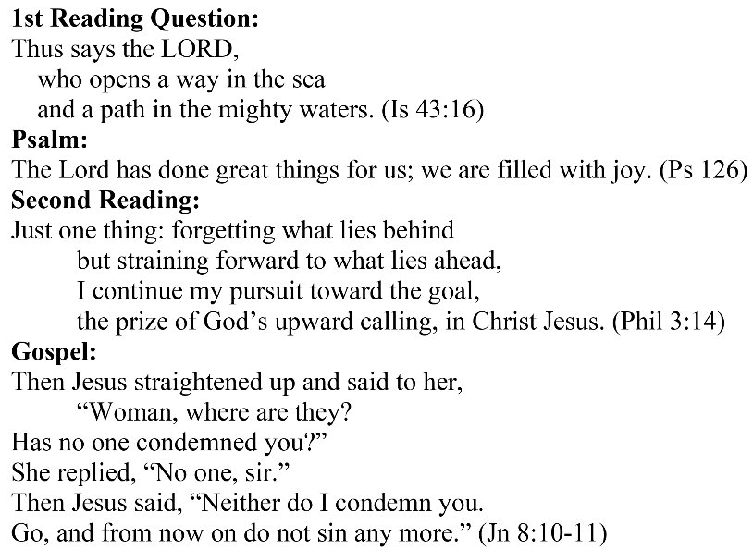
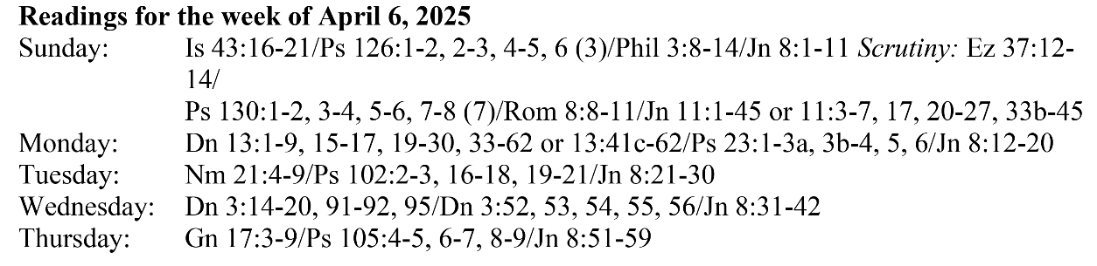
Are you in need of prayer? Do you have a prayer request? You can send your prayer requests to pcuadra@schottcommunities.org or call 954-434-3306 ext. 108

A copy of our prayer list can be found in the lobby of our chapel. To request a copy of our prayer list please email us at pcuadra@schottcommunities.org
To request a Mass please contact Pablo A. Cuadra at 954-434-3306 or e-mail at pcuadra@schottcommunities.org
Update: Celebrating a wedding anniversary soon? Let us know a week in advance and we can assist you with the renewal of your wedding vows.

Prayer to St. Michael the Archangel:
"St. Michael the Archangel, defend us in battle. Be our defense against the wickedness and snares of the Devil. May God rebuke him, we humbly pray, and do thou, O Prince of the heavenly hosts, by the power of God, thrust into hell Satan, and all the evil spirits, who prowl about the world seeking the ruin of souls. Amen"

