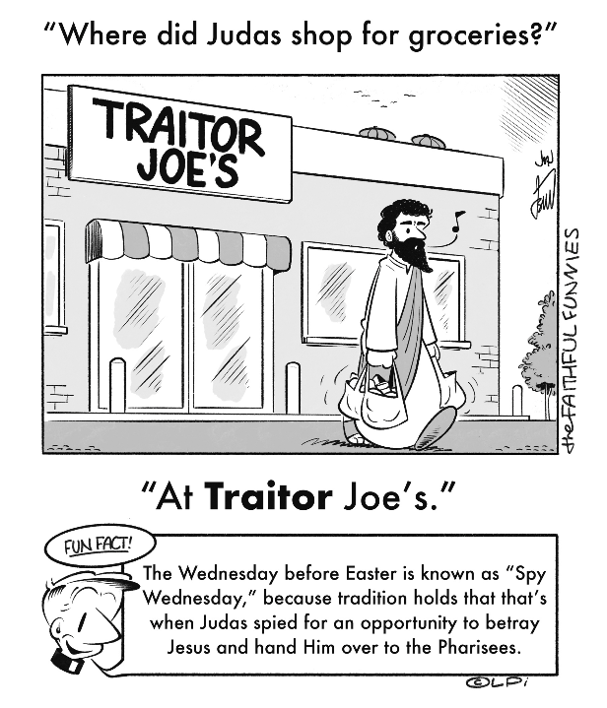
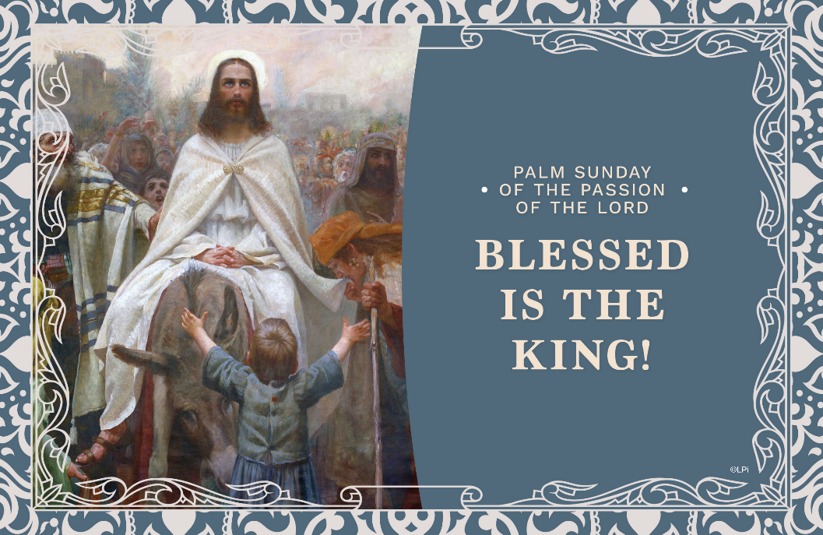
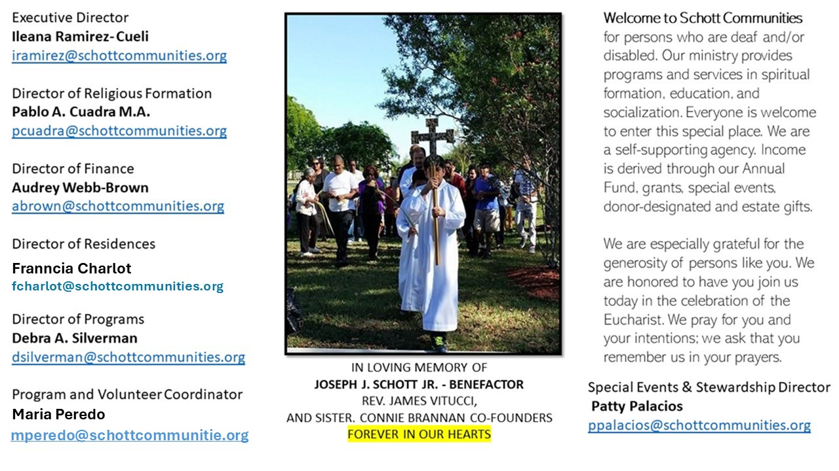

13 de abril de 2025
Domingo de Ramos

¡Hosanna al Hijo de David! ¡Bendito sea el que viene en nombre del Señor! ¡Hosanna en lo más alto de los cielos! (Mateo 21:9). Preparados o no, llegamos a la Semana Santa, también llamada Semana Mayor. Conmemoramos la entrada triunfante del Señor a Jerusalén. ¿Has pensado de qué forma acompañaremos a Jesús durante la semana? ¿Cuáles son los planes en familia y en la comunidad parroquial? Muchas familias aprovechan este tiempo para salir de vacaciones, lo cual es muy bueno. Sin embargo, eso no es motivo para dejar a Jesús solo. Dondequiera que estemos, podemos tener momentos de oración y reflexión en el Misterio de la Pasión del Señor.
Se agitan las palmas benditas en nuestras manos y se escuchan los vivas del pueblo. Y en menos de una semana, daremos comienzo al Triduo Pascual. Judas lo traicionará a cambio de unas cuantas monedas; sus discípulos lo abandonarán y Pedro terminará negándolo. Todos le habían prometido fidelidad. Sin embargo, fallaron a la hora del arresto. Jesús es el amor que no se deja vencer y da muestras de ello aun en su tribulación. Cura al soldado que se acerca a arrestarlo, perdona a quienes lo crucifican y le da esperanza al ladrón arrepentido que muere con él. ¿Qué podemos aprender de todo esto? ¿A qué nos invita Jesús en este tiempo tan concreto? La respuesta es personal, pero démonos cuenta que, al final de todo el Vía Crucis, lo que vence es el amor.

April 13, 2025
Palm Sunday
Luke 19:28-40
“As he rode along, the people were spreading their cloaks on the road.” (Luke 19:36)

Consider how useless it is to spread your clothes on the ground for a donkey to walk on. The clothes get smeared with hooves, and who knows the grimy places where they’ve been? The animal may leave some unsavory presents on them. They may get stolen by a thief looking to make a buck. The thorns, thistles, rocks and muck of the road will leave stains. The clothes may never be useful again, and you’ll probably walk home shivering without your normal covering. Yet this is precisely the gesture the people employ to welcome Jesus and his donkey. Why does this detail matter?

Wastefulness is an essential part of celebration. Consider the unnecessary extravagance of Christmas decorations, confetti and ticker tape parades, baseball players spraying each other with bottles of champagne after a victory, birthday gifts for kids and so on. This wastefulness signals celebration and therefore participation in higher identities (as believers, winners, and parents, to mention the above examples). That’s what the wasted cloaks are all about. Those who donate their cloaks participate in Christ’s kingship in Jerusalem — and we savor it two thousand years later.

The lesson? Learn how to “waste” money, time, clothes, and food on Christ. We do this at Mass, but in so many other ways, too, like serving the poor, going on retreats, and doing prayerful study. When we practice this holy wastefulness, Jesus will ride into our lives and we’ll be more deeply members of his kingdom.

— Father John Muir

St. Jude Chapel, Sunday, April 13th 2025
Father Celsus Auguiste
Celebrant

Seven Churches Pilgrimage
The Seven Churches Pilgrimage is the practice of visiting seven different churches on Holy Thursday, in imitation of the journey of Christ on the eve of his crucifixion, when he asked his disciples to stay with him as he awaited his Passion and death.


Christian Giving
April 6th, 2025
$490

We sincerely thank you and bless you for your generosity.
A bequest is a powerful tool to help the Deaf or Disabled.

Mass Intentions
“For the repose of the Souls in Purgatory
Requested by Schott Communities


Follow us on Facebook
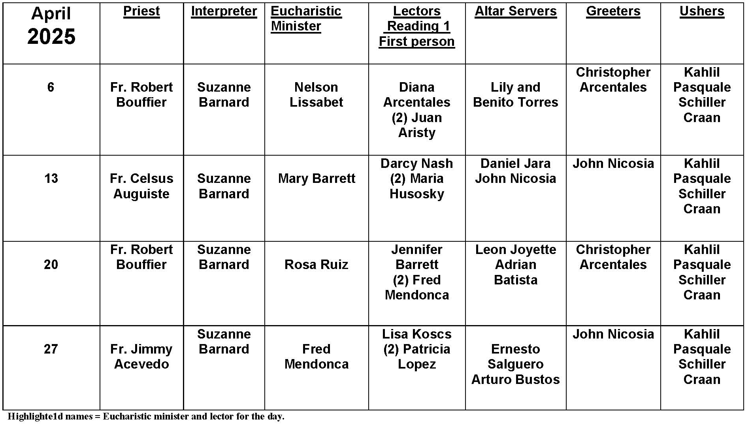
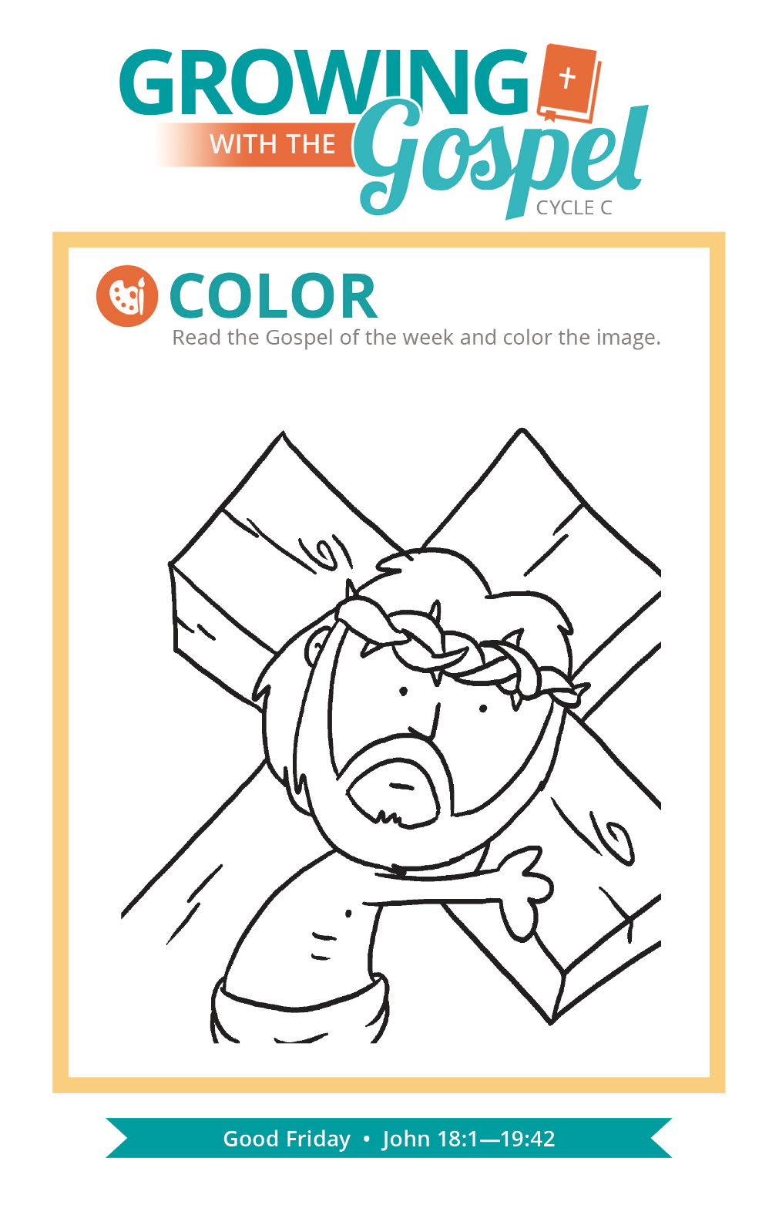
Palm Sunday

Question:
Where do Palm Sunday palms come from and where should they go?

Answer:
The Palm Sunday celebration has ancient origins. Beginning the liturgy “outside” the church, we symbolically reenact Christ’s entry into Jerusalem. The crowds in ancient Israel waved palm branches – a symbol of royalty – to welcome Jesus. These days, obtaining palms takes a lot of planning and coordination, as hundreds of thousands of churches worldwide need them on the same day! Many in the United States order palms from Florida, California, Texas, or Central America. Many companies stress the sustainability of their production and the just wages paid to their workers.

The palms used on Palm Sunday are blessed at Mass. This means they shouldn’t end up in the trash! Many people weave palms into crosses or families display them in their homes. If you do not plan on displaying your palms throughout the year, they should be burned, buried, or left at the church. In the final case, the palms are burned to provide the ashes for next year’s Ash Wednesday service.

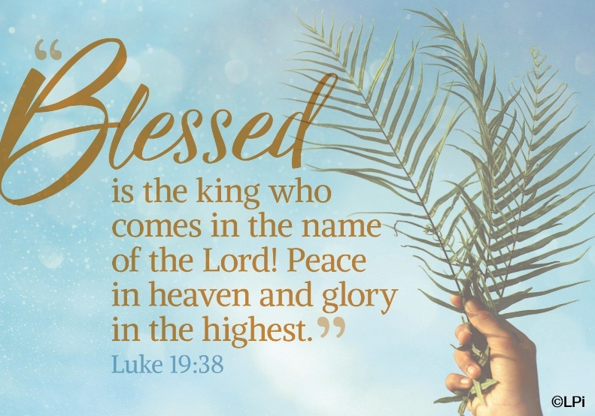
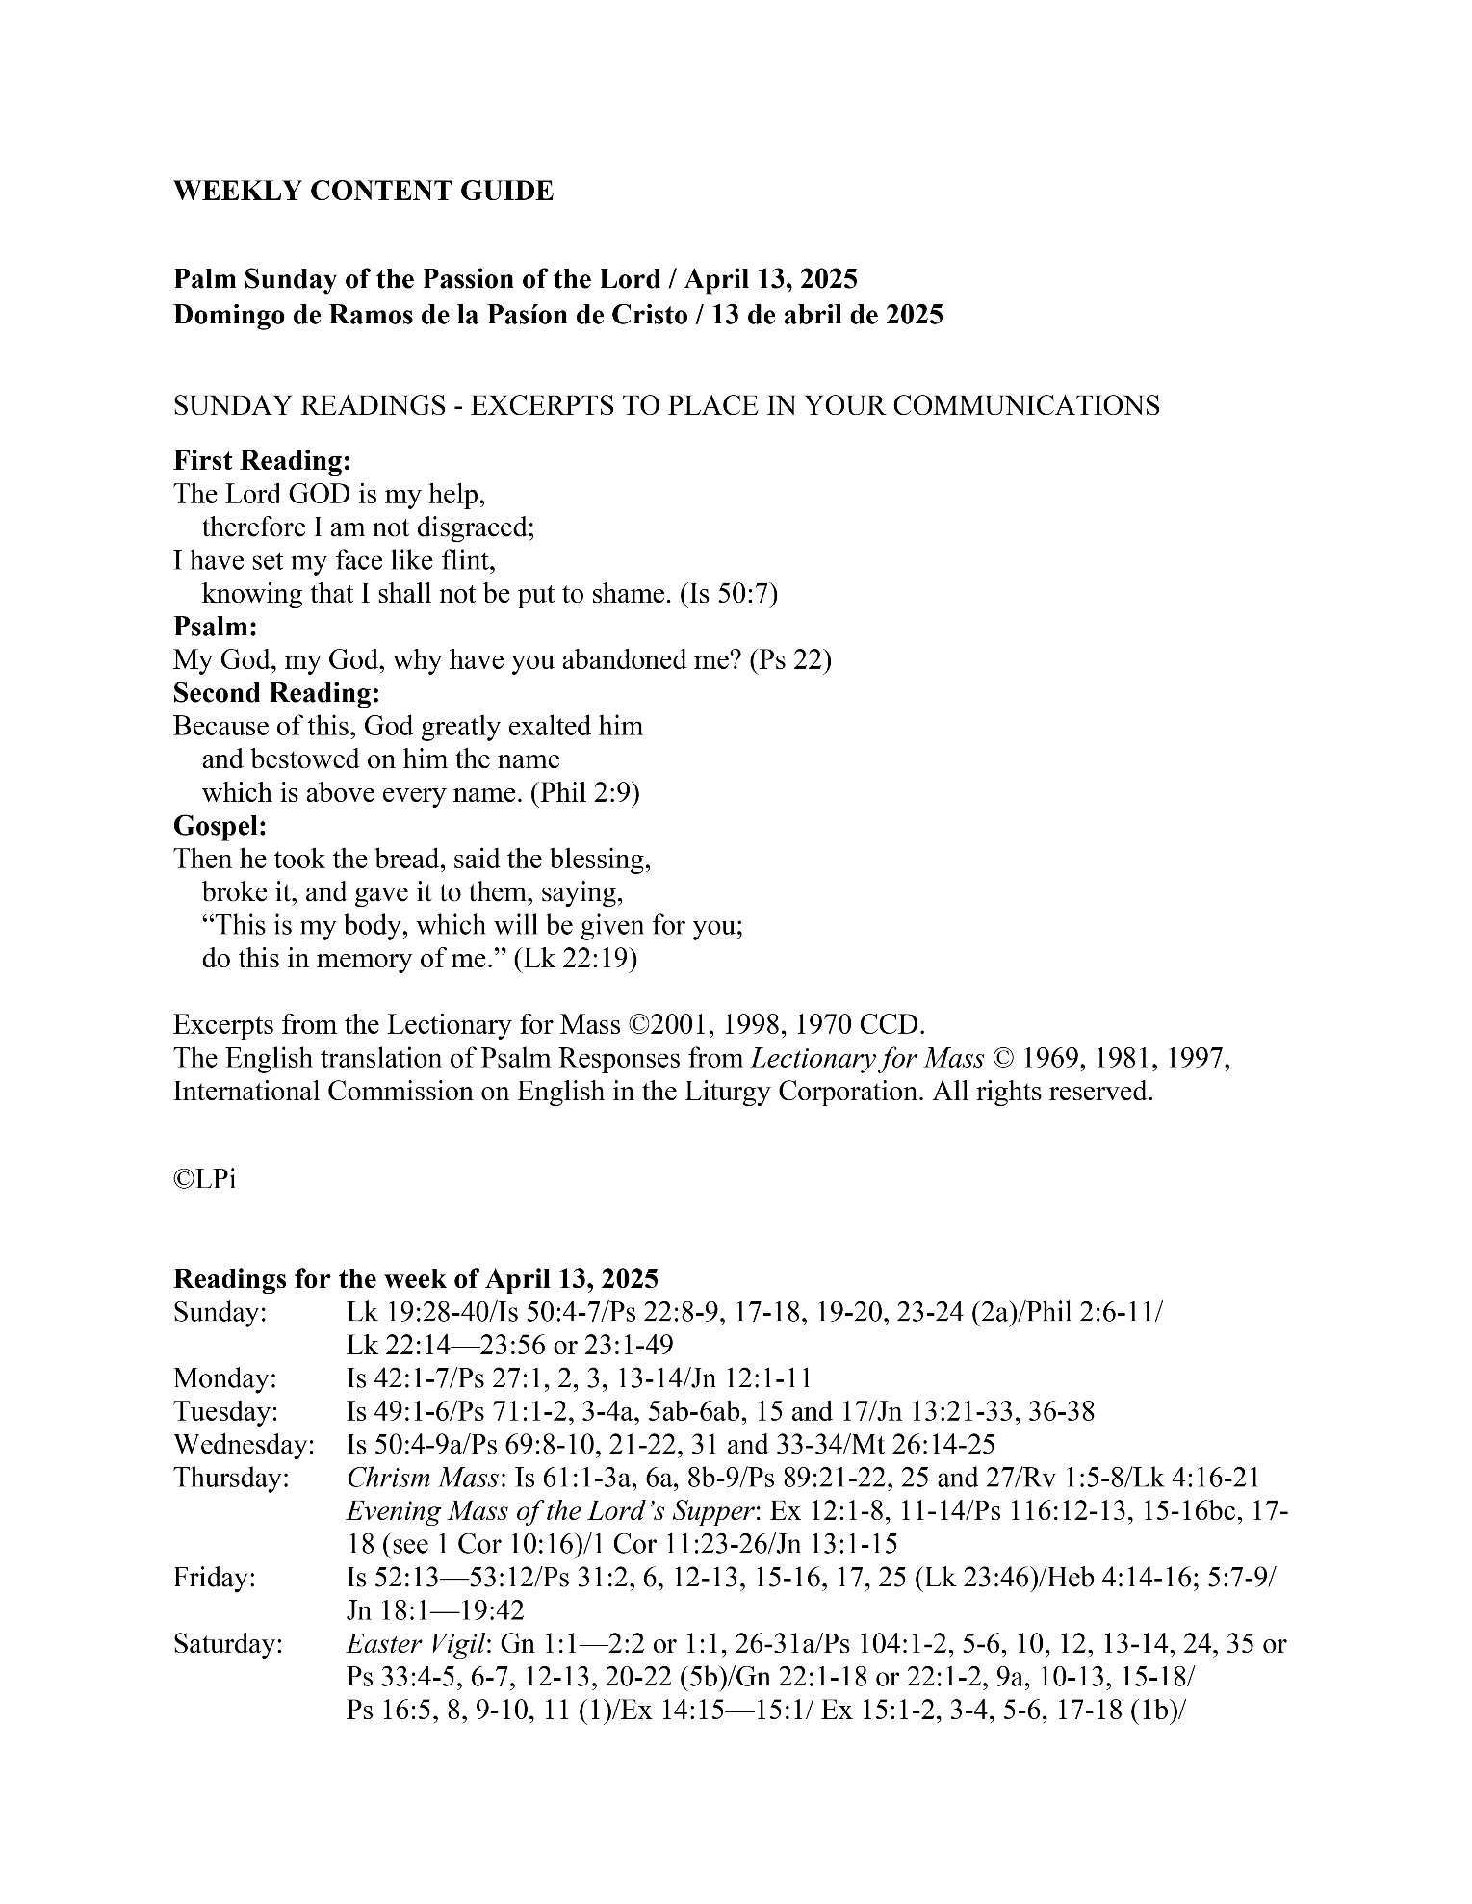
Are you in need of prayer? Do you have a prayer request? You can send your prayer requests to pcuadra@schottcommunities.org or call 954-434-3306 ext. 108

A copy of our prayer list can be found in the lobby of our chapel. To request a copy of our prayer list please email us at pcuadra@schottcommunities.org
To request a Mass please contact Pablo A. Cuadra at 954-434-3306 or e-mail at pcuadra@schottcommunities.org
Update: Celebrating a wedding anniversary soon? Let us know a week in advance and we can assist you with the renewal of your wedding vows.

Prayer to St. Michael the Archangel:
"St. Michael the Archangel, defend us in battle. Be our defense against the wickedness and snares of the Devil. May God rebuke him, we humbly pray, and do thou, O Prince of the heavenly hosts, by the power of God, thrust into hell Satan, and all the evil spirits, who prowl about the world seeking the ruin of souls. Amen"

