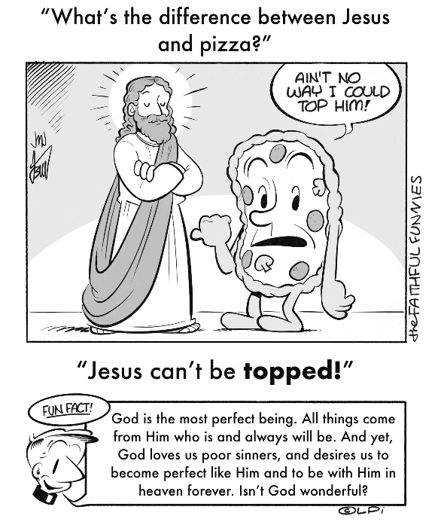
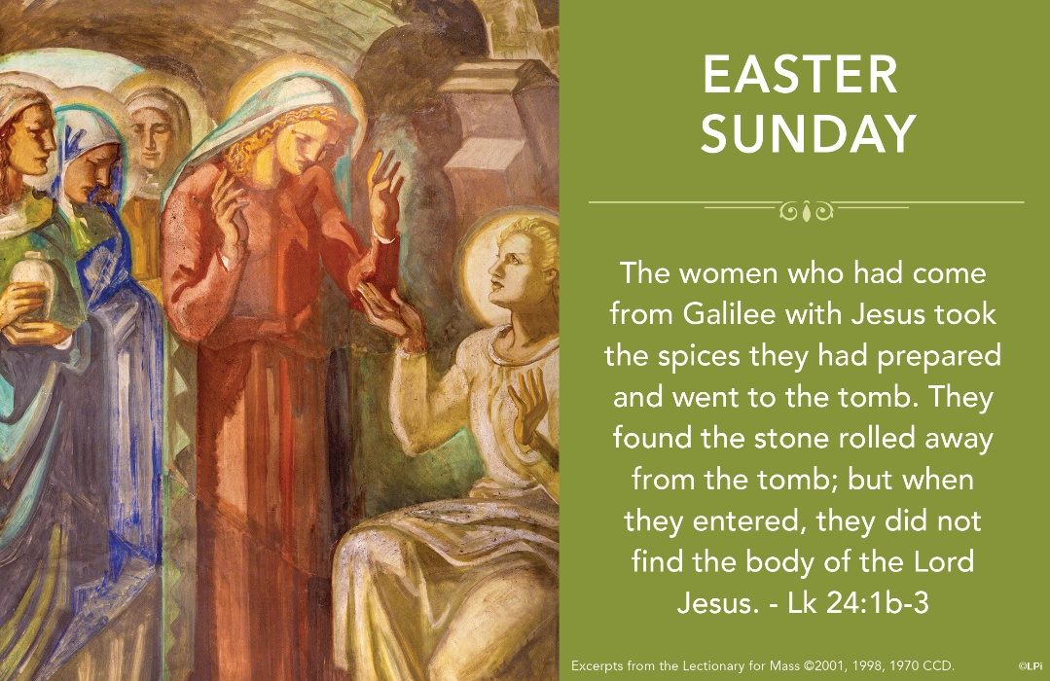
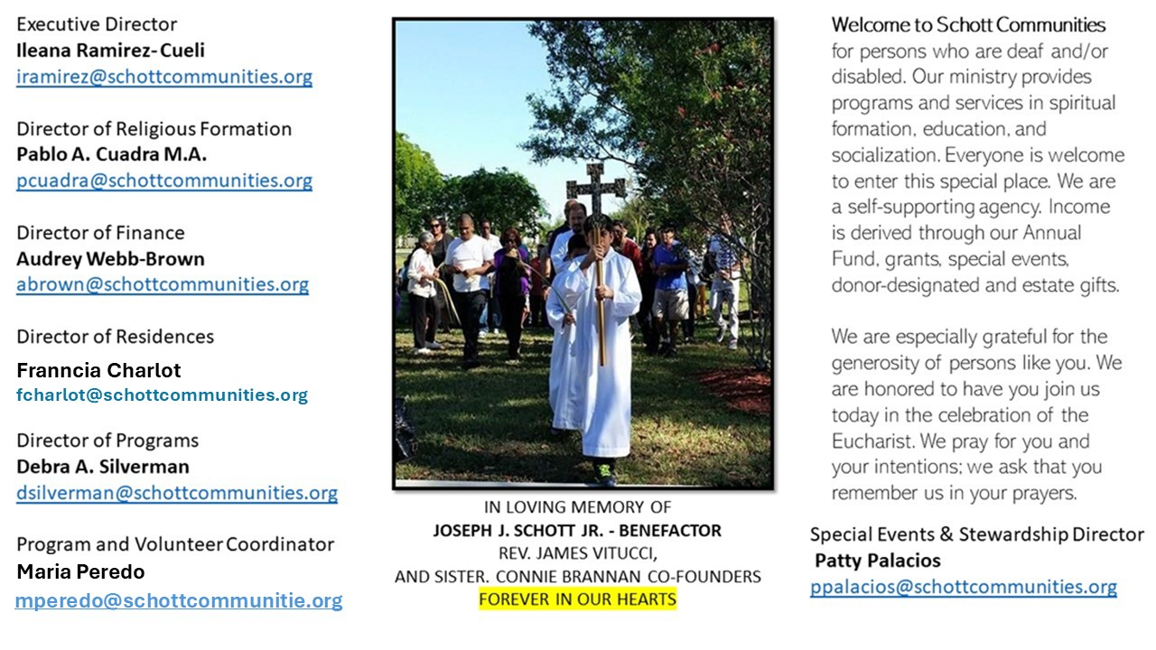

20 de abril de 2025
Domingo de Pascua

El Señor Jesús vive y de ello damos testimonio porque hemos sido testigos de su Resurrección. La presencia del resucitado llena de alegría todas las cosas y al mundo entero. ¡Ha cumplido su palabra; está vivo! “Entonces entró también el otro discípulo, el que había llegado primero, vio y creyó. Pues no habían entendido todavía la Escritura: él debía resucitar de entre los muertos” (Juan 20:8-10). Jesús ya nunca volverá a morir, ¡Cristo Resucitó! ¡Verdaderamente Resucitó! ¿Crees esto? Es el saludo de este gozo pascual de este Domingo de Pascua.
Todos los bautizados debemos de estar alegres porque, por el hecho de ser bautizados, somos hijos e hijas de Dios, herederos del cielo, miembros de la Iglesia y por lo tanto estamos llamados a resucitar con él. Sin embargo, debemos estar conscientes que esto no ocurrirá de modo rápido y como apretar un botón mágico. Hay que trabajar en ello; debemos de poner nuestro esfuerzo en mejorar cada día. Hay que acercarnos a la intimidad de Dios por medio de una relación personal con él y a través de la oración y los sacramentos. La salvación ya está realizada; solo nos toca a nosotros aceptarla y seguir caminando con fe y gozo. Este es el gran regalo que Jesús nos da: salvación, gracia y amor. ¡Aleluya! ¡Felices Pascuas de Resurrección! Dejemos que Jesús nos acompañe en el camino y que su presencia en la Eucaristía nos consuele cada vez que lo recibimos.
April 20, 2025
Easter Sunday
John 20: 1-9

When I was a young boy, my parents told me about their wedding. Then a few years later, they showed me my mother’s wedding dress and my dad’s suit. It was astonishing to see and touch garments that connected me to the event that led to my existence. Of course, I already believed they were married based on their word. But these holy garments made the event real and tangible for me.

Something like this is at play when St. John reports encountering in Jesus’ tomb, “the cloth that had covered his head, not with the burial cloths but rolled up in a separate place” (John 20:7). Those two separate cloths, for his head and for his body respectively, meant a great deal to St. John and to the early Christians. Some years after the resurrection, there surfaced reports of two cloths with unusual characteristics, one bearing the image of a crucified man’s body, another smaller one with the image of a wounded man’s face. Some call them the Shroud of Turin and the Veil of Manoppello; they both can be seen today.

These two cloths have a long and complicated history, and scholars debate aspects of them. If you’re curious, I encourage you to read about them. To be clear, I believe in the resurrection of Jesus because of the testimony of eyewitnesses and the gift of faith in the Church. Nevertheless, seeing these two mysterious cloths have made the life-giving event of Jesus’ resurrection more real and tangible for me. Maybe they will for you, too.

— Father John Muir

St. Jude Chapel, Sunday, April 20th 2025
Father Robert Bouffier
Celebrant

Seven Sorrows of Mary

The Seven Sorrows of Mary helps us to unite our own sufferings with those of Jesus, following Mary’s perfect example, as we meditate upon the great sufferings endured by Our Lord and his Blessed Mother.


Christian Giving
April 13th, 2025
$648

We sincerely thank you and bless you for your generosity.
A bequest is a powerful tool to help the Deaf or Disabled.

Mass Intentions
“For the repose of the Souls in Purgatory
Requested by Schott Communities”


Follow us on Facebook
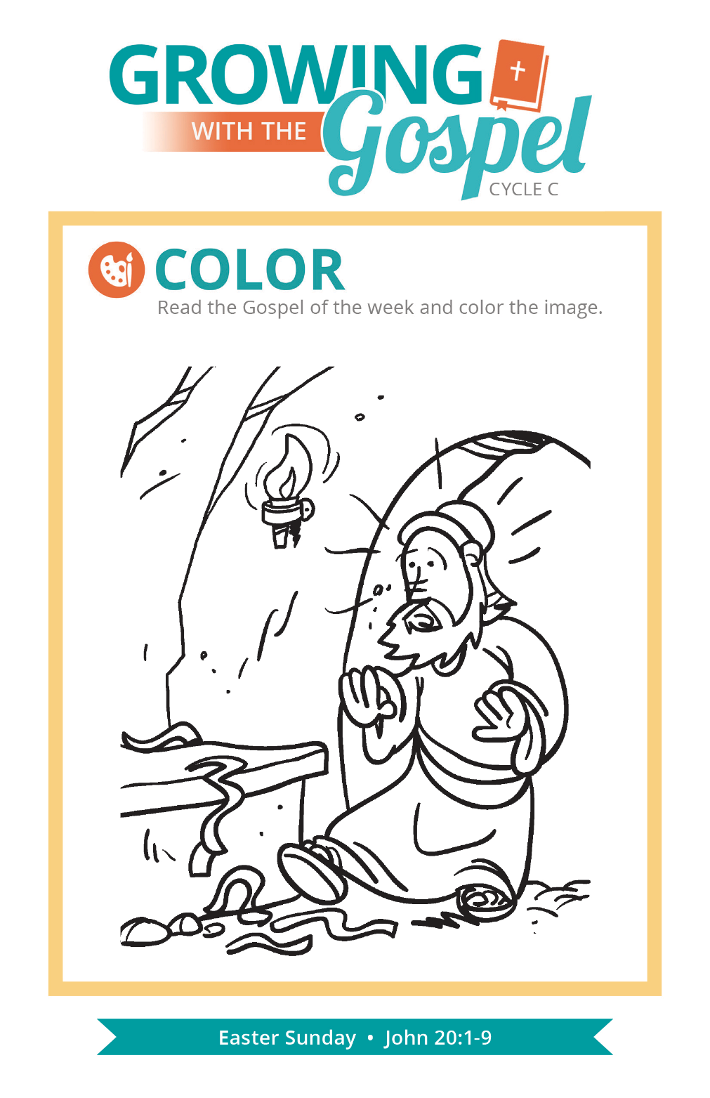
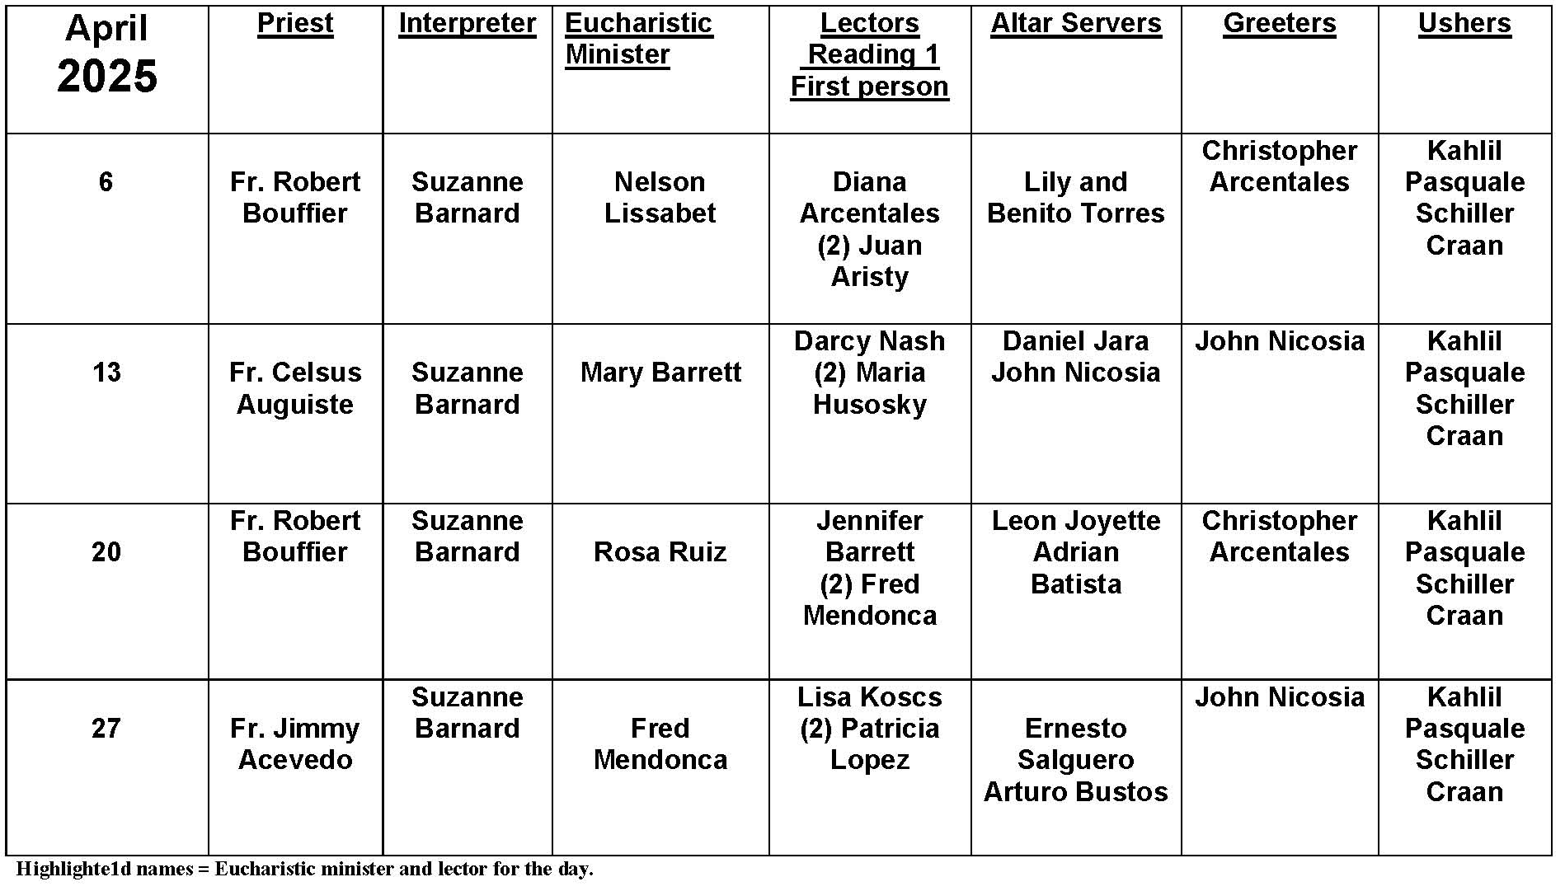
Question:
How do I discern if a call to do something big is really from God?

Answer:
Each day we face plenty of decisions about following God: whether or not to pray, how to treat people, and how to prioritize our time. Sometimes there can be something much more significant we discern: a vocational call, a promotion at work that requires a move, or a new ministry position at church. In addition to a pro-con list or a cost-benefit analysis, here are a few things to prayerfully consider and to talk over with trusted individuals.

Does it conform to God’s will revealed in the Church? God doesn’t call us to do something that contradicts the moral law. Will it encourage spiritual growth? Sometimes we need to choose between multiple good options. Consider the personal impact on you and others you are responsible for, like family. Other times we might be invited to do good for others, but when we assess our other life commitments, we see that saying yes to this would actually impede our prior responsibilities in the long run. Does the call seem consistent? This isn’t to say that God won’t do something new. Even so, consider if the call is consistent with your gifts and abilities. Can you see a “through-line” so to speak, with how your experiences have led you to this point? Do others confirm it? Share your reflections with trusted, insightful confidantes. Have they seen the same things you have, or are they bringing up new points to consider? Humbly add their relevant points to your considerations. Don’t forget your gut. After you’ve carefully considered everything in your mind, don’t neglect your instincts. Does your heart say yes or no?

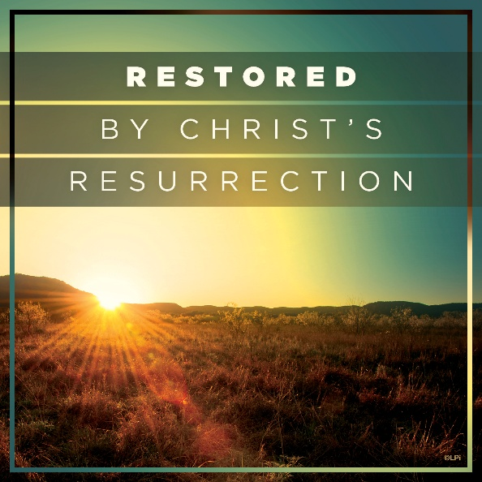
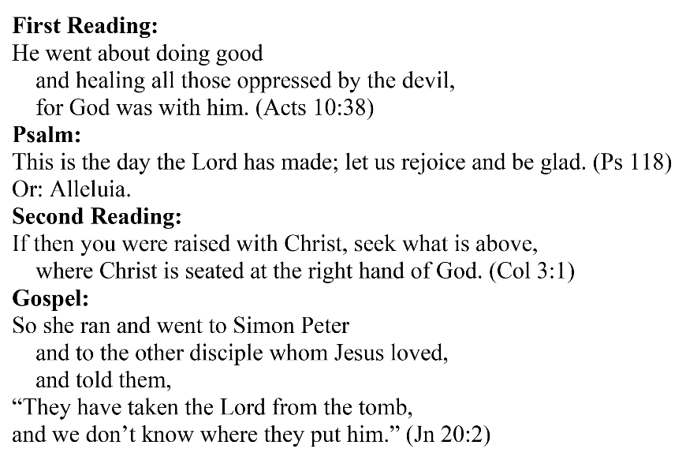
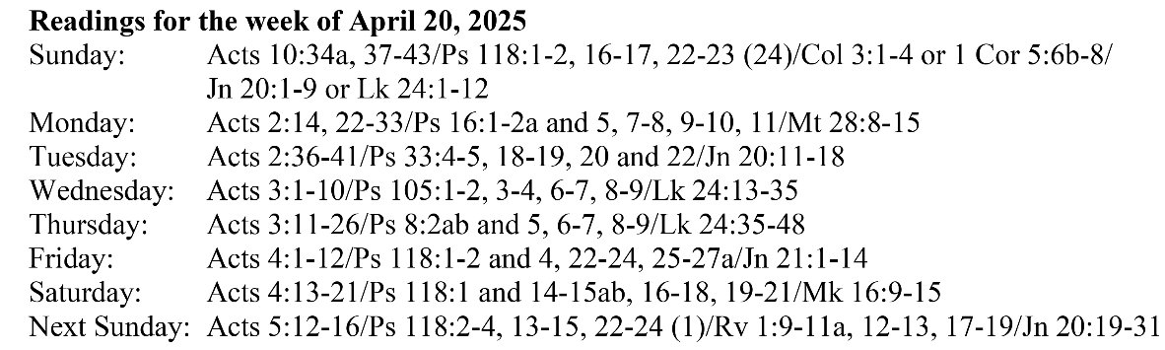
Are you in need of prayer? Do you have a prayer request? You can send your prayer requests to pcuadra@schottcommunities.org or call 954-434-3306 ext. 108

A copy of our prayer list can be found in the lobby of our chapel. To request a copy of our prayer list please email us at pcuadra@schottcommunities.org
To request a Mass please contact Pablo A. Cuadra at 954-434-3306 or e-mail at pcuadra@schottcommunities.org
Update: Celebrating a wedding anniversary soon? Let us know a week in advance and we can assist you with the renewal of your wedding vows.

Prayer to St. Michael the Archangel:
"St. Michael the Archangel, defend us in battle. Be our defense against the wickedness and snares of the Devil. May God rebuke him, we humbly pray, and do thou, O Prince of the heavenly hosts, by the power of God, thrust into hell Satan, and all the evil spirits, who prowl about the world seeking the ruin of souls. Amen"

