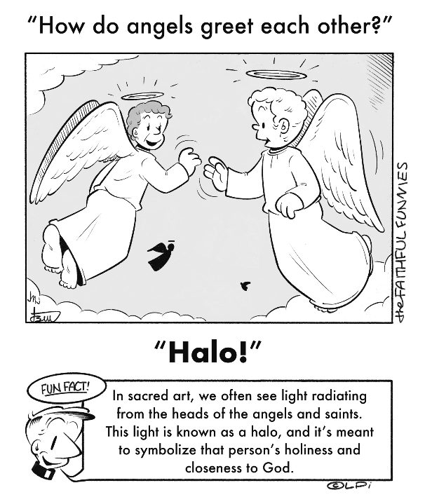
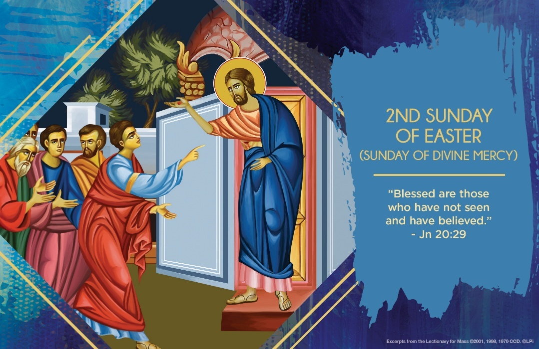
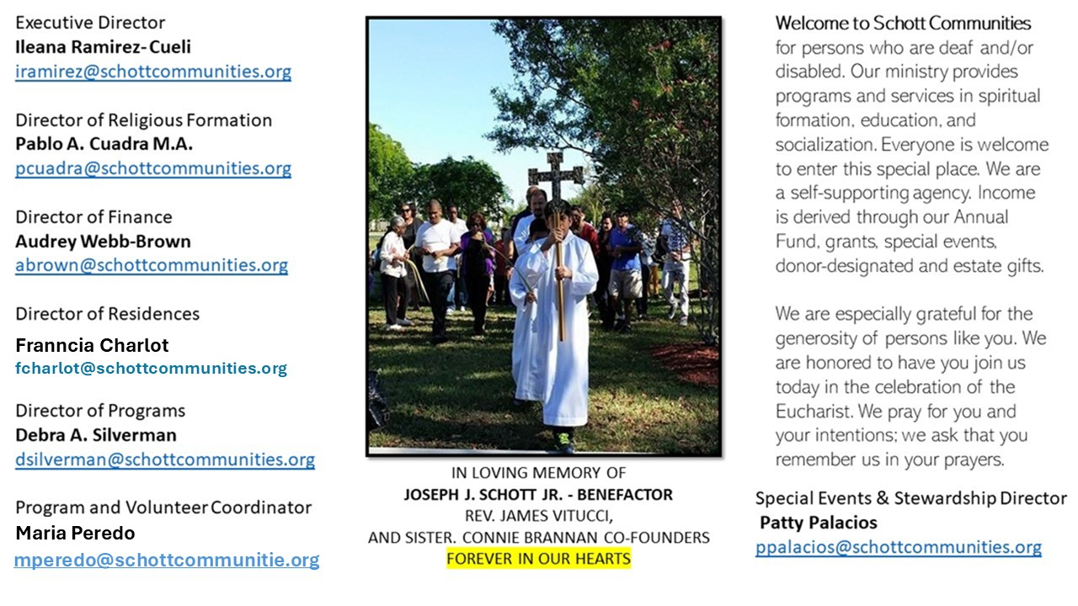

27 de abril de 2025
II Domingo de Pascua (Divina Misericordia)
Hoy es Domingo de la Misericordia; celebramos la gran misericordia de Dios al darnos a su Hijo para que nos salvara por medio de su vida, pasión, muerte y resurrección. El Catecismo de la Iglesia Católica, en su numeral 1225, nos lo explica de la siguiente manera: “La sangre y el agua que brotaron del costado traspasado de Jesús crucificado (ver Juan 19:34) son figuras del Bautismo y de la Eucaristía, sacramento de vida nueva (ver 1 Juan 5:6-8): desde entonces, es posible ‘nacer del agua y del Espíritu’ para entrar en el Reino de Dios (ver Juan 3:5). Con la Pasión, Muerte y Resurrección, se derramó su Misericordia. Por eso, hoy cantemos, llenos de alegría y esperanza, el Salmo 117: ¡La misericordia del Señor es eterna. ¡Aleluya!
Señor, para dar un sincero testimonio de tu resurrección, enséñame a ser dócil como Tú lo fuiste en tu vida terrena, y principalmente en la cruz. Encontrarnos y reconciliarnos es el mensaje que el Evangelio nos trae en este segundo Domingo de Pascua. Nos narra, también, la falta de fe de Tomás, de su incredulidad al recibir la noticia de que el Señor había resucitado. Tuvo que verlo y tocarlo para comprender toda la misericordia de Dios viva en Jesús: “Señor mío y Dios mío” (Juan 20:28). Y ahora, nosotros tenemos la dicha de creer sin ver. Y Jesús nos llama dichosos por eso. Pero, a la vez, debemos de madurar en la fe y eso se logra pidiendo al Espíritu Santo que nos ayude a comprender los misterios del Jesús glorioso que serán lo definitivo para todos.

April 27, 2025
2nd Sunday of Easter
John 20:19-31

It’s common for Catholics to hear the question, “Why do I have to go to a priest to have my sins forgiven?” I’ve never liked that question because not only is it clunky (confession is the ordinary way for the pardoning of serious sins, not lesser ones). But it misses the larger context: the wonderful origins of the sacrament itself. And this context is deeply Jewish.

Ancient Jews associated forgiveness of sins with priests offering sacrifices in the Jerusalem temple. It was a solemn, public, and tangible way to access God’s mercy. So when the risen Jesus breathes on the Apostles and says, “Whose sins you forgive are forgiven them, and whose sins you retain are retained” (John 20:23), the upshot is remarkable: he is the new temple and his Apostles are the new priests. Jerusalem is no longer the place to find forgiveness from sin. Jesus’ body, the Church, is.

So why should we go to the Sacrament of Confession? For the same reason ancient Jews went to the temple in Jerusalem: to experience the intimacy, joy, and life-giving power of God’s eternal forgiveness.

— Father John Muir

St. Jude Chapel, Sunday, April 27th 2025
Father Dariel Fong
Celebrant

Sprinkling Rite
The rite of sprinkling, also called the Asperges rite, recalls the new life we receive in the waters of our baptism. Though most common during the Easter season, this rite can take place on any Sunday and is used in place of the penitential act.


Christian Giving
April 20th, 2025
$TBA

We sincerely thank you and bless you for your generosity.
A bequest is a powerful tool to help the Deaf or Disabled.

Mass Intentions
“For the repose of the Souls in Purgatory
Requested by Schott Communities


Follow us on Facebook
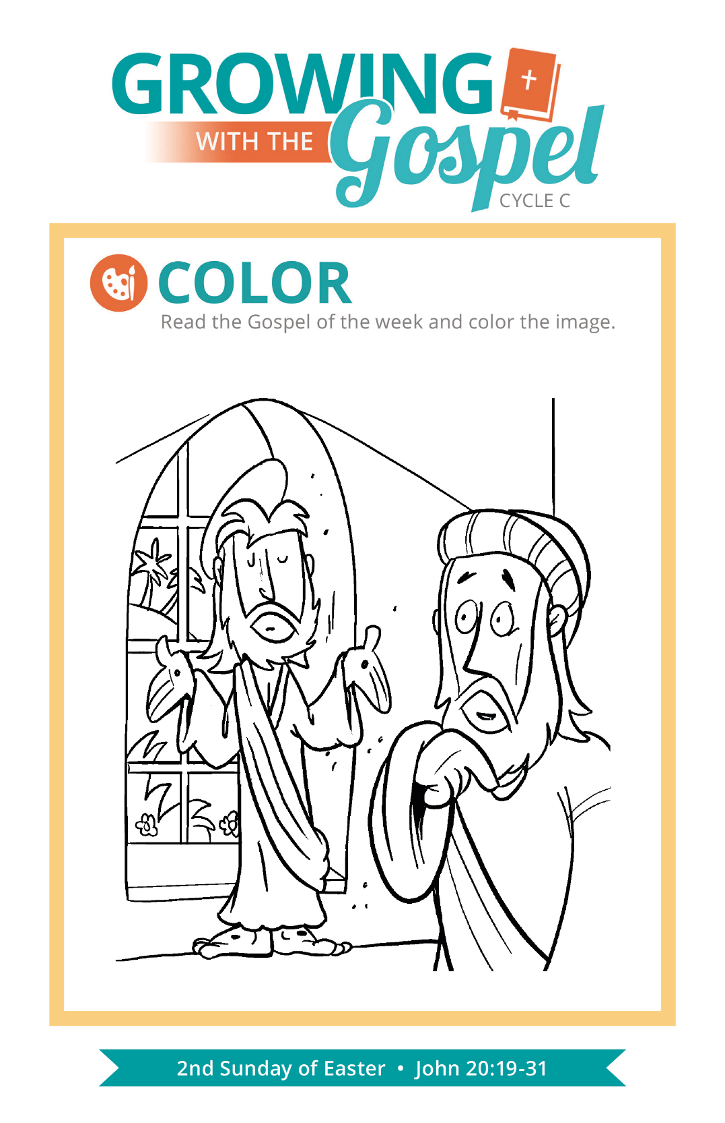
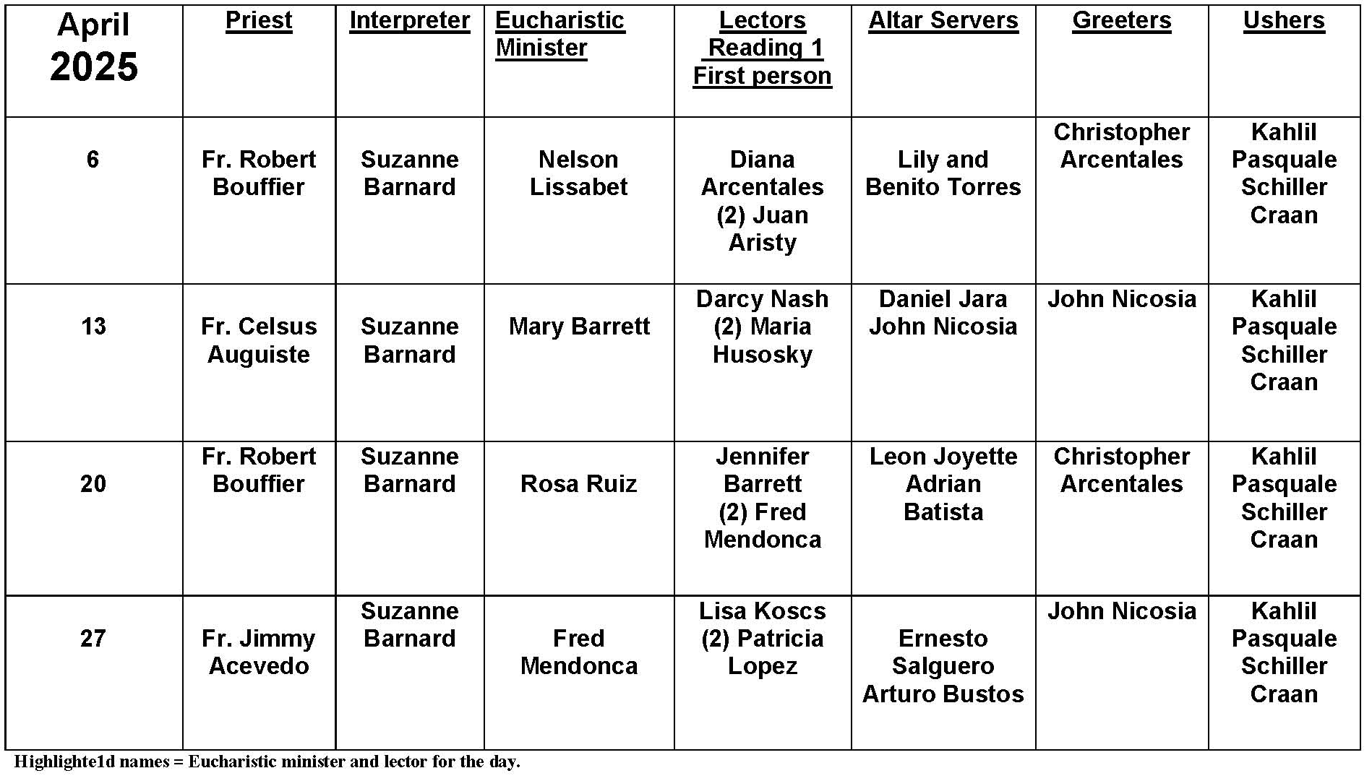
Fasting, Explained
The practice of fasting predates Christianity. The Old Testament is full of examples of righteous men and women mortifying their flesh for the purpose of making atonement or simply to grow closer to God.
Jesus himself fasted for forty days and forty nights in preparation for the beginning of his public ministry, and we see his disciples following his example in the Acts of the Apostles.
Fasting continues to be an important part of Christian devotional life today. Many people feel the practice of fasting enhances their prayer and helps them fulfill St. Paul’s advice to “put to death the deeds of the body” (Romans 8:13) to grow in the Spirit.
Most Catholics will associate fasting with the liturgical season of Lent, which begins and ends with obligatory fasting for all members of the Latin Catholic Church between ages 18 and 59.

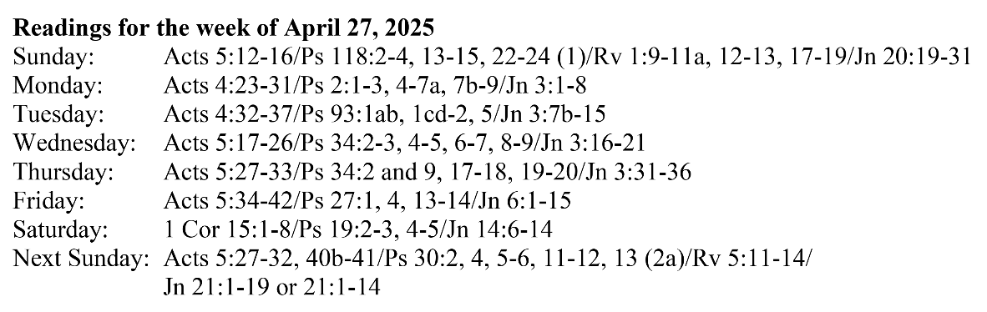
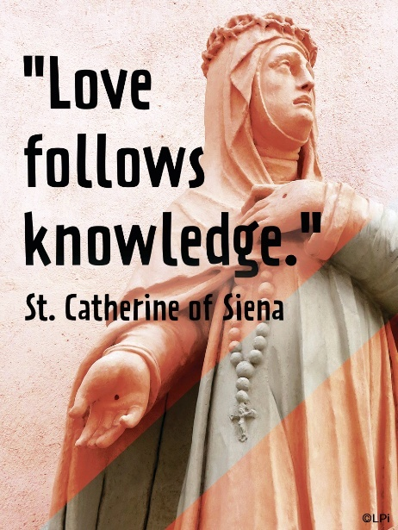
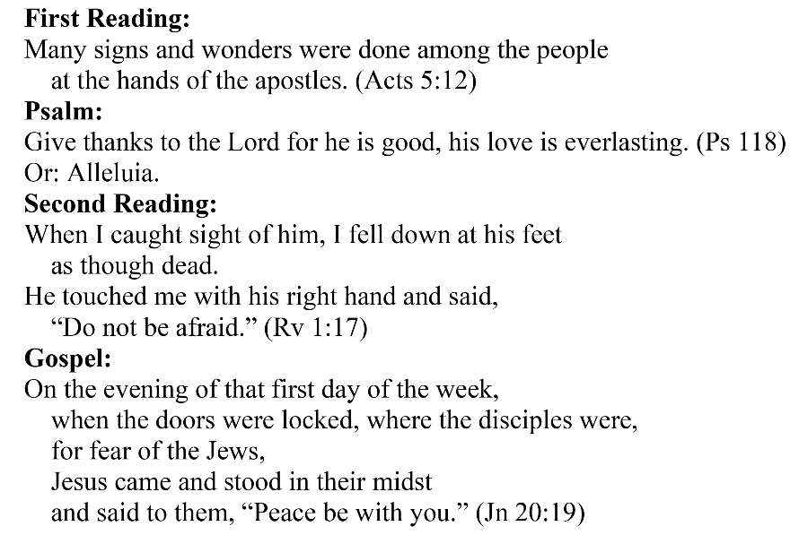
Are you in need of prayer? Do you have a prayer request? You can send your prayer requests to pcuadra@schottcommunities.org or call 954-434-3306 ext. 108

A copy of our prayer list can be found in the lobby of our chapel. To request a copy of our prayer list please email us at pcuadra@schottcommunities.org
To request a Mass please contact Pablo A. Cuadra at 954-434-3306 or e-mail at pcuadra@schottcommunities.org
Update: Celebrating a wedding anniversary soon? Let us know a week in advance and we can assist you with the renewal of your wedding vows.

Prayer to St. Michael the Archangel:
"St. Michael the Archangel, defend us in battle. Be our defense against the wickedness and snares of the Devil. May God rebuke him, we humbly pray, and do thou, O Prince of the heavenly hosts, by the power of God, thrust into hell Satan, and all the evil spirits, who prowl about the world seeking the ruin of souls. Amen"

