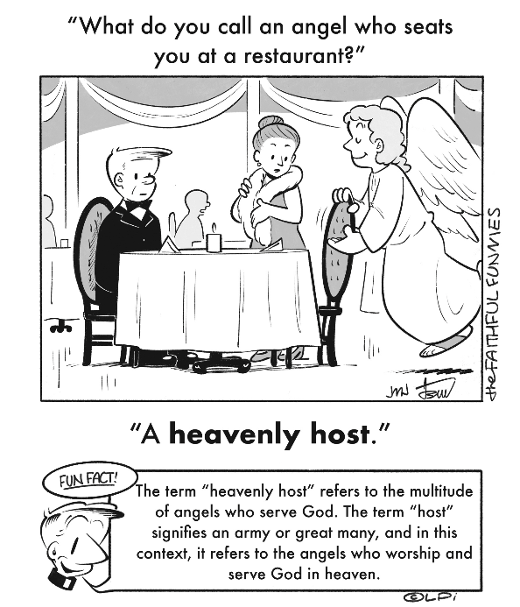
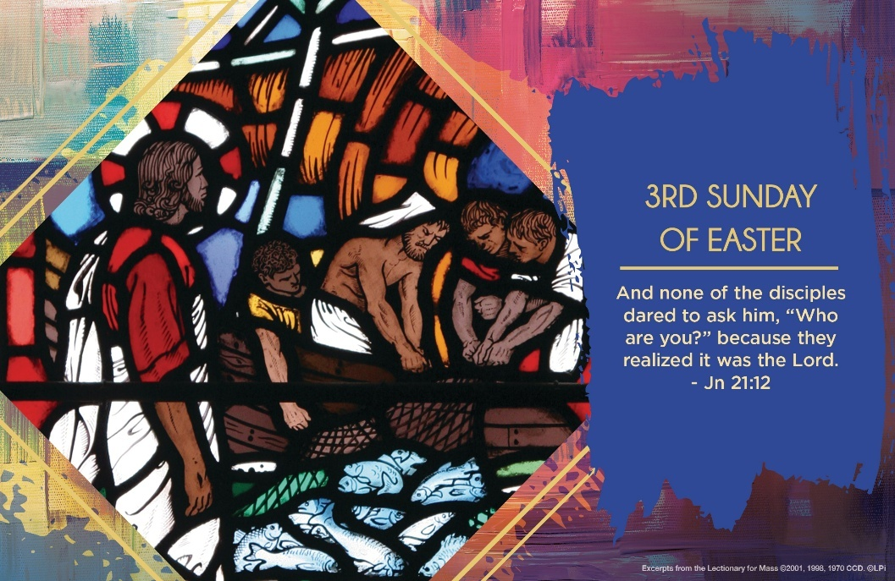
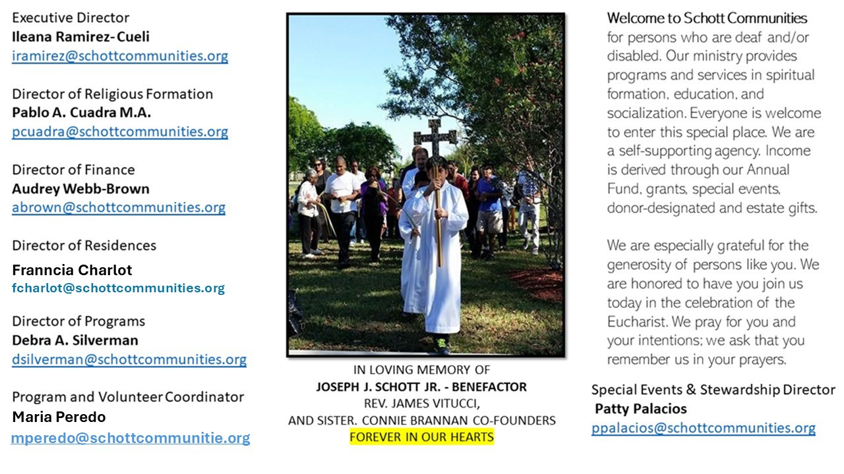

4 de mayo de 2025
III Domingo de Pascua

Te apareciste de nuevo a tus discípulos a orilla del lago de Tiberíades. Ahí les preparaste de comer un pescado que Tú mismo habías cocinado en las brasas. Con este hecho, les mostraste que también al evangelizar se disfruta comiendo todos juntos en comunidad. Señor, enséname a compartir la alegría de tu Buena Nueva a mi familia y amigos. Que no pase desapercibido el amor que nos muestras con tus detalles de ternura en hechos sencillos, como el de una invitación a almorzar. “Jesús, se acercó, tomó el pan y se lo repartió. Lo mismo hizo con los pescados” (Juan 21:13).
“En la Eucaristía se comunica el amor del Señor por nosotros: un amor tan grande que nos nutre de sí mismo, un amor gratuito siempre a disposición de toda persona hambrienta y necesitada de regenerar las propias fuerzas. Vivir la experiencia de la fe significa dejarse alimentar por el Señor y construir la propia existencia no sobre bienes materiales, sino sobre la realidad que no perece: los dones de Dios, su Palabra y su Cuerpo. El alimento que nos nutre verdaderamente y que nos sacia es solo el que nos da el Señor” (Papa Francisco).
¿Qué enseñanza podemos llevar a cabo de este hecho concreto de Jesús al preparar el desayuno a sus discípulos? ¿De qué forma expreso detalles de amor a mi familia y amigos? La presencia de Jesús en nuestra vida nos debe llenar de esperanza. ¡Aleluya!

May 4, 2025
3rd Sunday of Easter
John 21:1-19

I eat breakfast. If I don’t have something substantial, I’m fading by midmorning. Breakfast is my key meal because it sets up my physical wellbeing for the rest of the day.

Spiritually speaking, we need sustenance to get us going. This is true for the Apostles in this Sunday’s remarkable Gospel reading. The risen Jesus makes his third appearance to them in the early morning light and calls, “Come, have breakfast” (John 21:12). The exhausted and cold fishermen sit, and he feeds them bread and fish as the dawn breaks. They are overwhelmed by his presence to the point of awestruck silence. As they eat, their bodies and their hearts come alive. Once refreshed by their morning meal, they will be ready to feed others — indeed, the whole world — with the love of the risen Jesus. But first, they need breakfast from him.

Do you realize how essential early morning prayer is? Jesus desires to refresh us every morning with his word of love, with his grace-filled presence. This week, hear Jesus calling to you: “Come, have breakfast!” Embrace some form of spiritual, meditative practice each morning for spiritual strength to get you going.

— Father John Muir

St. Jude Chapel, Sunday, May 4th 2025
Father Robert Bouffier
Celebrant

Hail Mary
The words of the Hail Mary — undoubtedly the most recognizable Catholic prayer after the Lord’s Prayer — are deeply rooted in scripture, but Catholics did not begin to utilize the Hail Mary prayer in its current form until around the 11th century.


Christian Giving
April 27th, 2025
$TBA

We sincerely thank you and bless you for your generosity.
A bequest is a powerful tool to help the Deaf or Disabled.

Mass Intentions
“For the repose of the Soul of Jorge Danilo Guillen Castro
Requested by Schott Communities


Follow us on Facebook
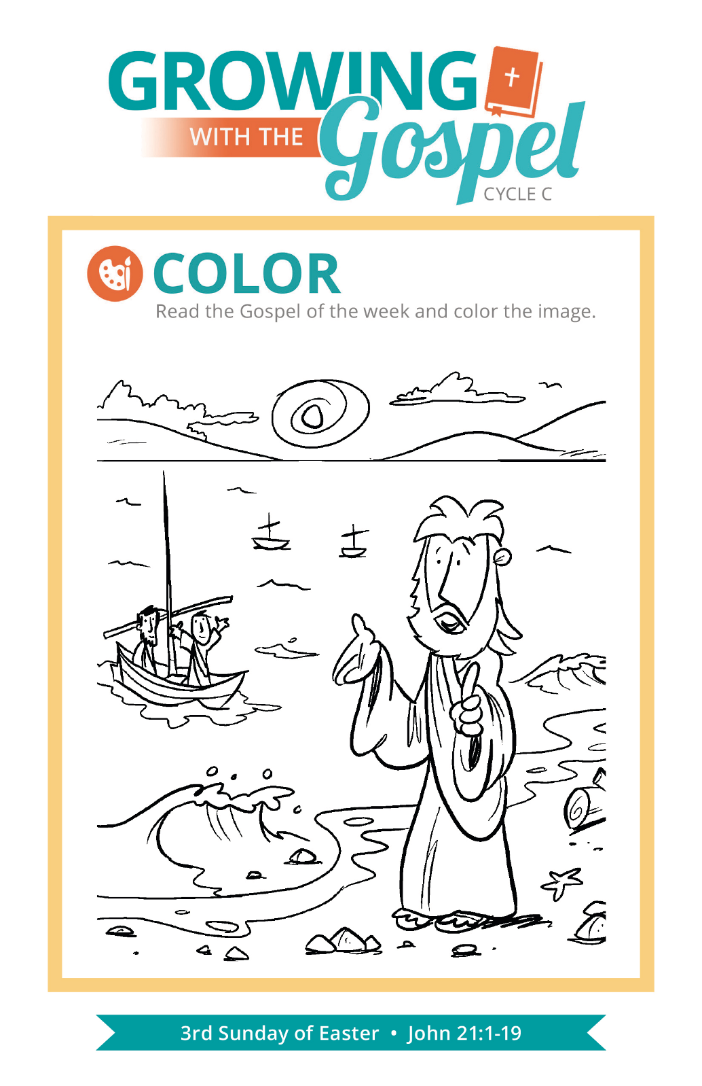
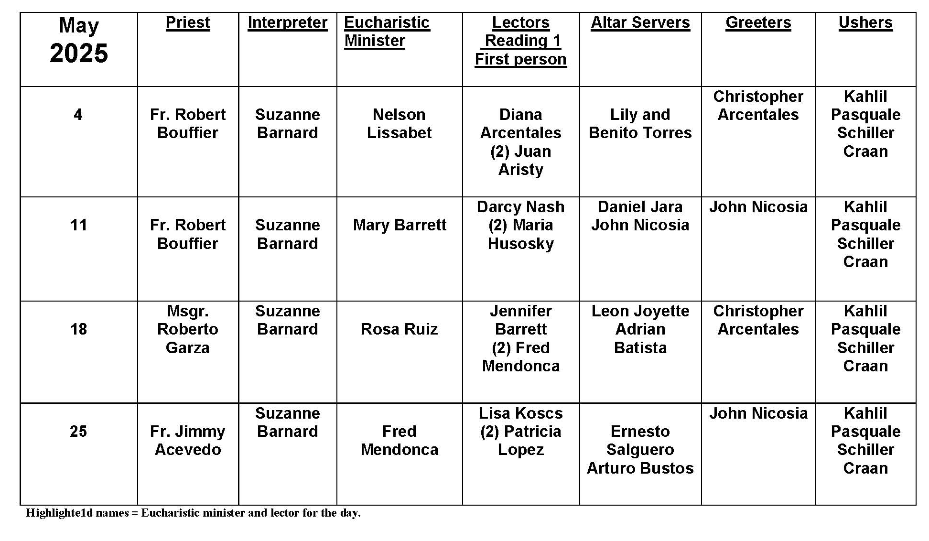
Responding to God

Question:
I can’t explain it. I feel a nudge from God to something out of the ordinary. How do I respond?

Answer:
You’re in good company! Abraham was asked to leave all he knew and loved for a strange land, with only abstract divine assurance that such a sacrifice would be worth it. Plenty of prophets protested against God’s call, whether it was claiming they were too young (Jeremiah) or running away entirely, only to end up in a whale’s belly (Jonah). St. Joseph was asked to do something very strange. He was asked to believe — on the word of an angelic appearance in a dream — that his betrothed was pregnant not from another man, but by a miraculous intervention of God. Then he was called to marry her.

Author Flannery O’Connor once wrote, “You shall know the truth, and the truth shall make you odd.” Sometimes God’s invitation might seem strange or challenging. It might require sacrifices we never expected to make. Our life might look different than we had always imagined. But as we all know, life throws its own curveballs, regardless of whether or not we’re listening for God’s will. Better, one would think, to be open to the promptings of God and to follow along the strange trails that they lead. We have the assurance that, eventually, we will find green pastures.

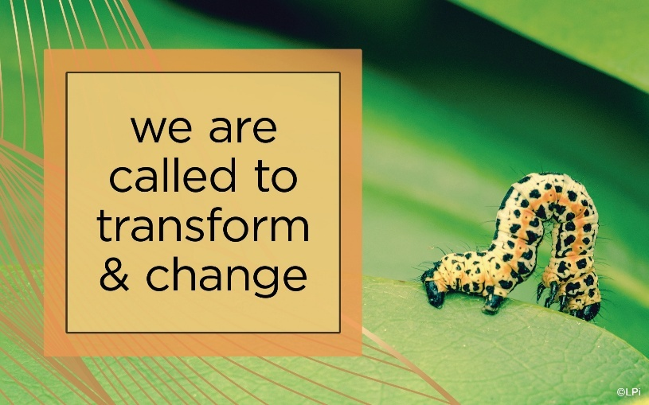
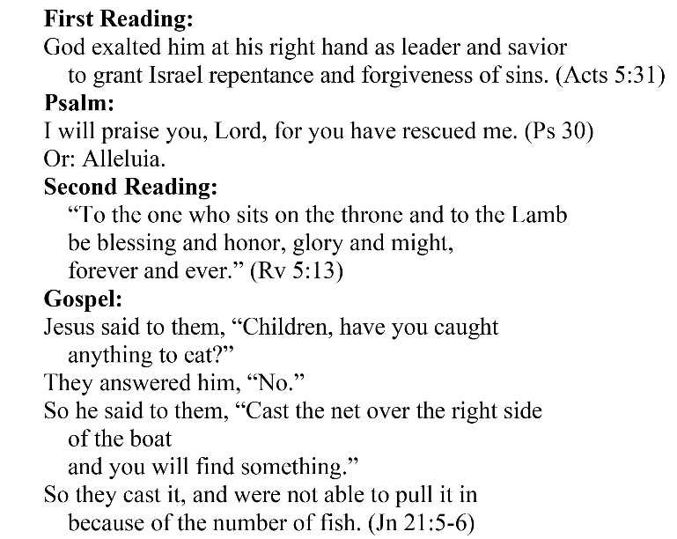
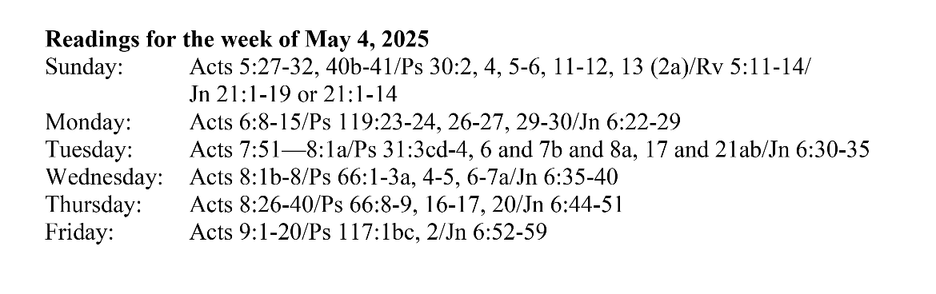
Are you in need of prayer? Do you have a prayer request? You can send your prayer requests to pcuadra@schottcommunities.org or call 954-434-3306 ext. 108

A copy of our prayer list can be found in the lobby of our chapel. To request a copy of our prayer list please email us at pcuadra@schottcommunities.org
To request a Mass please contact Pablo A. Cuadra at 954-434-3306 or e-mail at pcuadra@schottcommunities.org
Update: Celebrating a wedding anniversary soon? Let us know a week in advance and we can assist you with the renewal of your wedding vows.

Prayer to St. Michael the Archangel:
"St. Michael the Archangel, defend us in battle. Be our defense against the wickedness and snares of the Devil. May God rebuke him, we humbly pray, and do thou, O Prince of the heavenly hosts, by the power of God, thrust into hell Satan, and all the evil spirits, who prowl about the world seeking the ruin of souls. Amen"

