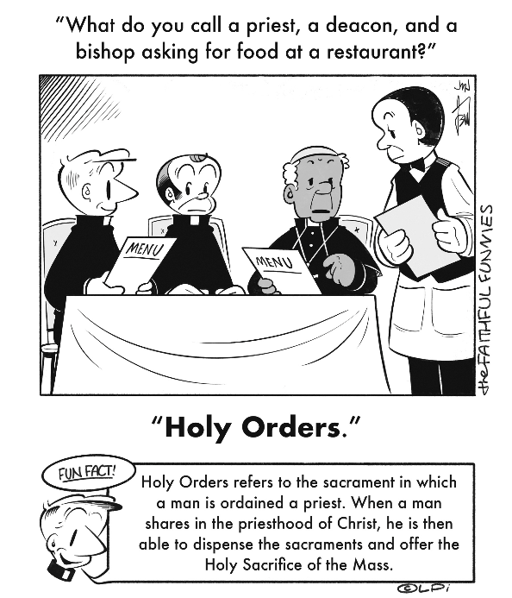
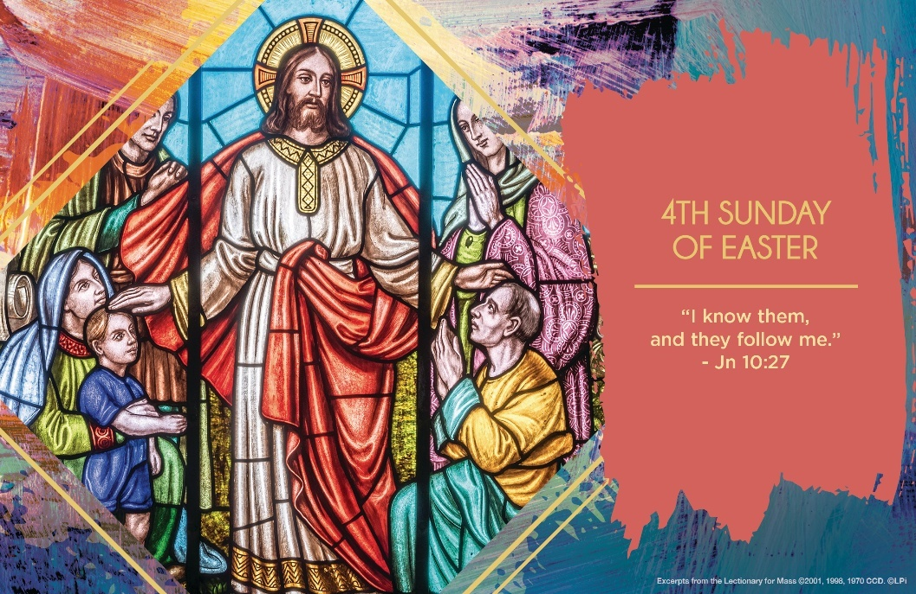
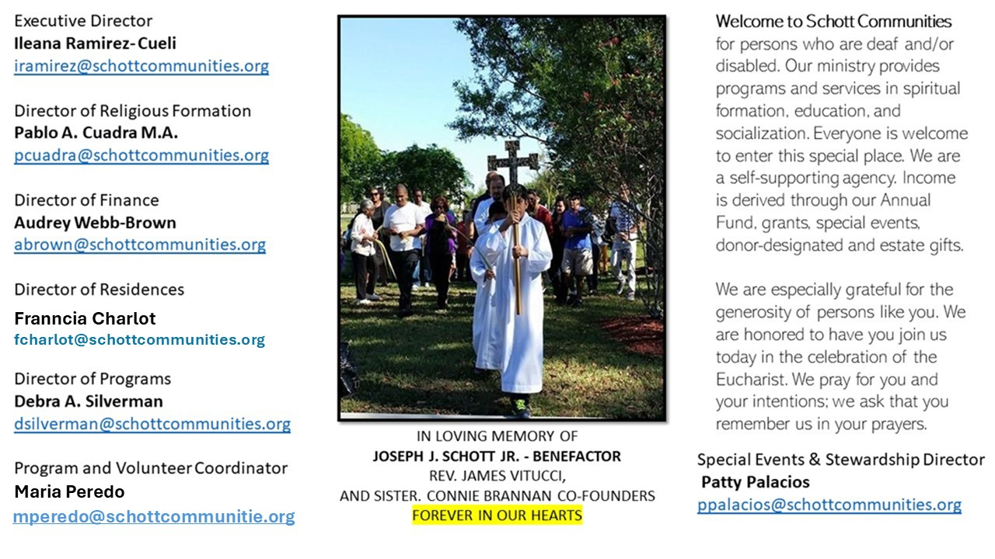

11 de mayo de 2025
IV Domingo de Pascua

Hoy Jesús nos revela que formamos parte de su rebaño. Son muchas ovejas, pero el Pastor trata con especial cariño a cada una de ellas, las conoce, cuida y protege del enemigo. Nunca olvida a ninguna de ellas, las ama y trasmite su amor. “Nuestra vida está totalmente segura en las manos de Jesús y del Padre, que son una sola cosa: un único amor, una única misericordia, reveladas de una vez y para siempre en el sacrificio de la cruz. Él es nuestro guía, nuestro maestro, nuestro amigo, nuestro modelo, pero sobre todo nuestro salvador. A veces Jesús nos llama, nos invita a seguirle, pero tal vez sucede que no nos damos cuenta de que es Él” (Papa Francisco).
¿Te das cuenta de cuándo Jesús te ha llamado? ¿Escuchas su voz o te haces el sordo? En la sociedad actual, vale la pena reflexionar sobre lo siguiente: ¿Qué voces nos dan confianza? ¿Cuáles nos hacen sentir seguros? Sobre todo, los niños y los jóvenes están muchas veces tan confundidos al escuchar voces que los llaman solo para perderlos, atacándolos con falsas promesas. Sin embargo, hay voces buenas que llaman a la unidad y a la paz, como el Papa Francisco, además de muchos padres y madres de familia, profesores y amigos buenos, que guían e instruyen para crecer en el bien y andar por el buen camino. Es un reto muy grande, pero no imposible de llevar a cabo. Dios te ama. ¡Grábatelo en el corazón!

May 11, 2025
4th Sunday of Easter
John 10:27-30

A few years back, I felt as if I couldn’t hear God’s voice the way I used to. The words in the Bible seemed like cold ink on a page. Prayer felt like sitting anxiously in a lonely room. I was worried — how could I, a priest, preach or help others if I couldn’t hear God’s voice? It went on for months.

Then a friend encouraged me to go on a retreat and spend as much time as possible in silence. After a day or two of quiet prayer, I noticed gentle but clear thoughts of repentance in two specific areas of my life. I asked God for the grace to change, and I went to confession. Suddenly, the divine silence that haunted me was filled with a sense of God’s closeness and goodness. I realized, gratefully, that God had been speaking to me in the quiet voice of my conscience.

This week we hear Jesus say, “My sheep hear my voice. I know them and they follow me” (John 10:27). Jesus links the hearing of his voice to following him. He speaks to us in our conscience in an intimate, personal way, when we most need to hear him. When you feel deaf to God’s voice, perhaps it is time to listen in silence for His voice in your conscience calling you to hear and follow the Good Shepherd of your soul.

— Father John Muir

St. Jude Chapel, Sunday, May 11th 2025
Father Robert Bouffier
Celebrant

Retreat
Spiritual retreats are an act of removing oneself from daily life for a period of prayer and reflection, with the intent of returning transformed. There are many kinds of retreats, but all share a common purpose: communion with God.


Christian Giving
May 4th, 2025
$TBA

We sincerely thank you and bless you for your generosity.
A bequest is a powerful tool to help the Deaf or Disabled.

Mass Intentions
“For the repose of the Souls in Purgatory
Requested by Schott Communities


Follow us on Facebook
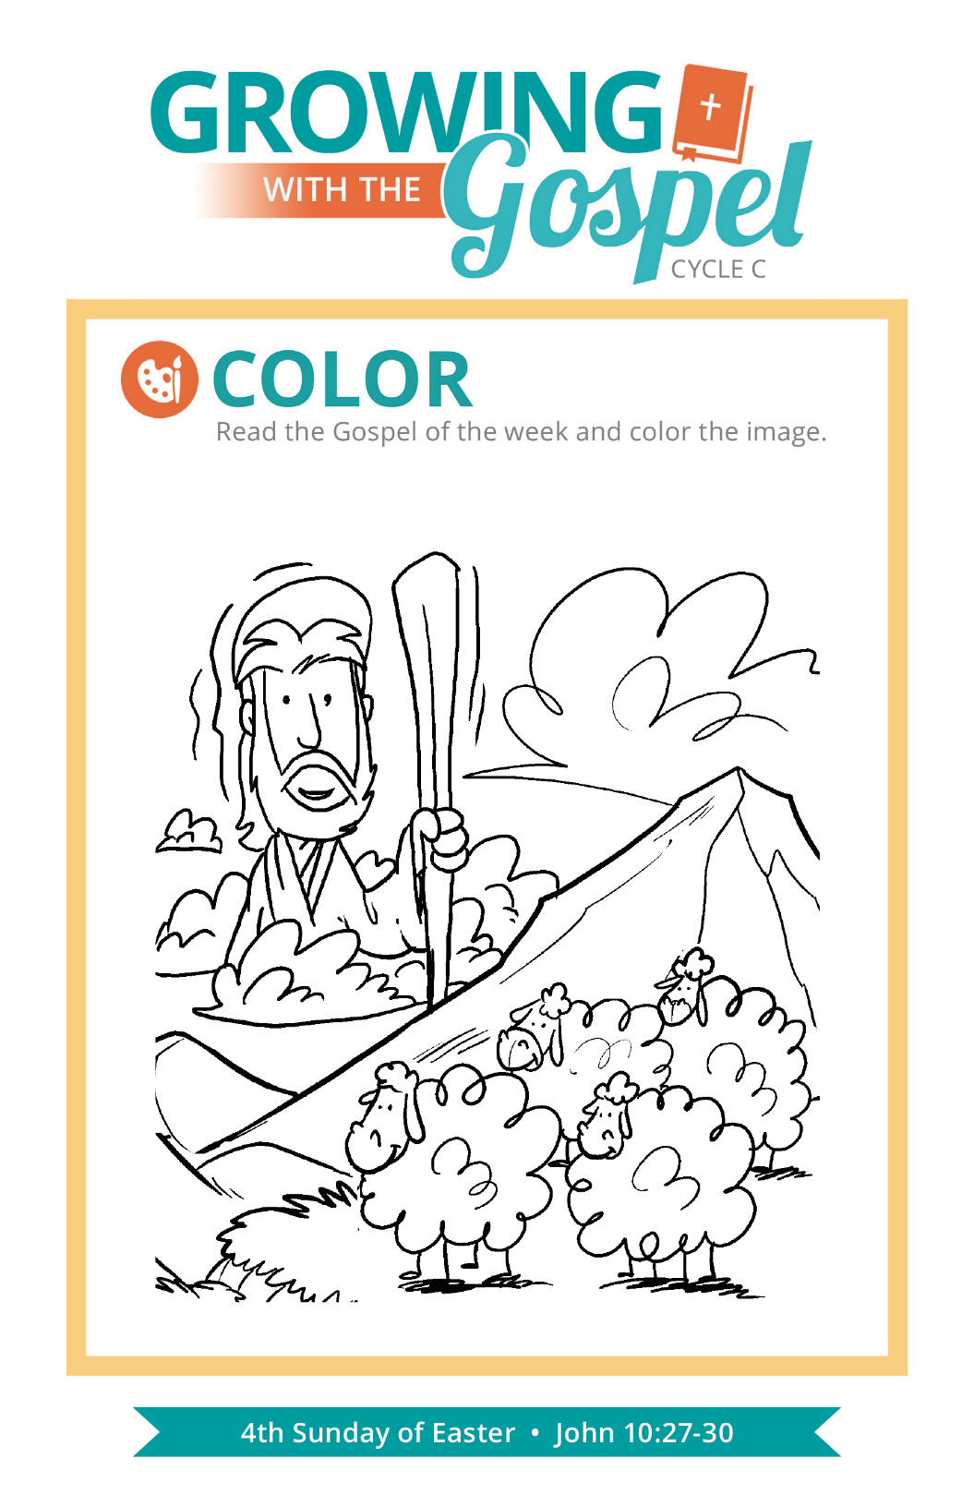
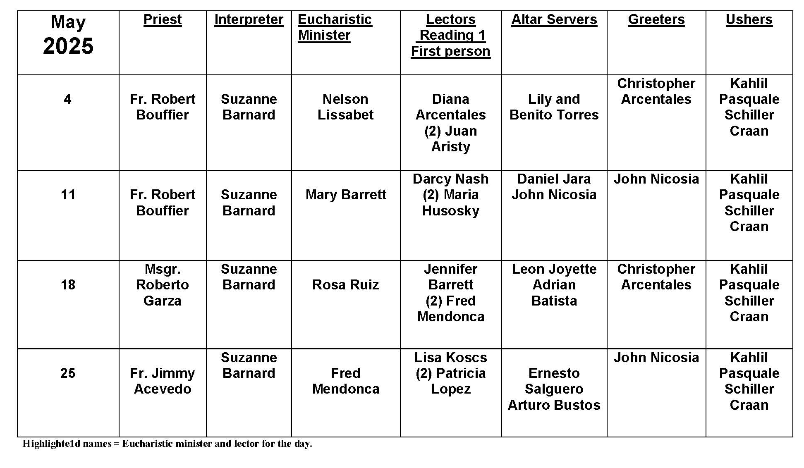
The Tradition of Genuflection

Question:
Why do Catholics genuflect?

Answer:
Genuflection is an act of devotion that literally means “to bend the knee.” For many Catholics, it’s an almost automatic gesture that we perform before entering our pew or row of seats at Mass. But, like many of the symbols and gestures of our faith tradition, genuflecting can also be an invitation for deeper reflection.

The practice of “bending the knee” is an ancient way of recognizing the presence of someone greater than we are. It has been said that the practice dates back to the time of Alexander the Great, but it became a common part of etiquette in the royal courts of the Middle Ages. From throne rooms and palaces, it was a small step to genuflecting becoming part of the devotional lives of Christians, who used this secular gesture as a way of recognizing the presence of the One who is King of Kings, especially in the Eucharist.

Today, Catholics are asked to genuflect in the presence of the Blessed Sacrament (whether in the tabernacle or exposed on the altar during eucharistic adoration). So, while it has become second nature to genuflect before entering your seat in church, we should pay attention to where the Blessed Sacrament is kept in each church or chapel that we visit, and genuflect in the direction of the tabernacle where the Blessed Sacrament is kept. In churches or chapels in which the tabernacle is in a separate space, we are invited to simply bow toward the altar.

In addition to genuflecting before the Blessed Sacrament, we are also instructed to genuflect before the cross used for veneration on Good Friday (during the solemn celebrations of the Lord’s Passion) and any time a relic of the True Cross is displayed for veneration. This long-standing tradition is a way of honoring the cross as the great sign of our salvation and of showing devotion to the passion of Jesus.

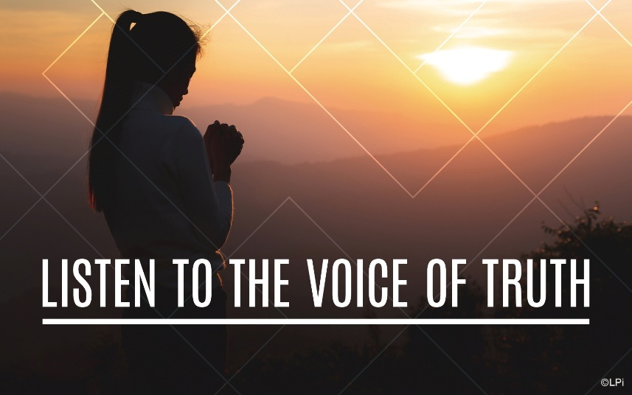
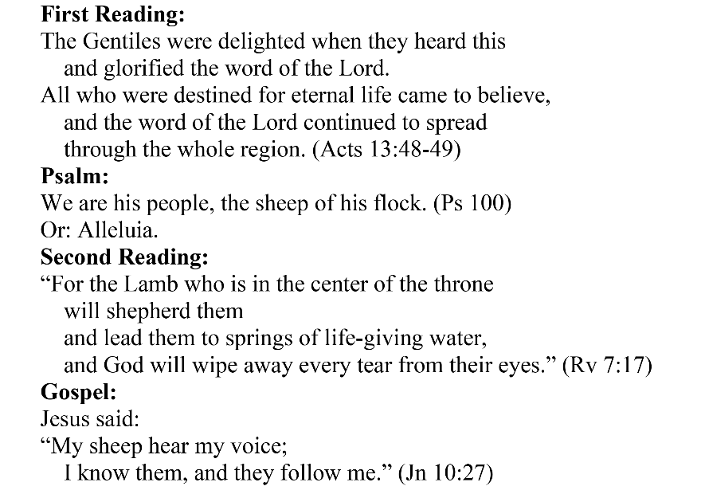
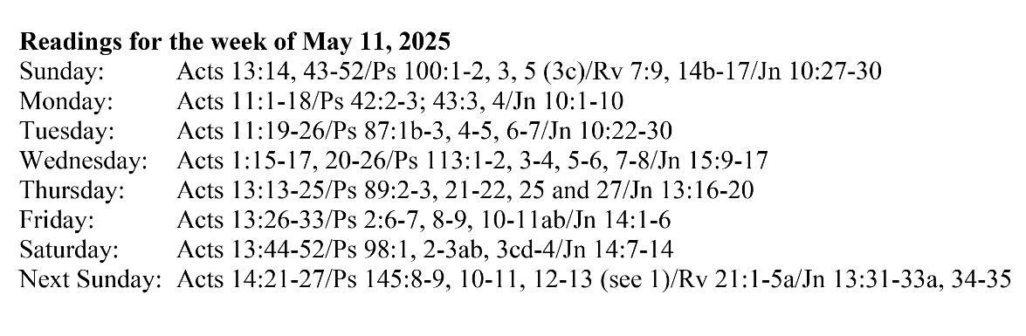
Are you in need of prayer? Do you have a prayer request? You can send your prayer requests to pcuadra@schottcommunities.org or call 954-434-3306 ext. 108

A copy of our prayer list can be found in the lobby of our chapel. To request a copy of our prayer list please email us at pcuadra@schottcommunities.org
To request a Mass please contact Pablo A. Cuadra at 954-434-3306 or e-mail at pcuadra@schottcommunities.org
Update: Celebrating a wedding anniversary soon? Let us know a week in advance and we can assist you with the renewal of your wedding vows.

Prayer to St. Michael the Archangel:
"St. Michael the Archangel, defend us in battle. Be our defense against the wickedness and snares of the Devil. May God rebuke him, we humbly pray, and do thou, O Prince of the heavenly hosts, by the power of God, thrust into hell Satan, and all the evil spirits, who prowl about the world seeking the ruin of souls. Amen"

