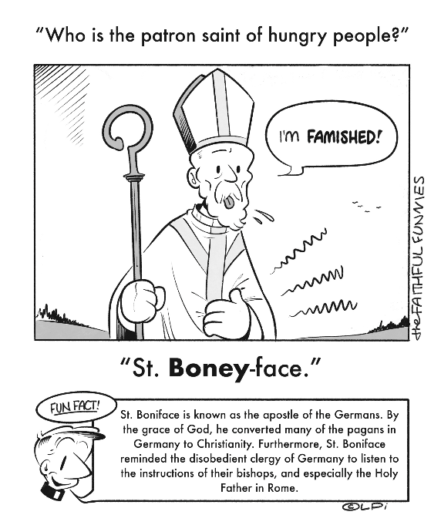
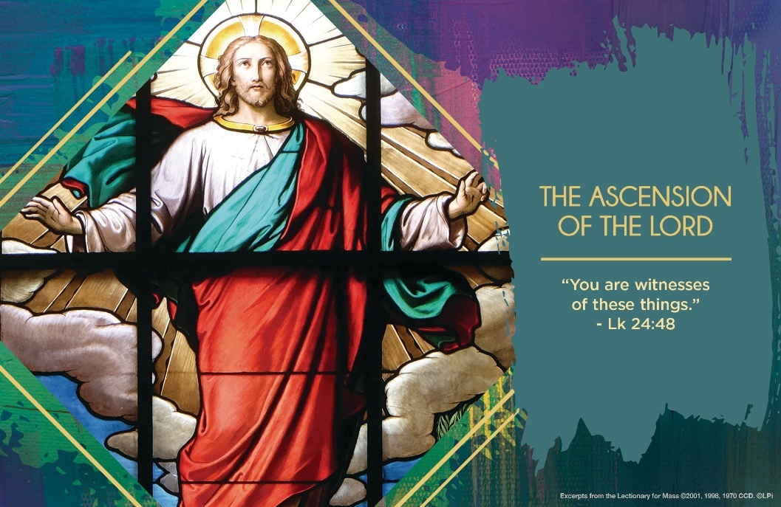
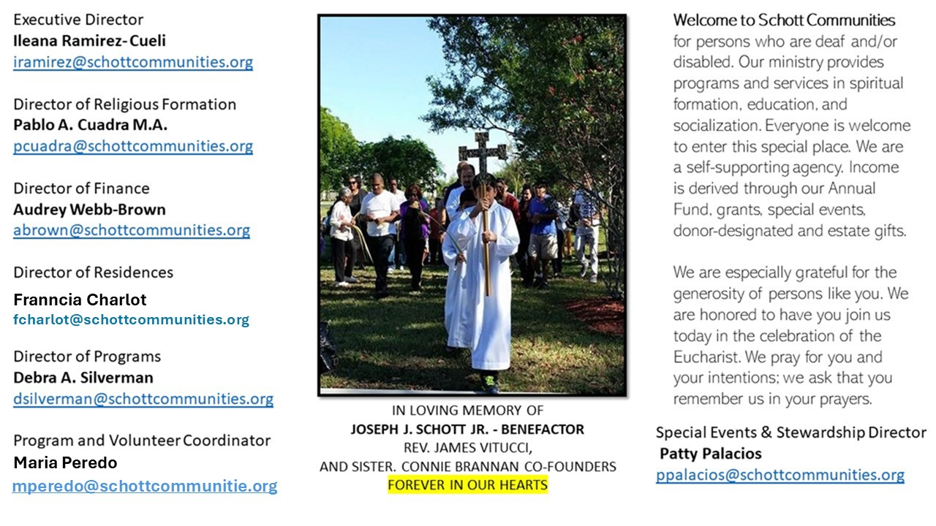

1 de junio de 2025
La Ascensión del Señor

Durante la Pascua, Jesús va preparando a sus discípulos para la ausencia definitiva, esa ausencia los prepara a ver que Jesús ya no estará con ellos físicamente. Ahora serán movidos por el Espíritu Santo para proclamar que el Reino de Dios ya estaba presente entre ellos. El Evangelio nos narra que “Jesús los llevó hasta cerca de Betania, levantando las manos, los bendijo. Y mientras los bendecía, se separó de ellos (y fue llevado al cielo). Ellos se postraron ante él. Después volvieron llenos de gozo a Jerusalén, y continuamente estaban en el Templo alabando a Dios” (Lucas 24:50-53).
Desapareció entre las nubes, subió a los cielos y está sentado a la derecha del Padre (nos dice el Credo que recitamos cada domingo en misa). Con su Ascensión al cielo, Jesús nos invita a mirar a lo alto, indicándonos que la meta no es aquí en la tierra, sino allá arriba con el Padre. San León Magno en su homilía sobre la ascensión nos dice que “De esta manera, los apóstoles y todos los discípulos, que habían quedado angustiados por la muerte en cruz de Jesús y vacilantes en su fe sobre la resurrección, fueron fortificados por la evidencia de la verdad. Por lo cual, cuando el Señor subió a lo alto de los cielos, no solo no se dejaron llevar por la tristeza, sino todo lo contrario, se sintieron llenos de alegría”. ¡Ven, Espíritu Santo, Ven!

June 1, 2025
The Ascension of the Lord
Luke 24:46-53

It was a Delta flight from Salt Lake City to Phoenix, and it looked like an on-time departure. As the large plane rolled away from the gate, the pilot announced over the intercom: “Ladies and Gentlemen, the crew outside didn’t fill up the tanks with fuel. We are going back to the gate to wait for them.” The passengers groaned with impatience. But over the next hour, we knew the waiting had a purpose: it meant fuel to get us to our destination.

The disciples at the Lord’s Ascension are in a similar predicament but on a massively higher plane. They want the Kingdom of God to begin on earth as it is in heaven. But Jesus says, “I am sending the promise of my Father upon you; but stay in the city until you are clothed with power from on high” (Luke 24:49). They stay together in prayer in Jerusalem and wait nine long days until the Holy Spirit descends. Empowered by supernatural gifts, they go forth to the ends of the earth and to their deaths proclaiming the Good News of Jesus. The wait was worth it.

Before you begin a task or endeavor, do you take time to patiently pray for the Holy Spirit to come? The bigger the task, the more ardent the prayer should be. Try it this week, and you’ll be clothed with power to get where God wants you to go.

— Father John Muir

St. Jude Chapel, Sunday, June 1st, 2025
Father Robert Bouffier
Celebrant

Prayer After Meals
Though it is a less common practice in the modern world, early Church fathers like Tertullian and St. Jerome extolled the importance of praying after a meal, an action meant to inspire an attitude of thanksgiving and an acknowledgment of our dependence on God.


Christian Giving
May 25th, 2025
$391

We sincerely thank you and bless you for your generosity.
A bequest is a powerful tool to help the Deaf or Disabled.

Mass Intentions
“For the repose of the Souls in Purgatory
Requested by Schott Communities


Follow us on Facebook

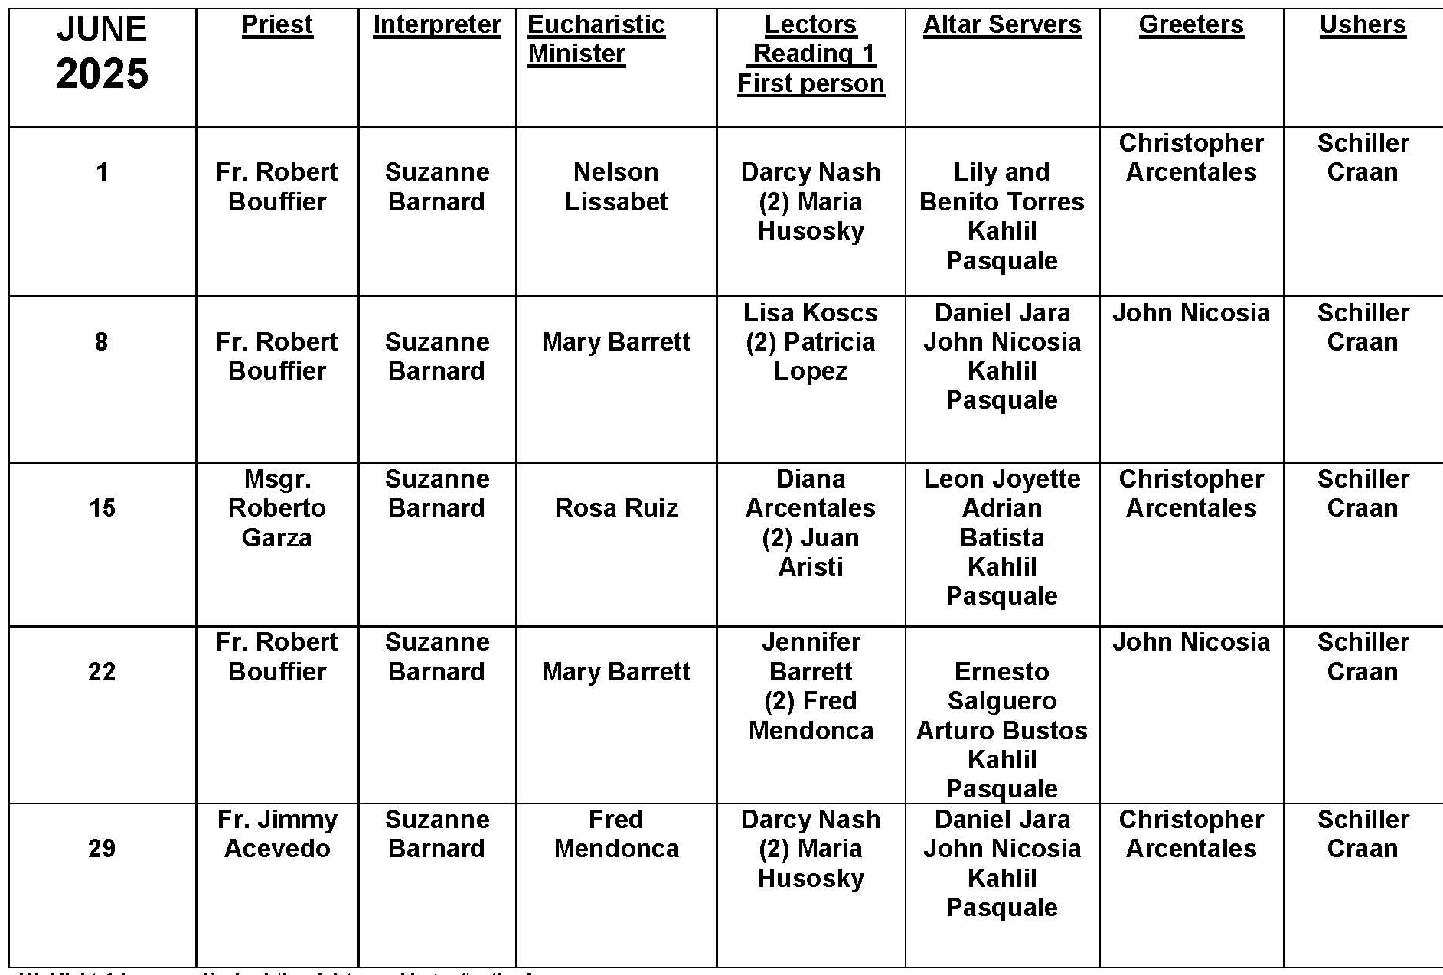
Ascension of the Lord

Question:
Couldn’t Jesus have done more good if he stayed on earth, rather than ascended into heaven?

Answer:
This is an interesting question! During his earthly life, Jesus gave sight to the blind, healed paralytics, drove out demons, and fed thousands with only a few loaves of bread. Imagine what he could have done if he’d never ascended into heaven! Imagine what our world could be! It’s an interesting thought to consider, especially as the world faces challenges that only seem to deepen and expand. Yet at the Last Supper, Jesus says, “It is better for you if I go.” Why? His response must have seemed strange to the Apostles at the time. In his place, Jesus says, he will send the Paraclete, the Comforter, the Advocate. He promises to send the Holy Spirit.

Jesus’ departure allows the Apostles to become the leaders he has formed them to be. Jesus is no longer situated in only one geographical location, and his Church will never be a political kingdom. Soon after the Ascension, we celebrate Pentecost — the descent of the Holy Spirit and the radical empowerment of the followers of Jesus. We share in that empowerment and in that mission. Jesus is present in the sacraments, and he is present in us. Through our faith, hope, and love, we are called to be the good he does here on earth!

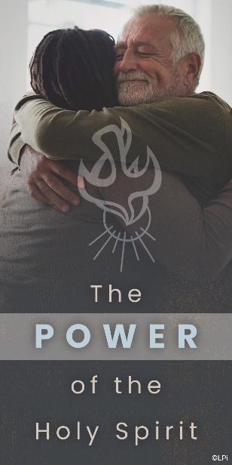
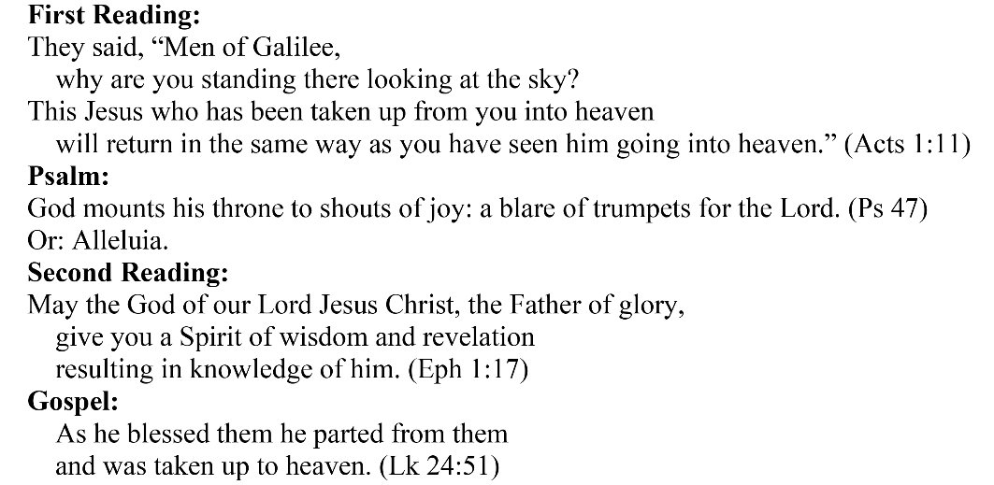
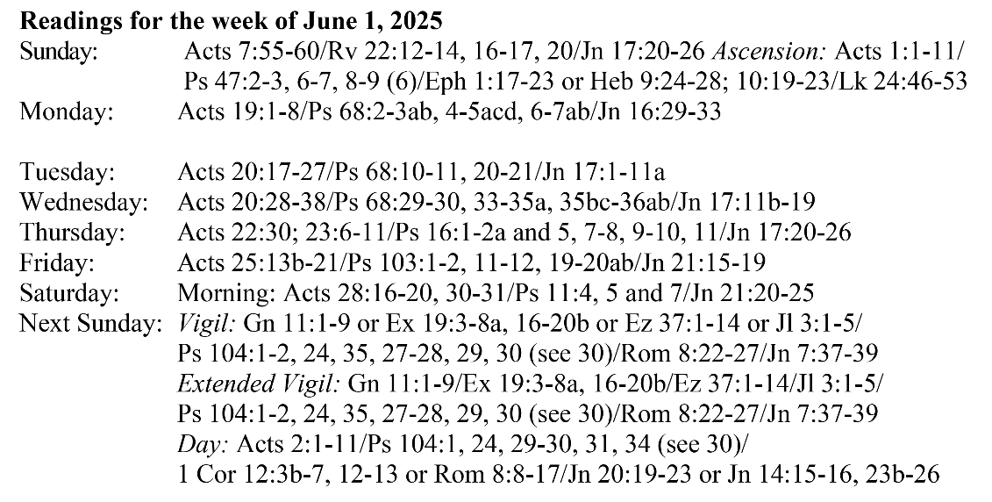
Are you in need of prayer? Do you have a prayer request? You can send your prayer requests to pcuadra@schottcommunities.org or call 954-434-3306 ext. 108

A copy of our prayer list can be found in the lobby of our chapel. To request a copy of our prayer list please email us at pcuadra@schottcommunities.org
To request a Mass please contact Pablo A. Cuadra at 954-434-3306 or e-mail at pcuadra@schottcommunities.org
Update: Celebrating a wedding anniversary soon? Let us know a week in advance and we can assist you with the renewal of your wedding vows.

Prayer to St. Michael the Archangel:
"St. Michael the Archangel, defend us in battle. Be our defense against the wickedness and snares of the Devil. May God rebuke him, we humbly pray, and do thou, O Prince of the heavenly hosts, by the power of God, thrust into hell Satan, and all the evil spirits, who prowl about the world seeking the ruin of souls. Amen"

