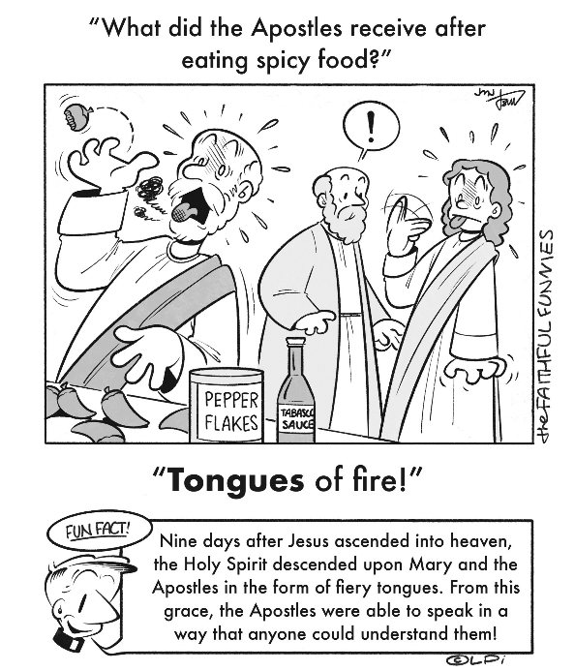
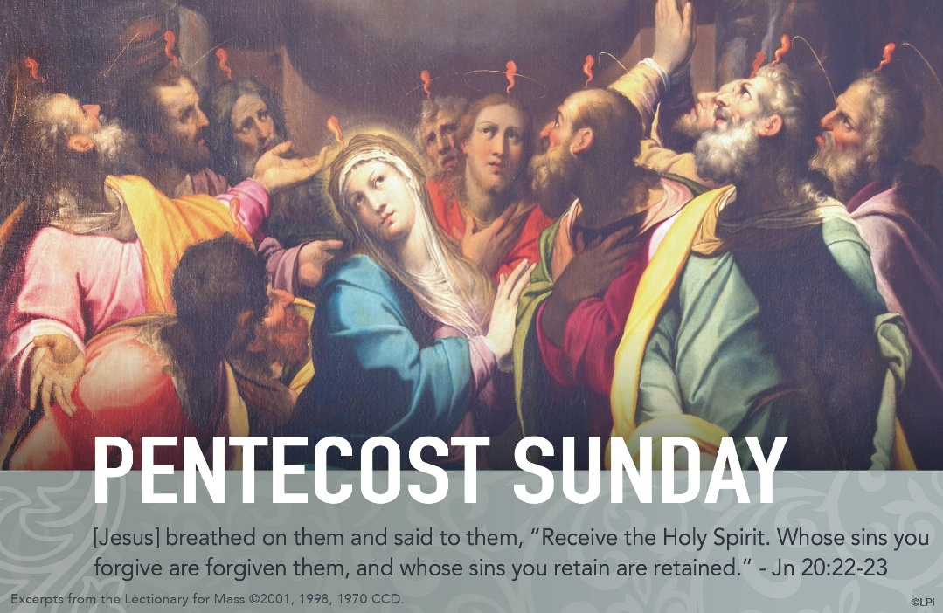
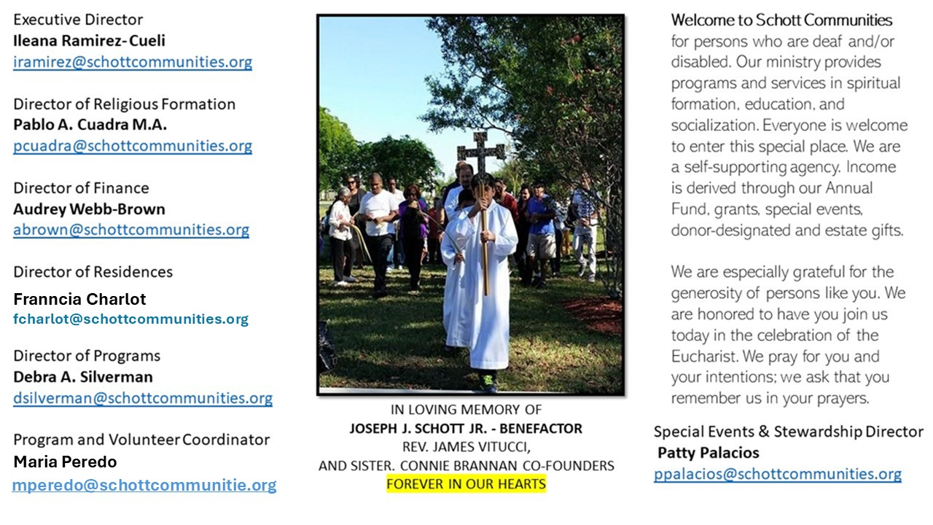

8 de junio de 2025
Domingo de Pentecostés

Este día de Pentecostés tenemos la oportunidad de pedir al Espíritu Santo que abra las puertas de nuestro corazón, nos regale la paz, y que seamos portadores de ella a dondequiera que nos presentemos. Hoy en día, el mundo, más que nunca, necesita la paz. Hay guerra y destrucción en varios países, dando como resultado vivir deseando la paz. La gente sufre atrapada en la incertidumbre y el miedo. Ojalá que hoy escuchemos este mensaje y se hagan realidad para muchas personas estas palabras: “Jesús les volvió a decir: ¡La paz esté con ustedes!” (Juan 20:21). El Espíritu Santo se manifiesta para el bien común, es decir, no es para unos cuantos, es para todos.
En una de sus catequesis sobre el Espíritu Santo, San Cirilo de Alejandría explicaba lo siguiente: “De igual modo el Espíritu Santo, siendo uno solo y siempre el mismo e indivisible, distribuye a cada uno sus gracias según su beneplácito. Al igual que un árbol seco, al recibir agua germina, de una manera semejante el alma pecadora al recibir al Espíritu Santo, el don del arrepentimiento produce frutos de justicia. Siendo siempre igual y el mismo, produce diversos efectos según su beneplácito de Dios y en el nombre de Cristo. De hecho, se sirve de la lengua de alguno para comunicar sabiduría. A otro le ilumina la mente con el don de profecía. A otro le da el poder de arrojar demonios. A aquel le da el don de interpretar las Escrituras”. ¡Ven Espíritu Santo, y llena nuestros corazones de amor!

June 8, 2025
Pentecost Sunday
John 20:19-23

When I was a seminarian almost 20 years ago, a bank vice president taught us etiquette classes. She said, “Gentlemen, please make sure your breath isn’t bad. Take some breath mints before you hear confessions, okay?” We nervously laughed because the proximity that makes breath noticeable (whether pleasant or not) can be a bit awkward.

When Jesus breathes on his Apostles (John 20:22), he must have been within inches of at least some of them. This closeness of his breath has a purpose: the purpose of forgiveness of sins. “Whose sins you forgive are forgiven them” (John 20:23). Why in the world would the almost uncomfortable closeness of his breath forgive sins?

In the Bible, breath is spirit or wind. It comes from above and makes that which is below to have identity. To not have a single identity is to be multiple, divided. The word “sin” comes from an ancient word that means “to split” or “render asunder.” Sin divides us sinners and the world around us; our spiritual “breath” leaves us and our identity splinters. Only breath from above restores. For example, a shattered vase is rendered whole because the craftsman breathes the spirit of the vase back into it when he repairs it. A human being shattered by sin is made whole by the breath of God, breathed by Jesus through his priests. His breath alone forgives sins. It's always done with his gentle, loving closeness.

— Father John Muir

St. Jude Chapel, Sunday, June 8th, 2025
Father Robert Bouffier
Celebrant

Prayer for Pentecost
Holy Spirit of God —
Disturb this room with your presence today, filling us, empowering us, emboldening us.
Descend upon us with your gifts, your inspiration, and your promptings.
Lead us to where we should go, stirring within us the movement of God.


Christian Giving
June 1st, 2025
$1,674

We sincerely thank you and bless you for your generosity.
A bequest is a powerful tool to help the Deaf or Disabled.

Mass Intentions
“For the repose of the Souls in Purgatory
Requested by Schott Communities


Follow us on Facebook
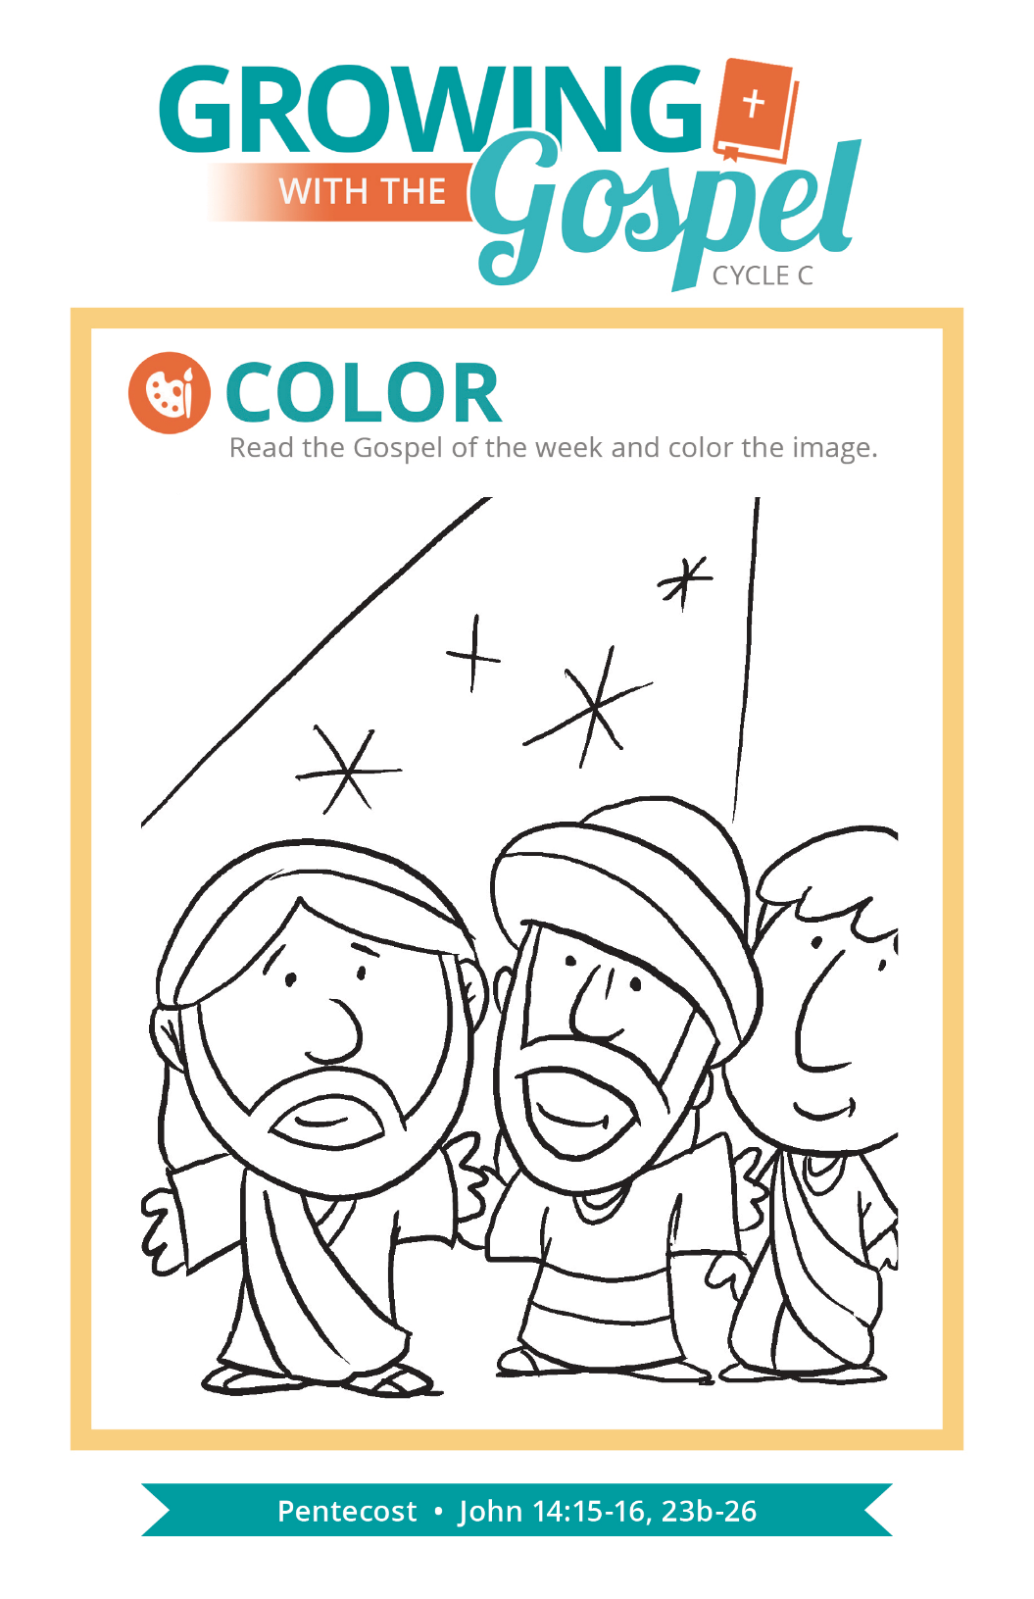
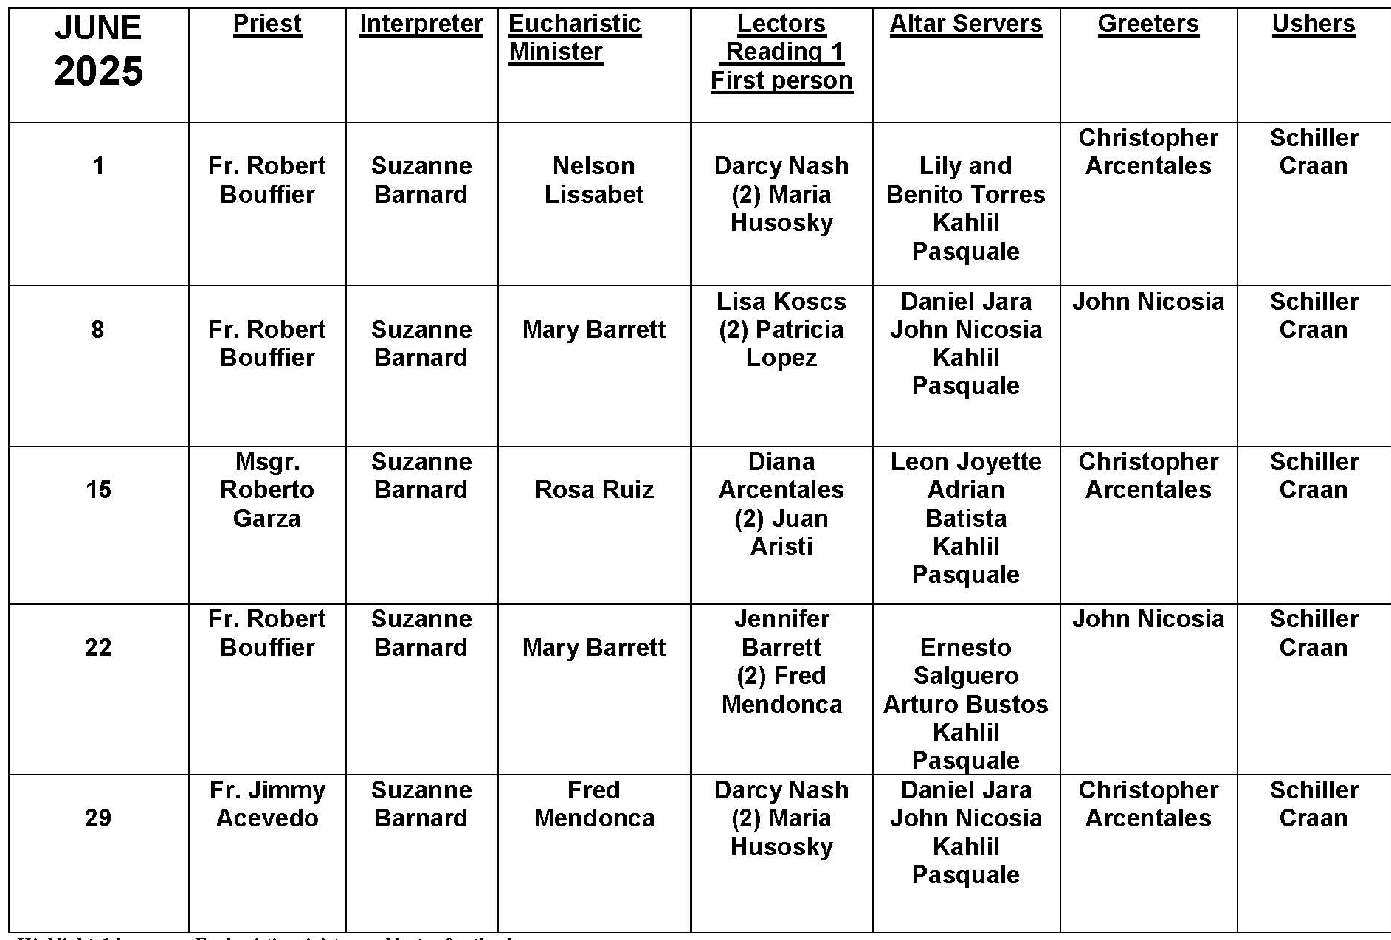
Why Use Incense?
Question:
Why do we use incense at Mass?
Answer:
The use of incense in religious ceremonies and worship is a practice that predates Christianity, and which is also found in many other religious traditions today.
Incense, which is made from resin infused with aromatic spices and oils, is one of those fundamentally human symbols that incorporates more than one of our senses, helping us to reflect on realities that transcend the everyday details of our lives.
The use of incense in the Church’s liturgy — in the Mass, as well as in devotions to the Eucharist and the Liturgy of the Hours — is inspired by the use of incense in the Jewish tradition. In the writings of the Old Testament, we hear about incense being used in the worship of the temple, and Psalm 141 asks, “Let my prayer be incense before you; my uplifted hands an evening offering” (vs. 2). The image here is that, as the incense gently rises to heaven, our prayers also rise to God as something sweet and pleasant.
Another ancient use of incense that has also become part of our Catholic tradition is the idea that when we incense something, it’s because it is something special or sacred. This is why the Book of the Gospel is incensed during the Liturgy of the Word and the bread, wine, priest celebrant, and congregation are incensed at the presentation of the gifts. To this, we can also add the incensing of the Blessed Sacrament during eucharistic adoration and benediction, and the body of the deceased at the end of the Mass of the Resurrection (the Funeral Mass).


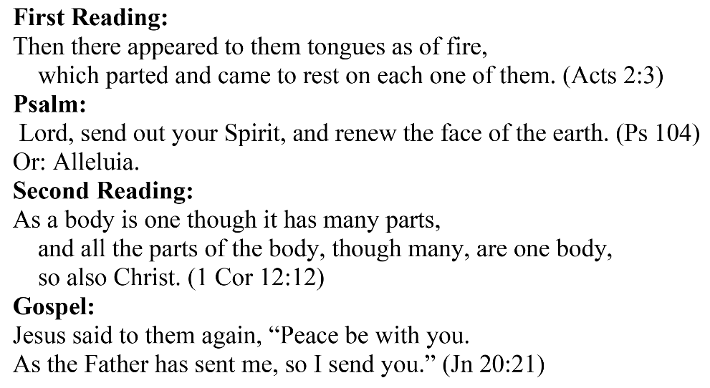
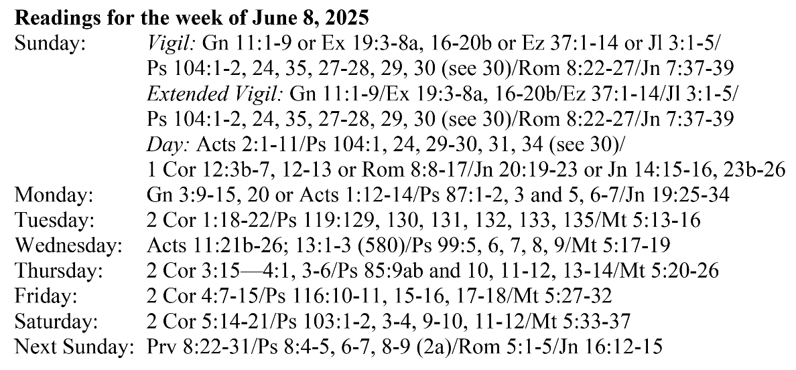
Are you in need of prayer? Do you have a prayer request? You can send your prayer requests to pcuadra@schottcommunities.org or call 954-434-3306 ext. 108

A copy of our prayer list can be found in the lobby of our chapel. To request a copy of our prayer list please email us at pcuadra@schottcommunities.org
To request a Mass please contact Pablo A. Cuadra at 954-434-3306 or e-mail at pcuadra@schottcommunities.org
Update: Celebrating a wedding anniversary soon? Let us know a week in advance and we can assist you with the renewal of your wedding vows.

Prayer to St. Michael the Archangel:
"St. Michael the Archangel, defend us in battle. Be our defense against the wickedness and snares of the Devil. May God rebuke him, we humbly pray, and do thou, O Prince of the heavenly hosts, by the power of God, thrust into hell Satan, and all the evil spirits, who prowl about the world seeking the ruin of souls. Amen"

