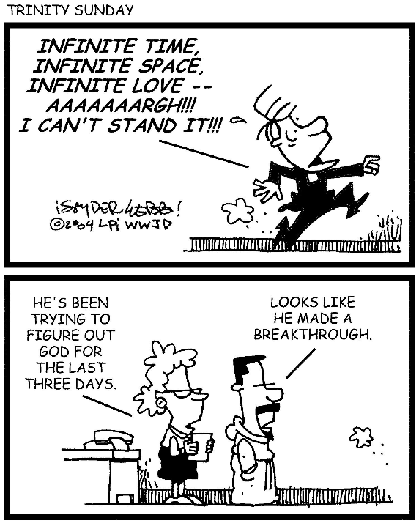
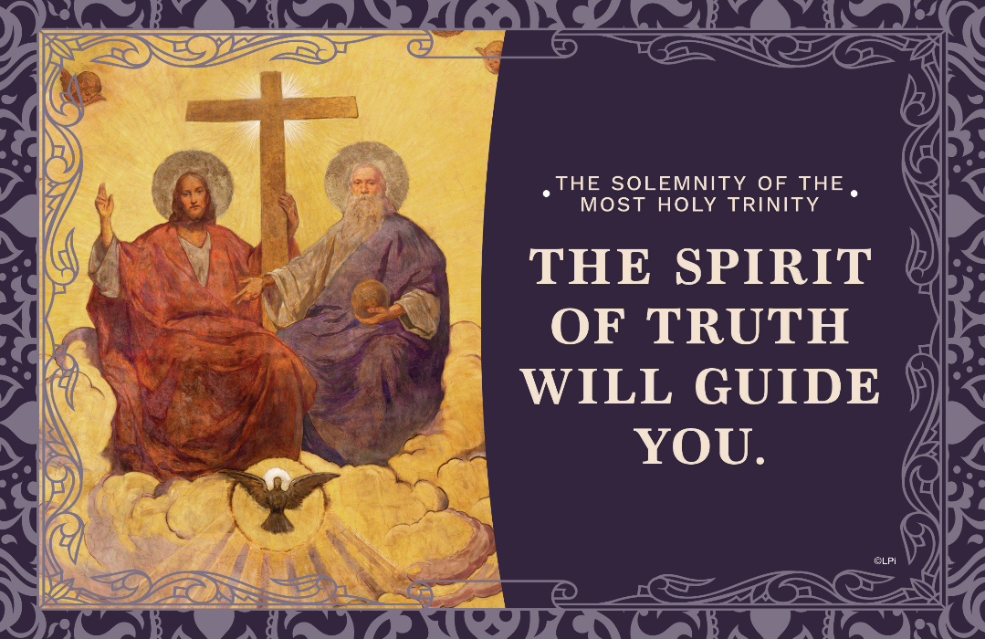
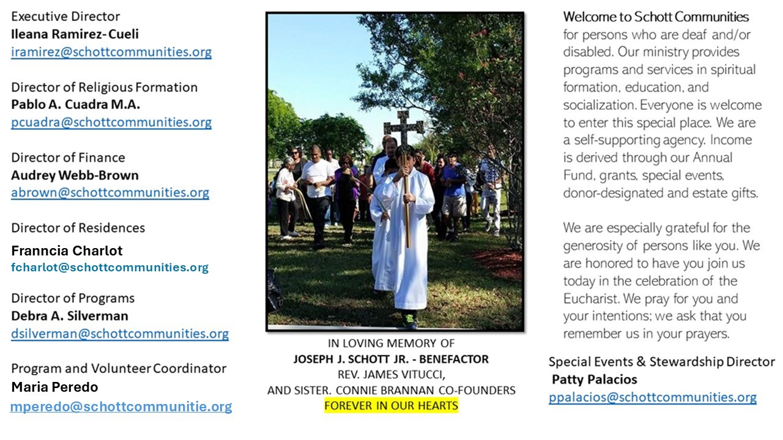

15 de junio de 2025
La Santísima Trinidad

Un solo Dios Trino, pero no solitario, sino comunitario. El misterio de la Santísima Trinidad es eterno, y si bien no lo comprendo del todo en mi corazón, por mi fe siento que es único y verdadero; me da vida como Padre, me ayuda y acompaña en mi jornada como Hijo, y habita en mí como Espíritu Santo, desde mi bautismo. El Catecismo de la Iglesia Católica, en el numeral 261, nos dice que “El misterio de la Santísima Trinidad es el misterio central de la fe y de la vida cristiana. Sólo Dios puede dárnoslo a conocer revelándose como Padre, Hijo y Espíritu Santo”. ¿Cómo te relacionas con Dios Trino? ¿Cuál de las Tres Divinas Personas invocas en tu oración?
“La fe católica es esta: que veneremos un Dios en la Trinidad y la Trinidad en la unidad, no confundiendo las personas, ni separando las substancias, una es la Persona del Padre, otra la del Hijo, otra la del Espíritu Santo; pero del Padre y del Hijo y del Espíritu Santo una es la divinidad, igual la gloria, coeterna la majestad” (Catecismo de la Iglesia Católica numeral 266). El amor de Dios es infinito y misericordioso, y su deseo es que el pueblo santo participe y goce de su misma vida divina. Por eso, es importante que, como discípulos, anunciemos la Buena Nueva del Evangelio, que es la salvación. Gloria al Padre, al Hijo, y al Espíritu Santo, sea siempre nuestra oración al despertarnos y al concluir el día.

June 8, 2025
The Most Holy Trinity
John 16:12-15

I am amazed at how my four siblings teach their many kids in age-appropriate ways. For example, now that my nephew Brandon is 24 years of age, they give him insights and freedoms that would have been positively confounding or even dangerous when he was a toddler. Imagine if they had taught him at age four how to drive a car, use a credit card online, or handle power tools. But eventually, they did, and he is a high functioning young man, I’m proud to say. They are good teachers.

This week we learn that Jesus teaches us in a similar way. He says to his Apostles, “I have much more to tell you, but you cannot bear it now” (John 16:12). How disappointing for them. But imagine at that moment, before his resurrection and ascension, if the Lord had started telling them about synods and sacraments, popes and parishes, martyrs and monasteries, rosaries and relics, catechisms and crucifixes? They would have been absolutely overwhelmed, confused, and discouraged. He tells them what they need to know, when it is time for them to know it.

So he does for us. Jesus has unceasingly taught the Church as she matures through the centuries, just as he teaches you and me through our lives in ways we can understand. Our task should be to learn what he is teaching us now, knowing that (although revelation per se is complete in him and his Apostles), he never ceases to teach us as we spiritually mature. Be confident: he knows what you are ready to learn now.

— Father John Muir

St. Jude Chapel, Sunday, June 15th, 2025
Monsignor Roberto Garza
Celebrant

Memorare
Popularized in the 17th century by a French priest named Fr. Claude Bernard, the Memorare is a prayer to the Blessed Mother in which the supplicant calls upon the maternal love and protection of Mary’s intercession in an hour of dire need.


Christian Giving
June 8th, 2025
$

We sincerely thank you and bless you for your generosity.
A bequest is a powerful tool to help the Deaf or Disabled.

Mass Intentions
“For the repose of the Souls in Purgatory
Requested by Schott Communities


Follow us on Facebook
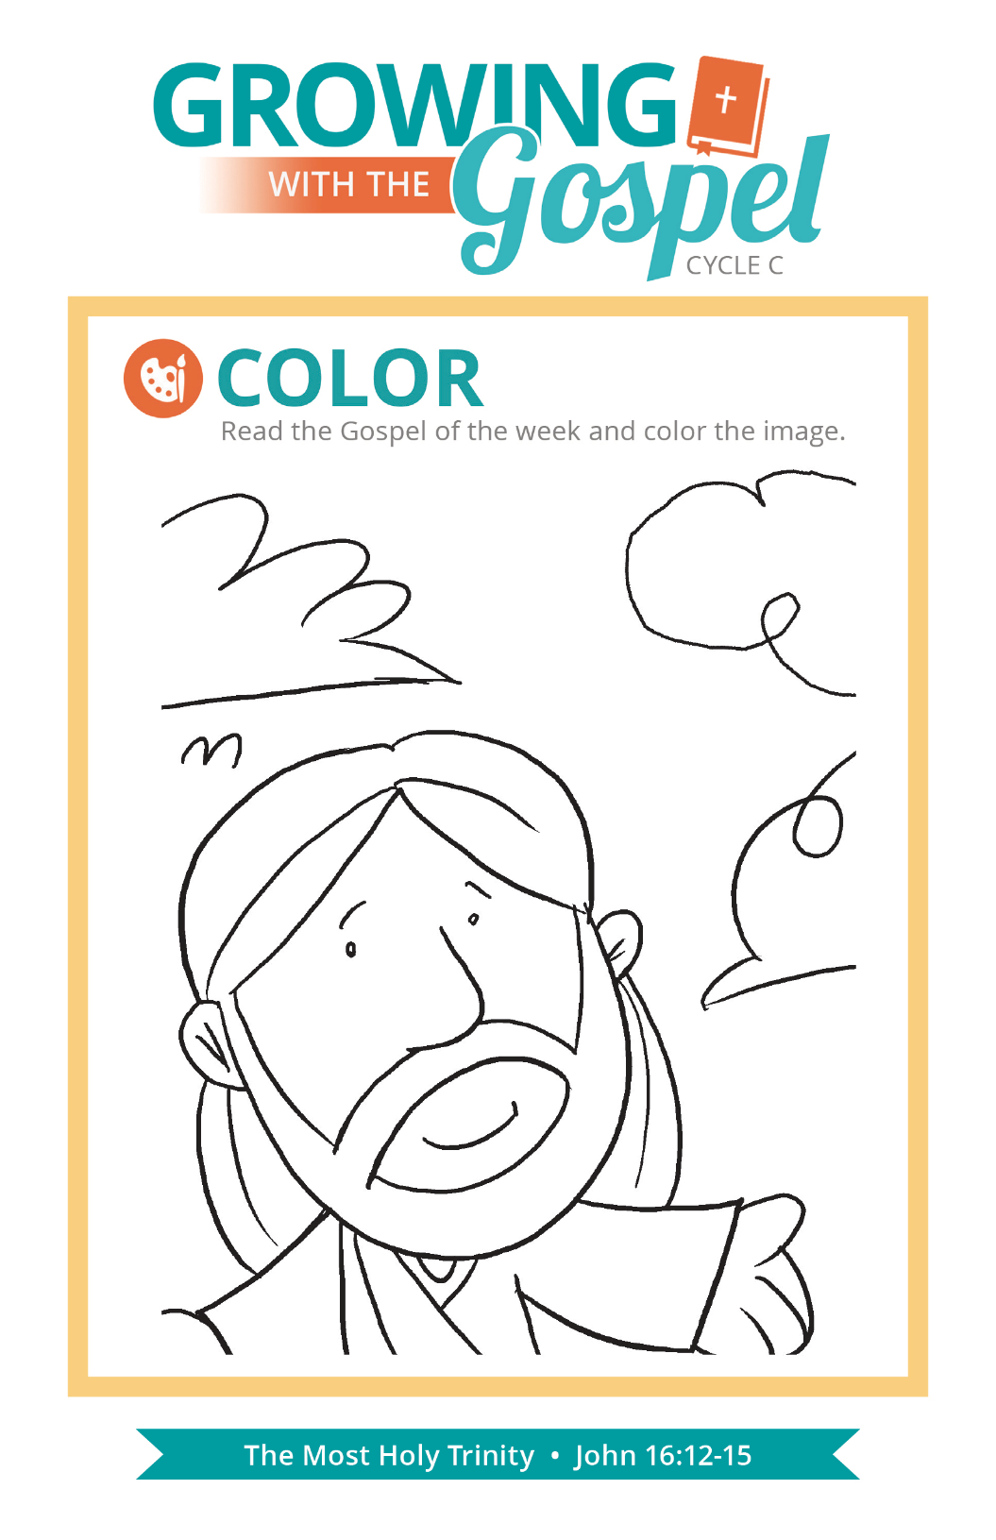
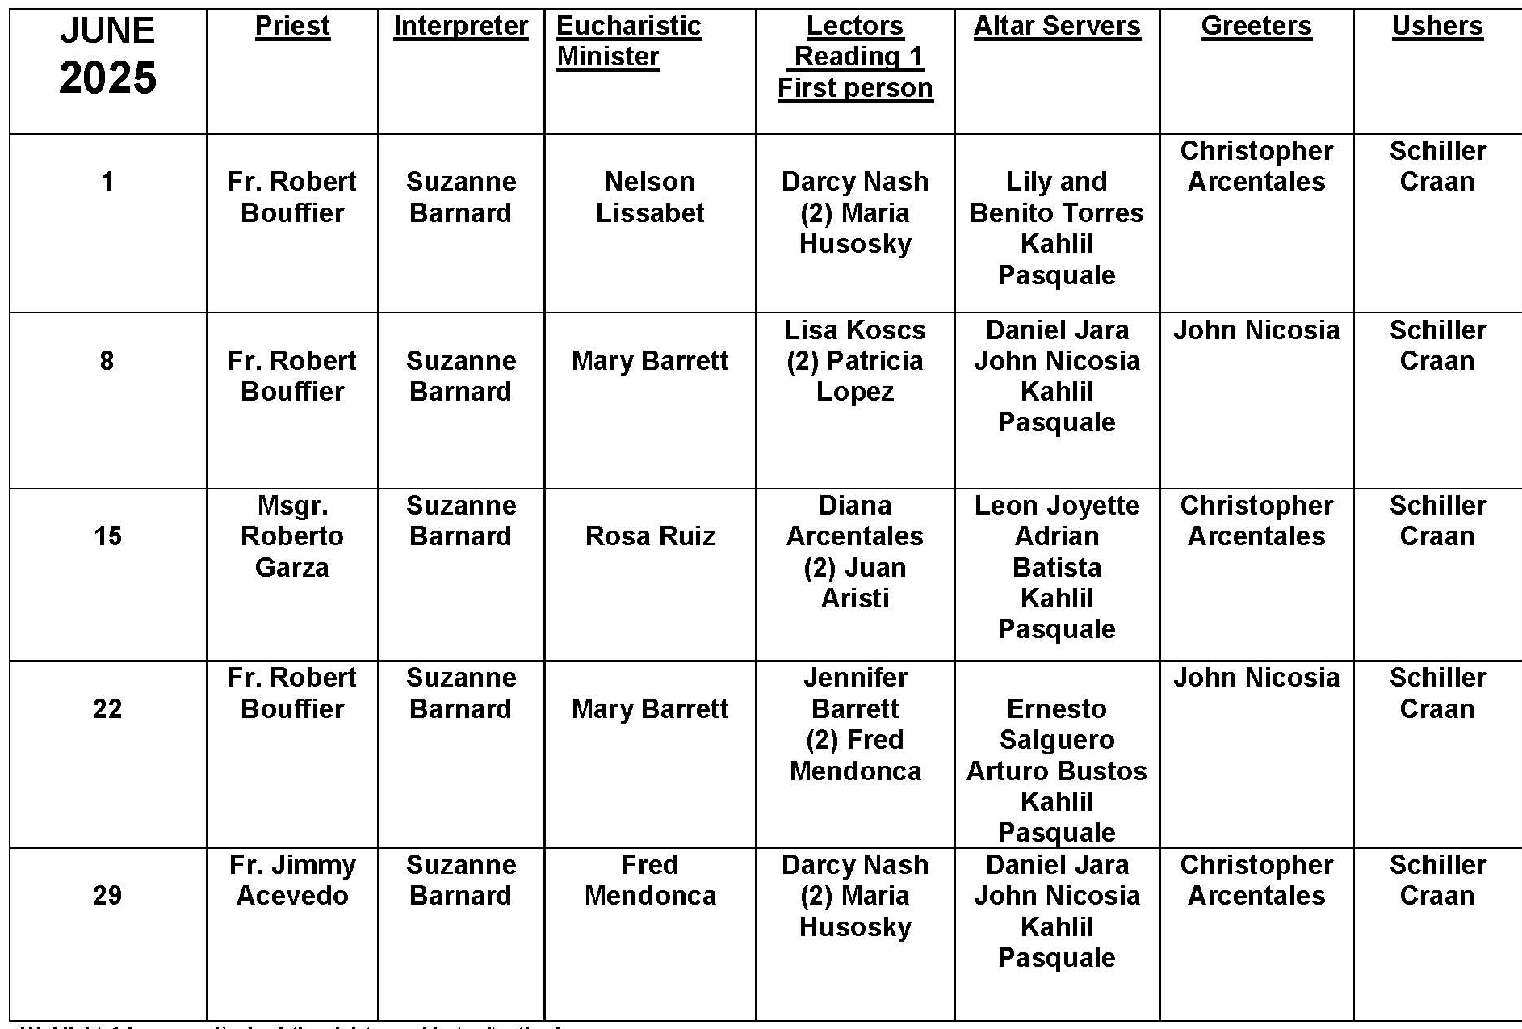
Rosaries as Decorations

Question: I’ve seen people hang rosaries over the rear-view mirrors in their cars and a few of them wear them around their necks. Is it OK to do that?
Answer:
The practice of hanging a rosary or a religious medal off of the rearview mirror of one’s car is a fairly popular custom across many cultures. While there is no particular rule approving or condemning this practice, we should also be mindful of the respect and reverence due to religious objects and devotional items (i.e. sacramentals).
An important point to consider would be the reason why one chooses to place a rosary or religious medal in our cars. Is it a reminder of the protection and intercession of Mary and the saints? Does it encourage us to be mindful of God’s presence, even in such a mundane task as driving? Is it an outward expression of our more private devotions?
One advantage of having a rosary or religious medal in our cars is that it can also serve as a reminder to pray when we travel, asking for protection for ourselves and for other motorists or commuters. Certainly, invoking the protection and prayers of the saints is a wonderful practice for families, helping to reinforce our belief in the communion of saints and the care and concern we owe to one another.

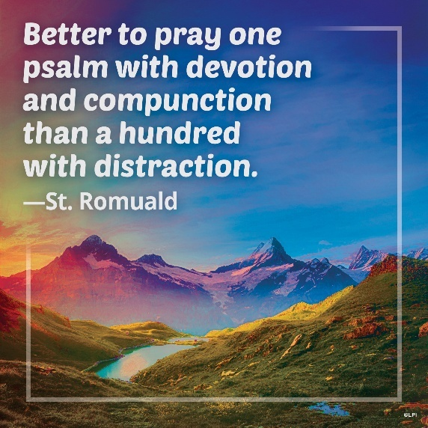
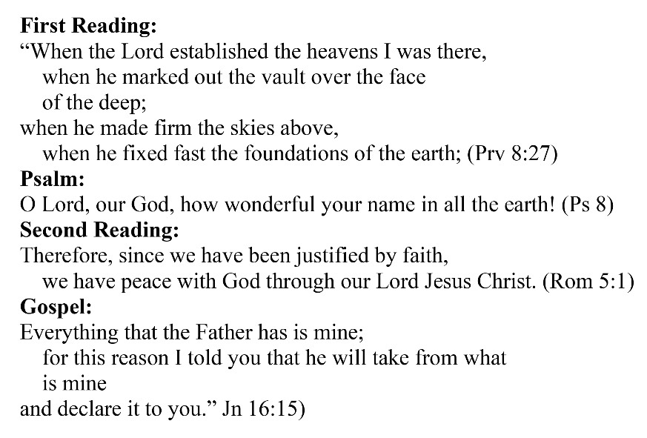
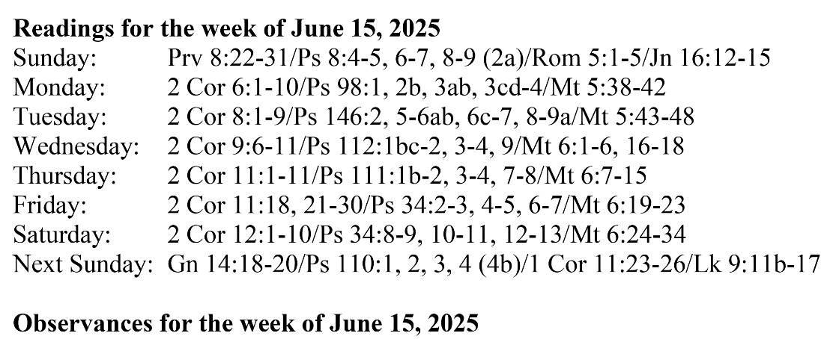
Are you in need of prayer? Do you have a prayer request? You can send your prayer requests to pcuadra@schottcommunities.org or call 954-434-3306 ext. 108

A copy of our prayer list can be found in the lobby of our chapel. To request a copy of our prayer list please email us at pcuadra@schottcommunities.org
To request a Mass please contact Pablo A. Cuadra at 954-434-3306 or e-mail at pcuadra@schottcommunities.org
Update: Celebrating a wedding anniversary soon? Let us know a week in advance and we can assist you with the renewal of your wedding vows.

Prayer to St. Michael the Archangel:
"St. Michael the Archangel, defend us in battle. Be our defense against the wickedness and snares of the Devil. May God rebuke him, we humbly pray, and do thou, O Prince of the heavenly hosts, by the power of God, thrust into hell Satan, and all the evil spirits, who prowl about the world seeking the ruin of souls. Amen"

