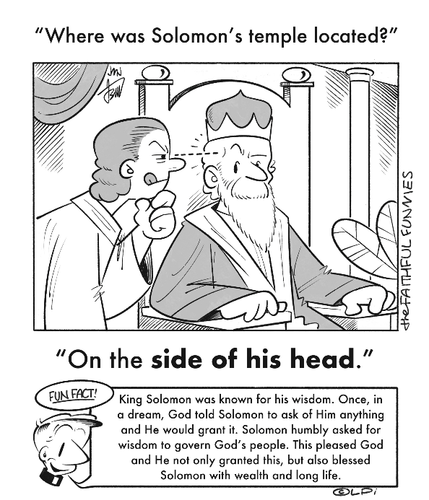
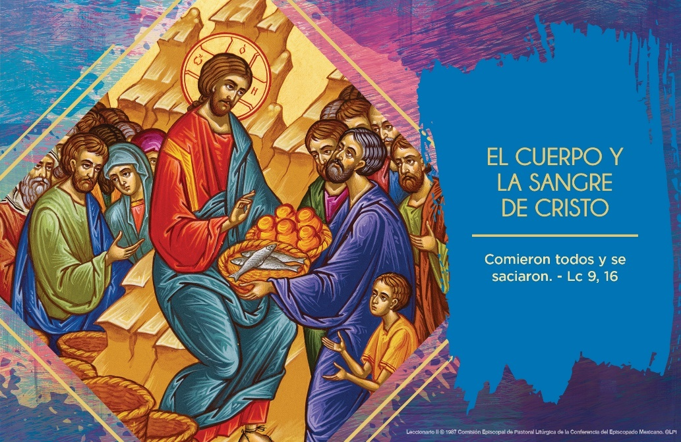
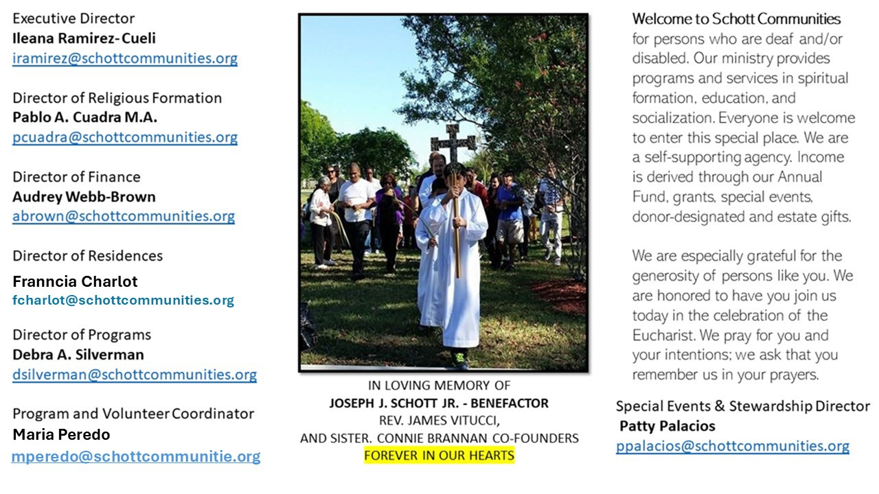

22 de junio de 2025
El Cuerpo y la Sangre de Cristo
Como Jesús nos conoce, él sabía y sabe que nos gusta comer. Jesús, multiplica la comida; él sacia el hambre de aquella gente que lo buscaba por sus enseñanzas y por sus milagros. ¿Por qué buscas a Jesús? ¿Qué tipo de hambre sacia en tu vida? En el sacramento de la Eucaristía, Jesús nos dejó su presencia real para poder alimentarnos espiritualmente.
“El culto que se da a la Eucaristía fuera de la Misa es un valor inestimable en la vida de la Iglesia. Dicho culto está estrechamente unido a la celebración del sacrificio eucarístico. La presencia de Cristo bajo las sagradas especies que se conservan después de la Misa---presencia que dura mientras subsistan las especies del pan y del vino, deriva de la celebración del Sacrificio y tiende a la comunidad sacramental y espiritual. Corresponde a los Pastores animar, incluso con el testimonio personal, el culto eucarístico, particularmente la exposición del Santísimo sacramento y la adoración de Cristo presente bajo las especies eucarísticas. Es hermoso estar con él y, reclinados sobre su pecho como el discípulo predilecto (ver Juan 13:25), palpar el amor infinito de su corazón” (Ecclesia de Eucharistia, en el número 25, san Juan Pablo II). ¿Cómo es nuestra participación en la Eucaristía? Estamos llamados a ser fuente de vida y pan compartido para los demás. “El que come mi carne y bebe mi sangre, permanece en mí y yo en él, dice el Señor” (Juan 6:56).

June 22, 2025
The Most Holy Body and Blood of Christ
Luke 9:11-17

A Catholic friend of mine occasionally says, “The Eucharist is not a noun. It’s a verb.” In so saying, he is making the point that the Eucharist isn’t simply Jesus’ bodily presence given to us in holy Communion. It also manifests the dynamic pattern by which Christ actively loves and saves us. He teaches us to cooperate with that pattern. This Eucharist actually embodies four verbs: Jesus takes, blesses, breaks, and gives. Let’s consider each one.

He takes: Do we acknowledge that we are totally in God’s hands? Do we receive everything in our lives as a gift, and act responsibly with it?

He blesses: Do we actively reflect that Jesus makes us holy in our baptism? Do we embrace our bodies and souls as temples of God, worthy of love, peace, and joy?

He breaks: Do we run from failure and disappointment, from getting old or being ignored? Are we too worried about getting hurt or sick? Do we embrace our sufferings with confidence?

He gives: Are we willing to make our lives a gift for others? Are we confident that we will always have enough love to give to others, that God will always provide enough for us? Do we rejoice in giving away what we have to others, expecting nothing in return? This is the dynamic life the Eucharist empowers us to live.

— Father John Muir

St. Jude Chapel, Sunday, June 22nd, 2025
Father Robert Bouffier
Celebrant

Marian Consecration
Marian consecration is the act of consecrating oneself to Jesus through the intercession of his Blessed Mother and is rooted in the words of Jesus himself when he beseeched the Apostle John to look upon Mary as his mother (John 19:27).

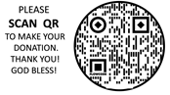
Christian Giving
June 15th, 2025
$

We sincerely thank you and bless you for your generosity.
A bequest is a powerful tool to help the Deaf or Disabled.

Mass Intentions
“For the repose of the Souls in Purgatory
Requested by Schott Communities


Follow us on Facebook
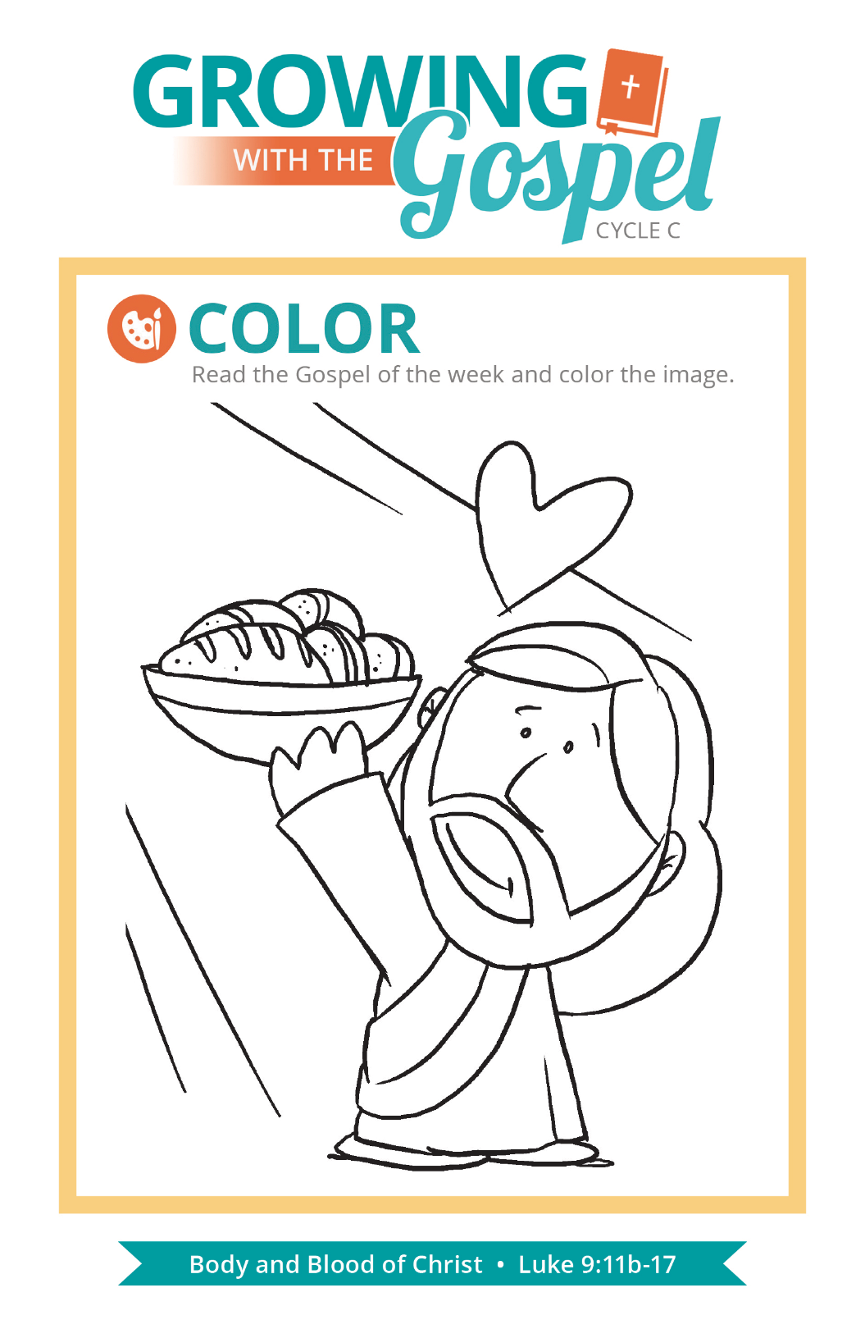
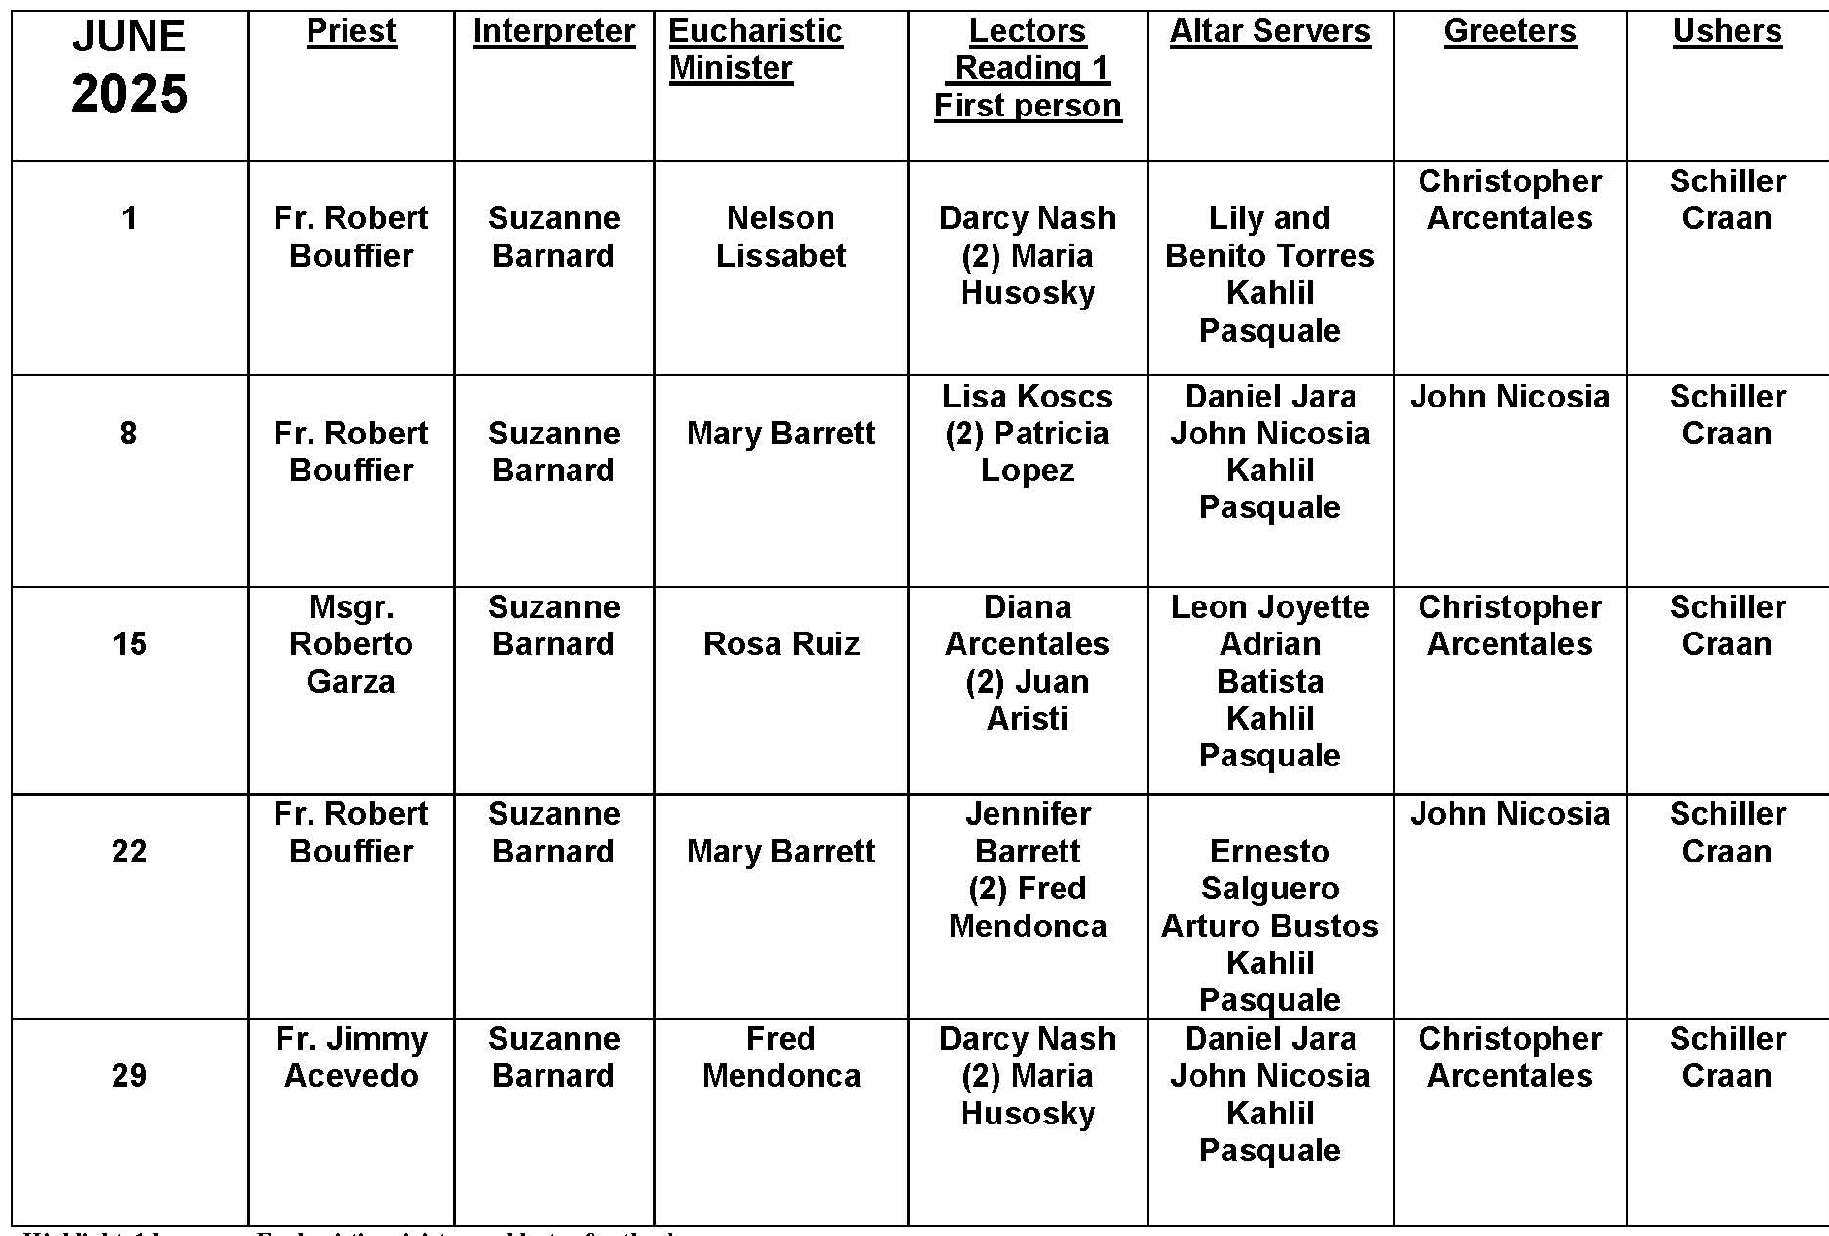
Sign Before the Gospel

Question:
I have been going to Mass for years and have always wondered: why do we make the three signs of the cross before the Gospel?

Answer:
Certainly, many people go to Mass or other devotions, doing and saying things out of habit or reverence and not really understanding the reasons behind some of these things. But everything we do has a meaning or purpose that helps us to worship better, proclaim our beliefs, or focus the attention of the people on something that has a greater importance or significance. A review of the meaning of various gestures and practices can help us have a deeper appreciation for what we do.

There is a little prayer that goes with the three crosses before the Gospel: “May the words of the Holy Gospel be on my mind, on my lips and in my heart.” In standing to hear the Gospel, we acknowledge that Jesus is present, and the words of the Gospel are addressed to us. All of the gestures and special postures we adopt before the Gospel are intended to help us prepare for hearing the Word as well as act on it. The incense, the Alleluia, the deacon or priest, and the special dialogue and announcement that introduces the Gospel help us focus our attention on the Good News we are about to hear. The three signs of the cross show our desire and good intention to hear and live the Gospel.

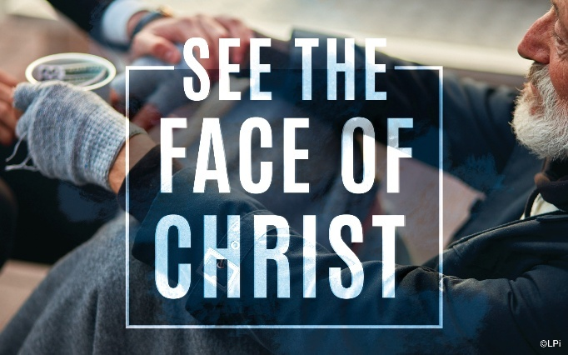
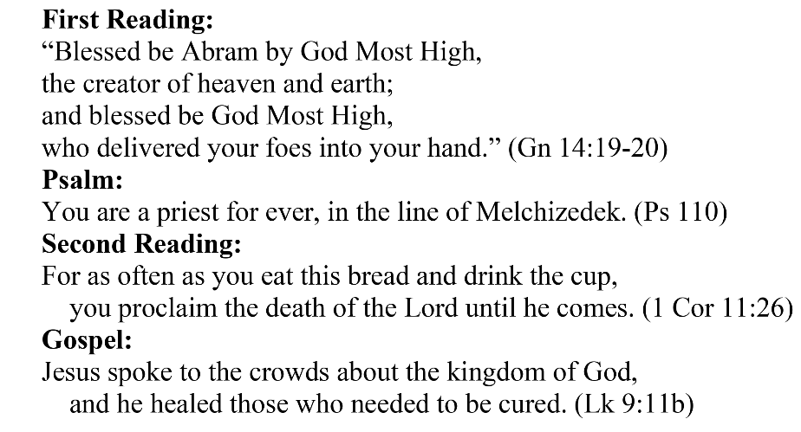
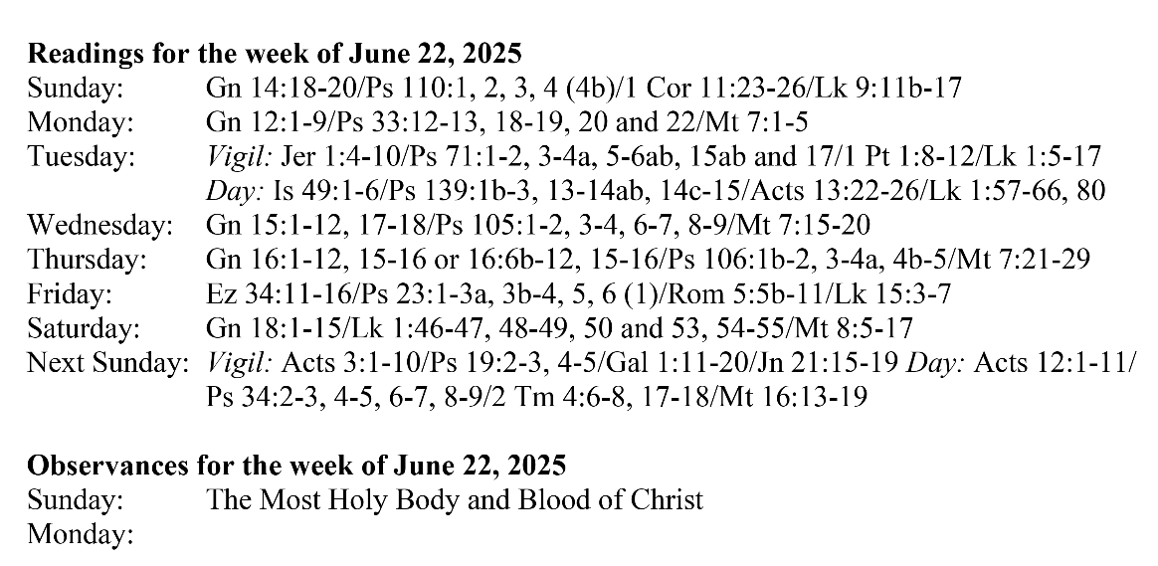
Are you in need of prayer? Do you have a prayer request? You can send your prayer requests to pcuadra@schottcommunities.org or call 954-434-3306 ext. 108

A copy of our prayer list can be found in the lobby of our chapel. To request a copy of our prayer list please email us at pcuadra@schottcommunities.org
To request a Mass please contact Pablo A. Cuadra at 954-434-3306 or e-mail at pcuadra@schottcommunities.org
Update: Celebrating a wedding anniversary soon? Let us know a week in advance and we can assist you with the renewal of your wedding vows.

Prayer to St. Michael the Archangel:
"St. Michael the Archangel, defend us in battle. Be our defense against the wickedness and snares of the Devil. May God rebuke him, we humbly pray, and do thou, O Prince of the heavenly hosts, by the power of God, thrust into hell Satan, and all the evil spirits, who prowl about the world seeking the ruin of souls. Amen"

