
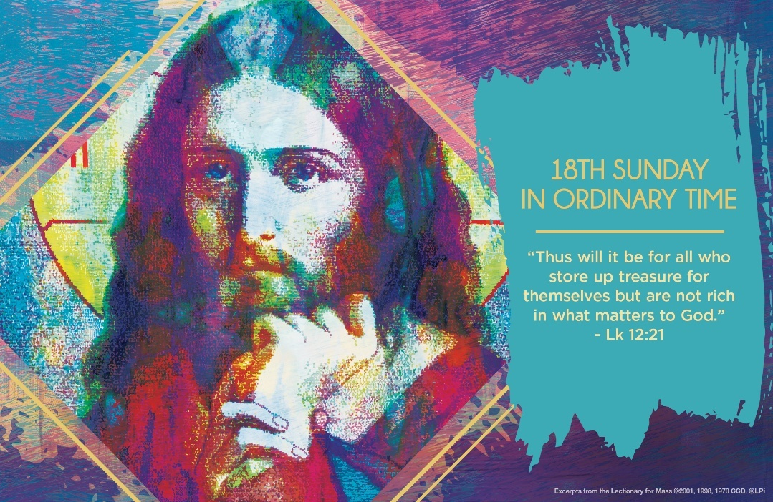
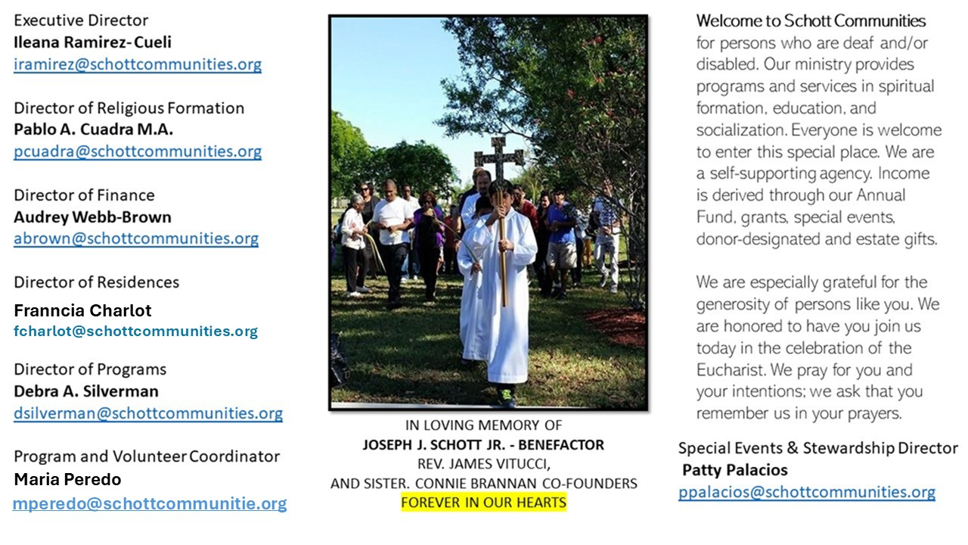

3 de agosto de 2025
XVIII Domingo del Tiempo Ordinario

A todos nos gusta hacer planes, tener metas y llegar a ellas. Eso nos pone contentos porque nos va bien en la vida y pensamos: "Qué bien, he luchado tanto que ya puedo disfrutar de lo que tengo". Pero nos olvidamos de lo más importante: en las metas nunca contamos contigo. Nos olvidamos de que sólo Tú, Señor, nos darás la auténtica libertad y felicidad. No está la vida en poseer bienes. “Eviten con gran cuidado toda clase de codicia, porque, aunque uno tenga todo, no son sus posesiones las que le dan vida” (Lucas 12:15).
Vale preguntarnos: ¿Cuál es el centro de tu vida? ¿Cuál es la meta en tu vida? ¿Está tu felicidad en lo que posees, en tu estatus social, en lo que dirá la gente de ti? Cuidado, nos advierte Jesús: “Esta misma noche vas a morir. ¿Quién se quedará con lo que has preparado?” (Lucas 12:20).
“Jesús percibe nuestros problemas, nuestras debilidades, nuestras necesidades; invita a convertirnos a la fe en la Providencia, saber compartir lo poco que somos y tenemos, y no cerrarnos nunca en nosotros mismos” (Papa Francisco). El tener muchos bienes y prestigio no es malo, lo que Dios desea es que aprendamos a ser desprendidos, es decir, generosos. No equivoquemos el proyecto de nuestra vida; la abundancia es pasajera, todo se queda al morir. Solo las riquezas espirituales serán eternas. “Esto vale para toda persona que amontona para sí misma en vez de acumular para Dios” (Lucas 12:21).

August 3, 2025
18th Sunday in Ordinary Time
Luke 12:13-21

Recent studies suggest that millennials will be the first generation in America to be worse off than their parents in terms of financial earnings and job status. Many lament this. I propose that this week’s Gospel provides a hopeful way to see the trend as good news.

The Lord Jesus says, “Take care to guard against greed, for though one may be rich, one’s life does not consist in possessions” (Luke 12:15). Greed damages us with the deception that we are what we possess. But to Jesus, this is simply not true. What makes us happy is who we are, who we become.

Does not the expectation that every generation should do better than their parents subtly mask the poison of greed? A similar attitude is mirrored in the man who demands that Jesus justly arrange his share of the family inheritance. Despite the injustice, Jesus will not play that game. In fact, he seems to prefer that the man have less than his parents. What good would having more be to this man if he becomes enslaved and miserable by greed? What good would it be for us to have more if it means we become much less?

In allowing the man to have less, Jesus opens a space for him to become more: a man free to love. In that much more meaningful sense, perhaps he was better off than his parents. Maybe the millennials will be, too.

— Father John Muir

St. Jude Chapel, Sunday, August 3rd, 2025
Father Robert Bouffier
Celebrant

Holy Hour
A holy hour is the practice of spending one hour’s time in the presence of the Blessed Sacrament, praying and meditating on the agony of Jesus Christ.


Christian Giving
July 27th 2025
$

We sincerely thank you and bless you for your generosity.
A bequest is a powerful tool to help the Deaf or Disabled.

Mass Intentions
“For the repose of the Souls in Purgatory
Requested by Schott Communities


Follow us on Facebook
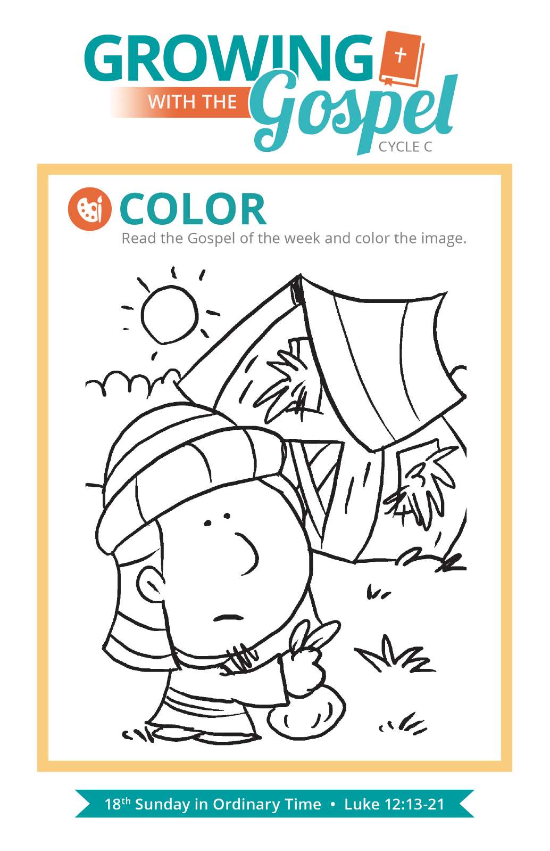
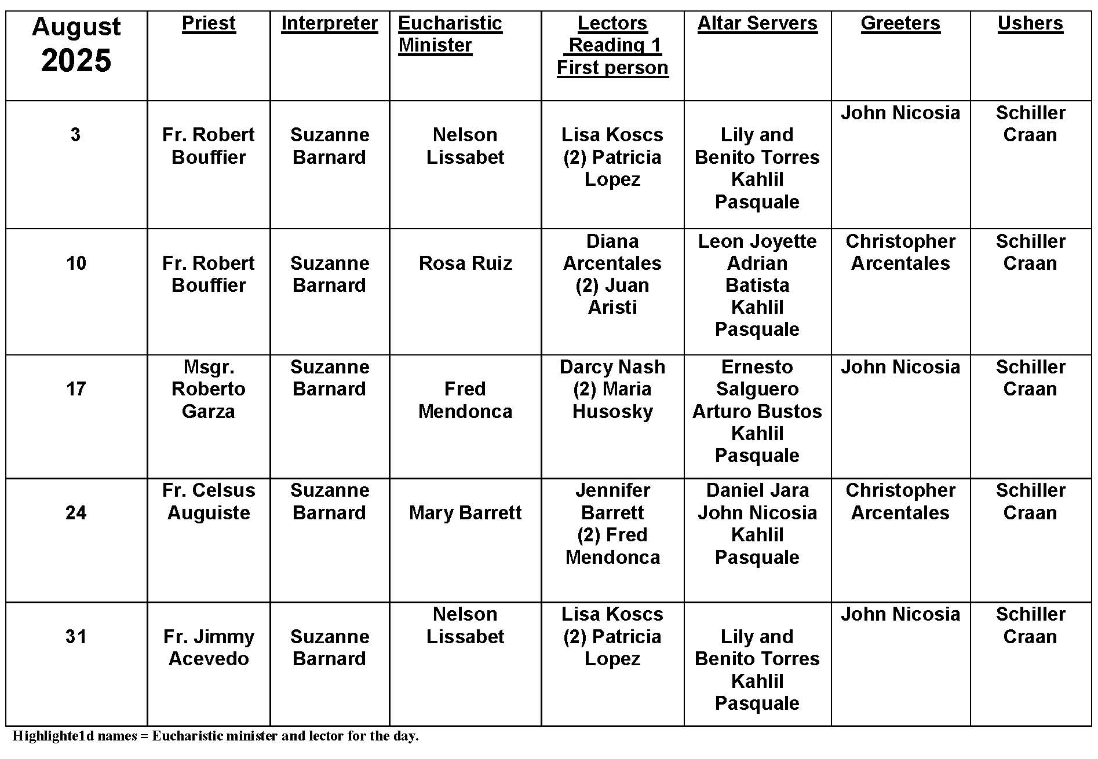
Marian Feasts

Question:
Why does Mary have so many feast days and names?

Answer:
Christians first began celebrating feast days in honor of Mary, the Mother of Jesus, in the fifth century. That celebration (originally called the Feast of the Dormition and now known by Roman Catholics as the Solemnity of the Assumption) was celebrated on August 15. Very soon, however, other special days dedicated to Mary began to appear in Jerusalem, Rome, and other major cities of the Christian world. These days of feasting became important parts of the life of the community. But, more importantly, each of these unique celebrations became an opportunity to focus on a different facet of the Christian faith, as believers focused their attention on specific events or mysteries of the lives of Mary and her Son.

Over the centuries, some of these celebrations became universal (such as the Assumption on August 15, the Immaculate Conception on December 8, and the Solemnity of Mary, Mother of God on January 1). Other celebrations were more closely tied to certain religious orders (such as the Carmelites celebration of “Our Lady of Mount Carmel” on July 16 or the Servite Friars feast of the “Seven Sorrows of Mary,” which is now celebrated as the Memorial of Our Lady of Sorrows on September 15).

In more recent times, Marian apparitions (like Guadalupe, Lourdes, and Fatima) have inspired special liturgical celebrations. Pope Francis has added two new celebrations of Mary to the Church’s calendar: The Memorial of Mary, Mother of the Church (on the Monday after Pentecost) and the Commemoration of Our Lady of Loreto (on December 10). The various titles of Mary (like those we find in the Litany of the Blessed Virgin Mary) help us to reflect on different aspects of Mary’s faith and the ways that the Holy Spirit is at work in her and through her, especially as the Mother of Jesus.
In the end, whatever the event or mystery being celebrated in a particular liturgy or the title of Mary being used, we are invited to always see Mary in connection with the saving work of her Son. She is, of course, a patroness and protector for every Christian, but she is also a model of discipleship and contemplation: “Having entered deeply into the history of salvation, Mary, in a way, unites in her person and re-echoes the most important doctrines of the faith: and when she is the subject of preaching and worship she prompts the faithful to come to her Son, to his sacrifice and to the love of the Father” (Lumen Gentium, 65).

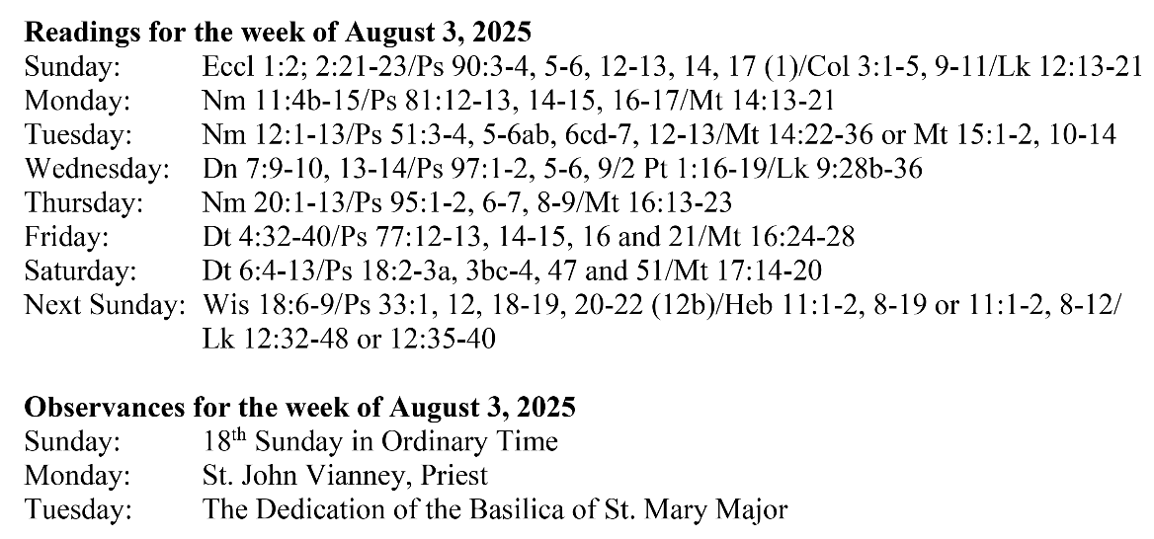
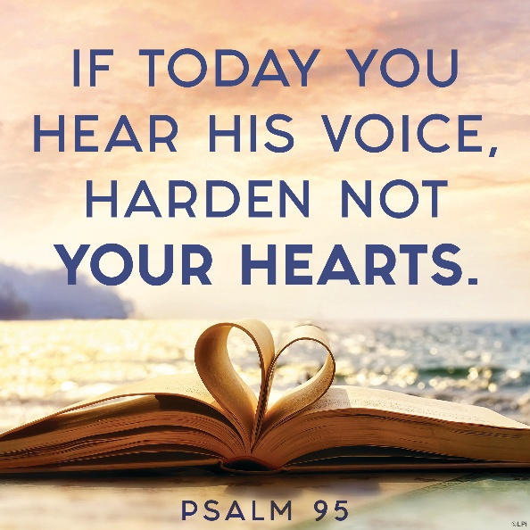
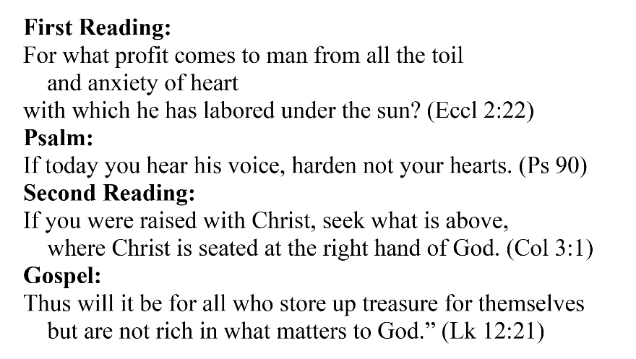
Are you in need of prayer? Do you have a prayer request? You can send your prayer requests to pcuadra@schottcommunities.org or call 954-434-3306 ext. 108

A copy of our prayer list can be found in the lobby of our chapel. To request a copy of our prayer list please email us at pcuadra@schottcommunities.org
To request a Mass please contact Pablo A. Cuadra at 954-434-3306 or e-mail at pcuadra@schottcommunities.org
Update: Celebrating a wedding anniversary soon? Let us know a week in advance and we can assist you with the renewal of your wedding vows.

Prayer to St. Michael the Archangel:
"St. Michael the Archangel, defend us in battle. Be our defense against the wickedness and snares of the Devil. May God rebuke him, we humbly pray, and do thou, O Prince of the heavenly hosts, by the power of God, thrust into hell Satan, and all the evil spirits, who prowl about the world seeking the ruin of souls. Amen"

