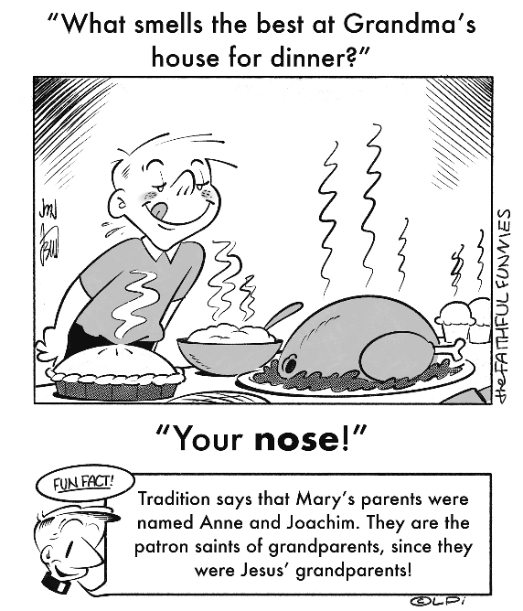
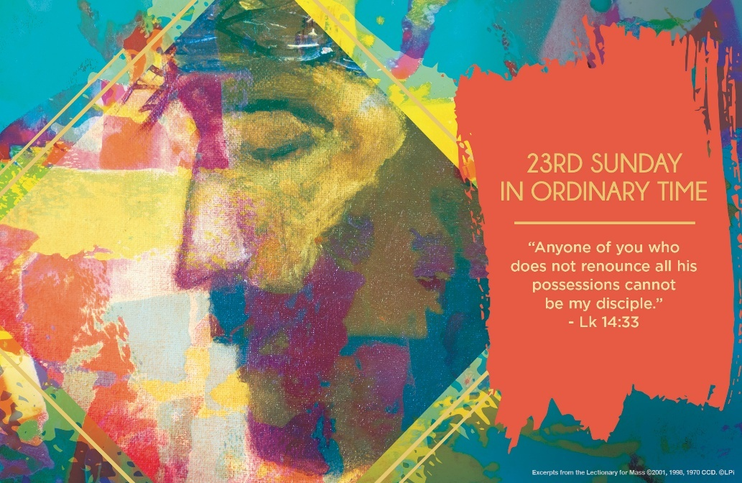
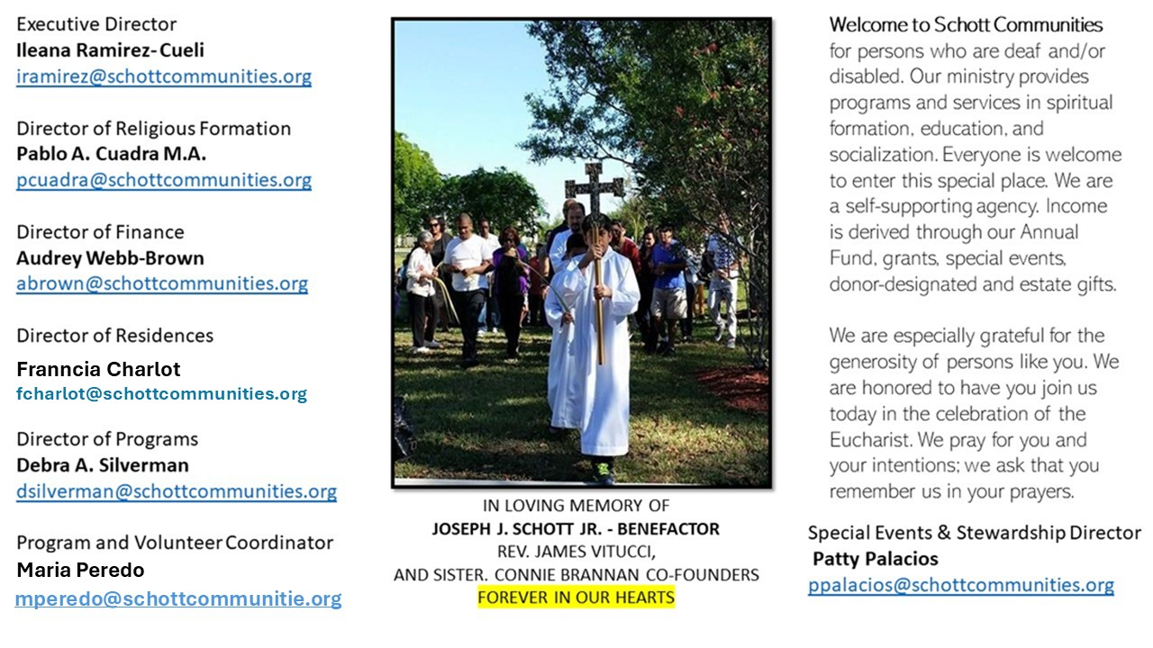

7 de septiembre de 2025
XXIII Domingo del Tiempo Ordinario

Para seguir a Jesús debemos realizar ciertos cambios en la vida, que implican salir de nuestro confort. Renunciar a cosas y situaciones a las que no estamos acostumbrados, pensamos, es casi imposible. Pero, recuerde, nada es imposible para Dios. Solo basta con que pongamos un poco de nuestra parte. Dejar nuestros caprichos, manías y malos hábitos que se oponen al Evangelio es cosa de trabajo y proceso. ¡Eso cuesta seguir a Jesús! "El que no carga con su propia cruz para seguirme no puede ser discípulo mío" (Lucas 14:27).
El Papa Francisco, en su catequesis, nos ayuda a comprender el mensaje de Jesús para que nuestra carga sea ligera y apreciemos la cruz que llevamos en nuestra vida. "Hay tres características que trazan claramente la personalidad de Jesús y que motivan nuestra confianza en Él: nos encomendamos a Él porque ora, porque nos ha elegido y porque está cerca de nosotros. Jesús ha pedido y sigue pidiendo por nosotros: es el intercesor. Jesús ama y elige con amor, nos elige a todos. Y la cercanía de Dios a su pueblo es la cercanía de Jesús con la gente". A Jesús le importa nuestra libertad, no quiere que lo sigamos a ciegas. Cargar con la cruz quiere decir medir y calcular las fuerzas que tenemos y darnos cuenta de cuánta fidelidad a sus enseñanzas existe en nuestro corazón. Ayúdame, con tu gracia, cuando flaqueo, cuando estoy solo y confundido, cuando estoy sin esperanza. ¿Quieres seguir a Jesús? Pues, adelante, Él te espera siempre.

September 7, 2025
23rd Sunday in Ordinary Time
Luke 14:25-33

One hot Arizona summer afternoon my car ran out of gas. I phoned the parish office and begged for help. My secretary came and helped me fill the gas tank. She chided me, “If you can’t manage getting your car from A to B, how can we expect you to guide the parish where it needs to go?” Point taken, Julie. I vowed to always make sure I have plenty of gas in my car.

The Lord Jesus chides us in this week’s Gospel, too. He uses the two images of a man building a tower and a king marching soldiers into war to make this single point: acquire what is needed to follow him or look ridiculous. We rightly mock the builder who lacks money for his tower and the king with a short-handed army. But our mocking boomerangs back on us. How do we expect to follow Jesus to the end with insufficient detachment from our possessions and divided hearts?

The good news is, there is still time. Jesus is building a great tower to heaven–his own body. So we renounce all and give ourselves to him as his precious stones. Jesus is waging a battle against our enemy. So we forsake all and swear allegiance and march under his banner. In this way, we will finish what has begun in our discipleship. Or better put, our Lord will have the stones and soldiers required to see his great work through.

— Father John Muir

St. Jude Chapel, Sunday, September 7th, 2025
Father Robert Bouffier
Celebrant

Prayer of Simplicity
Dear God,
In my desire for You, take away anything that keeps me from knowing You, myself, or my mission here on earth. Help me to remember what is truly important, and to seek and treasure that.
Amen.


Christian Giving
August 31st, 2025
$345

We sincerely thank you and bless you for your generosity.
A bequest is a powerful tool to help the Deaf or Disabled.

Mass Intentions
“For the repose of the Souls in Purgatory
Requested by Schott Communities


Follow us on Facebook
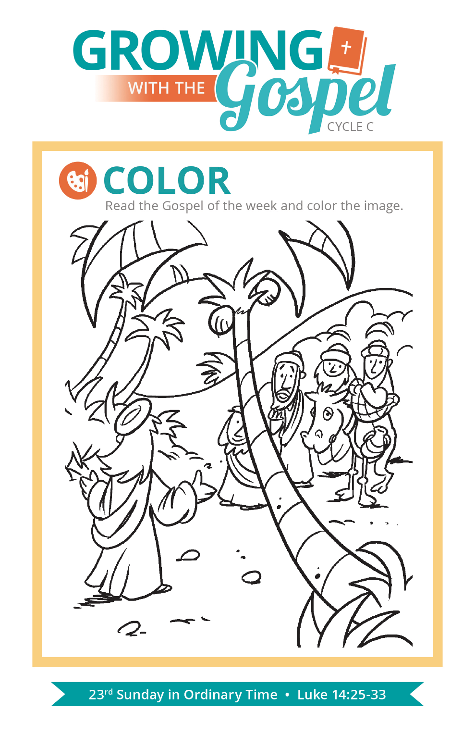
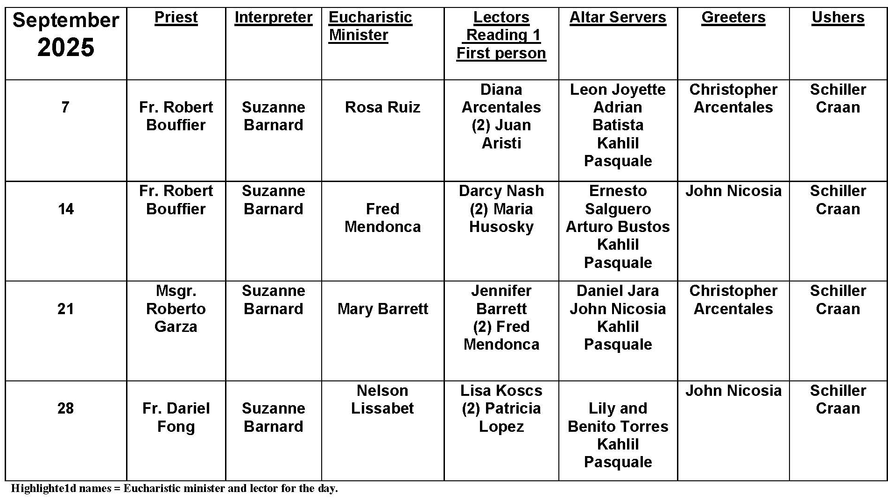
Title: What Happens if a Host is Dropped?

Question: What Happens if Someone Drops a Consecrated Host?
Answer: Despite our best efforts, and this is as true in our liturgical celebrations as in all of life, accidents happen. Occasionally at Mass, a host may be dropped or some of the Precious Blood could even be spilled from the chalice, despite the best efforts of the priests, deacons, and extraordinary ministers of holy Communion assisting at the liturgy.
So, when a host is dropped or the Precious Blood is spilled, we can take guidance from the U.S. Bishops’ statement Norms for the Distribution for Holy Communion Under Both Kinds:
All ministers of Holy Communion should show the greatest reverence for the Most Holy Eucharist by their demeanor, their attire, and the manner in which they handle the consecrated bread or wine. Should there be any mishap — as when, for example, the consecrated wine is spilled from the chalice — then the affected "area . . . should be washed with water, and this water should be then poured into the sacrarium.”
According to no. 280 of the General Instruction of the Roman Missal, the general rule is that a dropped host is picked up by the minister distributing Communion and reverently consumed. The minster should be careful to make sure that no other particles from the host remain on the ground. As we see in the instruction from the bishops, the Precious Blood would be absorbed (customarily with a purificator) and the area attentively and reverently washed with water which would then be disposed of properly.

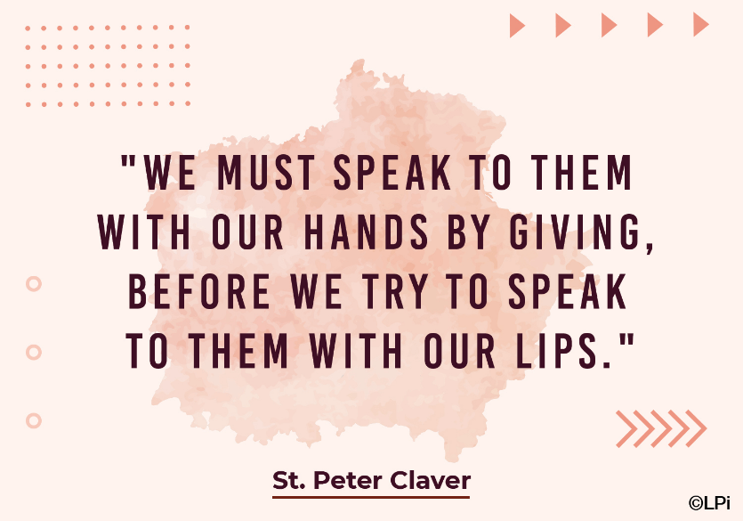
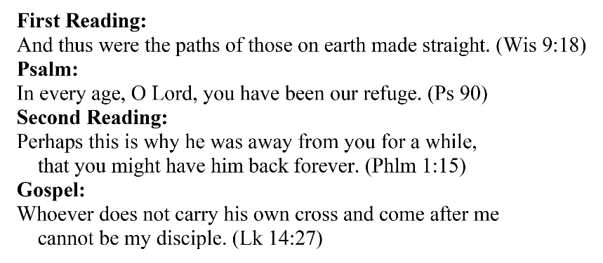
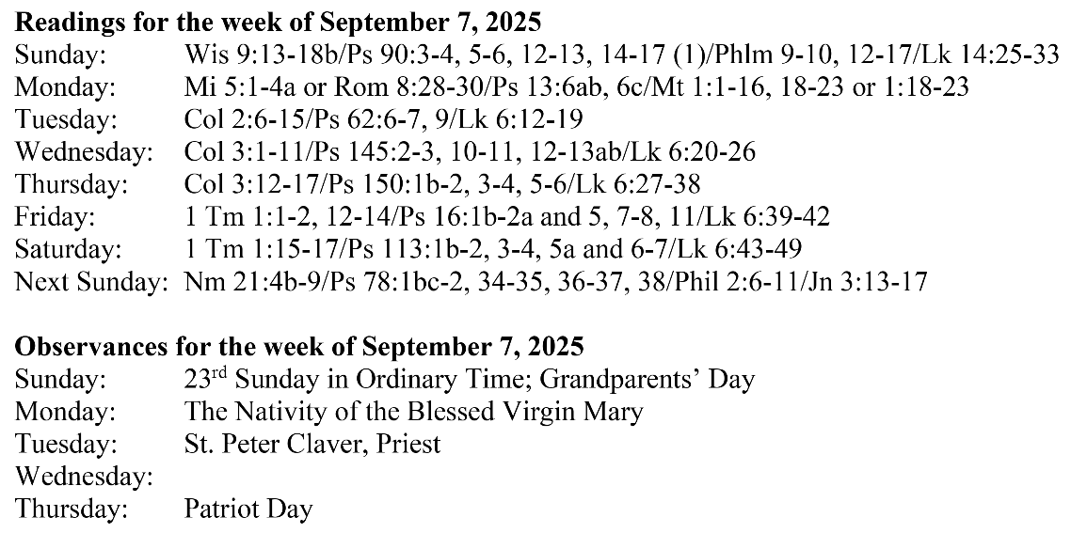
Are you in need of prayer? Do you have a prayer request? You can send your prayer requests to pcuadra@schottcommunities.org or call 954-434-3306 ext. 108

A copy of our prayer list can be found in the lobby of our chapel. To request a copy of our prayer list please email us at pcuadra@schottcommunities.org
To request a Mass please contact Pablo A. Cuadra at 954-434-3306 or e-mail at pcuadra@schottcommunities.org
Update: Celebrating a wedding anniversary soon? Let us know a week in advance and we can assist you with the renewal of your wedding vows.

Prayer to St. Michael the Archangel:
"St. Michael the Archangel, defend us in battle. Be our defense against the wickedness and snares of the Devil. May God rebuke him, we humbly pray, and do thou, O Prince of the heavenly hosts, by the power of God, thrust into hell Satan, and all the evil spirits, who prowl about the world seeking the ruin of souls. Amen"

