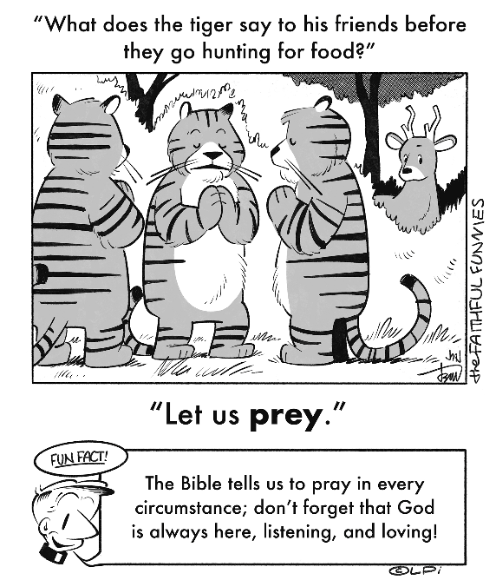
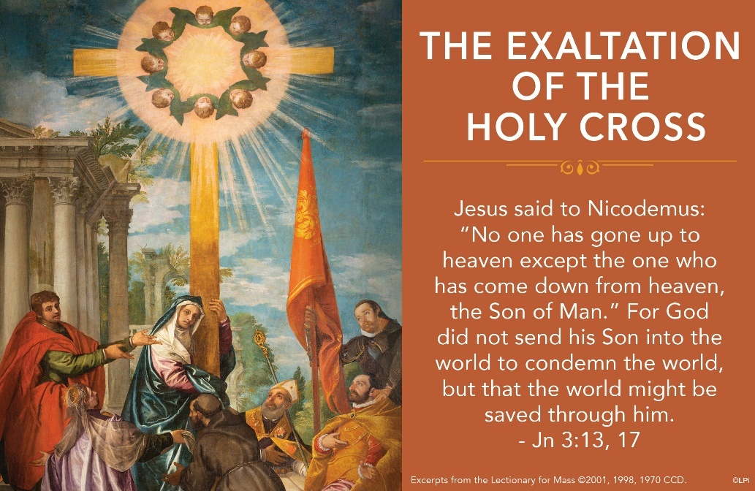
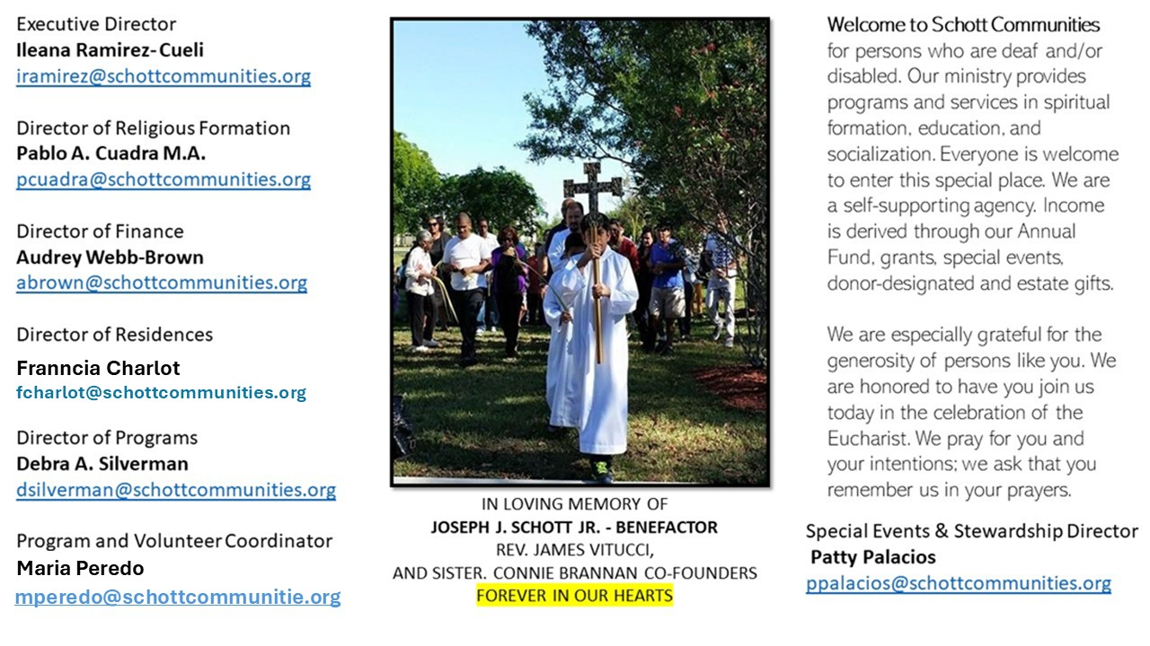

14 de septiembre de 2025
Exaltación de la Santa Cruz

“La Cruz es el camino que conduce de la tierra al cielo. Quien se abraza a ella con fe, amor y esperanza se siente transportado a lo alto, hasta el seno de la Trinidad” (Santa Benedicta de la Cruz). También decía en sus escritos: “La Cruz es el símbolo de la transformación de la debilidad en la fuerza”. Muchas personas llevan en su pecho una cruz y, muchas veces, la lucen tan solo porque es de oro y luce bonita. Pero, ¿sabes lo que significa? ¿Qué respeto tienes por ella?
“Hoy, 14 de septiembre, la Iglesia celebra la fiesta de la Exaltación de la Santa Cruz. Alguna persona podría preguntarnos: ¿Por qué exaltar la cruz? Podemos responder que no exaltamos una cruz cualquiera, o todas las cruces; exaltamos la cruz de Jesús, porque en ella se reveló al máximo el amor de Dios por la humanidad. Es lo que nos recuerda el evangelio de Juan en la liturgia de hoy: 'Tanto amó Dios al mundo que entregó a su Unigénito' (3:16). El Padre dio al Hijo para salvarnos, y esto implicó la muerte de Jesús, y la muerte en la cruz. ¿Por qué? ¿Por qué fue necesaria la cruz? A causa de la gravedad del mal que nos esclavizaba. La cruz de Jesús expresa ambas cosas: toda la fuerza negativa del mal y toda la omnipotencia mansa de la misericordia de Dios” (Papa Francisco). Por la señal de la santa cruz...

September 14, 2025
The Exaltation of the Holy Cross
John 3:13-17

One of my favorite movies is the 1991 comedy What About Bob? Bill Murray plays a troubled, paranoid hypochondriac named Bob Wiley who innocently but annoyingly hounds Dr. Leo Marvin, played by Richard Dreyfuss. Bob is paralyzed by his fear of, well, everything, and is convinced the psychologist can heal him. But Dr. Marvin’s failed attempts to heal Bob end up driving the doctor to attempt to murder Bob. He fails. The surprise is that, having faced death head on, Bob is suddenly healed. He attributes his healing to Dr Marvin for break-through “death therapy.” In facing the cause of his deepest illness and dysfunction, Bob is healed.

Underneath this light-hearted comedy is a dead-serious resonance with this week’s feast: the Exaltation of the Holy Cross. Christ is lifted up on the cross to force us to face the truth of sin and death. In that reckoning we find healing. Like Moses’ snake on a pole, the cross says: this is what is causing your sickness – rebellion, disobedience, sin. Look at it! Don’t run from it. Now seeing it exposed, we see life. We see our physician mercifully healing us. In this sense, we are all like Bob Wiley. The “death therapy” of the cross is our only hope for healing.

This week I invite you to “exalt the cross.” If you don’t have one in your house, get one. Use it for prayer. Gaze on it frequently. It teaches us to not be afraid. It heals us.

— Father John Muir

St. Jude Chapel, Sunday, September 14th, 2025
Father Robert Bouffier
Celebrant

Prayer of Love
Dear God,
Expand my heart in new ways today,
to understand the love You have for me,
to take that love deeply into myself,
and to act from that love.
Amen.

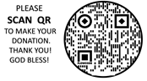
Christian Giving
September 7th, 2025
$720

We sincerely thank you and bless you for your generosity.
A bequest is a powerful tool to help the Deaf or Disabled.

Mass Intentions
“For the repose of the Souls in Purgatory
Requested by Schott Communities


Follow us on Facebook
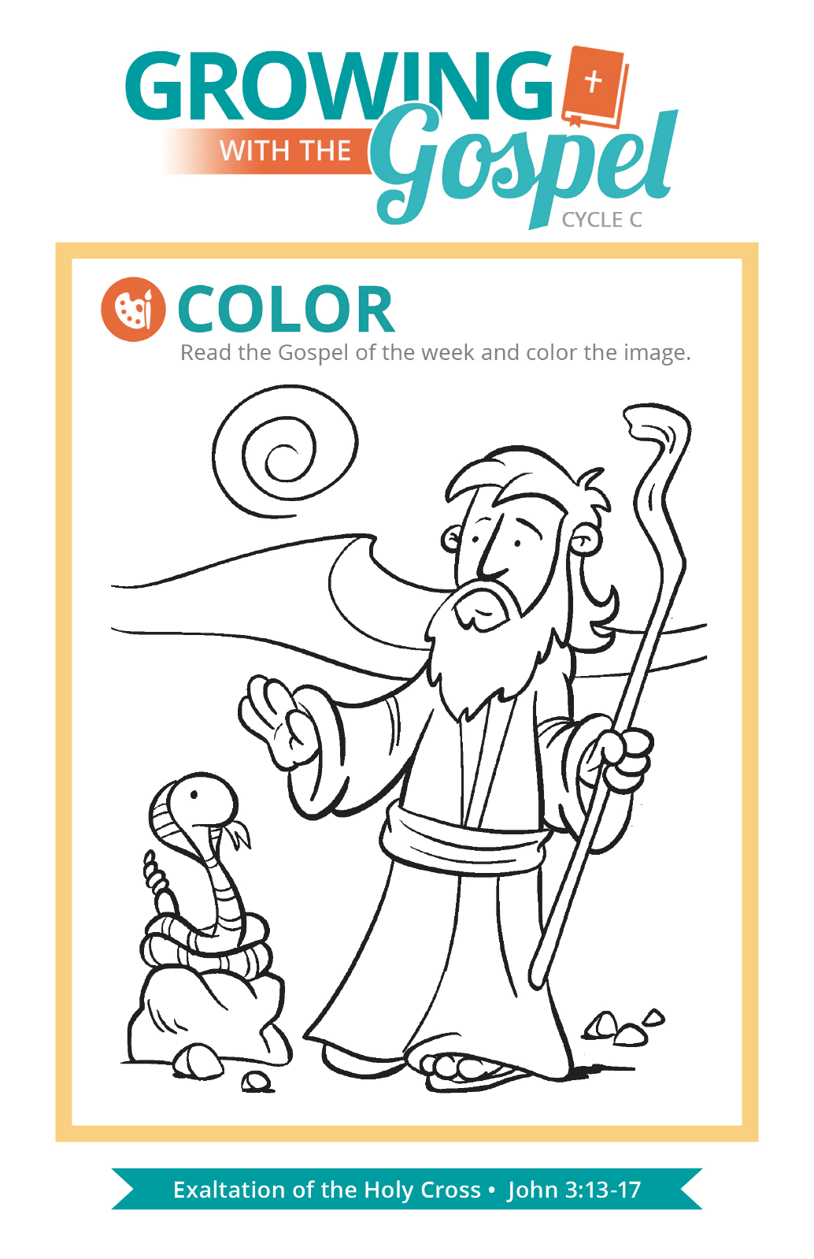
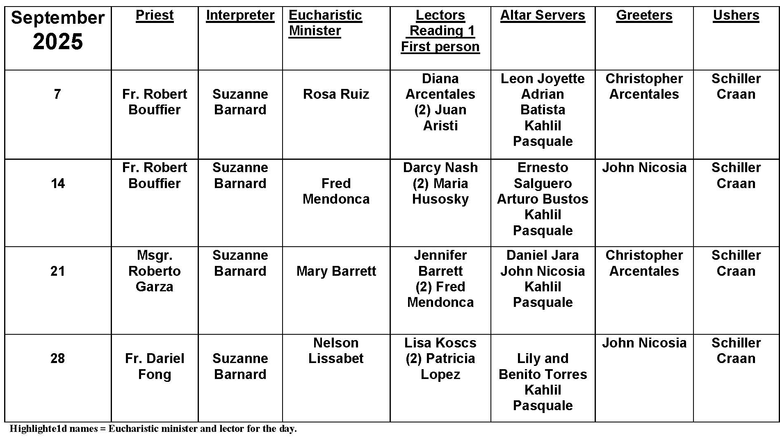
Daily Prayer Versus Mass?

Question:
I have a friend who says she doesn’t need to attend Mass because she prays to God every day. What are your thoughts on this justification?

Answer:
If the only reason for going to church were to talk to God, your friend might be right. Prayer is not something limited to a physical place or even a holy place. If the sole purpose of the Church were prayer, it would be a narrow purpose indeed. The Church is a community of believers, formed by “one Lord, one faith, one Baptism.” It is an outward sign of our faith in God instituted by Christ, and the purpose of the Church is to give us grace, that is, a share in God’s life.

Coming to Mass is not really for God’s sake, but for ours. If we believe that Jesus is truly present in the holy Eucharist, then we will want to be in his presence. We will want to be fed by him. Our daily prayer and good works are strengthened by our authentic encounter with our Lord. For Catholics, it is at Mass that we celebrate the source and summit of our faith. If this is true, why would we ever stay away?

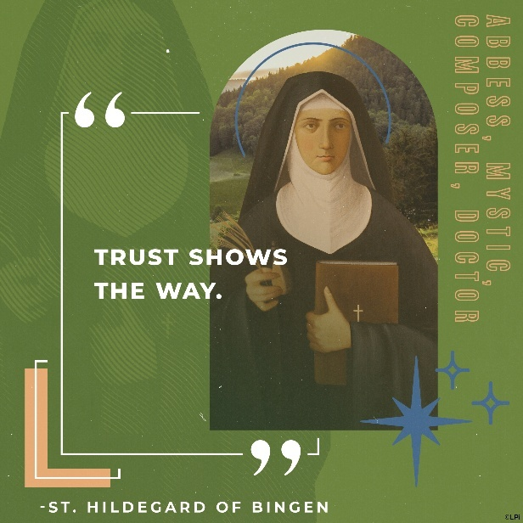
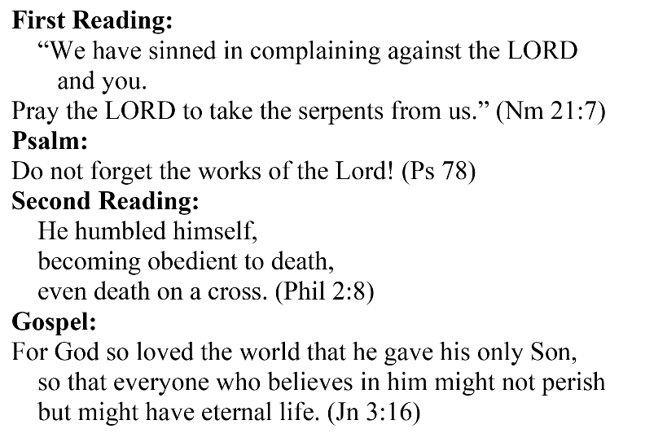
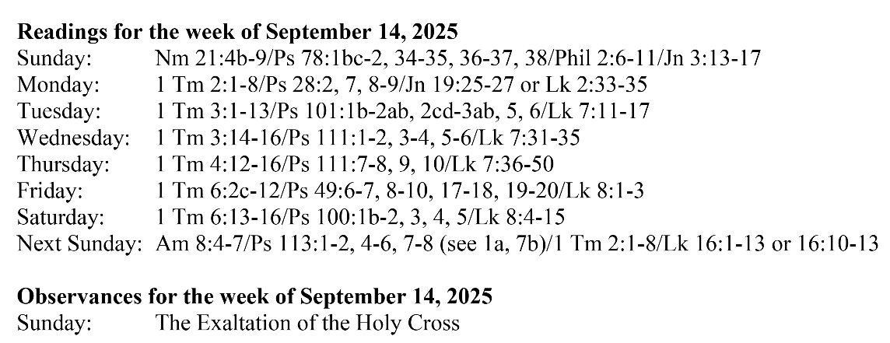
Are you in need of prayer? Do you have a prayer request? You can send your prayer requests to pcuadra@schottcommunities.org or call 954-434-3306 ext. 108

A copy of our prayer list can be found in the lobby of our chapel. To request a copy of our prayer list please email us at pcuadra@schottcommunities.org
To request a Mass please contact Pablo A. Cuadra at 954-434-3306 or e-mail at pcuadra@schottcommunities.org
Update: Celebrating a wedding anniversary soon? Let us know a week in advance and we can assist you with the renewal of your wedding vows.

Prayer to St. Michael the Archangel:
"St. Michael the Archangel, defend us in battle. Be our defense against the wickedness and snares of the Devil. May God rebuke him, we humbly pray, and do thou, O Prince of the heavenly hosts, by the power of God, thrust into hell Satan, and all the evil spirits, who prowl about the world seeking the ruin of souls. Amen"

