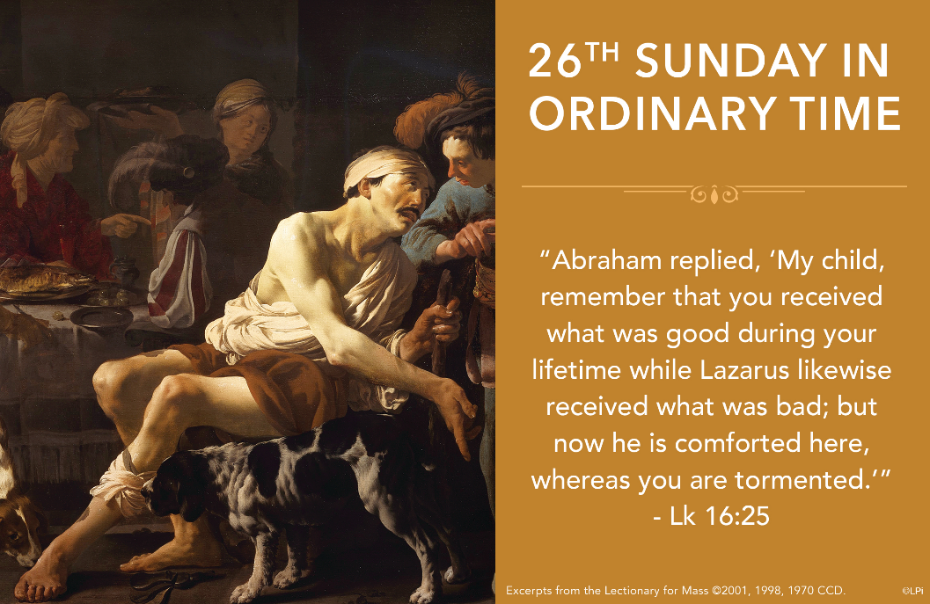
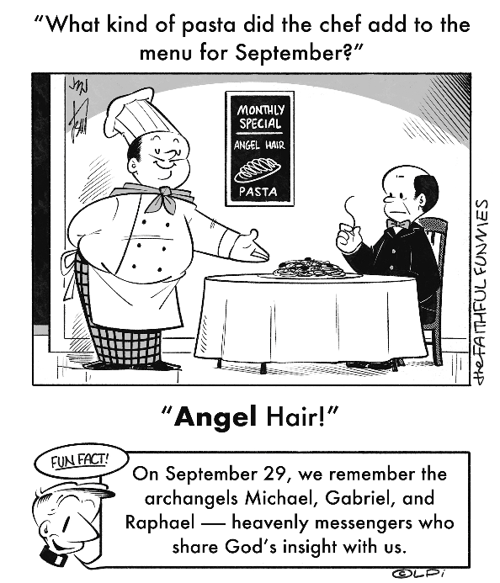
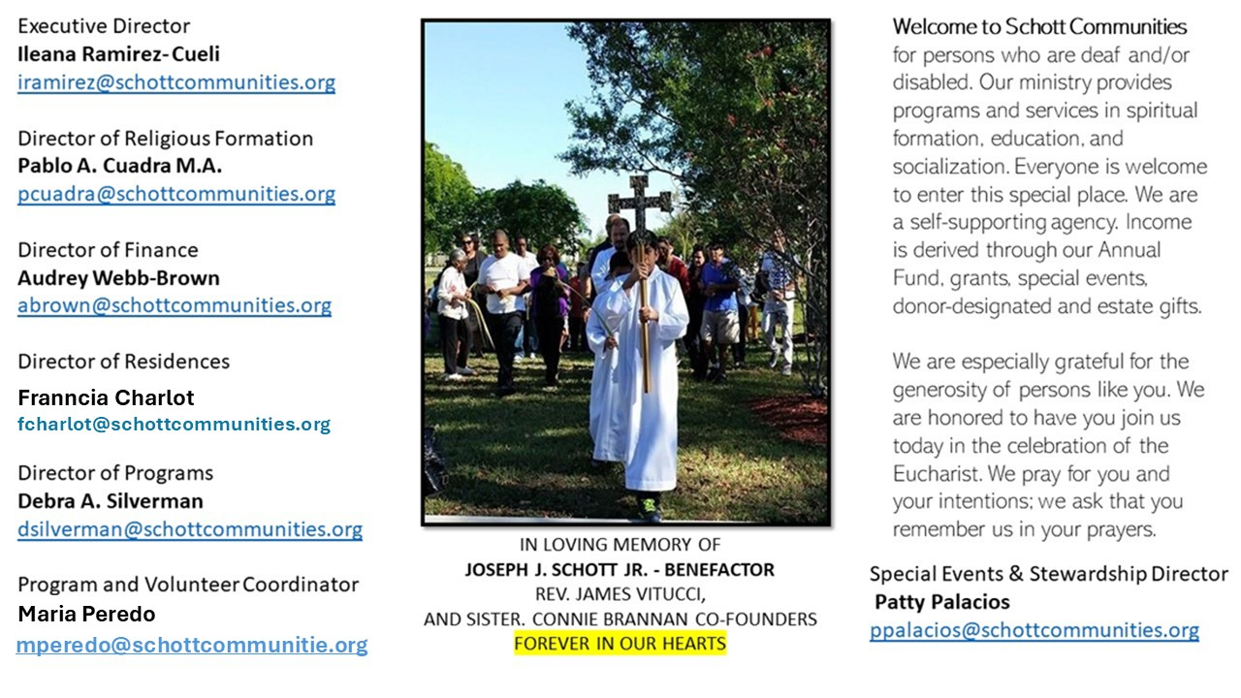

28 de septiembre de 2025
XXVI Domingo del Tiempo Ordinario

Un abismo enorme sigue existiendo entre la línea del pobre y del rico, entre los Lázaros y los ricos de nuestro tiempo. ¿Quiénes son? ¿Dónde están? Están mezclados, porque existen ricos tan pobres que no los conocemos; ellos, de su riqueza, comparten sus bienes calladamente con quienes los necesitan. Y podemos encontrar pobres tan ricos por su modo de vivir egoístamente y por almacenar rencor en su corazón. "Además, entre ustedes y nosotros hay un abismo tremendo, de tal manera que los que quieran cruzar desde aquí hasta ustedes no pueden hacerlo, y tampoco lo pueden hacer del lado de ustedes al nuestro" (Lucas 16:26). Aquí se trata de interiorizar la Palabra de Dios y darnos cuenta de que estamos representados en los dos personajes. Y lo importante es ayudar a la gente en sus diferentes necesidades, no hacernos sordos, como si no ocurriera nada.
San Agustín, en su Sermón 33 sobre el Antiguo Testamento, dice lo siguiente: "Escucha el evangelio, mira y examina los pensamientos de los dos hombres de la parábola: Había un hombre rico que se vestía de púrpura y lino y banqueteaba espléndidamente cada día… En cambio, un mendigo llamado Lázaro yacía a la entrada de su casa. No mencionó el nombre del rico, pero sí dijo el nombre del pobre. Dios calló el nombre del que andaba en boca de todos, mientras que mencionó el nombre del que todos callaban". ¿Crees que Dios menciona tu nombre? ¿O crees que lo calla?

September 28, 2025
26th Sunday in Ordinary Time
Luke 16:19-31

I am embarrassed to admit that I frequently find myself dining and socializing with people who have millions and sometimes billions of dollars. I’ve eaten more caviar, lobster and wagyu steak than most people on the planet. I justify it by saying it’s part of my job. But I have seven pairs of nice jeans and expensive shoes.

So it is rather uncomfortable to hear Our Lord say: “My child, remember that you received what was good in your lifetime, while Lazarus likewise received what was bad; but now he is comforted here, whereas you are tormented” (Luke 16:25). Fellow rich people (and if you’re American, you’re rich), do we not vehemently though quietly object to this parable’s karma-esque reward system? Why bless the rich man just to curse him later? And curse Lazarus just to bless him later? So Americans go to hell, while Burundians and Afghans go to heaven? What is going on?

One clue is that the condemned rich man doesn’t complain of injustice. Rather, he simply begs to help his brothers to repent. Of what? We don’t know exactly. Perhaps another clue is that the rich man now seems more like the downtrodden Lazarus. He knows what it is to be hungry and thirsty, to be wounded in the gutter; that he deserved that, not fancy meals and clothes. Maybe the rich man finally understands how to receive true blessings, but it is too late for him. But not for me. Not for us.

— Father John Muir

St. Jude Chapel, Sunday, September 28th, 2025
Father Dariel Fong
Celebrant

St. Thérèse of Lisieux

St. Thérèse of Lisieux (1873-1897) was a French Carmelite sister whose autobiography has inspired Catholics across the world to deepen their relationship with God. She died at 24 from tuberculosis and is currently the youngest person to be named a Doctor of the Church.
Amen.


Christian Giving
September 21st, 2025
$

We sincerely thank you and bless you for your generosity.
A bequest is a powerful tool to help the Deaf or Disabled.

Mass Intentions
“For the repose of the Souls in Purgatory
Requested by Schott Communities


Follow us on Facebook
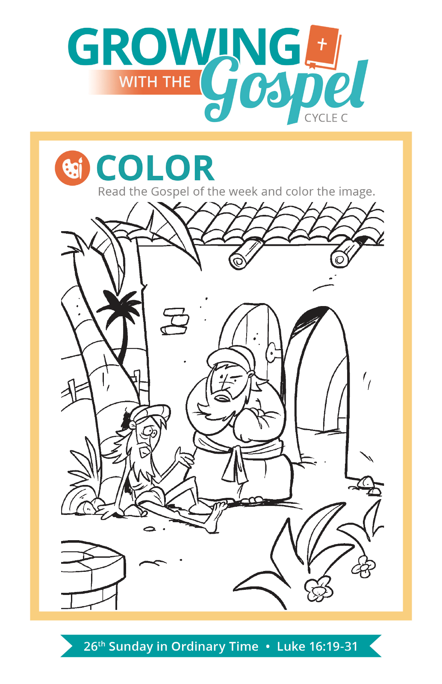
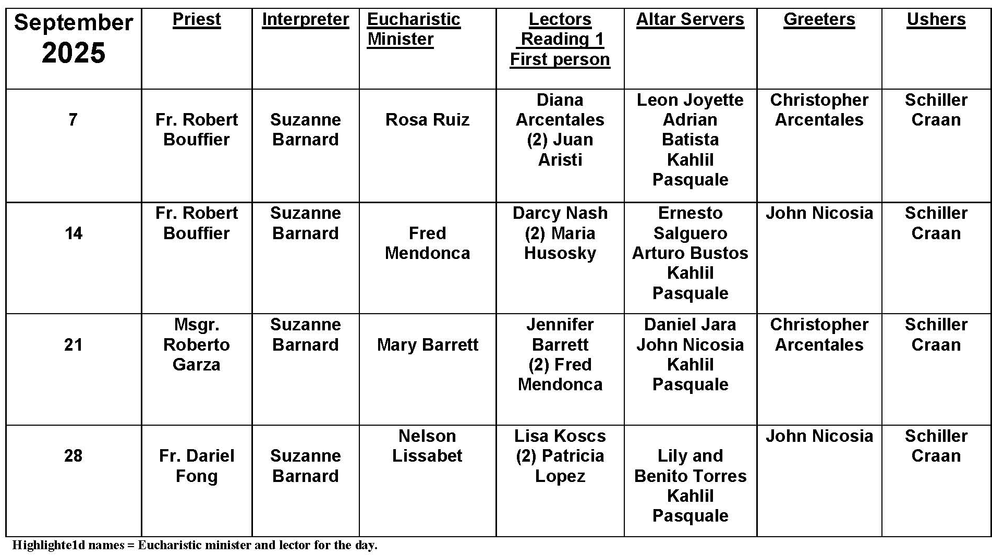
Can Divorced Catholics Take Communion?

Question: Can a divorced Catholic receive holy Communion?
Answer:
Unfortunately, too many people today — Catholics and non-Catholics alike — mistakenly believe that divorce separates one from the Communion of the Church and that divorced persons may not receive Communion. However, as the Church has communicated in a number of places, the issue at hand is not the reality of divorce, but is more often the reality of re-marriage outside of the Church (such as in the case of a Catholic who was previously married within the Church, divorced, and remarried without receiving an annulment).
Divorced persons are called to live chastely as single people and to observe the same call to avoid sin as anyone else who desires to receive the Eucharist. Beyond this, however, Pope Francis has reminded us that the healing power of the Eucharist can be especially significant for those who have “endured separation, divorce, or abandonment … divorced people who have not remarried, and often bear witness to marital fidelity, ought to be encouraged to find in the Eucharist the nourishment they need to sustain them in their present state of life.” (Amoris Laetitia, no. 242) Moreover, he continues, “The local community and pastors should accompany these people with solicitude, particularly when children are involved or when they are in serious financial difficulty.” (AL, no 242)
As Pope Francis has also reminded us, the Eucharist is “not a prize for the perfect,” but “a powerful medicine and nourishment” (Evangelii Gaudium, no. 47). Because we all stand in need of healing and wholeness, the Church invites all who seek to live their faith in integrity and devotion to come and receive the grace offered in the Eucharist.

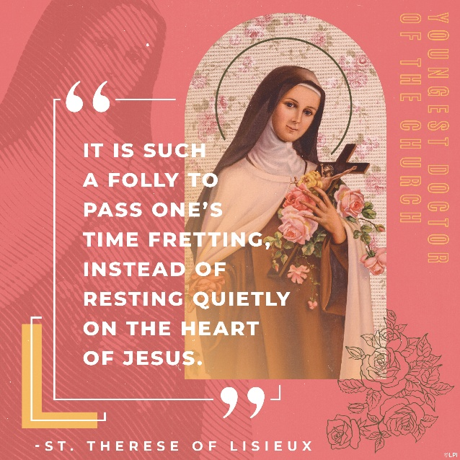
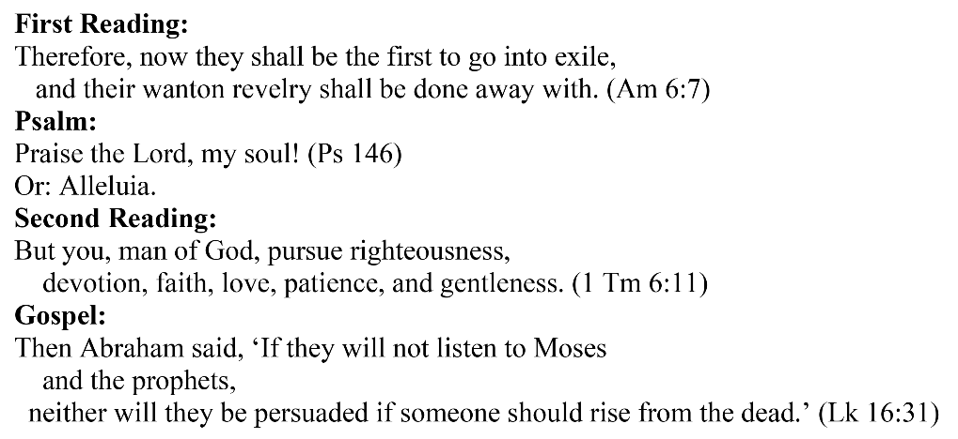
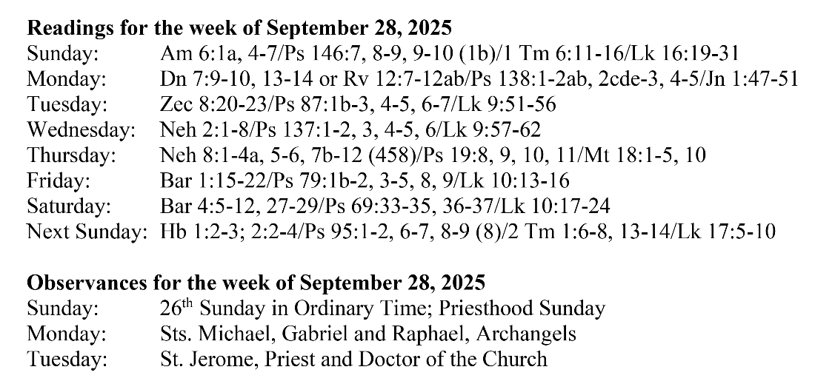
Are you in need of prayer? Do you have a prayer request? You can send your prayer requests to pcuadra@schottcommunities.org or call 954-434-3306 ext. 108

A copy of our prayer list can be found in the lobby of our chapel. To request a copy of our prayer list please email us at pcuadra@schottcommunities.org
To request a Mass please contact Pablo A. Cuadra at 954-434-3306 or e-mail at pcuadra@schottcommunities.org
Update: Celebrating a wedding anniversary soon? Let us know a week in advance and we can assist you with the renewal of your wedding vows.

Prayer to St. Michael the Archangel:
"St. Michael the Archangel, defend us in battle. Be our defense against the wickedness and snares of the Devil. May God rebuke him, we humbly pray, and do thou, O Prince of the heavenly hosts, by the power of God, thrust into hell Satan, and all the evil spirits, who prowl about the world seeking the ruin of souls. Amen"

