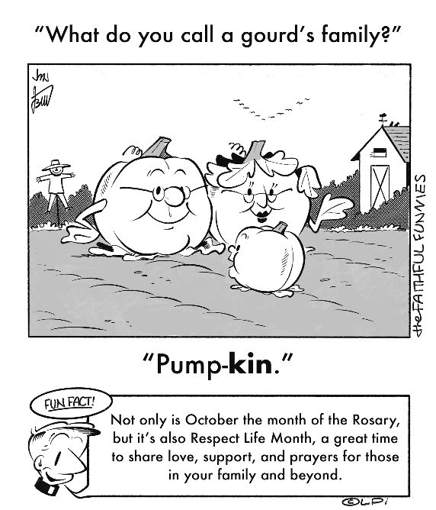
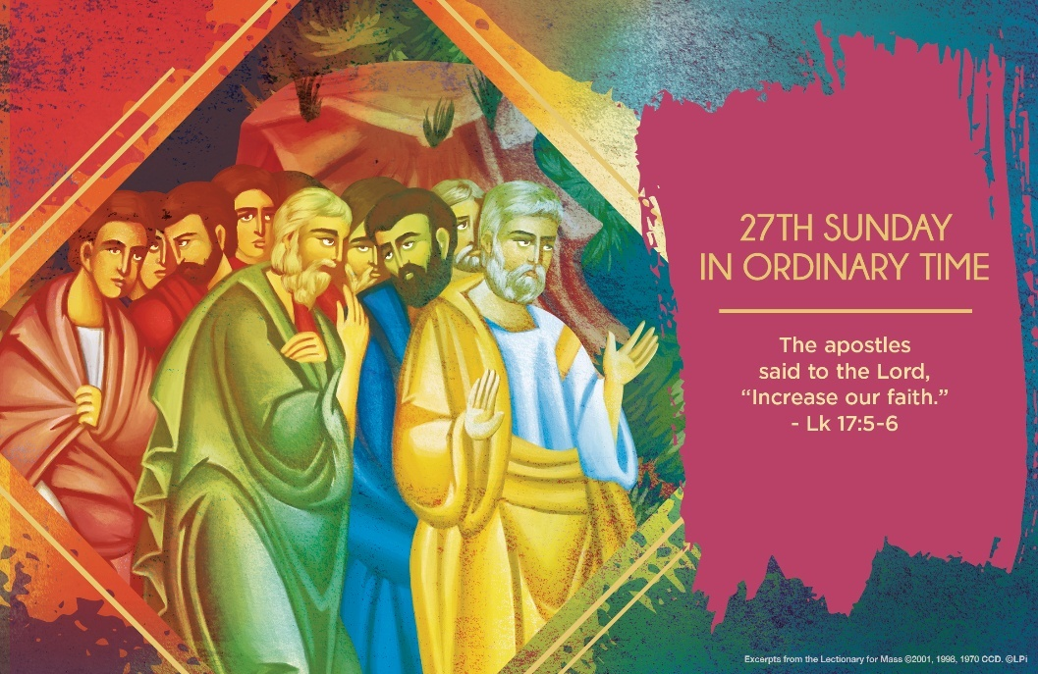
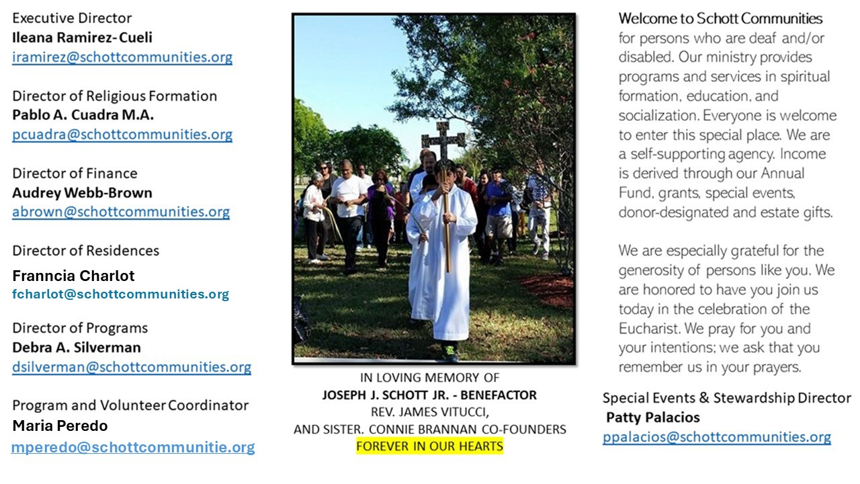

5 de octubre de 2025
XXVII Domingo del Tiempo Ordinario
Lucas 17:5-10

A lo largo del Evangelio encontramos diferentes pasajes donde Jesús elogia a las personas que tienen fe. Por ejemplo: "Levántate, tu fe te ha salvado" (Lucas 17:19). Un buen reto podría ser darnos a la tarea de leer los cuatro evangelios y tomar nota de estos pasajes, para así poder comparar a las personas de aquel tiempo con nosotros hoy, en lo que respecta a la fe. ¿En qué creemos actualmente? ¿Cómo podemos medir la fe que hay en nosotros? ¿Seguimos a Jesús solo para pedirle favores y que nos haga milagros, o porque de verdad tenemos fe en Él?

El Catecismo de la Iglesia Católica, en sus números 176 y 184, nos dice lo siguiente sobre la fe:
"La fe es una adhesión personal del hombre entero a Dios que se revela. Comprende una adhesión de la inteligencia y de la voluntad a la revelación que Dios ha hecho de sí mismo mediante sus obras y sus palabras". Y añade: "La fe es un gusto anticipado del conocimiento que nos hará bienaventurados en la vida futura". La vida de fe no se construye en solitario. Para su crecimiento, intervienen muchos factores. El primero nos fue dado desde el bautismo, y nuestros padres y abuelos participaron de primera mano en su desarrollo. La comunidad de fe es otro factor esencial. Después, el crecimiento de la fe depende de cada uno. Hoy, hagamos la misma petición que hicieron los apóstoles: "Señor, auméntanos la fe". Seguramente, la respuesta será la misma. ¿Verdad?

October 5, 2025
Twenty-Seventh Sunday in Ordinary Time
Luke 17:5-10

A priest friend of mine received a call from a family whose elderly mother was dying. Within thirty minutes, he was at her bedside, offering the consolation of the sacraments, anointing her with the oil of the sick, and commending her soul to God. She passed not long after, and for months, her family spoke of their deep gratitude for his presence. When I phoned him to commend his faithful ministry, he simply said, “I was just doing my job.”
His words brought to mind Jesus’ teaching this week in Luke 17:10: “So you also, when you have done everything you were told to do, should say, ‘We are unworthy servants; we have only done our duty.’” In a world that often seeks recognition and applause, the Lord invites us into a different mindset — one of humble service. The priest did not see his response as extraordinary; he saw it as a grace to fulfill his vocation.
How tempting it is to seek affirmation for doing what I ought to do! Yet Jesus reminds us that true discipleship is not about grandstanding but about quiet faithfulness. It is enough to have served. It is enough to have loved. It is enough to be grateful that we were given the chance to do our duty in the first place. Whether in priesthood, parenthood, or any vocation, what peace-soaked freedom there is in simply doing what is asked of us. No more, no less. Jesus, that is how you quietly love us.

— Father John Muir

St. Jude Chapel, Sunday, October 5th, 2025
Father Robert Bouffier
Celebrant

Saint John XXIII, Pope | October 11
Saint John XIII was born Angelo Giuseppe Roncalli on November 25, 1881, in a small village in Italy. He was ordained in 1904 and later earned a doctorate in canon law. During World War I he served as a stretcher-bearer and chaplain for the Italian army. Beginning in 1925 he served as a Vatican diplomat, first in Bulgaria, then in Greece and Turkey. From 1935 through the Second World War he helped save thousands of Jewish people. In 1944 he was named papal nuncio to France. He was named cardinal and appointed patriarch of Venice in 1953.


Christian Giving
September 28th, 2025
$520

We sincerely thank you and bless you for your generosity.
A bequest is a powerful tool to help the Deaf or Disabled.

Mass Intentions
“For the repose of the Souls in Purgatory
Requested by Schott Communities


Follow us on Facebook

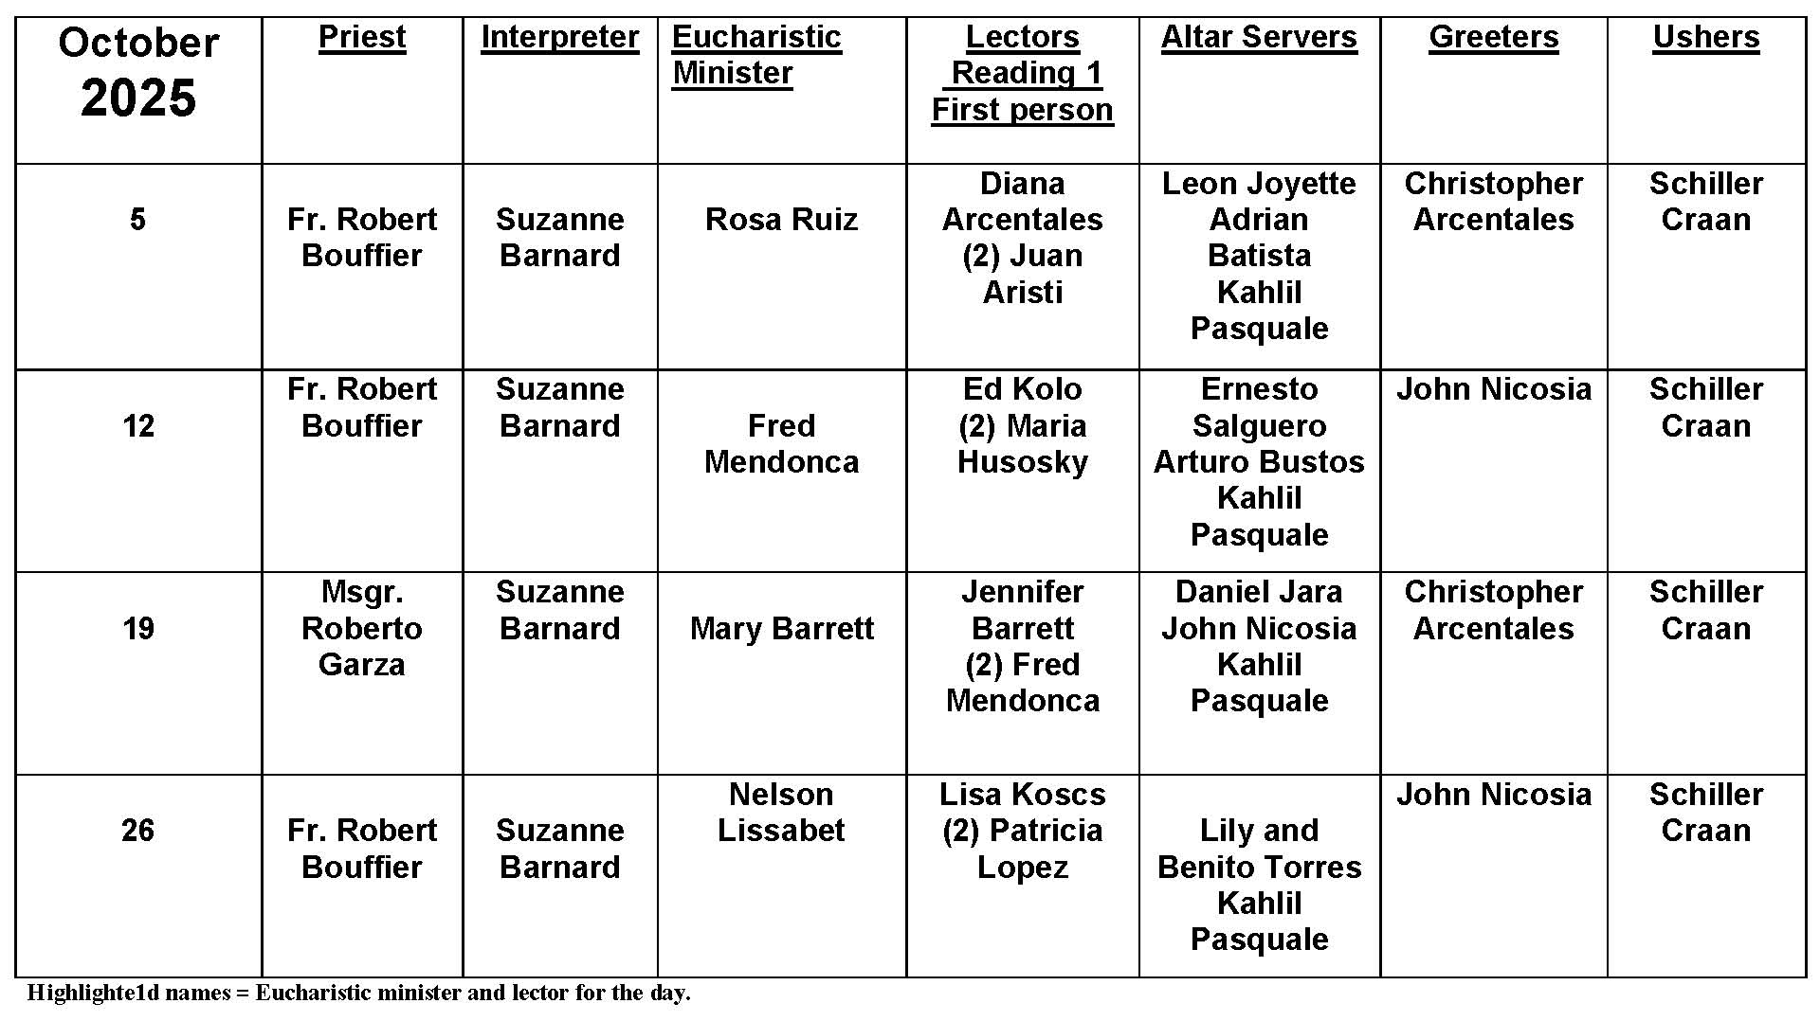
Stations of the Cross

Question:
Who invented the Stations of the Cross?

Answer:
The first Stations of the Cross were walked by Jesus himself on the way to Calvary. Known as the "Via Dolorosa" ("The Way of Suffering") or the "Via Crucis" ("The Way of the Cross"), it was marked out from the earliest times and was a traditional walk for pilgrims who came to Jerusalem. The early Christians in Jerusalem would walk the same pathway that Jesus walked, pausing for reflection and prayer. Later, when Christians could not travel to the Holy Land, artistic depictions of "The Way of the Cross" were set up in churches, or outside and Christians would walk from station to station, reading the Gospel account of the Passion, or simply praying and reflecting on each event. While the content or place of each station had changed, the intention was to make a mini-pilgrimage and follow--literally--in the footsteps of Jesus.

This devotion became better known in the Middle Ages, and the Franciscans are credited with its spread. Lent is a time when many people make the Stations and some churches present Passion plays or Living Stations. But anyone can pray the Stations at any time. It is a simple and personal reflection on the passion of Jesus and what it means to us.

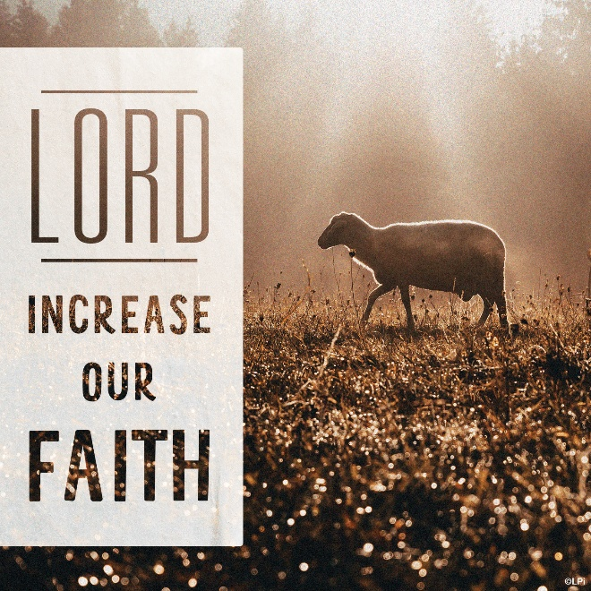
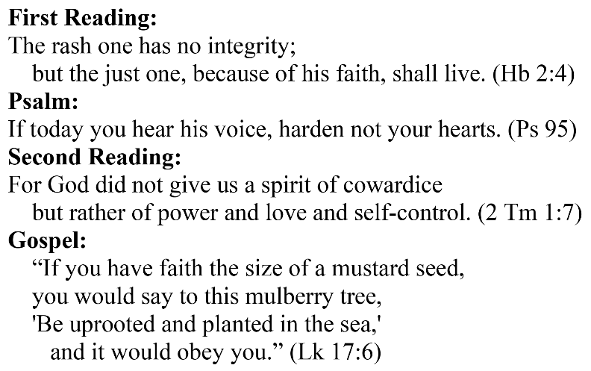
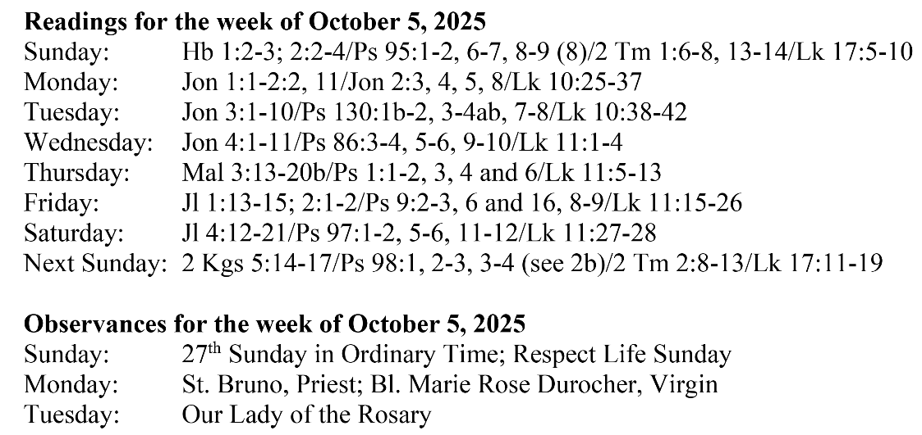
Are you in need of prayer? Do you have a prayer request? You can send your prayer requests to pcuadra@schottcommunities.org or call 954-434-3306 ext. 108

A copy of our prayer list can be found in the lobby of our chapel. To request a copy of our prayer list please email us at pcuadra@schottcommunities.org
To request a Mass please contact Pablo A. Cuadra at 954-434-3306 or e-mail at pcuadra@schottcommunities.org
Update: Celebrating a wedding anniversary soon? Let us know a week in advance and we can assist you with the renewal of your wedding vows.

Prayer to St. Michael the Archangel:
"St. Michael the Archangel, defend us in battle. Be our defense against the wickedness and snares of the Devil. May God rebuke him, we humbly pray, and do thou, O Prince of the heavenly hosts, by the power of God, thrust into hell Satan, and all the evil spirits, who prowl about the world seeking the ruin of souls. Amen"

