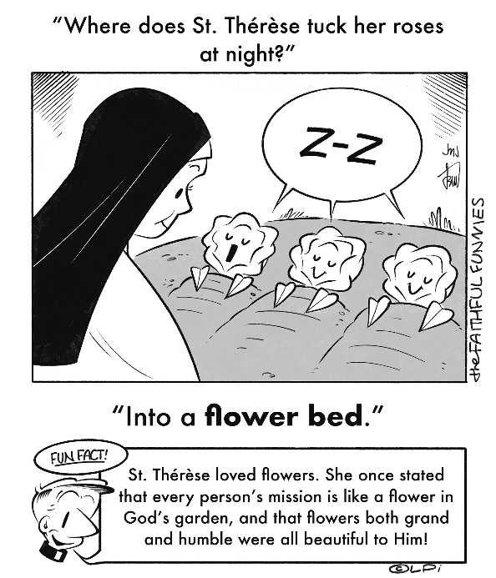
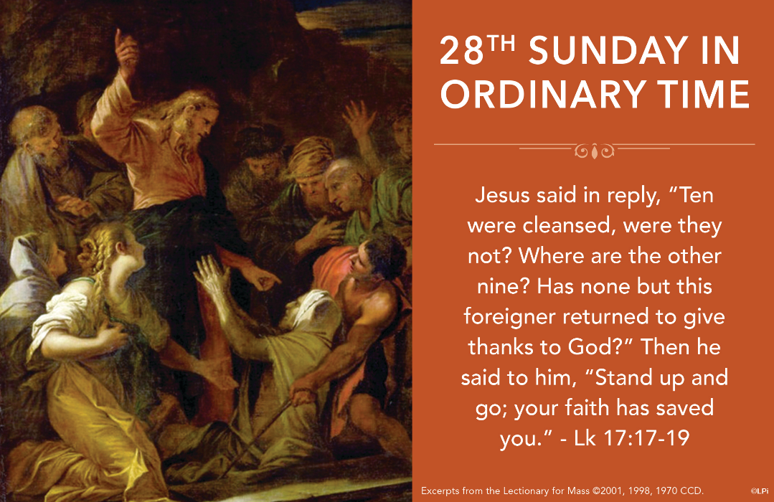
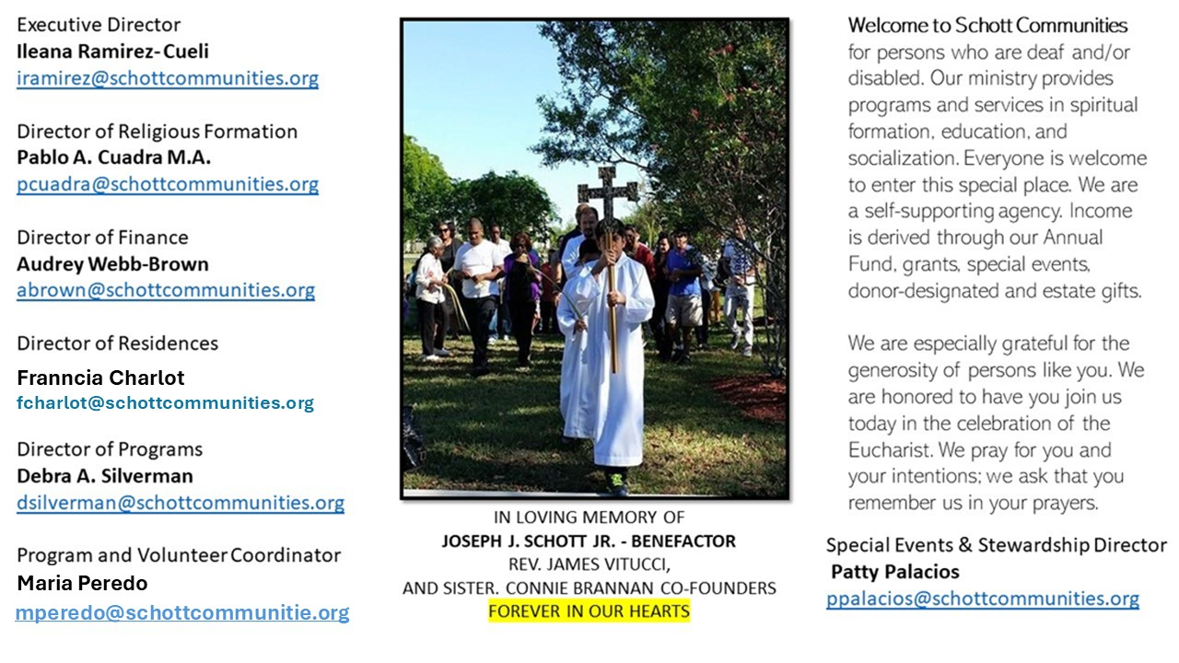

12 de octubre de 2025
XXVIII Domingo del Tiempo Ordinario
Lucas 17:11-19

En nuestros tiempos se conversa sobre muchas cosas: moda, política, belleza, o sobre quién tiene mejor estatus en la sociedad. Pero de lo que rara vez se dialoga es sobre la fe. Para muchas personas, ese tema parece pasado de moda. Sin embargo, el domingo pasado y este domingo, Jesús nos muestra lo que es la fe. Hoy se alaba el espíritu de agradecimiento de un leproso, y ese agradecimiento a Dios nace precisamente de su fe. Fueron curados diez, pero solo uno, nos narra el Evangelio, regresó a dar gracias: "Uno de ellos, al verse sano, volvió de inmediato alabando a Dios en alta voz, y se echó a los pies de Jesús con el rostro en tierra, dándole las gracias" (Lucas 17:15-16). Después de ese acto de gratitud, se dio un diálogo entre Jesús y el hombre, y Jesús le dio una respuesta inmediata: "Levántate y vete: tu fe te ha salvado" (Lucas 17:19).

San Atanasio de Alejandría, en su Carta Festal (c. 295–373), dice lo siguiente: "El Maestro alabó el espíritu agradecido de uno de aquellos, pero le disgustó el comportamiento de los nueve ingratos, porque no reconocieron al autor de su beneficio. Pensaron más en la curación de su lepra que en quien los había curado. Ciertamente, el que fue curado escuchó del Señor: 'Levántate, vete: tu fe te ha salvado'. Los agradecidos y los que alaban a Dios son como hermanos, que bendicen a su Salvador por los beneficios que de Él han recibido." ¡Señor, dame un corazón agradecido!

October 12, 2025
Twenty-Eighth Sunday in Ordinary Time
Luke 17:11-19

Dorothy Day, the great Catholic activist, doubted God’s existence. At least in her early adult years. But something changed when after giving birth to her daughter, she experienced an overwhelming gratitude. She later described how, as she held her daughter, the only appropriate response was a kind of unlimited gratitude. She had done nothing to deserve such a gift — this tiny, miraculous life — but there she was, flooded with gratitude, completely undone by the love of such a Giver.
Something similar occurs in Luke 17:19 when Jesus tells a healed leper, “Stand up and go; your faith has saved you.” This man had already received physical healing through his faith. But the moment of an even deeper transformation came when he turned back, fell at Jesus’ feet, and gave thanks. Like Dorothy, this man’s gratitude led him to encounter the Giver.
Isn’t that what we want, too? Gratitude to God has the power to break our chains of sadness, bitterness, and disenchantment. It empowers us to step out of the prison of self-pity and into the reality of God’s abundant love. It shifts our focus from what we lack to what we have received, from what wounds us to what heals us.
Where do we learn this? The Mass. The priest prays: “It is truly right and just, our duty and our salvation, always and everywhere to give you thanks.” Always. Everywhere. Not just when life is easy. Not just when prayers are answered as we expect. Gratitude is not a passive feeling; it is an act of faith. In the eucharist, we remember that Christ himself has given everything for us. And in this act of gratitude, we are healed.

— Father John Muir

St. Jude Chapel, Sunday, October 12th, 2025
Father Robert Bouffier
Celebrant

St. Teresa of Ávila | Feast Day October 15
St. Teresa of Ávila (1515-1582) was a Spanish Carmelite nun who lived in the 16th century. She was a mystic and author of spiritual writings and poems. The originator of the Carmelite Reform, she founded numerous convents throughout Spain and restored a contemplative life to the order. She became well known for the mystical experiences, many of which she described in her autobiography.


Christian Giving
October 5th, 2025
$

We sincerely thank you and bless you for your generosity.
A bequest is a powerful tool to help the Deaf or Disabled.

Mass Intentions
“For the repose of the Souls in Purgatory
Requested by Schott Communities


Follow us on Facebook

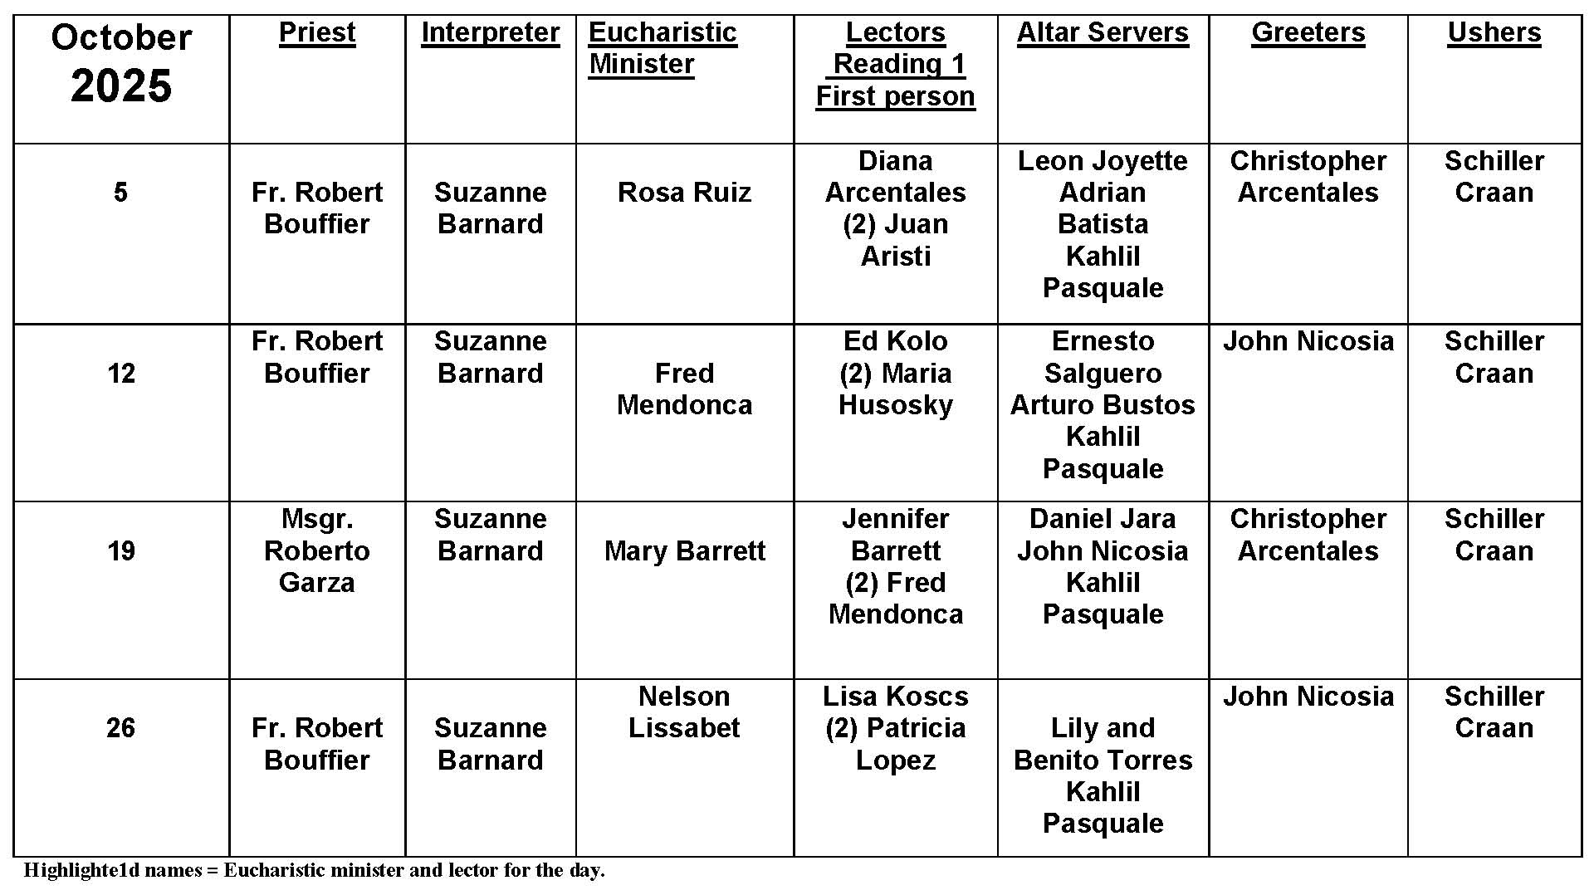
Vicar General and Chancellor

Question:
I have seen the title of Vicar General and Chancellor used in our Catholic newspaper. Who are they and what do they do?
Answer:
A bishop is in charge of a diocese and appoints people to help with its administration. Two of those positions are the Vicar General and the Chancellor. Both play a role in the life of a diocese, despite the many jokes priests may tell at their expense! A chancellor is the archivist of a diocese, charged with task of keeping the records of the diocese. Often a bishop may add other responsibilities and the chancellor may end up being like the executive director of the diocesan office. The chancellor does not need to be a priest.
The vicar general is a priest, appointed by the bishop and acts in the name of the bishop in administering the diocese. He has an advanced degree in canon law or theology. He also has executive authority within the diocese. This means that he is involved in the day-to-day pastoral and temporal administration of the diocese. Canon law does not allow a bishop to appoint a relative to the position, nor the priest in charge of the sacrament of penance. In both cases, the purpose of the law is to avoid conflicts of interest.

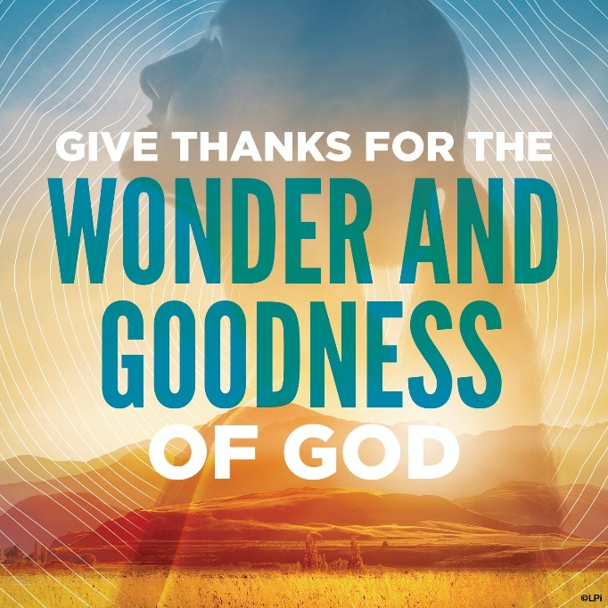
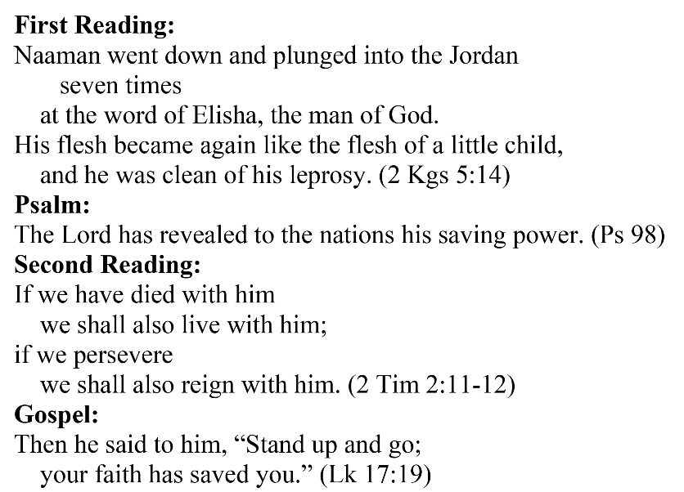
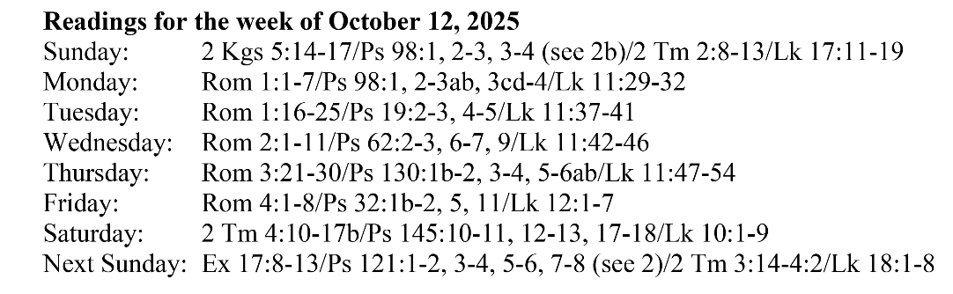
Are you in need of prayer? Do you have a prayer request? You can send your prayer requests to pcuadra@schottcommunities.org or call 954-434-3306 ext. 108

A copy of our prayer list can be found in the lobby of our chapel. To request a copy of our prayer list please email us at pcuadra@schottcommunities.org
To request a Mass please contact Pablo A. Cuadra at 954-434-3306 or e-mail at pcuadra@schottcommunities.org
Update: Celebrating a wedding anniversary soon? Let us know a week in advance and we can assist you with the renewal of your wedding vows.

Prayer to St. Michael the Archangel:
"St. Michael the Archangel, defend us in battle. Be our defense against the wickedness and snares of the Devil. May God rebuke him, we humbly pray, and do thou, O Prince of the heavenly hosts, by the power of God, thrust into hell Satan, and all the evil spirits, who prowl about the world seeking the ruin of souls. Amen"

