
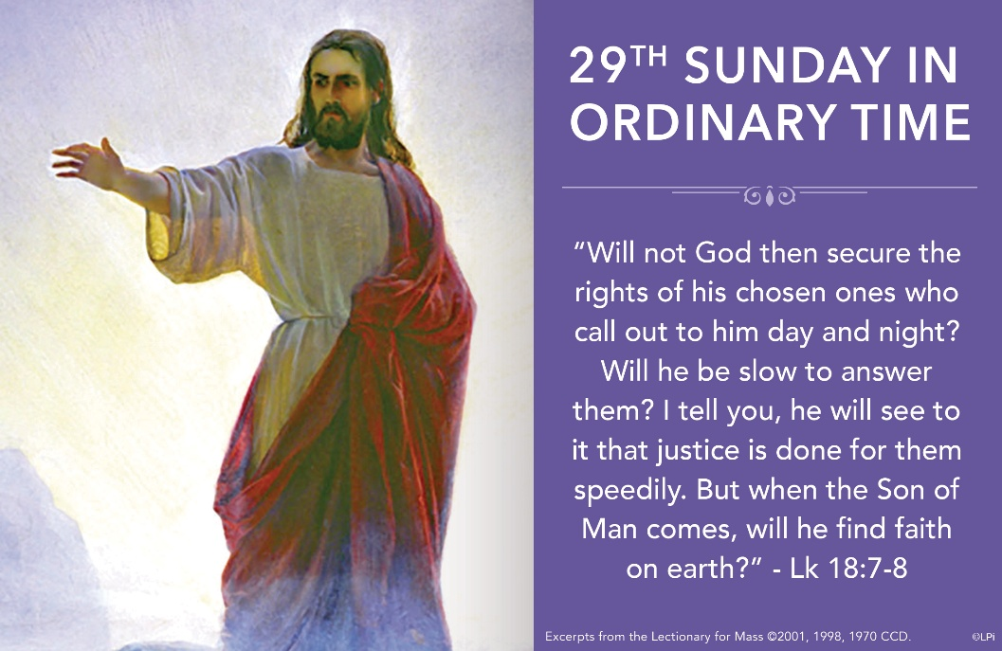
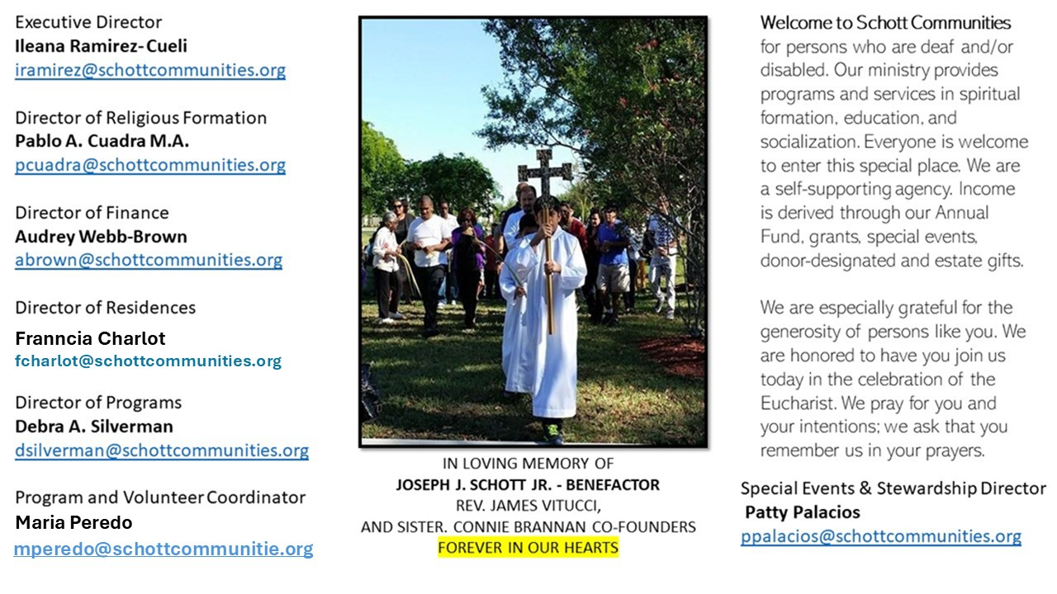

19 de octubre de 2025
XXIX Domingo del Tiempo Ordinario
Lucas 18:1-8

La forma de actuar de Dios es muy diferente a la nuestra. A veces, con nuestras súplicas, queremos moldear a nuestro modo el actuar de Dios. Es por eso que muchas veces se pierde la esperanza: porque deseamos que las cosas sucedan cuando queremos y como queremos. Sin embargo, la Palabra de Dios nos invita a ser perseverantes en la oración: "Predica la Palabra, insiste a tiempo y a destiempo, corrige, reprende y exhorta con toda paciencia y doctrina" (2 Timoteo 4:2).

En lo que respecta a la injusticia, se necesita una tenacidad descomunal; es decir, no desmayar ante las adversidades, como lo demuestran los personajes de la parábola de hoy. San Efrén (306–373), en su Comentario al Diatesarón, escribe: "De hecho, la perseverancia de la viuda humilló la iniquidad del juez rebelde a Dios y la insolencia arrogante contra los hombres. La voluntad de la viuda las sometió, y de esta manera pudo encontrar justicia ante su adversario. La oración inoportuna transformó las dos ramas amargas para que dieran frutos dulces, ajenos a su naturaleza… El fruto de la justicia es la correcta atribución de los oprimidos, y el fruto de la bondad es el consuelo de los afligidos”. Oremos hoy por todas las personas que buscan justicia, luchando día a día hasta encontrarla. Tengamos la seguridad de que Dios, en su infinita bondad, escucha sus ruegos, porque Él es justo y su misericordia no tiene límites.

October 19, 2025
Twenty-Ninth Sunday in Ordinary Time
Luke 18:1-8

A woman in my parish has an adult son who has rejected his faith. She prays for him every day. She lights candles, says rosaries, and asks God again and again to bring him back. But nothing changes. Is God listening? Is He delaying? She told me once that she feels like the widow in Jesus’ strange parable — crying out for justice, but hearing only silence. And yet, she said, she is at peace. I asked why. She responded, “God is already answering. I just can’t see it yet.”
She embodies something of the mystery in Jesus’ parable this week in Luke 18. A powerless widow demands justice from a corrupt judge. This isn’t about wearing God down until He gives in. It’s about faith in the justice that is already coming. The widow isn’t just persistent; she believes that justice is inevitable. And when Jesus points to the judge’s words — his fear of being “struck” — He hints at something deeper: God’s justice does not creep in gradually. It strikes. It comes like lightning.
Blessed Mary is, of course, the ultimate widow demanding justice. At the foot of the cross she stands before what looks like the ultimate injustice — the brutal execution of her son. But she did not despair. She did not beg for a last-minute rescue. She knew that justice was not delayed. In fact, it was happening. The power of the cross was already unleashing justice upon the world — suddenly, decisively, like a blow that would topple every corrupt power, making even the most corrupt fear her strike.
This parable asks us: will the Son of Man find faith on earth? Or will we mistake God’s silence for absence? The cross proves that justice is not slow. It is only hidden. The lightning has already struck. In the cross, justice is speedily being done.

— Father John Muir

St. Jude Chapel, Sunday, October 19th, 2025
Monsignor Roberto Garza
Celebrant

St. Anthony Mary Claret | October 24

Saint Anthony Mary Claret (1807-1870), sometimes called the “spiritual father of Cuba,” was a priest and popular preacher with a missionary heart. He founded the Claretians missionary order and the Religious Publishing House and reformed the Archdiocese in Cuba.


Christian Giving
October 12th, 2025
$

We sincerely thank you and bless you for your generosity.
A bequest is a powerful tool to help the Deaf or Disabled.

Mass Intentions
“For the repose of the Souls in Purgatory
Requested by Schott Communities


Follow us on Facebook

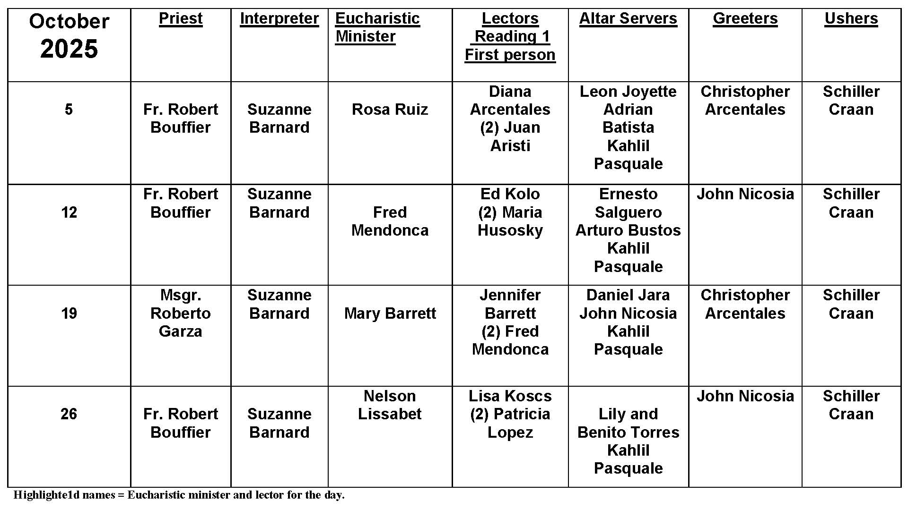
Serving Others

Question:
I volunteer every once in a while. How can I incorporate serving the poor in my everyday life?

Answer:
In the Gospels, Jesus is very clear about emphasizing outreach to vulnerable persons on the margins of society. These may be the materially poor, the disabled, the lonely, or any others whose circumstances drive them from mainstream society. We can all respond to Christ’s call to love by incorporating direct service into our regular life routine. Here are some ideas to find your niche:

Consider your life. Before you look for direct service opportunities, consider your schedule, commitment levels, and personal gifts. When can you help out and how regularly? Where have you volunteered in the past that has felt like a good fit? Do you have any particular skills or personality traits that lend you to particular work?

Do some research. There are a lot of structured ways you can get involved in your community. Your parish might have a social concerns outreach program. If not, ask friends and family. A simple online search for local nonprofits can also expose you to new opportunities.

Be open to God’s invitation. The chance to serve may be closer than you think. Befriending an elderly neighbor, widowed and far from children, is an act of serving the poor. Keep your eyes and heart open!

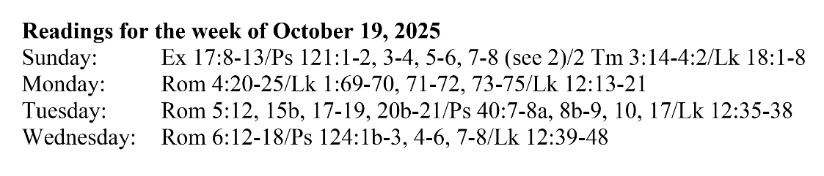
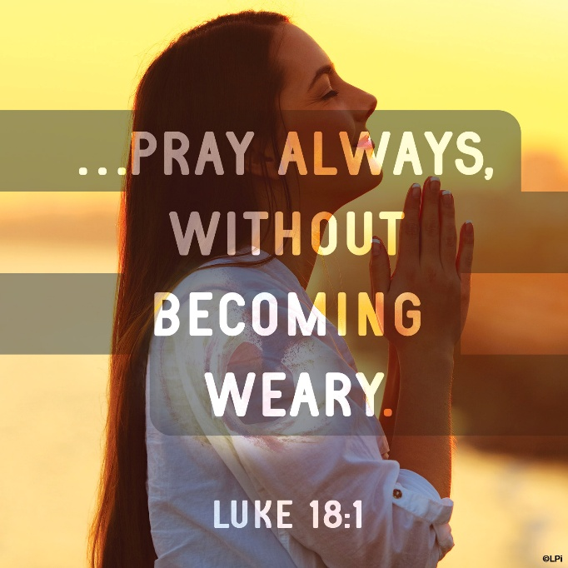
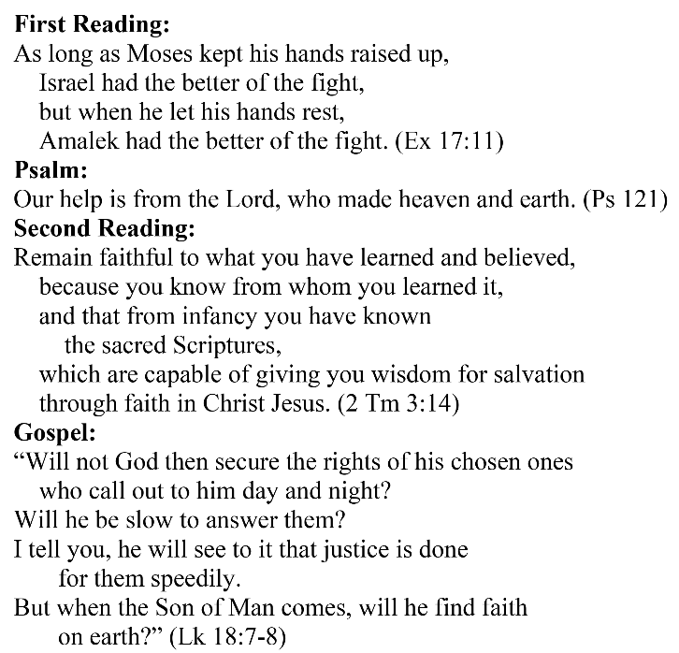
Are you in need of prayer? Do you have a prayer request? You can send your prayer requests to pcuadra@schottcommunities.org or call 954-434-3306 ext. 108

A copy of our prayer list can be found in the lobby of our chapel. To request a copy of our prayer list please email us at pcuadra@schottcommunities.org
To request a Mass please contact Pablo A. Cuadra at 954-434-3306 or e-mail at pcuadra@schottcommunities.org
Update: Celebrating a wedding anniversary soon? Let us know a week in advance and we can assist you with the renewal of your wedding vows.

Prayer to St. Michael the Archangel:
"St. Michael the Archangel, defend us in battle. Be our defense against the wickedness and snares of the Devil. May God rebuke him, we humbly pray, and do thou, O Prince of the heavenly hosts, by the power of God, thrust into hell Satan, and all the evil spirits, who prowl about the world seeking the ruin of souls. Amen"

