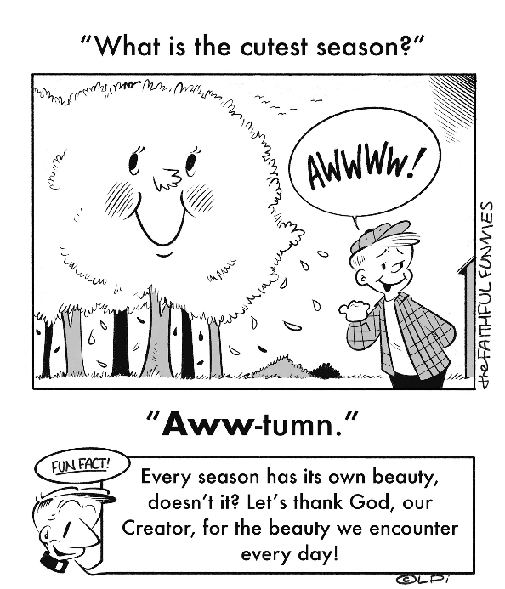
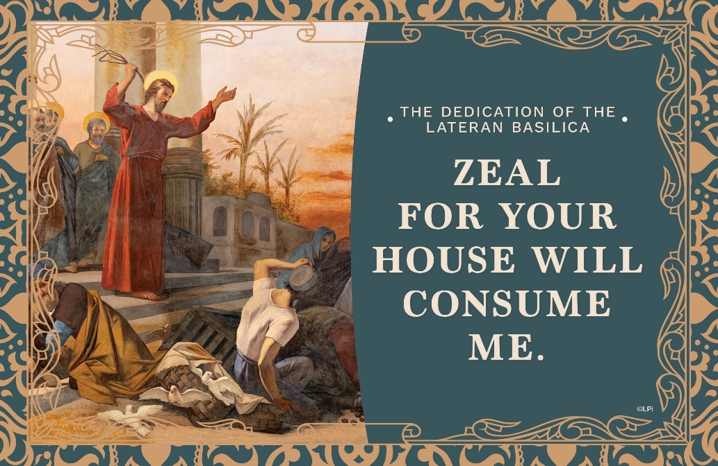
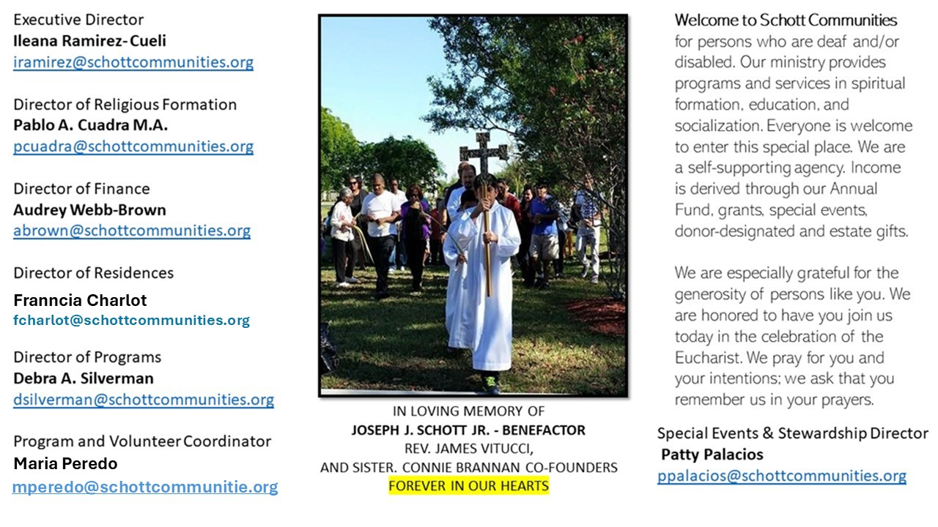

9 de noviembre de 2025
Dedicación de la Basílica de Letrán
Juan 2:13-22
El Espíritu de Dios vive en nosotros. La dignidad humana radica en esto: en que somos templo vivo del Espíritu Santo. Este es el gran regalo de Dios a nosotros, otorgado por la gracia. El apóstol san Pablo nos ofrece una poderosa reflexión al respecto: “¿No saben que son templo de Dios y que el Espíritu de Dios habita en ustedes? Si alguno destruye el templo de Dios, Dios lo destruirá a él. El templo de Dios es sagrado, y ese templo son ustedes” (1 Corintios 3:16–17). Saber esto conlleva una gran responsabilidad para cada uno de nosotros. ¿Cómo cuido el templo de Dios que es mi cuerpo? ¿Qué tipo de cimientos sostienen su construcción diaria? Recuerda que su principal función es demostrar que allí habita el Dios vivo.
El pasaje del Evangelio nos presenta otra imagen de la hermosura y santidad del templo: “Jesús purifica el templo, y lo hace con el látigo en la mano. Se pone a expulsar las actitudes paganas, en este caso, de los mercaderes que vendían y habían transformado el templo en pequeños negocios. Jesús purifica el templo reprendiendo: ‘Está escrito: mi casa será casa de oración, no de otra cosa’. El templo es un lugar sagrado. Y nosotros debemos entrar allí, en la sacralidad que nos lleva a la adoración. No hay otra cosa. Hay dos templos: el templo material, lugar de adoración, y el templo espiritual dentro de mí, donde mora el Espíritu Santo” (Papa Francisco).

November 9, 2025
The Dedication of the Lateran Basilica
John 2:13-22

When I was 22, I entered St. Peter’s Basilica for the first time. It floored me. I could hardly take it in, its grandeur, majestic arches, vibrant colors, and the light that danced through its high windows. Somehow, amidst such splendor, I felt an overwhelming sense of belonging, as if I had finally come home.
Jesus reorients how we Catholics see sacred buildings. In today’s Gospel he says, “Destroy this temple, and in three days I will raise it up” (John 2:13-22). His riddle implies, shockingly, that his own body is now the fundamental dwelling place of God and humanity. The temple in Jerusalem has been superseded.
In our churches today — whether they mirror the basilica’s grandeur or embrace humble simplicity — we experience architectural symbols of Christ’s risen body. It is no accident we call them “churches”: they make visible in brick-and-mortar Christ’s body which is made up of the living stones we call Christians. Each church building, like St. John Lateran in Rome, or St. Peter’s, or any other, is meant to be a vibrant sign of Christ’s resurrected body. We should cherish and protect our churches as places where heaven touches earth, where we, as a community, are raised to the fullness of life in Christ.

— Father John Muir

St. Jude Chapel, Sunday, November 9th, 2025
Father Robert Bouffier
Celebrant

St. Frances Xavier Cabrini | November 13

St. Frances Xavier Cabrini (1850 –1917) dreamed of being a missionary. She first served Italian immigrant populations, from New York to Chicago, and across the U.S. She is the first United States citizen to be canonized and is the Universal Patron of Immigrants.


Christian Giving
November 2nd, 2025
$523

We sincerely thank you and bless you for your generosity.
A bequest is a powerful tool to help the Deaf or Disabled.

Mass Intentions
“For the repose of the Souls in Purgatory
Requested by Schott Communities


Follow us on Facebook
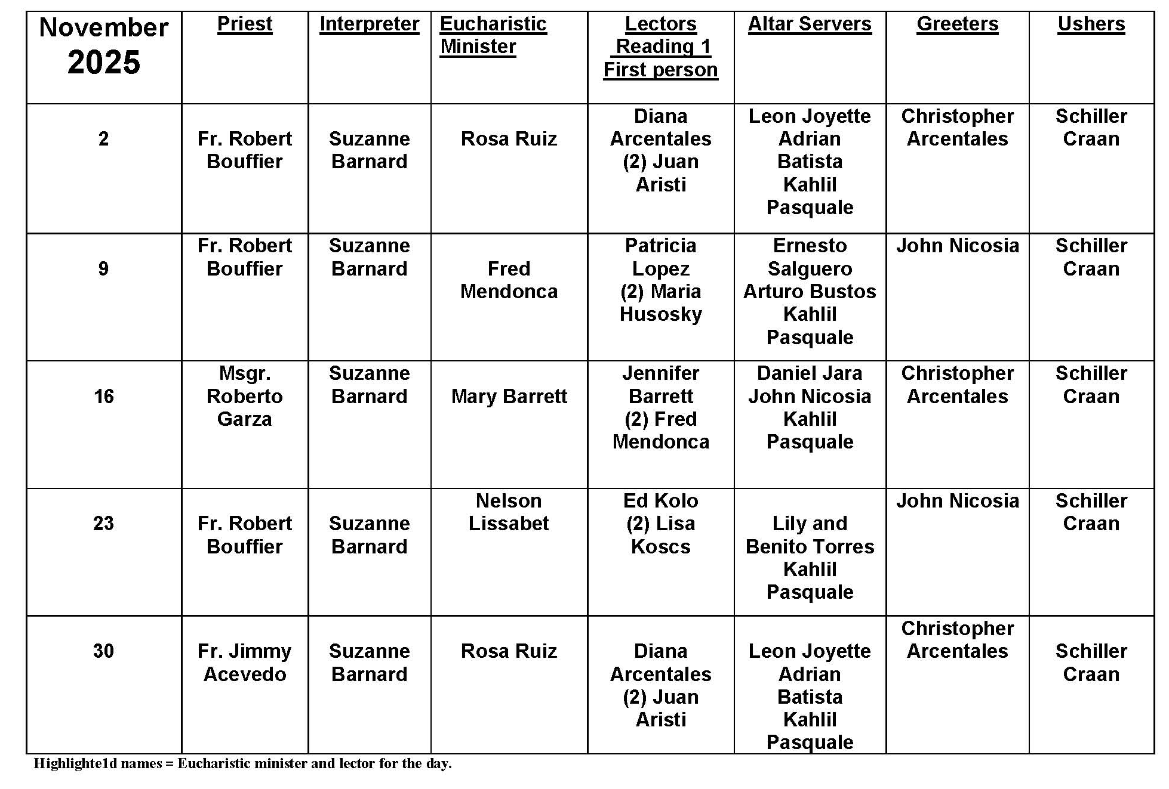
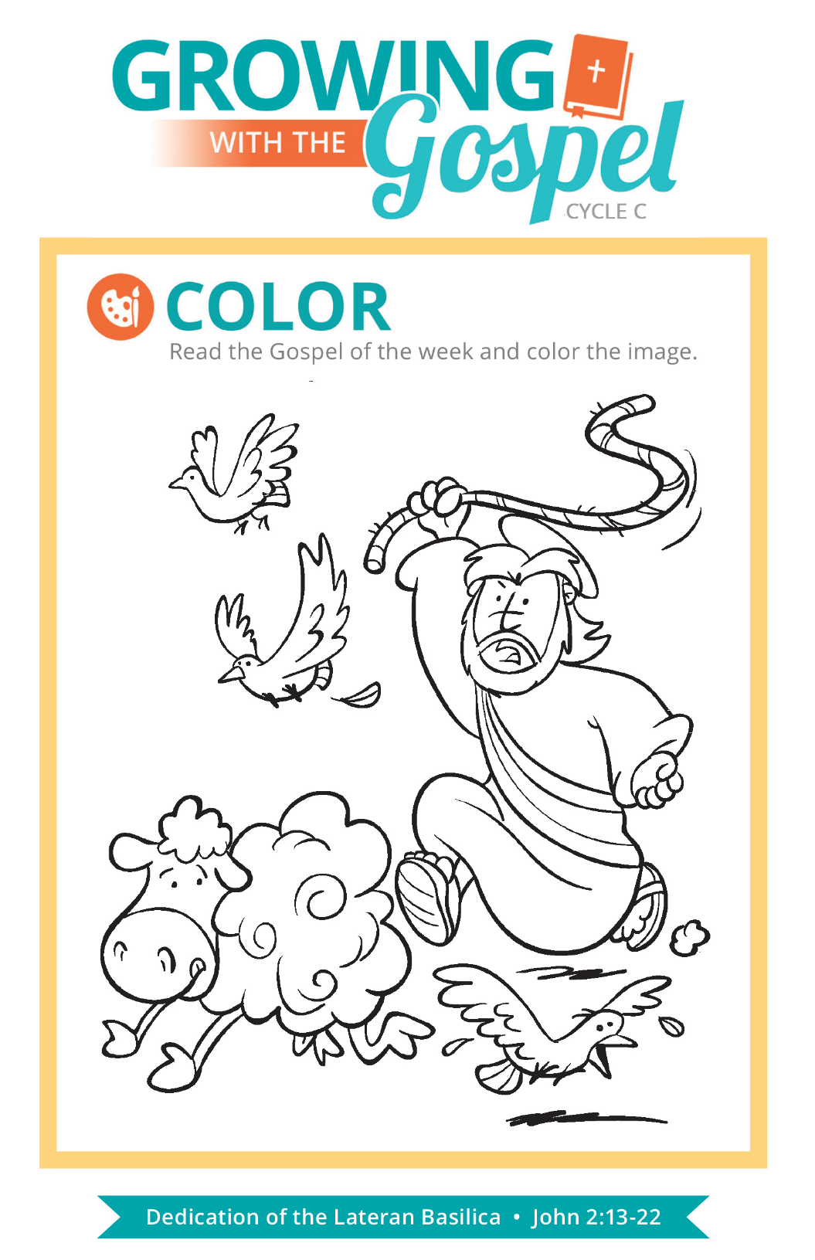
Cremation and The Church
Question:
Can Catholics be cremated?

Answer:
As the practice of cremation becomes more and more common, it’s important to know what the Church asks of families who have chosen this for a loved one who has died.

As the US Bishops observe on their website, “Ideally, if a family chooses cremation, the cremation would take place some time after the Funeral Mass, so that there can be an opportunity for the Vigil for the Deceased in the presence of the body.” However, if cremation takes places before the Funeral Mass, the cremated remains can be present at the Funeral Mass and the appendix to the Order of Christian Funerals provides adaptations for the texts and rituals that are part of the Funeral Mass and the Committal.

The primary concern is that the cremated remains should be treated with the same respect given to any human remains. The Order of Christian Funerals instructs, “This includes the use of a worthy vessel to contain the ashes, the manner in which they are carried, and the care and attention to appropriate placement and transport, and the final disposition. The cremated remains should be buried in a grave or entombed in a mausoleum or columbarium. The practice of scattering cremated remains on the sea, from the air, or on the ground, or keeping cremated remains on the home of a relative or friend of the deceased are not the reverent disposition that the Church requires” (no. 417).

It is becoming more and more common for parishes or diocese-sponsored cemeteries to include columbaria to house cremated remains in a way that respects Church teaching, allowing family and friends the opportunity to honor the remains of the one they have lost with dignity, reverence, and care.

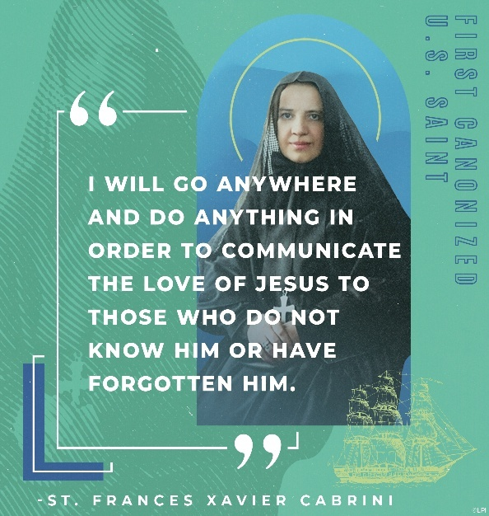
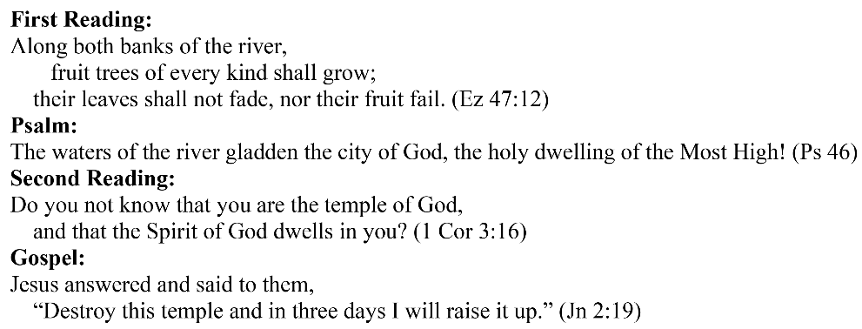
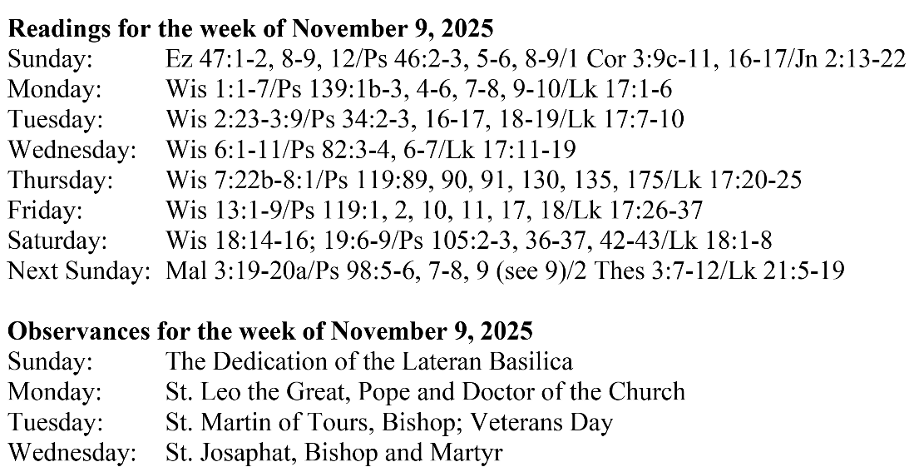
Are you in need of prayer? Do you have a prayer request? You can send your prayer requests to pcuadra@schottcommunities.org or call 954-434-3306 ext. 108

A copy of our prayer list can be found in the lobby of our chapel. To request a copy of our prayer list please email us at pcuadra@schottcommunities.org
To request a Mass please contact Pablo A. Cuadra at 954-434-3306 or e-mail at pcuadra@schottcommunities.org
Update: Celebrating a wedding anniversary soon? Let us know a week in advance and we can assist you with the renewal of your wedding vows.

Prayer to St. Michael the Archangel:
"St. Michael the Archangel, defend us in battle. Be our defense against the wickedness and snares of the Devil. May God rebuke him, we humbly pray, and do thou, O Prince of the heavenly hosts, by the power of God, thrust into hell Satan, and all the evil spirits, who prowl about the world seeking the ruin of souls. Amen"

