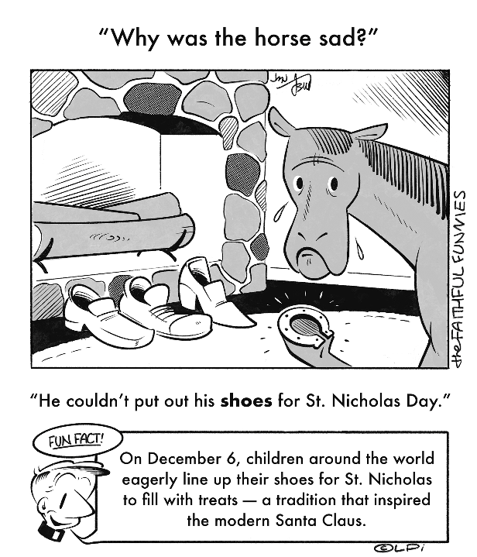
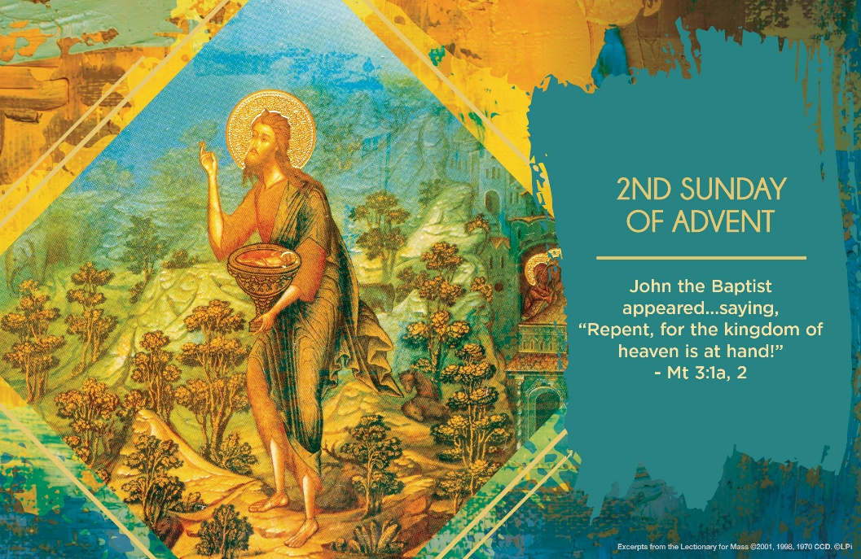
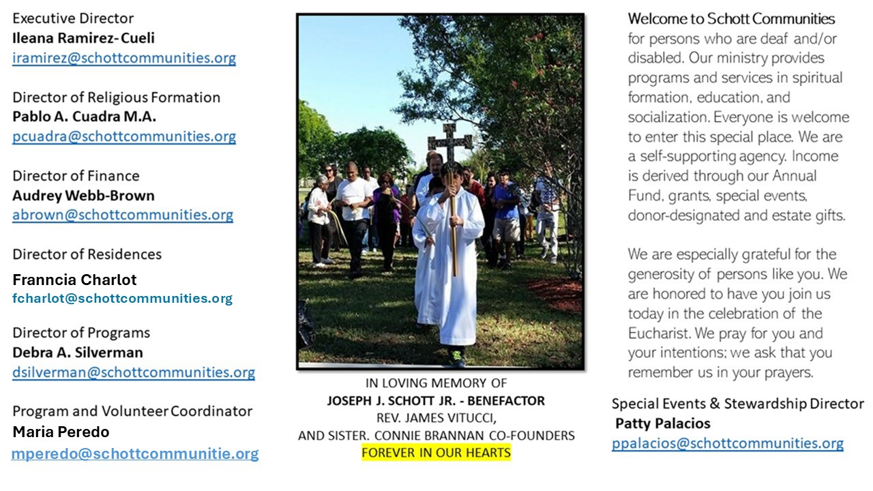

7 de diciembre de 2025
II Domingo de Adviento
Mateo 3:1-12

Durante el Adviento, Dios nos brinda la oportunidad de trabajar y movernos, de no quedarnos en un solo sitio. Como ejemplo, tenemos a Juan Bautista, personaje importante de este tiempo. Él trabajó incansablemente anunciando cómo preparar el camino del Señor, cómo sería su venida. El profeta Isaías se refería a Juan de esta forma: "Una voz grita en el desierto: preparen un camino al Señor, hagan sus senderos rectos" (Juan 3:3). Hacer los senderos rectos, es decir, implica una conversión desde el fondo del corazón; un cambio radical a través de un proceso suave pero firme para llegar a Dios.

“La Iglesia de este tiempo es igual a un campo sembrado que tiene grano y paja mezclados, es decir, juntos buenos y malos. Después del juicio, en cambio, tendrá solamente buenos, sin malo alguno… De ahí vendrá el juzgar a vivos y muertos, y como dice el Evangelio: Él tiene el bieldo en su mano para separar el trigo de la paja. Guardará el trigo en su granero y quemará la paja en un fuego que no se extingue” (San Agustín, 354–430. Sermón 223). Preparados o no, este Adviento es el tiempo de aprender que los tiempos de Dios son momentos de gracia. Paja y trigo crecen en nosotros, y es tiempo de ponerse a trabajar en la conversión para ir al encuentro del Señor. No olvidemos que Dios espera de nosotros lo mejor y nos da la libertad de seguirlo o dejarlo. ¿Qué escoges? El tiempo de Adviento es para revisar nuestra conciencia: cómo pensamos, creemos y actuamos.

Dec. 7, 2025
Second Sunday of Advent
Matthew 3:1-12

This week we hear that John the Baptist is out in the wilderness eating “locusts and wild honey” (Mark 1:6). It’s not just a strange historical detail. It’s a symbolic expression of a healthy spiritual diet. The path to Christ includes both the hard and the beautiful, the gritty and the sweet. We have to learn to gulp the locusts and savor the honey.I remember working with a young couple preparing for marriage. They were sincere, but raw — barely beginning to discover faith. Part of me wanted to rush them ahead, to fill in all the gaps, to bombard them with scripture and church documents. I swallowed that instinct. It was like eating locusts.But I also recall them light up as they spoke about each other, about their first child, then their second. And they wanted to be close to God. Something innocent and beautiful was unfolding. That was the honey. I knew God was asking me to savor it. This Advent, maybe we’re each being invited to accept both locusts and honey. Maybe it’s time to stop avoiding the difficult parts of faith — prayer that feels dry, the call to repentance, the patience with the troublesome. It’s time to eat some locusts.
But we also need to notice the small gifts God gives us: a peaceful moment, a good conversation, the joy of serving someone else, new life, good intentions of our friends. That’s the honey. Savor it!
John didn’t avoid either. He took it all in. And so can we. What are your locusts? Your honey? If we let God feed us with both, we’ll be ready — really ready — for the coming of Christ.

— Father John Muir

St. Jude Chapel, Sunday, December 7th, 2025
Father Thomas Coughlin and Fr. Robert Bouffier
Celebrants

St. Lucy |Feast Day December 13
A name that means “light,” St. Lucy (283 – 304) is the patron saint of those blind or suffering with eye trouble. Not much is known about her life, except that she was determined to remain a virgin and thus refused marriage. History tells the story of a frustrated suitor who eventually accused St. Lucy of being a Christian (at crime at the time), and she was executed in Syracuse, Sicily, in the year 304.


Christian Giving
November 30th, 2025
$478

We sincerely thank you and bless you for your generosity.
A bequest is a powerful tool to help the Deaf or Disabled.

Mass Intentions
“For the repose of the Souls in Purgatory
Requested by Schott Communities


Follow us on Facebook
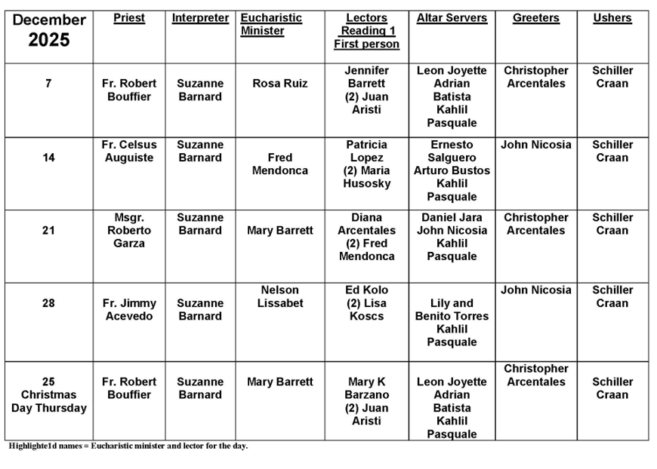
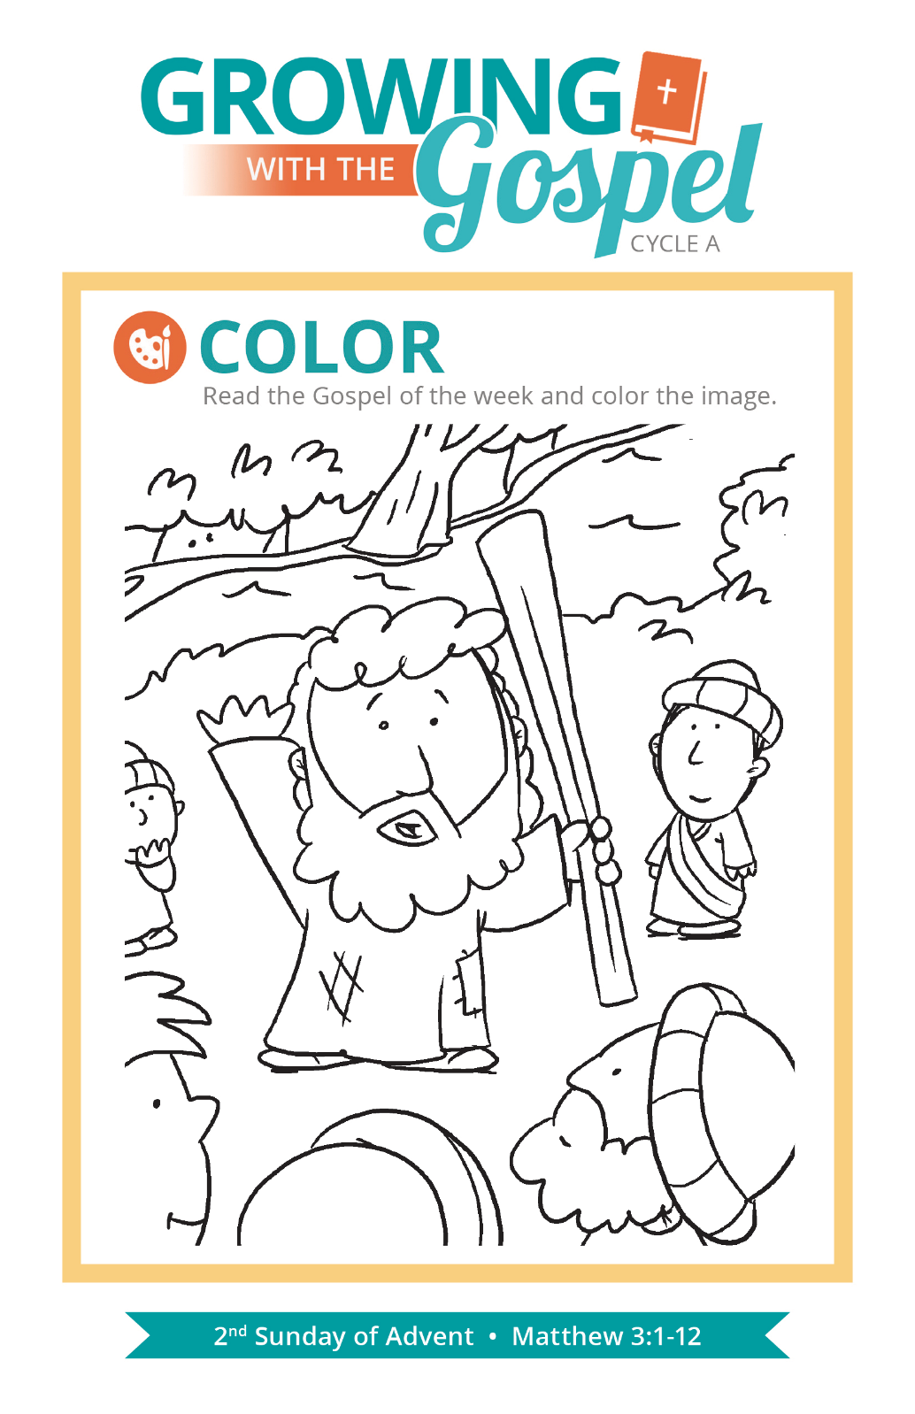
Immaculate Conception

Question:
I’ve heard people call Jesus’ conception by the Holy Spirit being “immaculately conceived.” Is that what the Immaculate Conception is?

Answer:
While these two events are often confused, they are not the same thing. We celebrated the conception of Jesus on March 25th, the feast of the Annunciation. While that was surely miraculous, it isn’t what we refer to as the “immaculate conception.” The Immaculate Conception is Mary’s conception, and we typically celebrate it on December 8th. If the 8th happens to be a Sunday, the Church moves the feast to December 9th. It is a holy day of obligation. Why does the Church consider it so important to celebrate?

Mary’s conception is immaculate because she was conceived without original sin. The angel Gabriel acknowledges this when he hails Mary as “full of grace” (Luke 1:28). Scripture scholars identify several theological ideas that confirm this. In the Old Testament, the sacred, pristine Ark of the Covenant held the presence of God. The presence of God is now held within a new “arc” — the womb of Mary. Genesis 3 also prophesies of a woman who would oppose the devil and whose child would crush the devil’s head. Christ is the “New Adam.” This passage sets up Mary, then, as the “New Eve.” Jesus and Mary are the beginnings of a new creation, one we all can participate in through the grace of our baptism. After all, God’s love is more “original” than our sin!

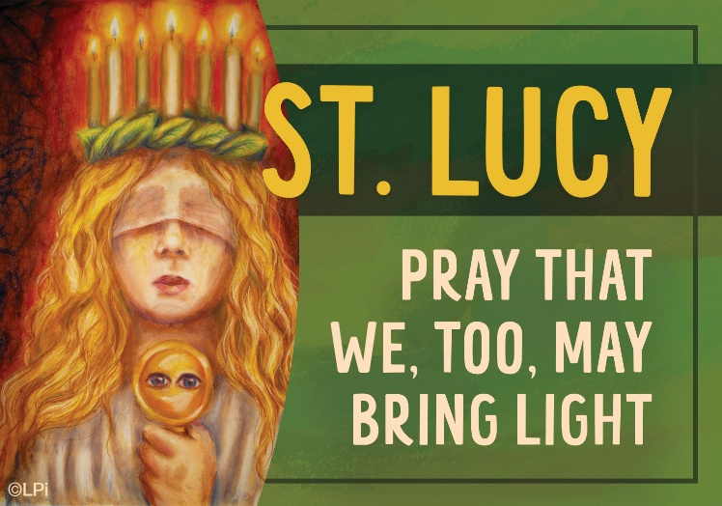
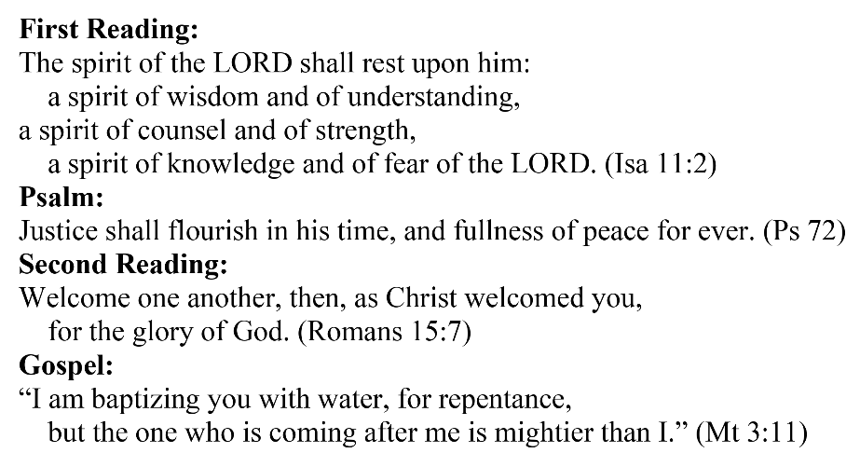
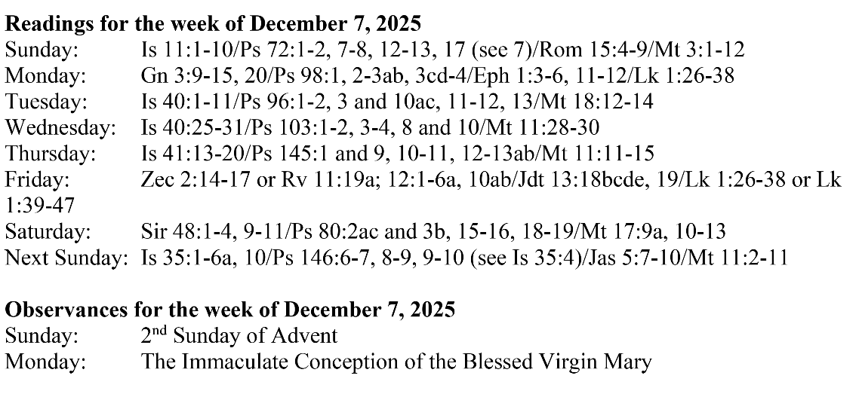
Are you in need of prayer? Do you have a prayer request? You can send your prayer requests to pcuadra@schottcommunities.org or call 954-434-3306 ext. 108

A copy of our prayer list can be found in the lobby of our chapel. To request a copy of our prayer list please email us at pcuadra@schottcommunities.org
To request a Mass please contact Pablo A. Cuadra at 954-434-3306 or e-mail at pcuadra@schottcommunities.org
Update: Celebrating a wedding anniversary soon? Let us know a week in advance and we can assist you with the renewal of your wedding vows.

Prayer to St. Michael the Archangel:
"St. Michael the Archangel, defend us in battle. Be our defense against the wickedness and snares of the Devil. May God rebuke him, we humbly pray, and do thou, O Prince of the heavenly hosts, by the power of God, thrust into hell Satan, and all the evil spirits, who prowl about the world seeking the ruin of souls. Amen"

