
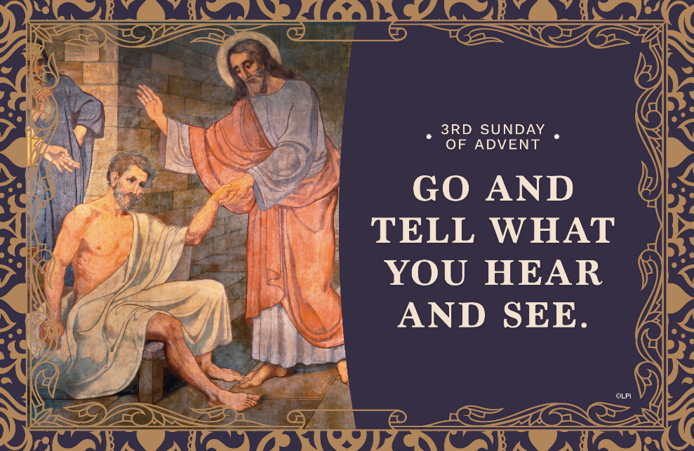
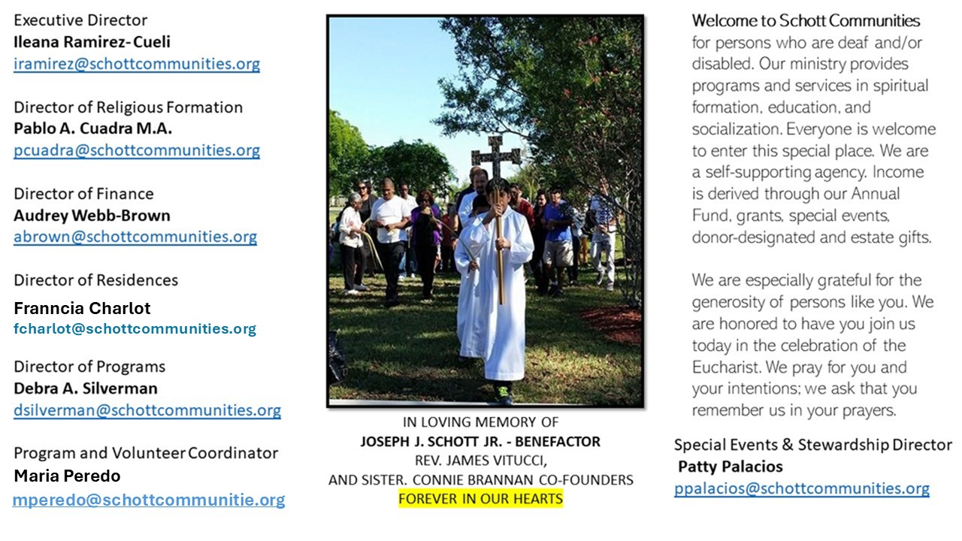

14 de diciembre de 2025
III Domingo de Adviento
Mateo 11:2-11

¿Dónde está nuestra esperanza en este tercer domingo de Adviento? ¿En qué se basa nuestra alegría? Este domingo es llamado el domingo de la alegría, porque ya estamos acercándonos a la Navidad. En latín se conoce como Gaudete, que significa “alegría” o “regocíjense”. El verdadero gozo consiste en el nacimiento del Salvador, siendo este nacimiento la causa profunda de nuestra alegría. A veces perdemos mucho tiempo en las tiendas, comprando regalos, sin siquiera darnos cuenta de que el tiempo pasa y se va sin provecho alguno para nuestra alma. Miremos al cielo, de donde nos llega la esperanza y la gracia. Ahí es donde está Dios.

El Evangelio nos narra que Juan estaba en la cárcel y quería saber si era verdad lo que había escuchado sobre Jesús. La respuesta para Juan fue la siguiente: "Vayan y cuéntenle a Juan lo que ustedes están viendo y oyendo: los ciegos ven, los cojos andan, los leprosos quedan limpios, los sordos oyen, los muertos resucitan, y una Buena Nueva llega a los pobres" (Mateo 11:5). Con esta respuesta, Juan quedó lleno de esperanza, seguro de que el Reino de Dios ya estaba presente.
Juan predicaba la conversión, un cambio de mentalidad radical, válido tanto entonces como ahora. Para nosotros, la venida del Salvador es un hecho seguro y esperanzador. Sin embargo, solo los pobres de espíritu logran visualizarlo en el horizonte de la Navidad. Aguardemos con paciencia los regalos de la gracia de Dios: la paz y el amor entre nosotros, que tanto necesitamos.
¡Ven, Señor Jesús!

December 14, 2025
Third Sunday of Advent
Matthew 11:2-11

When I was 11, I was riding my bike on a Friday night in Scottsdale, Arizona. I saw giant spotlights swirling in the sky. Something amazing had to be happening. I pedaled after them with excitement. Sweaty and tired, I arrived, only to find a used car lot. Bright lights, flapping banners, inflatable balloon men swaying wildly in the wind. I stood there, heart sinking. All that spectacle, and all my effort … for this?
As life proceeds, we learn what it is like to pursue promising but fruitless searches. This week we hear Jesus ask the crowds regarding John the Baptist: “What did you go out to the desert to see? A reed swayed by the wind?” (Matthew 11:7). He’s not just describing the crowd’s mis-aimed pursuit. He’s naming our tendency to chase after what’s flashy but flimsy.What are our swaying reeds? For me, it is endless video reels on my phone, worldly pleasures, entertainment in sports, and the good opinion of others. Inflated distractions that bend whichever way the wind blows. But they can’t satisfy my soul. What are your flimsy reeds?
John the Baptist wasn’t a swaying reed. He was rooted, grounded, unafraid to speak the solid truth. The people went to see him because, deep down, they were starving for something real.This Advent, the Church asks us to reassess: What are we really looking for? Are we chasing the dazzling but hollow? Or are we seeking what is solid and lasting — that which points to Christ?

— Father John Muir

— Father John Muir

St. Jude Chapel, Sunday, December 14th, 2025
Father Celsus Auguiste
Celebrant

St. Lucy |Feast Day December 13
A name that means “light,” St. Lucy (283 – 304) is the patron saint of those blind or suffering with eye trouble. Not much is known about her life, except that she was determined to remain a virgin and thus refused marriage. History tells the story of a frustrated suitor who eventually accused St. Lucy of being a Christian (at crime at the time), and she was executed in Syracuse, Sicily, in the year 304.


Christian Giving
December 7th, 2025
$TBA

We sincerely thank you and bless you for your generosity.
A bequest is a powerful tool to help the Deaf or Disabled.

Mass Intentions
“For the repose of the Souls in Purgatory
Requested by Schott Communities


Follow us on Facebook
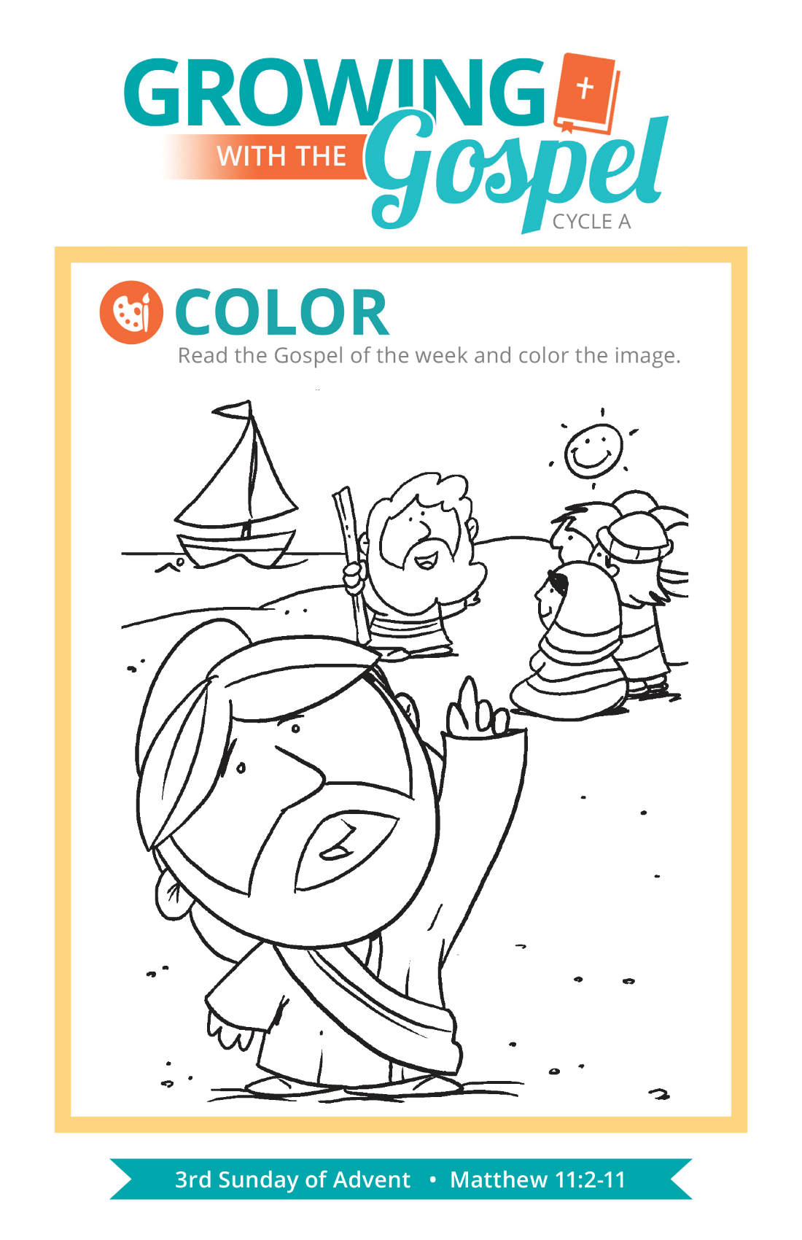
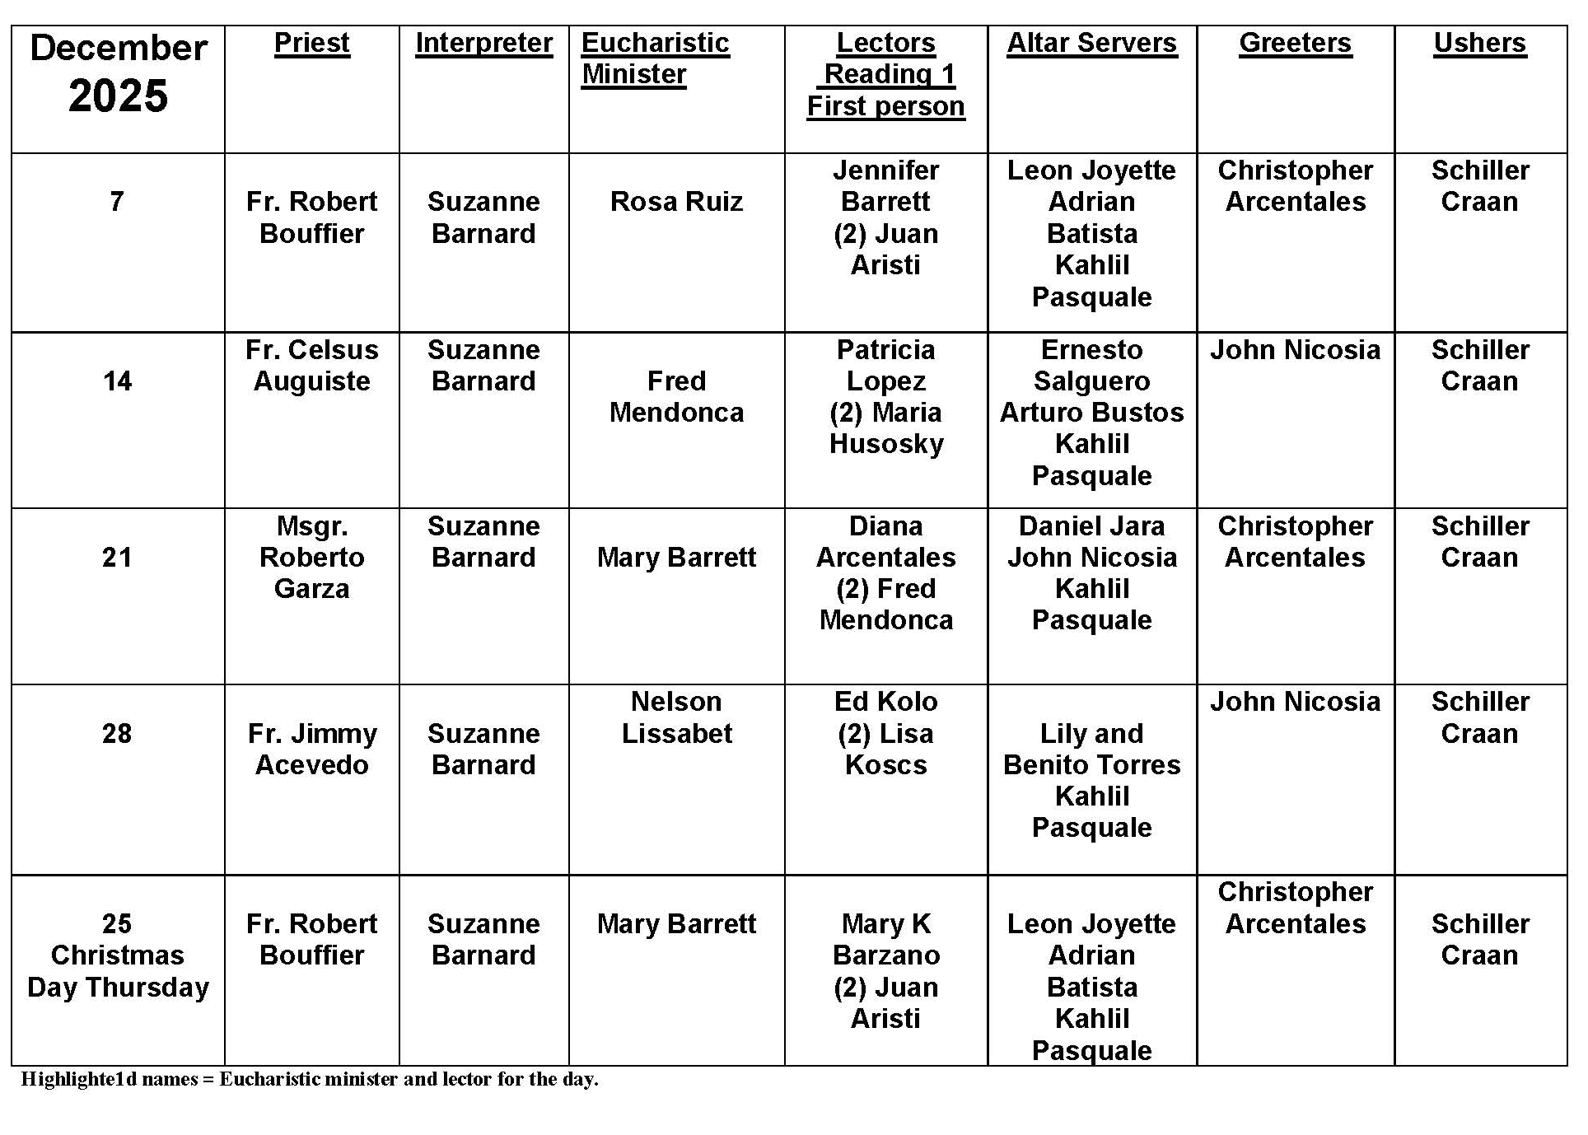
Saints or Sinners?

Question:
Our prayer group has been reading the lives of some saints, and we were struck by how some of them thought they were such sinners. Why would someone so holy think they had such serious sin?

Answer:
Professional athletes practice the fundamentals of their sport over and over again, reaching for better form, consistency, and performance. They focus on the basics, review past performances, and visualize greater success. Practice makes better, if not perfect!

Spiritual masters such as the saints also looked for perfection. They practiced their faith in the search for holiness, grace, and virtue. Through sacraments, prayer, study, good works, and penance, they raised their level of awareness and their sensitivity to the presence of God, the demands of the Gospel, and the workings of the Holy Spirit. They examined their consciences daily, reviewing the day for moments of failure and times that they could have been more virtuous in one way or another. They resolved to do better, be more attentive, and alert!

Therefore, anything that would distract them or interfere with their relationship with God would be like a small black spot on a bright white wall — you can't miss it! The great saints were aware of sin and the presence of evil because they were so tuned into the struggle between good and evil that was fought in their own lives, hearts, and souls.


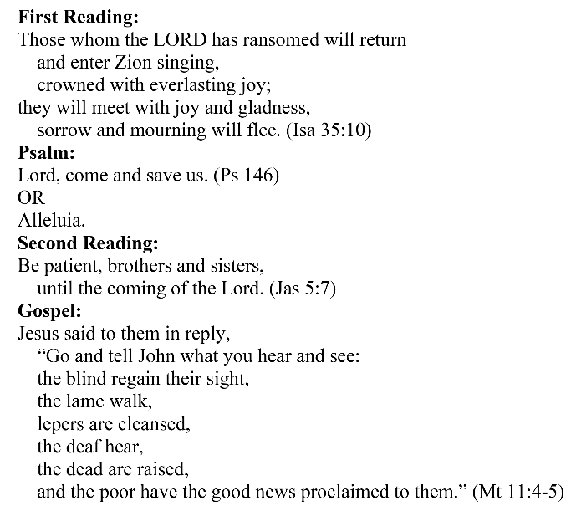
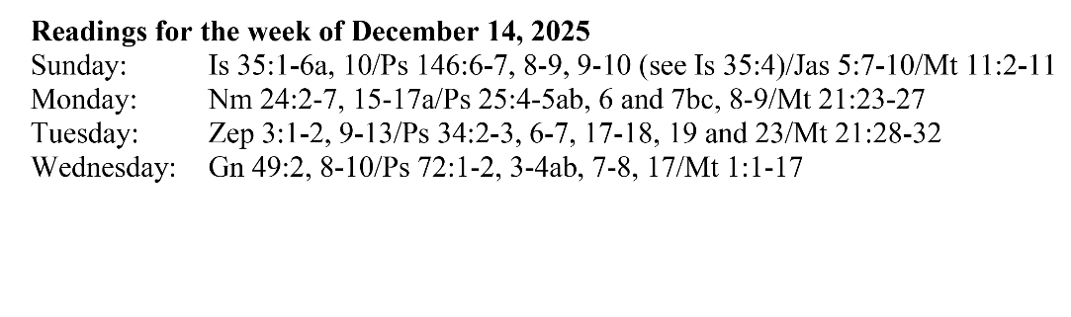
Are you in need of prayer? Do you have a prayer request? You can send your prayer requests to pcuadra@schottcommunities.org or call 954-434-3306 ext. 108

A copy of our prayer list can be found in the lobby of our chapel. To request a copy of our prayer list please email us at pcuadra@schottcommunities.org
To request a Mass please contact Pablo A. Cuadra at 954-434-3306 or e-mail at pcuadra@schottcommunities.org
Update: Celebrating a wedding anniversary soon? Let us know a week in advance and we can assist you with the renewal of your wedding vows.

Prayer to St. Michael the Archangel:
"St. Michael the Archangel, defend us in battle. Be our defense against the wickedness and snares of the Devil. May God rebuke him, we humbly pray, and do thou, O Prince of the heavenly hosts, by the power of God, thrust into hell Satan, and all the evil spirits, who prowl about the world seeking the ruin of souls. Amen"

