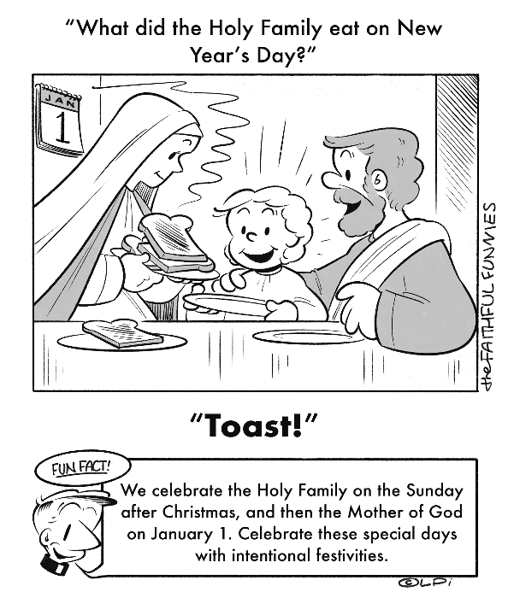
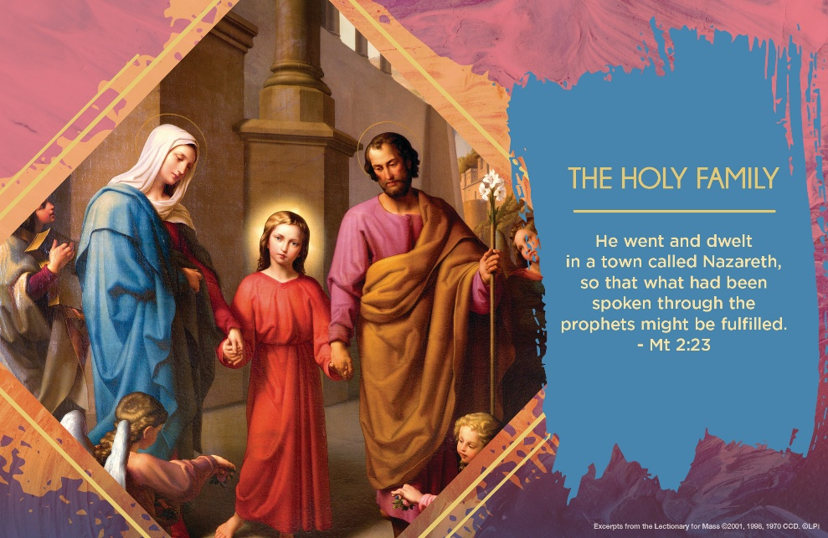
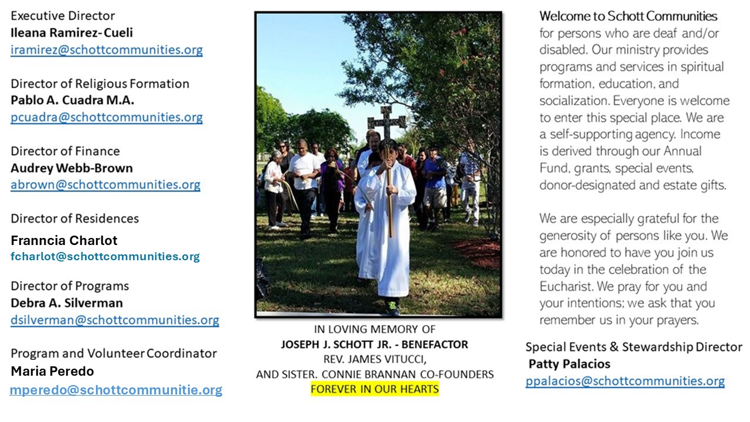

28 de diciembre de 2025
La Sagrada Familia
Mateo 2:13-15, 19-23

Jesús y su familia saben lo que es emigrar, cambiar de lugar y moverse con rapidez porque son perseguidos. Ellos vivieron en carne propia los efectos de esta situación. Quizá nosotros tenemos algún familiar o amigo que actualmente sufre las penurias de dejar su hogar, su escuela o su trabajo. José y María huyen por la amenaza de peligro que pesaba sobre ellos: "Levántate, toma al niño y a su madre, y huye a Egipto. Quédate allí hasta que yo te avise, porque Herodes buscará al niño para matarlo" (Mateo 2:13). Padre, madre e hijo huyeron hacia donde Dios les indicó, para salvar al niño. Este es un fiel reflejo de lo que representa la Sagrada Familia de Nazaret. Celebrar la fiesta de la Sagrada Familia durante la Navidad debe animarnos con esperanza, deseando que nuestras propias familias sean un lugar donde se respire amor y alegría entre sus miembros. ¿Cómo recibo hoy a las familias de mis hermanos y hermanas? ¿Cómo es mi convivencia con ellos?

"Ustedes, familias, son la esperanza de la Iglesia y del mundo. Con su testimonio del Evangelio pueden ayudar a Dios a realizar su sueño; pueden contribuir a acercar a todos los hijos de Dios, para que crezcan en la unidad y aprendan qué significa para el mundo entero vivir en paz como una gran familia" (Papa Francisco). Oremos por nuestras familias, deseando que, en este día dedicado a la Familia de Nazaret, imitemos su esperanza en Dios y su unidad en todo momento.

December 28, 2025
The Holy Family of Jesus, Mary and Joseph
Matthew 2:13-15, 19-23

When I was ten, my dad gathered our family around the table in small-town Vermont and told us we were moving to the big desert city of Phoenix, Arizona. We were leaving behind family, friends, and everything familiar. None of us knew what to expect.
But something beautiful happened. As we made the move together, our family grew closer. In retrospect, I’m amazed at my parents’ courage to go on that adventure. Even as a kid I realized our family found, in that challenge, a deeper unity and mutual love.
In today’s Gospel, Joseph is told: “Rise, take the child and his mother, and flee…” (Matthew 2:13, 20). First to Egypt, then later to Israel. The Holy Family is frequently challenged to move and change, to adapt to God’s will for them, in order to find safety in the midst of threat. It’s not just an idiosyncratic story about survival. It’s a spiritual pattern for all of us. Every Christian family is called to be a kind of sanctuary, especially in a world full of noise, busyness, and fear.
May I make a practical application for us? The Lord’s Day, Sunday, is perhaps the most practical way we imitate this dynamic we see in Joseph and his family. Sunday is not meant to be just like every other day, filled with errands and stress. It’s meant to be a day set apart; a holy “escape” into rest, worship, joy, and peace. A day to rise, take your family, and flee, into God’s presence.
— Father John Muir

St. Jude Chapel, Sunday, December 28th, 2025
Father Dariel Fong
Celebrant

St. Basil the Great | January 2

St. Basil the Great (329–379) shares his feast day with his friend St. Gregory of Nazianzen. These accomplished men fought against heresies that threatened the foundations of the early Church, shaping doctrines around Christ’s divinity and the nature of the Holy Trinity.


Christian Giving
December 21st, 2025
$TBA

We sincerely thank you and bless you for your generosity.
A bequest is a powerful tool to help the Deaf or Disabled.

Mass Intentions
“For the repose of the Souls in Purgatory
Requested by Schott Communities


Follow us on Facebook
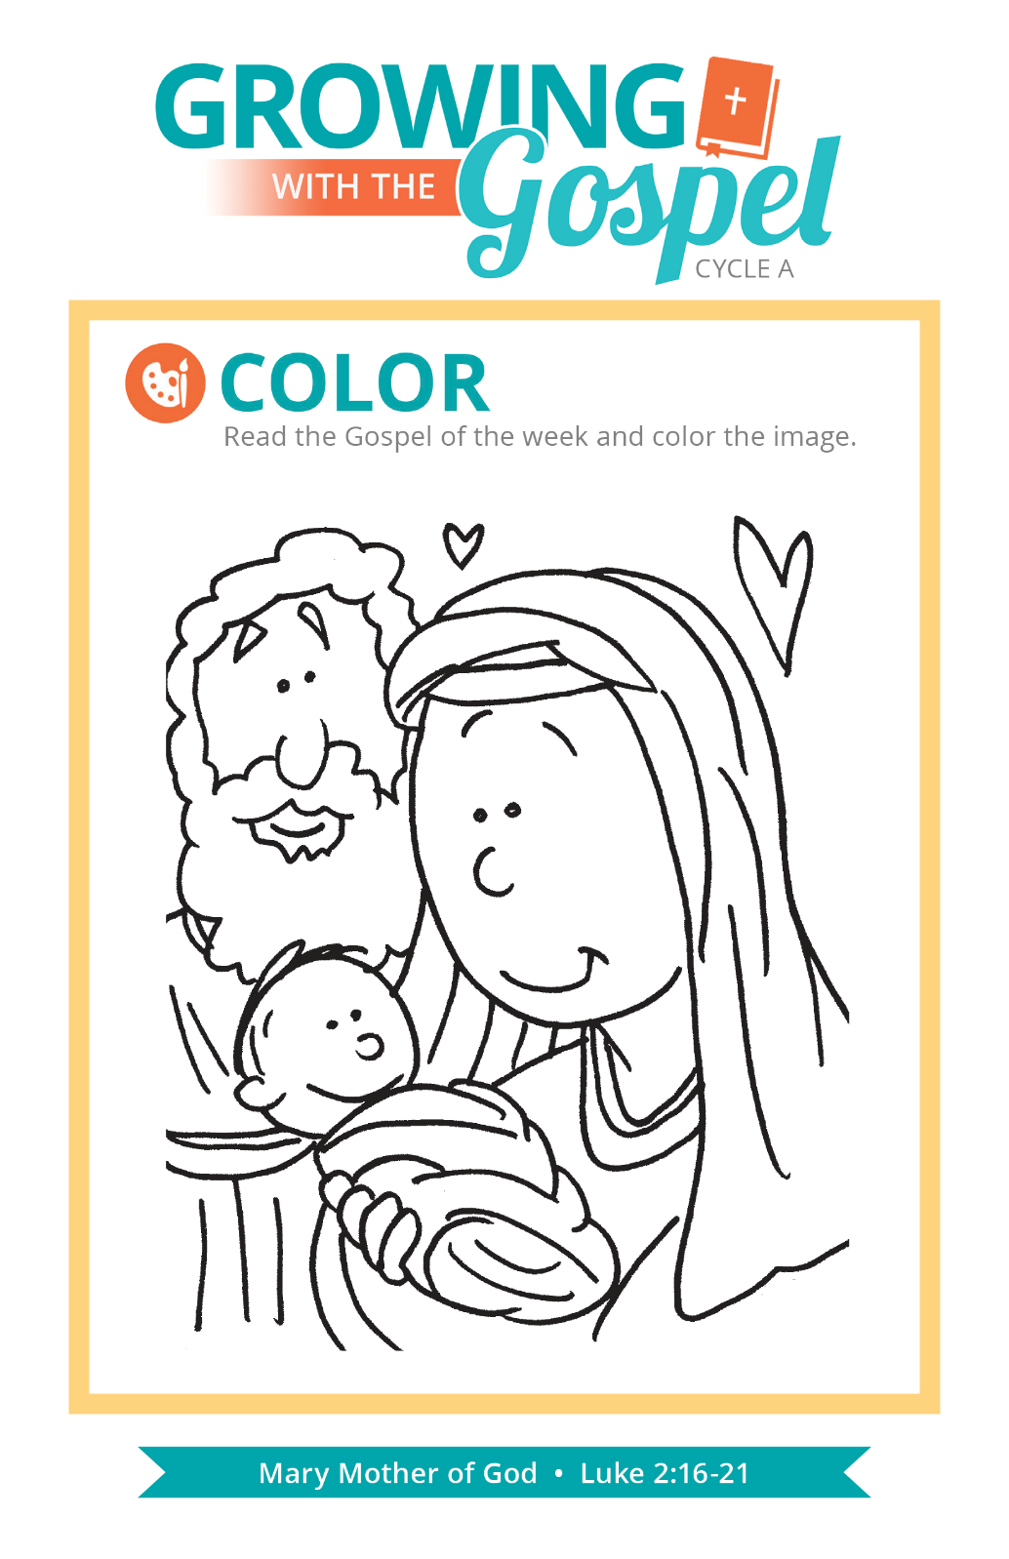
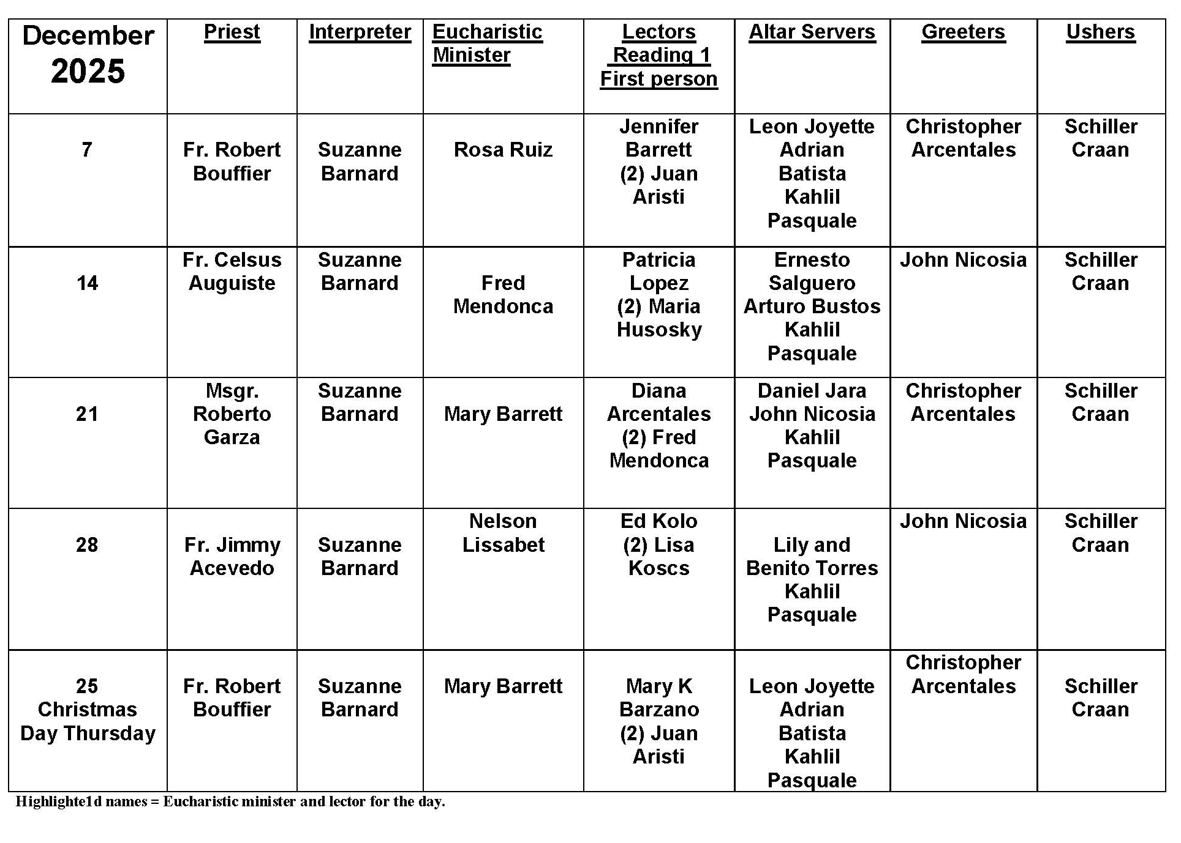
Confessing Sins

Question:
If I go to the Sacrament of Penance and end up repeating the same sins, does that mean I do not have a strong enough intention to amend my life?

Answer:
There is a popular expression that says, “Be patient. God isn’t finished with me yet!” Growing in faith and holiness is an ongoing, life-long project, and our struggle with sin is at the heart of it. As St. Paul says, the good he intends to do, he does not do. The evil he does not intend, he does! It is not always a lack of intention, but more often the allure of evil that makes it difficult to change.

When we confess our sins, we are to come with a fully contrite heart. You need to reflect on your true feelings toward your actions before approaching the sacrament. After confession, there are strategies you can make to avoid falling into the same traps of sin. First, pray for and seek out strength and perseverance through multiple sacraments, charitable work, and personal sacrifice. Second, avoid occasions of sin when you might fail or be sorely tempted. In doing these things, remind yourself daily that it is a spiritual war we wage, and with God’s grace, we will succeed.

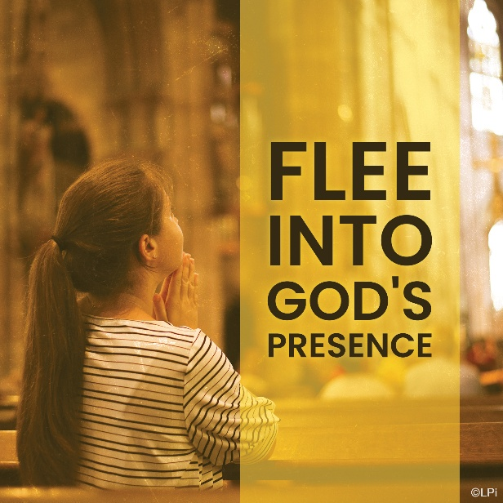
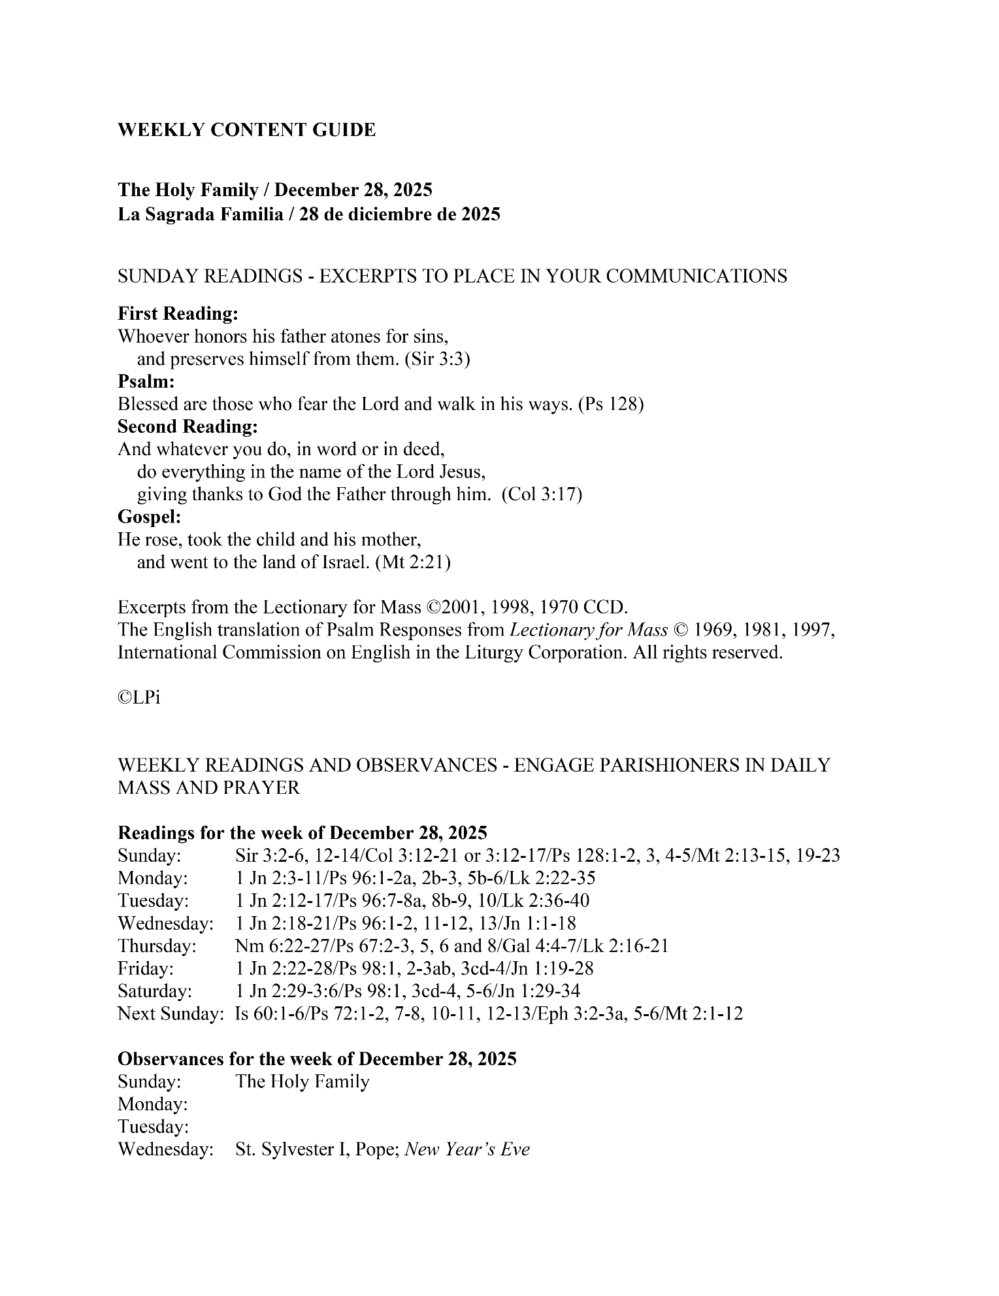
Are you in need of prayer? Do you have a prayer request? You can send your prayer requests to pcuadra@schottcommunities.org or call 954-434-3306 ext. 108

A copy of our prayer list can be found in the lobby of our chapel. To request a copy of our prayer list please email us at pcuadra@schottcommunities.org
To request a Mass please contact Pablo A. Cuadra at 954-434-3306 or e-mail at pcuadra@schottcommunities.org
Update: Celebrating a wedding anniversary soon? Let us know a week in advance and we can assist you with the renewal of your wedding vows.

Prayer to St. Michael the Archangel:
"St. Michael the Archangel, defend us in battle. Be our defense against the wickedness and snares of the Devil. May God rebuke him, we humbly pray, and do thou, O Prince of the heavenly hosts, by the power of God, thrust into hell Satan, and all the evil spirits, who prowl about the world seeking the ruin of souls. Amen"

